WEAR Project Site Information |  |  |  |  |  |  | Options
Community |  | Atka
Site name |  | Airport Barrel Dump
Site Type |  | Barrel Dump |  |  |  |  | Landfill, Tank Farm, Drum Dump, Military, Mining, Other
Status |  |  |  |  |  |  | Active/Open, Covered/Closed, Inactive, Removed/Remediated, etc.
Location: | Description | 800 ft east of Korovin Lake
 | Latitude | 52.215348
 | Longitude | -174.209082
Approximate size: |  |  |  | years operated:
Probable contaminants: |  | Fuels, metals
Distance to: | Eroding area | 190 |  | Subsistence
(ft) | S. water | 190 |  | C. Habitat
 | Residences |  |  | Stress Veg
Exposure Pathways: |  |  |  |  |  |  | inhalation, direct contact
Drinking Water: | 1° Source: |  |  | 2° Source: |  |  | surface water, groundwater
 | Treatment: |  |  |  |  |  | Types??
 | Well depth (ft.): |  |  | Protection Zone: |  |  | Zone A, Zone B, Zone C, Zone E, Zone F
Erosion: | Type |  |  |  |  | Waves, Currents, Ice, Heat, Wind, Precipitation, Seepage
 | Factors |  |  |  |  | Tides, Storm Surge, Flooding, Permafrost, Human Influenced, Other
 | Symptoms |  |  |  |  | Slides, Undercutting, Scarps, Exposed Permafrost, Root Exposure/Fallen Trees, Waste Exposed, Ice Gouging, Other
 | Soil type | High organics sand |  |  |  | clay, silt, sand, gravel, etc
 | Rate |  |  | Erosion Rate QA |  |  | reported, calculated, BEA calculated
Erosion mitigation: |  | none
 |  | Notes: on back

Inventory: 17 barrels
Erosion: Closest source of erosion is a river 190 ft east
Soil: Sand with high organic content
Vegetation: some stressed and dead vegetation, contaminated soil
Slope: flat
General water flow: eventually to the ocean

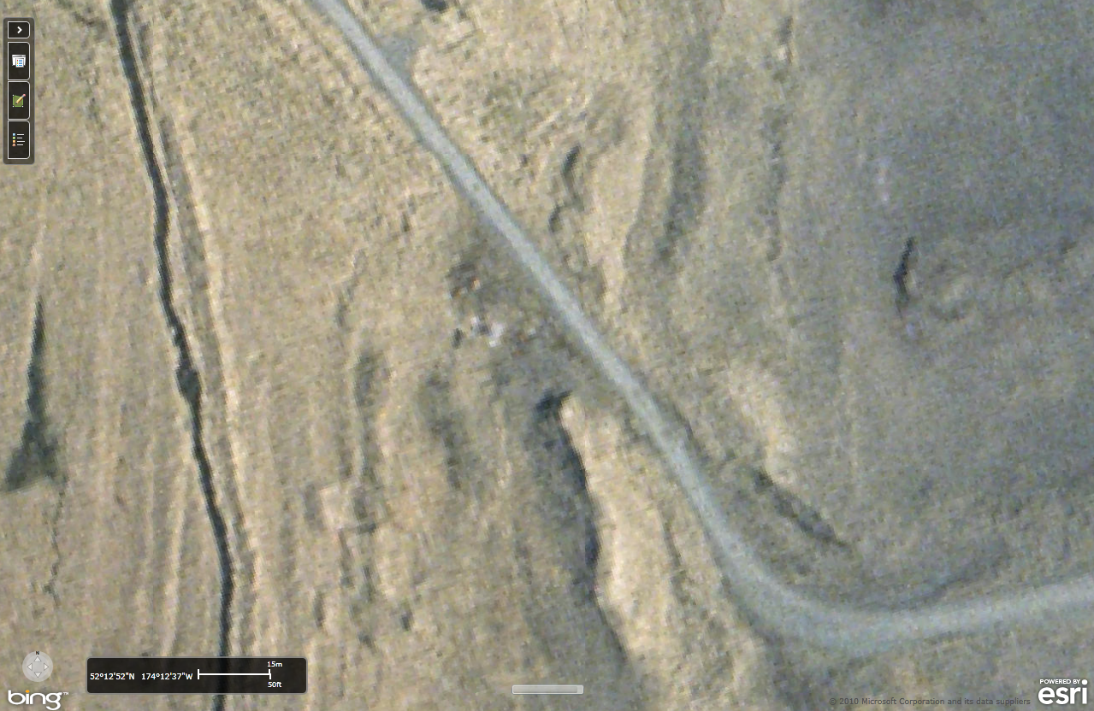
River flow direction
Site area

