The Compliance Monitoring Data Portal (CMDP) Training Materials

Module 5: Composite Samples and Results
There are three ways to submit samples and results into the Compliance Monitoring Data Portal (CMDP) in order to report them to your primacy agency:
- Uploading the sample information as an XML file using web-services;
- Manually uploading sample information in XML files (including XML files for CMDP, which can be generated by using the Excel templates that are available in CMDP, or, if desired, generated by some other application); and
- Entering the information directly into the CMDP using the data entry screens that are part of the CMDP application.
In this training module, the third method will be presented and we’ll focus on the data entry screens for composite samples and results. We covered entry of chemical, radionuclide, and microbial samples and results in Module 4.
After logging into the CMDP, which is covered in Module 1, the steps are as follows:
- Select the “Drinking Water Sample Jobs” module tab
- Create a new job (or select a job from the jobs search list to view job details in a new tab).
- Use the “Composite Samples” sub-tab to add samples and results.
- Click on the Add button and enter information about the composite sample.
- Click on the Add button under Individual Sample to enter information about the samples in the composite.
- Click on the Add button under Chem/Rads Results to enter information about the results for the composite.
To add another composite sample, click on the Close button and start at Step 4.
Let’s look at each step in more detail.

Select the “Drinking Water Sample Jobs” Module Tab
If you are creating a new Sample Job with composite samples and results, which is what this module is about, then select the Drinking Water Sample Jobs module tab. On the Drinking Water Sample Jobs tab, you’ll initially see a list of all the jobs you’ve entered. Each row represents a separate job.
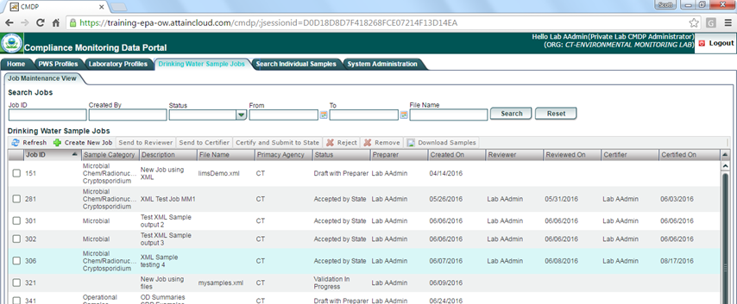
Each job can consist of one or more samples and results for one or more types of samples. Lots of information is provided about each job including its Status, the Category of sample record(s) in the job (Microbial, Chem/Radionuclides, Operational, etc.), and so forth.

Create a New Job
If you are entering a new job, you don’t need to look at the existing jobs - just click on the Create New Job button on the menu (see the box outlined in red below.
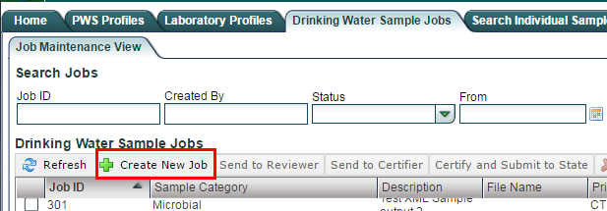
A popup dialog box called “Create New Job Options” will appear.
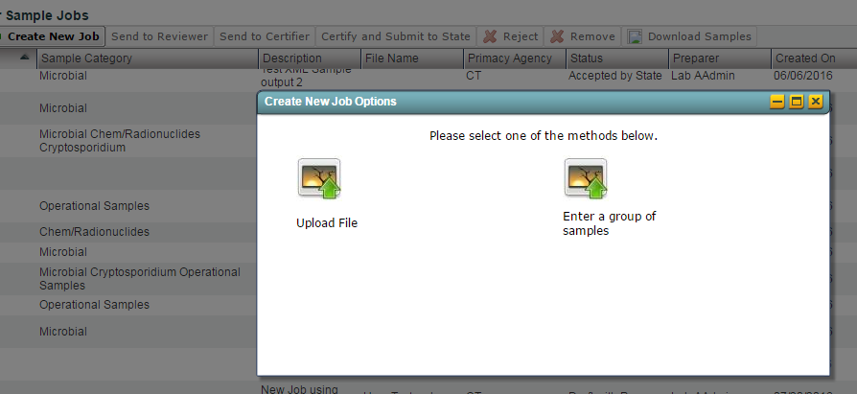
Click on “Enter a group of samples” (if you were uploading an Excel file, you’d select the other option and go to Module 8).
Another popup, “Please enter a value” will appear. In this one, enter a description for the job and click OK (see below).
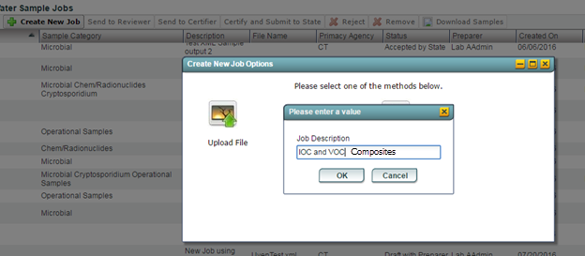
You’ll want to think about a naming convention to help you better keep track of the samples and results you enter.
For example, a water system user might want to include the monitoring period and type of samples being submitted (e.g., total coliform May 2016) whereas a laboratory user might only focus on the particular kind of results in the job (e.g., IOC and VOC). Note that the date the job was created is recorded and displayed so you don’t need that type of timestamp in the name.

Use the “Composite Samples” Tab
When you click on the OK button to save the Job Description, a new Job Summary View tab is presented, waiting for you to enter data. It includes a third row of five tabs. Three of the tabs on this third row are used to enter samples and results: Sample Result, Operational Data, and Composite Samples. For composite samples, which is what this module is about, click on the Composite Samples sub-tab (see below).
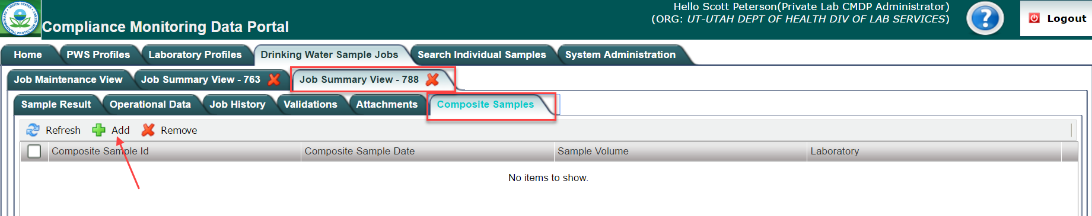

Click on the Add button and enter the composite sample information
To add a composite sample, click on the Add button as indicated above. The Composite Sample Results form (below) will open for you to enter information about: (a) the composite sample at the top; (b) the individual samples that make up the composite in the middle; (c) and the analytical results for the composite at the bottom.
You can enter composite samples for chemicals or for radionuclides. We'll walk through adding a composite sample for chemicals first. When you intend to enter a composite sample for radionuclides, you check the box next to "For Radionuclides." For chemicals, you leave it unchecked.
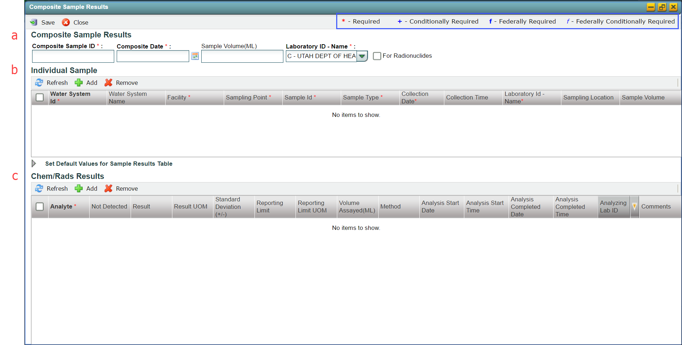
The red asterisk (*) next to a field label means it is “software required” - you must enter a value into that field before you can save the Sample Job. The blue box at the top right of the picture above highlights the meaning of all the superscript items (+ f f). If a federally required field is not valued, it will be listed as a validation error when you save the record (validation errors can be seen on the Validation subtab). However, these errors will not prevent you from saving the record nor prevent you from certifying and submitting it in a Job to a primacy agency.
Notice the "For Radionuclides" checkbox.

Click on the Add button under Individual Sample
Once you’ve finished entering the composite sample information, you can begin entering information for each of the samples in the composite by clicking on the Add button under the Individual Sample section on the form (see below). (Note that, if there are errors in the composite sample fields, you need to fix them before you can add any individual samples. Error messages are presented at the top of the form.)
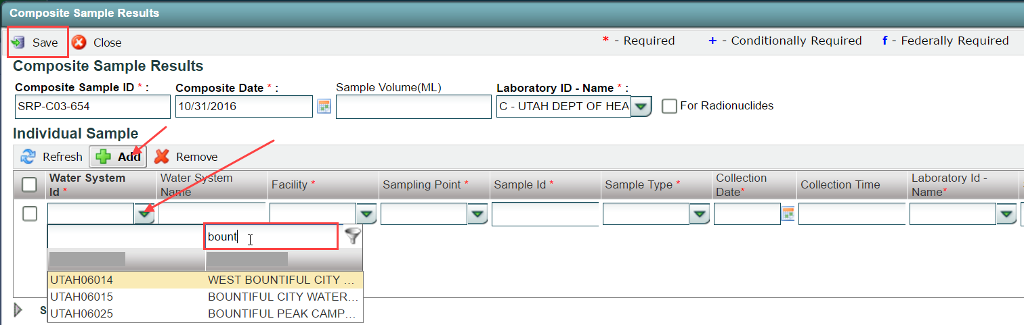
Note that dropdown fields, like Water System, allow you to filter and sort the values available (also known as permitted values). In the picture above, the user knew the name of the water system and so started typing it in. The CMDP filters use the logic “matching anywhere in the values” and is not case sensitive - meaning that, so long as the string entered is found, the value is displayed (note all the records that have “bount” in its name are displayed in the above example). This filter logic is true throughout the application.
After entering all the required fields for an individual sample, click on the Add button to enter another individual sample until you've entered all the individual samples in the composite. Hit the "Enter" key (or click outside the Individual Sample table) and the Save button at the top to complete the entry of individual samples and then go on to enter the analytical results for the composite.

Click on the Add button under Chem/Rads Results
Once you’ve finished entering the individual samples for the composite, you can begin entering analytical results. There are two ways to enter analytical results: click on the Add button below the Chem/Rads Results heading or click on Add to Grid button in the Set Default Values for Sample Results Table section. Each method is covered below.

Use the "Add" button to enter results one at a time
You can enter results one at a time by clicking on the Add button on the "Chem/Rads Results" menu (see below). If you click on the Add button, a row will be added to the result grid.
Enter the analyte first as it controls some of the rest of the result entry (e.g., Method). To select an analyte, just start typing its name or code in the analyte field in the grid. The CMDP will filter using both the name field and code field for analytes.
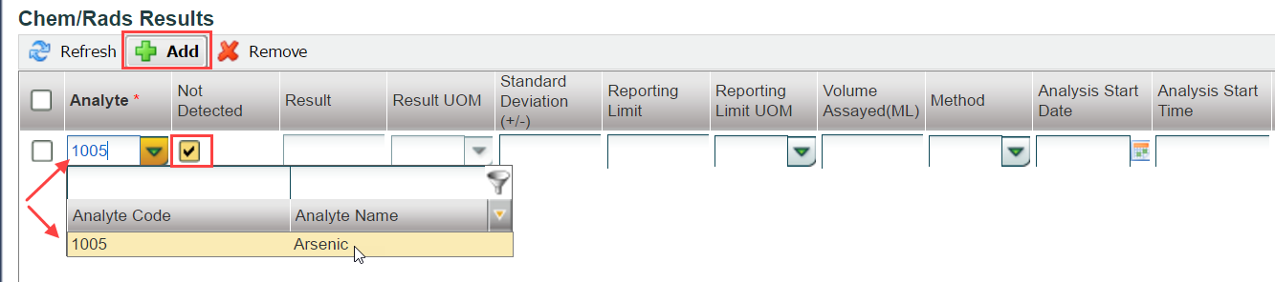
In the above picture, I clicked in the Analyte cell and typed “1005” to filter the list of analytes to the one I wanted, which was arsenic. I could have instead typed "ars…" Also note that the result is defaulted to not detected (i.e., the box is checked in column "Not Detected").
Once you’ve clicked the Add button, the application expects you to complete its entry or hit the ‘Esc’ key before you do anything else (the ‘Esc’ key cancels the entry of a new result).
To finish entering results hit the ‘Enter’ key or click outside the results grid. To enter several results in a row, keep hitting the tab key and the application will start you on a new row after the last column for the last row or keep clicking the Add button.
If you need to change something in a result record, double-click anywhere on the row for the result.
Note that you can remove and sort the columns in the results grid. For example, you can remove Standard Deviation, Volume Assayed, Analyzing Lab ID (by the way, this is used if the particular result was analyzed by a different laboratory than the one to which the sample was sent). However, any changes you make to the grid are only for your current session.

Enter several results at once
If you’re entering a large number of results (e.g., volatile organic chemical results) with at least some of the same information (e.g., reporting limit, analysis start and finish), you’ll want to expand the Set Default Values for Sample Results Table area and use it, including the Add To Grid button. The picture below shows you an example of how you might use it.
Notice that, if you want to use one of the Analyte Groups, you have to not only select the Analyte Group, but also select the analytes from the group that you want. In the picture, all the analytes in the group were selected by clicking on the checkbox in the header.
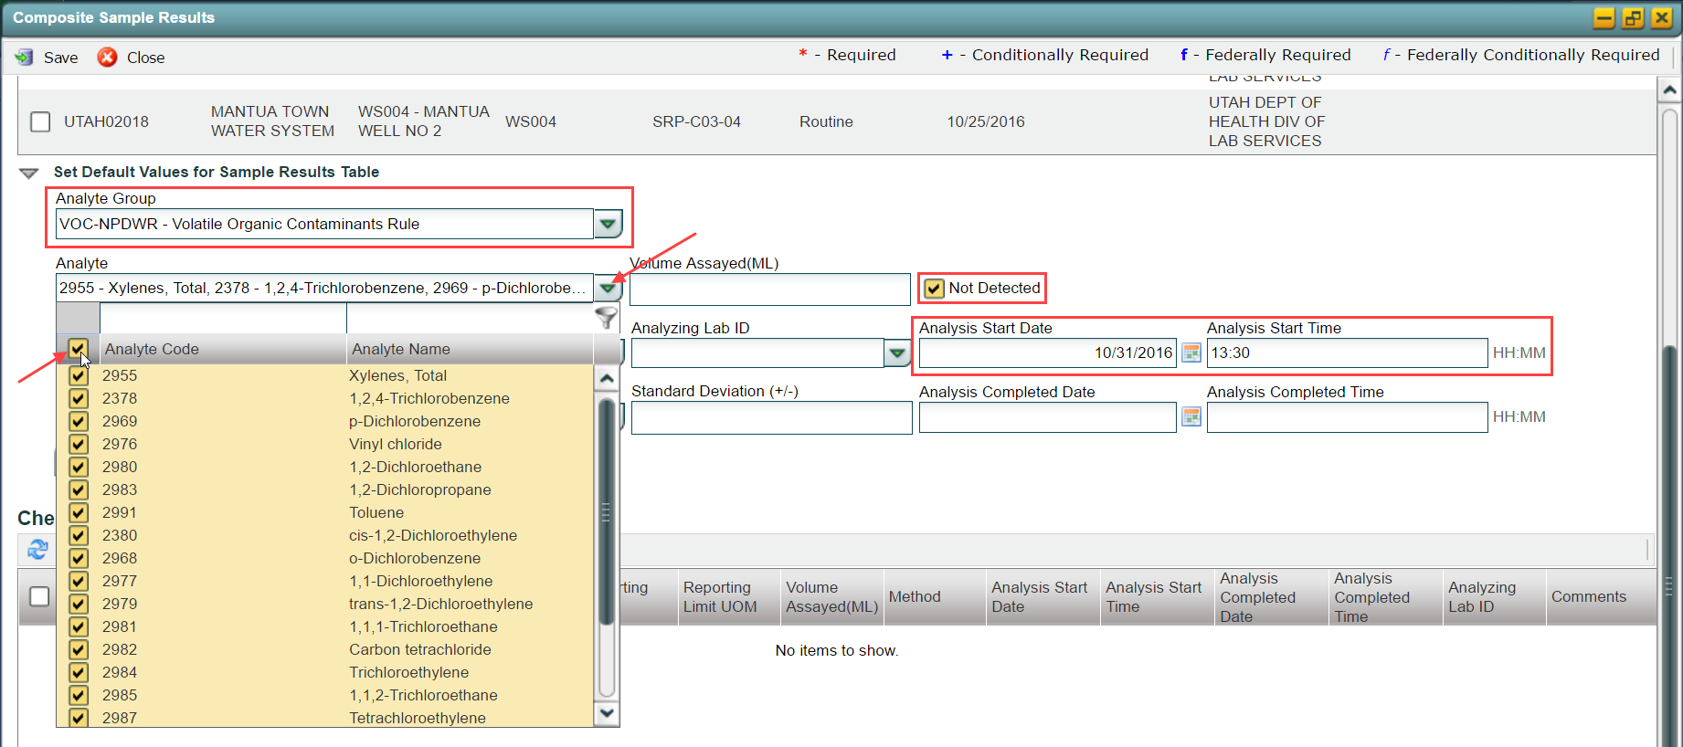
When you click on the Add To Grid button, a result will be created for each of the analytes in the Analyte Group selected (see below). Be sure to update any results that are not as defaulted (e.g., below the result for toluene was updated from no detect to 0.0008 mg/l detected).
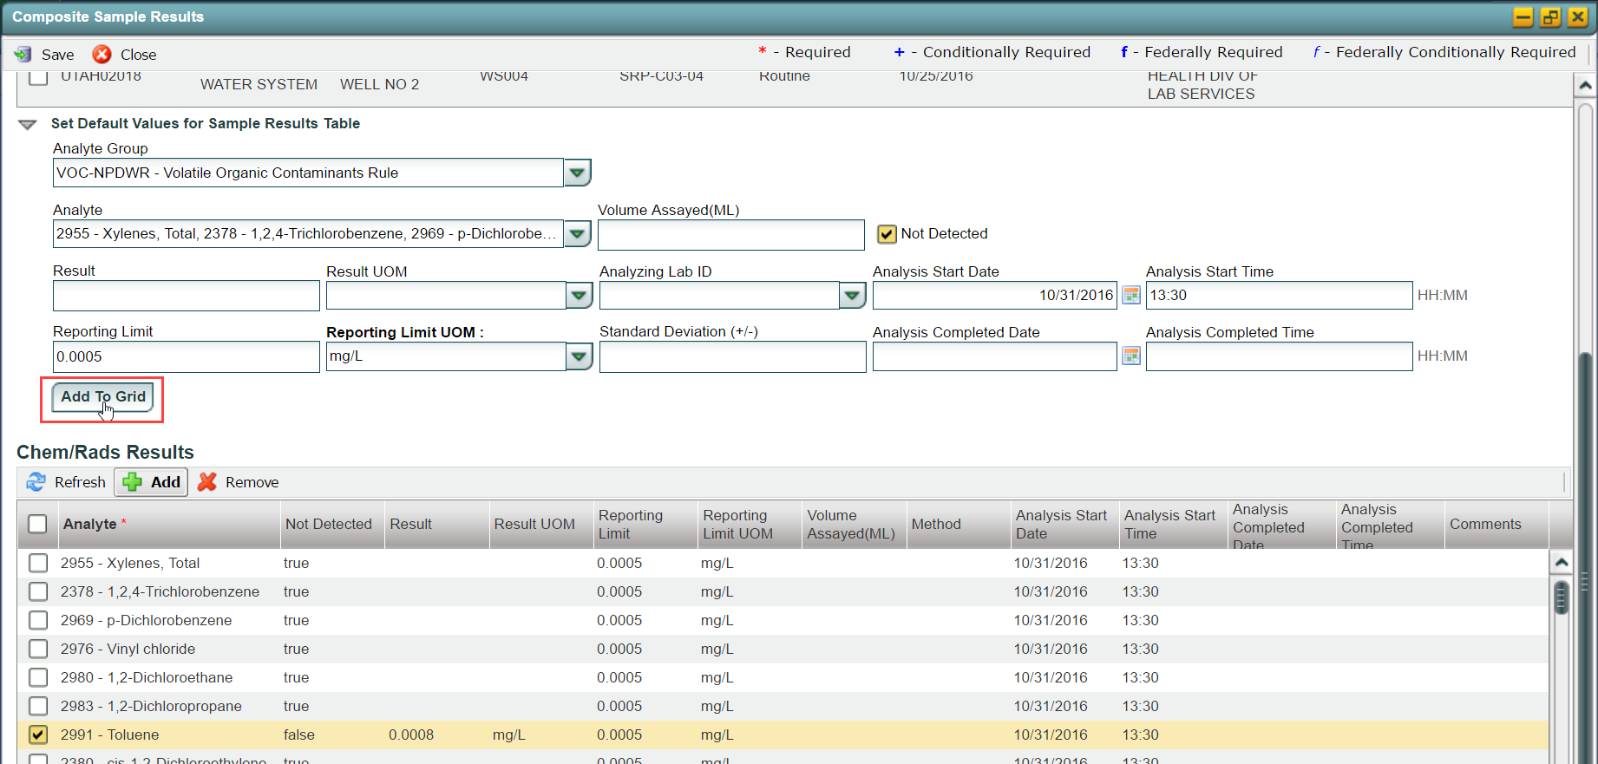
Note that, when initially displayed, the scroll in the Chem/Rads Results grid will be at the bottom so you'll only see the last result. Don't be tricked by that.
To add another composite sample, click on the Close button and return to Step 4. After you’ve entered the last sample and results, click on the Close button to return to the Job Summary View. Once you are done entering all the samples and results for a job, you’re ready to go to the next step. Refer to Module 9 - Submission Workflow Validations, Job History, & Attachments for what those next steps are.

Entering a Composite Sample for Radionuclides
As mentioned above, you can enter composite samples for chemicals or for radionuclides. When you intend to enter a composite sample for radionuclides, enter the information about the composite sample at the top and check the box next to "For Radionuclides" (see below).
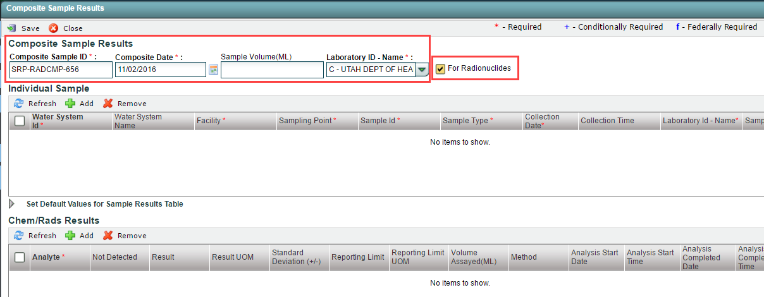

Click on the Add button under Individual Sample
Once you’ve finished entering the composite sample information, you can begin entering information for each of the samples in the composite by clicking on the Add button under the Individual Sample section on the form (see below).
Notice that when you add additional individual samples, the location for the additional samples is defaulted to the same location that was entered for the first individual sample and you cannot change it. That is because composite samples collected under the Radionuclides Rule must be collected from the same sampling location.
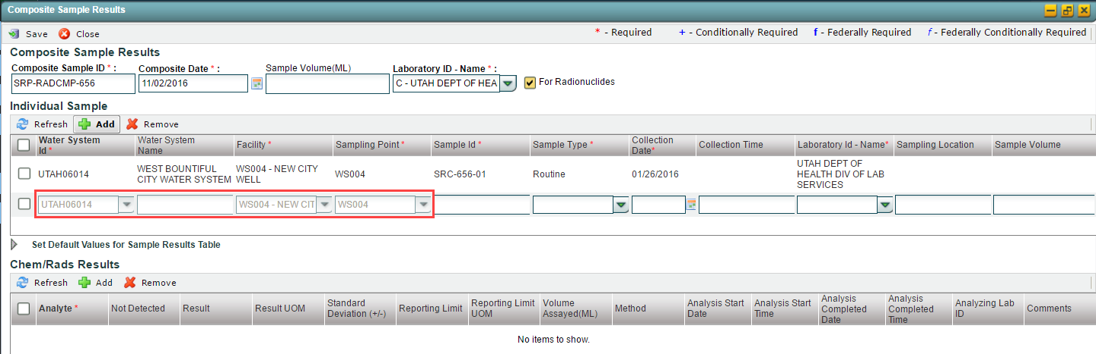

Click on the Add button under Chem/Rads Results
Once you’ve finished entering the individual samples for the composite, you can begin entering analytical results. As with chemical composite samples, there are two ways to enter analytical results: click on the Add button below the Chem/Rads Results heading or click on Add to Grid button in the Set Default Values for Sample Results Table section. Refer to Step 6 above for detailed instructions.

Attachment One: Sample Category to use to Enter Samples and Results
The following table lists the sub-tabs and web forms to use for the types of samples and results you want to enter along with the module to refer to.
Sub-Tab Name | Types of Samples and Results | Module Number
Sample Result | Chemical | Five (5)
 | Radionuclide
 | Microbiological
 | Cryptosporidium
Operational Data | Combined Filter Effluent (CFE) Turbidity | Seven (7)
 | Individual Filter Effluent (IFE) Turbidity
 | Chlorine Dioxide/Chlorite
 | Chlorine Chloramines Entering the Distribution System
 | Chlorine Chloramines In the Distribution System
 | Lead and Copper Water Quality Parameters (LCR WQP)
 | Total Organic Carbon (TOC)
 | TTHM and HAA5
 | Ozone Treatment (Bromate)
Composite Samples | Chemical | Six (6)
 | Radionuclide
Note that, though the highlighted web forms will be active in CMDP, at the time of this video they were not mapped to SDWIS/State. Please be sure to review the user manual for more information and the ZenDesk for regular updates on CMDP software updates.

