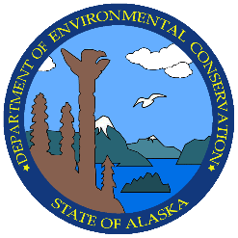
Human Health Criteria Public Workshop
October 29-30, 2015
Alaska Performing Arts Center, Voth Hall
Registration Form

The Alaska Department of Environmental Conservation (DEC) is holding a public workshop to discuss the process of revising human health criteria in water quality standards. A two day conference will be held in Anchorage, October 29-30, 2015 at the Alaska Performing Arts Center, Voth Hall. The primary focus of the workshop is to review key issues associated with the development of human health criteria, sources of information, and potential options for implementation.

The workshop will be technical in nature, and those attending the workshop should be familiar with the process of developing water quality regulations, be prepared to propose and discuss technical and policy issues associated with developing water quality criteria, and potential implications on the permitted community. If you are planning on attending, please fill out and return this registration form by October 15, 2015. Space may be limited, so attendees who plan to attend in person are encouraged to send in their registration forms early to allow DEC time to accommodate as many participants as possible. If attending via teleconference, the dial in number and webinar information will be provided after registration.

Name:

Title:

Organization:

Mailing Address:

Email:

Phone Number:

Attending via teleconference? (Circle one) Yes / No

Briefly describe your knowledge about human health criteria in water quality standards:

Briefly identify any agenda items that are important to you. Non-agenda items may be discussed if time permits or discussed at potential future workshops.

Please return completed registration forms to DEC_HHC_rulemaking@alaska.gov or fax (907) 465-5274

