Background
In an effort to determine the chemicals regulated by human health criteria (HHC) that have been permitted or otherwise released in Alaska, Department of Environmental Conservation (DEC) conducted a review of the following sources of information:
- Alaska Pollutant Discharge Elimination System (APDES) Permits
- National Pollutant Discharge Elimination System (NPDES_ Permits
- Permittee correspondence
- DEC Contaminated Sites Database
- U.S. Environmental Protection Agency (EPA) Toxic Release Inventory (TRI)
- State/Federal Whitepapers
The purpose of this white paper is to provide the DEC HHC Technical Workgroup with some of the chemicals for which DEC will need to implement revised HHC once state water quality standards are adopted.

Potential Sources of Chemicals with HHC
The following industries are potential sources of HHC-regulated chemicals in Alaska. Note list is in alphabetical order and the order does not indicate the amount of pollutant discharged.
- Chemical wholesalers
- Electric utilities
- Metal mining operations
- Military sites
- Petroleum bulk storage terminal
- Petroleum processing plants
- Publicly Owned Treatment Works (POTWs)

Documented Releases

Federal Monitoring
DEC reviewed EPA 2015 TRI for chemical releases into water. TRI tracks the management of certain toxic chemicals that may pose a threat to human health and the environment. U.S. facilities in different industry sectors must report annually the amount of waste containing one or more of the listed chemicals. TRI indicates wastes released to the environment and/or managed through recycling, energy recovery and treatment (TRI Website 2016). A "release" of a chemical means that it is emitted to the air or water, or placed in some type of land disposal. According to TRI, 55 incidents released toxic chemicals into water in Alaska in 2015 (does not differentiate between surface or groundwater). Twenty of the 55 incidents were chemicals regulated by HHC.

Table 1. Chemical release information noted in EPA TRI database for 2015
Contaminant | Source
1,1,2,2 Tetrachloroethane* | Other- US Coast Guard Base Kodiak
1,2,4 Trimethylbenzene* | Petroleum bulk storage terminals
Arsenic* | Metal mining operations
Benzene* | Petroleum bulk storage terminals
Copper | Metal mining operations
Cyanide | Metal mining operations
Ethylbenzene | Petroleum processing
Mercury | Petroleum processing
Nickel | Metal mining operations
Selenium | Metal mining operations
Toluene | Petroleum bulk storage terminals
Zinc | Metal mining operations
Orange indicates bioaccumulation or bioconcentration factor > 5,000
* Carcinogen
This list is similar to releases documented in the 2014 TRI database with the exception of 1,1,2,2 Tetrachloroethane as this incident appears to have been a unique occurrence in 2015.

State Regulatory Efforts
DEC also reviewed chemical release information provided by the DEC Contaminated Sites program (C-Sites). C-Sites tracks the total number of active and inactive contaminated sites through the Contaminated Sites Program Database. These projects cover a range of sectors and properties.
Figure 1. DEC C-Site Database by Site Type
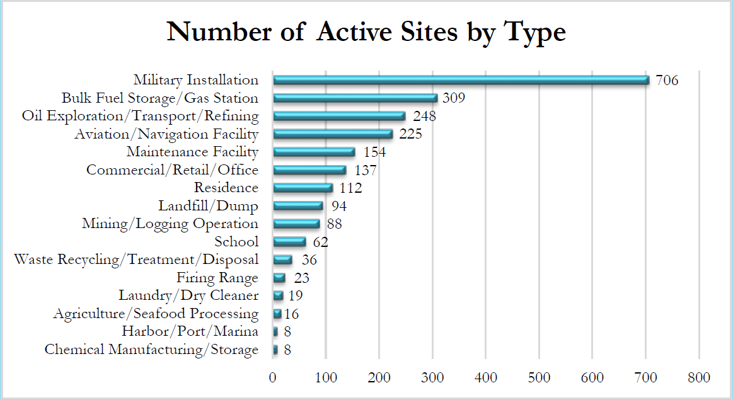
2014 Database Search: Site Type = (select from drop down menu) and Status = Active. Several oil production site types are combined, as are bulk fuel storage and crude and non-crude terminals.
A review of the C-Sites database indicated the following chemicals with HHC that are regulated under C-Site regulations. In general, this information is applicable to groundwater releases although some contaminated sites may include releases to surface waters based on groundwater connectivity and contaminant migration.
Table 2. Chemicals with HHC present in groundwater at Alaska C-Sites
1,1,1-Trichloroethane | Dibenzo(a,h)anthracene*
1,1,2,2-Tetrachloroethane* | Dichloroethane* (or 1,1 Dichloroethane or 1,2- Dichloroethane)
1,1,2-Trichloroethane* | Dichloroethene (or 1,1-, 1,2-cis- or 1,2- trans dichloroethylene)
1,1-Dichloroethylene | Dichloromethane (methylene chloride)
1,2,4-Trimethylbenzene* | Ethylbenzene
1,2-Dichloroethane* | Nickel, Dissolved
1,2-Dichloropropane* | n-Nitroso-di-n-propylamine*
2,3,7,8 TCDD (Dioxin)*⁺ | Polychlorinated biphenyls (PCBs), total*
3,3'-Dichlorobenzidine* | Tetrachloroethylene*
Arsenic, Total* | Thallium, Total
Benzene* | Trichloroethylene*
Benzo(a)anthracene* | Toluene
Benzo(a)pyrene* | Trans-1,2-Dichloroethen
Benzo(b)fluoranthene* | Vinyl Chloride*
Bis(2-ethylhexyl)phthalate* | Zinc, Total
Carbon Tetrachloride*
Copper, Total
Orange indicates bioaccumulation or bioconcentration factor > 5,000
* Carcinogen
+ Present only in soil

Table 3: Top 10 COC/Chemical compounds known in actively regulated C-Sites
Analyte | Number Of Active Sites with Groundwater Contamination
BTEX (including Benzene*, Ethylbenzene, Toluene) | 294
DRO (diesel range organics) | 283
GRO (gasoline range organics) | 167
Trichloroethylene* (TCE). Industrial solvent | 68
RRO (residual range organics) | 45
Tetrachloroethylene* (PERC). Dry cleaning agent | 37
Lead | 20
TPH (total petroleum hydrocarbons) | 17
1,2 Dichloroethane* Byproduct of vinyl chloride production. | 14
Cis- 1,2 Dichloroethylene* (DCE). Byproduct of vinyl chloride production. | 13
Bold indicates an HHC chemical of concern
* Carcinogen

Figure 2. Active C-Sites by contaminant class. Includes both groundwater and soil
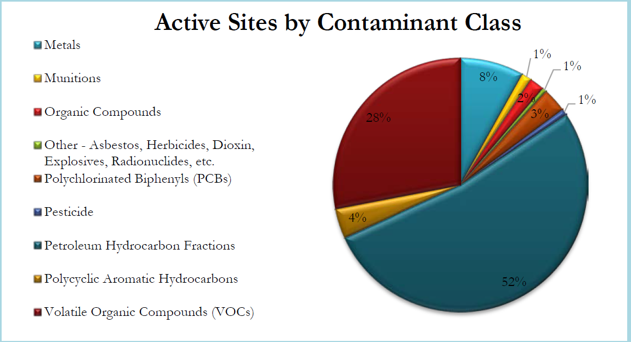
Source: DEC C-Site 2014 Annual Report

APDES Monitoring
DEC conducted a targeted survey of APDES discharge permits to ascertain which chemicals with HHC have permit limits or monitoring requirements based on a reasonable potential analysis. The following is a list of chemicals with HHC that occurred in discharge monitoring reports (DMRs) for APDES permitted facilities. Table 4 does not reflect monitoring information from general permits, annual reports or monitoring studies which are not entered in the DMR data system.
Table 4. Chemicals in APDES permits submitting DMRs
Chemicals | # of permits reporting
Arsenic* | 17
Benzene* | 1
Copper | 14
Cyanide | 7
Ethylbenzene | 1
Manganese | 19
Mercury | 34
Nickel | 7
Polychlorinated biphenyls (PCBs)* | 2
Selenium | 6
Zinc | 37
2,3,7,8 TCDD (Dioxin)* | 1
* Carcinogen Orange indicates bioaccumulation or bioconcentration factor > 5,000

General Permits
. APDES general permit (GP) coverage applies to a specified group, category or class of discharges that are substantially similar in nature or type of pollutants discharged. Examples of general permits in Alaska include the Cook Inlet Oil and Gas Development GP, Pesticide GP, Placer Mining GP, and Seafood (onshore/offshore) GPs.

Arsenic
Arsenic is a chemical of potential concern in Alaska for several reasons. From a geochemical perspective, arsenic is known to exist in elevated concentrations in groundwater and potentially, surface waters., A variety of APDES permits include arsenic. In 1992 EPA promulgated a human health criterion of 0.18 μg/L. In 1998 EPA approved withdrawal of the applicability of Alaska’s waters to HHC. The decision was based on the premise that the Safe Drinking Water MCL adequately protects human health when the principle exposure is drinking water and that the most toxic form of arsenic is in its inorganic form which is available in surface and groundwater; not aquatic life. Should EPA choose to rescind their approval, the criteria would become significantly more stringent (order of magnitude) than the existing criterion, consider both organic and inorganic forms, and potentially require treatment prior to discharge and reclassification/TMDL where naturally occurring arsenic exceeds HHC in surface waters.

Benzene
Benzene is part of the BTEX analytical suite that is regulated with other Total-aromatic hydrocarbons (TAHs) and reported as TAH in petroleum-related discharges. The exception is benzene-specific monitoring and discharge limits in the Tesoro Refinery APDES permit.

Copper
Copper is a chemical of concern in numerous sectors as well as surface waters. Much like manganese and zinc, copper is noted in a variety of APDES discharge permits. While copper is not currently one of the pollutants in which EPA has developed new recommended criteria, adoption of EPA’s updated exposure values will affect how site-specific criteria would be recalculated.

Cyanide
Cyanide is noted in APDES permits for certain publicly owned treatment plants, petroleum refining, and mining effluent.
U.S. EPA Solutions to Analytical Chemistry Problems with Clean Water Act Methods (1), or “Pumpkin Guide”, states; “Next to oil and grease, cyanide is the pollutant for which the most matrix interferences have been reported to EPA.”
Cyanide testing is prone to interference issues at when testing at very low concentrations, such as those proposed by the revised HHC. This issue is exacerbated by the fact that cyanide toxicity does not accumulate or bio- magnify, so chronic exposure to sublethal concentrations does not result in acute toxicity.

Ethylbenzene
Ethylbenzene is part of the BTEX chain that is regulated with other Total-aromatic hydrocarbons (TAHs) and reported as TAH in petroleum-related discharges. Ethylbenzene is noted in a single petroleum industry permit.

Manganese:
Manganese is noted in APDES permits for a variety of industries. As with copper, manganese is a metal which has human health criteria assigned to it in Alaska regulation but is not currently being proposed for update by EPA. This does not absolve Alaska from applying the updated EPA exposure values when developing site specific criteria.

Mercury/Methylmercury
Alaska currently regulates mercury rather than methylmercury. APDES permits for mercury have been issued for a wide variety of publicly owned treatment works and industries although the vast majority applies to the petroleum industry.
Alaska has yet to adopt EPA-recommended methylmercury criteria. This is a COC to Alaska as it has been noted in varying concentrations in fish tissue around the state yet not sourced within Alaska. The testing of fish tissue rather than in water column samples will require new permitting and compliance monitoring requirements to be developed. The proposed HHC are likely exceed natural concentrations of methylmercury in fish tissue in many locations and will require the development of TMDLs and/or statewide variances.

Nickel
Nickel is a naturally occurring metal with HHC assigned yet not updated as part of the EPA 2015 recommended criteria. Nickel is present in certain publicly owned treatment works and mining APDES permits. Nickel would be required to apply updated HHC exposure values should site-specific criteria be proposed.

Polychlorinated Biphenyls (PCBs)
PCBs are members of the group of persistent organic pollutants that are both toxic and persistent in the environment. PCBs are permitted in select powerplant discharges. These chemicals have been found in marine mammals in elevated concentrations yet are not actively sourced in Alaska outside of active contaminated sites.

Selenium
Selenium is a naturally occurring metal with HHC assigned yet not updated as part of the EPA 2015 recommended criteria. Selenium is present in certain publicly owned treatment works and mining APDES permits. Selenium would be required to apply updated HHC exposure values should site-specific criteria be proposed.

Zinc
Zinc is a naturally occurring metal with HHC assigned yet not updated as part of the EPA 2015 recommended criteria. Zinc would be required to apply updated HHC exposure values should site-specific criteria be proposed. Zinc is present in a wide range of different sectors ranging from publicly owned treatment works to fish oil manufacturing.

2,3,7,8 TCDD (Dioxin)
Dioxin is permitted for discharge into surface waters in a single instance (Petroleum Refining). Dioxin is a byproduct of the refining process. Dioxin has been noted as a COC by the contaminated sites program. EPA is not proposing updates to this chemical as part of the 2015 process but may do so in the future.

Example of permitting issues that may occur as a result of adoption of certain revised HHC values
Anchorage Water and Waterwater Utility (AWWU) responded to an informal DEC survey regarding chemical with HHC that could be of concern to the utility. AWWU was targeted due to the size of the facility and monitoring requirements. AWWU noted the following chemicals due to the inability of current technology to meet the monitoring detection limits (MDL) using updated toxicology information and an FCR of 175 g/day. The table also notes chemicals that will require monitoring in the future but not currently monitored. This creates uncertainty as to whether the MDL is precise enough to detect their presence.
Table 4. AWWU permitted pollutants with HHC implementation issues
Chemical with HHC- MDL too low | Chemical with HHC- Unknown if present/MDL?
Aldrin | Alpha-BHC*
Benzidine* | Beta BHC*
Chlordane* | Bis (Chloromethyl) Ether
Dibenzo(a,h)Anthracene* | Bis (2-Chloro-1-Methlyethyl) Ether
Dieldrin* | Hexachlorocyclohexane, Technical*
Hexachlorobenzene* | Pentachlorobenzene
Toxaphene | 1,2,4,5 Tetrachlorobenzene
4,4 DDD (Pesticide) | 2,4 Dichlorophenol
4,4 DDT (Pesticide) | 2,4,5 Trichlorophenol
Orange indicates bioaccumulation or bioconcentration factor > 5,000
* carcinogen

A bioaccumulation factor of 5000 is used based on the Toxic Substances Control Act. Referenced at http://www.pbtprofiler.net/criteria.asp
USGS Fact Sheet FS-083-01 (2001)
Arsenic has been documented in numerous surface waters (e.g., Gold Creek, Juneau) in concentrations above EPA-recommended values
TAH means the sum of the following volatile monoaromatic hydrocarbon compounds: benzene, ethylbenzene, toluene, and the xylenes isomers, commonly called BETX [sic]. 18 AAC 70.990(60).

