Alaska Department of Environmental Conservation
Human Health Criteria Discussion Paper: Adoption of Statewide versus Regional Human Health Criteria
Human Health Criteria Technical Workgroup Meeting #7
Tabor, Brock
4-26-2016

Note that this paper is designed for discussion purposes only and does not represent official DEC policy.
INTRODUCTION
Under section 304(a) of the Clean Water Act, EPA is tasked with updating water quality criteria using science, science policy, and risk management. In the case of developing nationally- recommended ambient water quality criteria for human health, states face two very different challenges; defining what is technically-appropriate for a particular state and determining what is publicly acceptable from a science policy and/or risk management perspective. While it would be ideal for the national dataset to consider the full range of environmental conditions that could influence the reaction of an organism to a pollutant, Alaska and its regional concerns do not easily fit into the national mold.

At present, Alaska’s water quality criteria and uses apply to all state waters unless they have undergone a designated use reclassification (18 AAC 70.230) or site-specific criterion (18 AAC 70.235). Very few of Alaska’s millions of waters have these exceptions.

Data provided by Alaska Department of Fish and Game (ADF&G) Division of Subsistence and Dr. Jim Fall (Arctic, 2016. Vol. 69. No.1) demonstrates subsistence variability on a regional basis (see Figure 1). The consumption of marine mammals is a good example of regional variance as marine mammals constitute the largest source of protein in Northwest Alaska, but only a minor source in Southeast. It is also expected that consumption will vary within the populations of the seven rural areas and the non-subsistence areas of Anchorage, Fairbanks, Juneau, Valdez and Ketchikan. The conclusion is that existing data tells us that the consumption of aquatic life and marine mammals varies widely and may not be easily characterized with a single statewide value.

While much concern has been based on fish and marine mammal consumption rates, the question of statewide v. regional differences also affects other aspects of the human health criteria (HHC) question. Studies have demonstrated that exposure to certain pollutants does not necessarily occur at equal exposure levels on a temporal or spatial basis- an assumption in the relative source contribution component of the HHC formula. This same issue occurs when considering bioaccumulation (BAF) values based on trophic levels (e.g., eating more species from one trophic level over another changes the amount of exposure). Idaho has had some success with developing a species adjusted BAF but it has yet to be approved of by EPA. Thus, the question remains; if Alaska were to adopt human health criteria,
- at what scale should it be considering;
- what regional adjustments can be made that are
  - scientifically defensible,
  - technically feasible to implement
  - and politically acceptable to protect sub-populations that may have a fish consumption rate significantly higher than the general population?

STATEWIDE versus REGIONAL CRITERIA
Development of statewide default values as the basis for its human health criteria has certain advantages and disadvantages. This approach is most typical of states as it
- Requires the least amount of data acquisition and review;
- Is in a format that is most simple to implement in wastewater discharge permits;
- Is familiar to the regulated public; and
- Continues to allow adjusted criteria on a waterbody-specific basis using established procedures.
While development of alternatives (e.g., regional criteria) in Alaska is appealing, Alaska does not have an abundance of water chemistry data that would easily allow such an action. In fact only two states have developed regional pollutant criteria to date (nutrients and BLM-based copper) and with debatable success. The following is a simple pro/con list of statewide versus regional criteria application. This list is by no means exhaustive and only meant for discussion purposes.

Table 1. Adoption of HHC on a Statewide Basis
Pro: Technical | Con: Technical
- Statewide adoption will require the least amount of data to support adoption  - Potential to apply ADF&G Subsistence database info in lieu of independent fish consumption survey data.  - Allows use of larger, more general datasets for making decisions (e.g., census data, body weight, drinking water consumption  - Adoption of statewide criteria could use different percentiles to protect both rural and urban populations. For example  - Could use 90th percentile of general population value (urban/national and rural data combined).  - Use 50th percentile of rural subpopulation (ADF&G subsistence data) to protect rural watersheds.  - Both approaches consistent with EPA guidance.  - DEC has the option to be more conservative. | - Range of values used to develop criteria are wider and more varied than those applicable on a regional basis  - Will require the state or a SSC applicant to develop scientifically defensible site specific adjustment values for certain HHC inputs if an alternative HHC is desired:  - State may need to provide guidance on development of fish consumption surveys and other applicable tools for developing SSC.  - DEC does not necessarily have the technical expertise on staff to provide feedback on certain HHC subjects (e.g., adjustment of BAF values on a regional basis).
Pro: Administrative | Con: Administrative
- State has a process in place to readily apply statewide criteria via existing water pollution control programs and products (APDES, WQS, TMDL plans)  - Burden of proof/cost to adjust criteria is paid for by the applicant rather than the Department  - Note that in this instance the applicant may be a tribe, local community or a permittee if site specific adjustments are needed including situations where statewide criteria are not considered to be stringent enough for local stakeholders. | - Likely to generate more site specific criteria requests  - Increased workload on DEC and EPA due to site specific criteria approval process  - Burden of proof and costs are borne by the applicant, which may not be palatable for certain groups (e.g., permittees or tribes depending on how conservatively the criteria are set).  - SSC development and adoption is a long process, usually years.  - SSC are likely not to have universal support (e.g., trade industries, local municipalities) since decisions to create more conservative criteria may be influenced by perceived risk rather than measurable risk.  - More SSC requests will lead to increased administrative burden on DEC staff.
Pro: Policy | Con: Policy
- Statewide values have a tendency to be more acceptable to large interest groups, because they are consistent and predictable across the state.  - Process to apply or adjust statewide values are fairly standardized (SSC process) and numerous examples exist nationally. | - SSC applications may not necessarily be vetted across an entire region-therefore they may only apply to a small area or set of stakeholders  - Statewide values do not necessarily reflect traditional or cultural knowledge.  - May be considered underprotective or overprotective of certain populations.  - Proposed level of protection by a particular interest group may not match that of state policy and create tension for projects that may be controversial.
Other options for SSC
Will site-specific factors (e.g., fish consumption rate (FCR) and BAF values (trophic level 2-4) need to be approved by EPA or can Alaska develop language to develop and implement SSC via administrative process?
- DEC develops and EPA approves a “process” rather than specific values. Note that this may require an exceptionally high burden of proof.
- DEC could set a “basement” level and then adjust values according to region-specific issues at the state level.
  - This approach may be challenging because most FCR information is specific to rural rather than urban areas/watersheds. Would require additional work on the part of either applicants or DEC to develop adjustment factors.
Challenge: Certain groups might not want DEC to have this level of flexibility and would prefer to have EPA retain case by case approval authority on those issues.

Table 2. Adoption of HHC on a Regional Basis
NOTE- for the purposes of this exercise it is assumed that some regional criteria will be more conservative (i.e., stringent) than statewide HHC criteria, while others will be less conservative.
Pro: Technical | Con: Technical
- Adoption of criteria on a regional basis will be more representative of the amount of risk present to sub-populations in that region.  - Adoption of regional criteria could different FCRs for rural and urban watersheds. For example,  - Could use 90th percentile of general population value for urban watersheds.  - Use 90th percentile of subpopulation data (ADF&G subsistence data) for rural watersheds. | - Will require the state to develop scientifically defensible region-specific adjustment values for certain HHC inputs (FCR, BAF values (trophic level adjustments) and relative source contribution).  - Likely to increase the amount of time it will take to adopt HHC.
Pro: Administrative | Con: Administrative
- SSC process remains an option.  - If permittees believe that regional HHC are too conservative, or  - If individual communities find regional HHC not conservative enough,  - SSC may be implemented via existing SSC process at 18 AAC 70.235. | - Likely to generate more site specific criteria requests from permittees since some regions may have fairly conservative HHC.  - Increased workload on DEC and EPA due to approval process.  - Burden of proof is on the applicant- may not be palatable for certain groups (permittees or tribes depending on how conservative the criteria are set at) and likely to lead to increased tension with permittees over SSC process.  - Long process-years to complete depending on the complexity and amount of data needed to make a decision.  - Likely not to have universal support (tribes if becoming less conservative) since it is based on perceived risk.  - State will incur significant costs to develop regional criteria and streamlined ways to adjust based on SSC factors.
Pro: Policy | Con: Policy
- Regional approach may be more acceptable to sub-population groups (e.g., tribes and community groups in rural areas)  - Once DEC makes specific policy decisions regarding how to define the population of interest, level of protection (e.g., 90th percentile), and whether to include relative source contribution, the scope of data required to complete SSC will be more limited and consistent. | - SSC applications may be more challenging to permittees due to the nature of the data needed to adjust values.  - Proposed level of protection by a particular interest group may not match that of permittees and/or state agencies and create additional tension for certain controversial projects.  - Criteria may be considered to be “protectionist” and not able to accommodate industry or community needs.  - EPA may challenge this approach based on an individual’s desire to consume fish from one region while living in another- local v. non local source argument. Should be protective regardless of the source of the fish.
Statewide v. Regional influences on HHC formula.
The following is a short discussion on those exposure factors in the HHC formula that may be more influenced by regional/local conditions.

- Bioaccumulation: One option for making regional adjustments is based on BAF for those chemicals that EPA has provided BAF recommendations. BAF could be also adjusted based on local consumption of certain species (e.g. eating more fish from TL 4 than 3 or 2) or for the consumption of marine mammals. This assumes that the tradeoff between choosing marine mammals over fish does not result in a 1:1 tradeoff in exposure risk.

Idaho used an approach in which the 2015 EPA-recommended BAF was recalculated using Idaho-specific weighting of EPA trophic level (TL) accumulation values. Such adjustment in Alaska would require additional information on specific species consumed by sub-populations on a regional level.

- Fish Consumption Rate: FCR can be adjusted according to local/region consumption patterns. This does not mean that determining an appropriate value is easy, just that data may be available to accomplish such a task. Specific questions to be considered are:
- Identification of a population of concern, i.e., general population or sub-group, and
- Percentile of FCR data to apply to the population of concern.

Answering these two fundamental questions is applicable to both statewide and regional criteria. DEC would need to establish precedent and policy on this issue, e.g., protection applies to the Nth percentile of population X.

- Relative Source Contribution: RSC may also be affected by regional conditions. Alaska still needs to determine whether adoption of 0.20 default RSC value is appropriate when there are a limited number of active sources of pollutants. 0.2 may be considered overprotective in some regions as the RSC assumes a body burden from other source is evident. Use of an RSC may also raise questions regarding the scope of the Clean Water Act to provide protection to residents.

Addressing marine mammal consumption on a regional basis could be addressed through three different RSC scenarios:
- Urban areas: Likely be the lowest amount and could potentially be accounted for in the Relative Source Contribution (e.g., 0.8)
- Rural- Low Consumption: Likely be somewhat higher in certain sub-populations. Again, because this is a smaller part of the overall diet, accounting for marine mammal consumption could potentially be accounted for in the Relative Source Contribution (RSC) adjusted value. (e.g., 0.8)
- Rural-High Consumption: Marine mammal consumption could be addressed directly through the RSC by adopting a value less than 0.8 as this factor is designed to account for other sources of pollutants not addressed through the fish consumption rate (e.g., 0.5 instead of 0.8 would acknowledge a greater amount of possible contaminants from marine sources).

Figure 1: Subsistence and Non-Subsistence Areas of Alaska (Tabor, 2016)

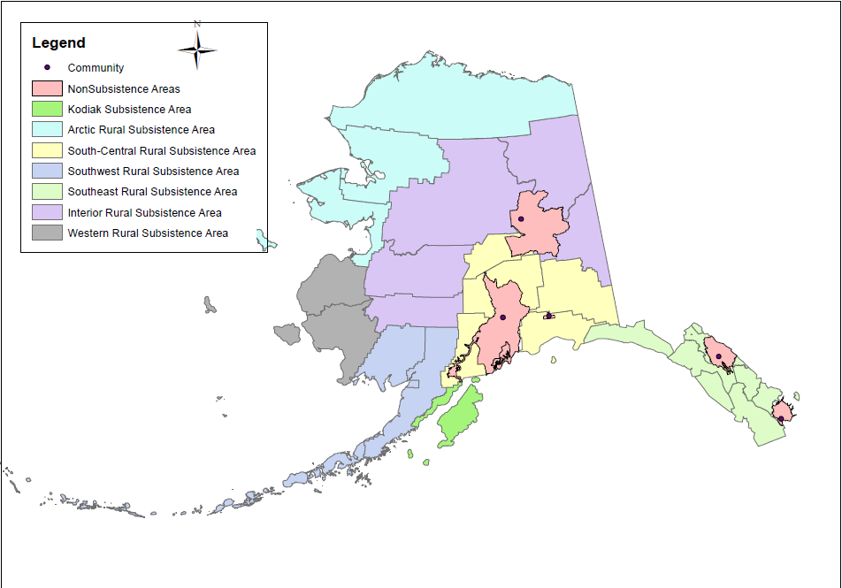
Figure 2: USGS HUC 4

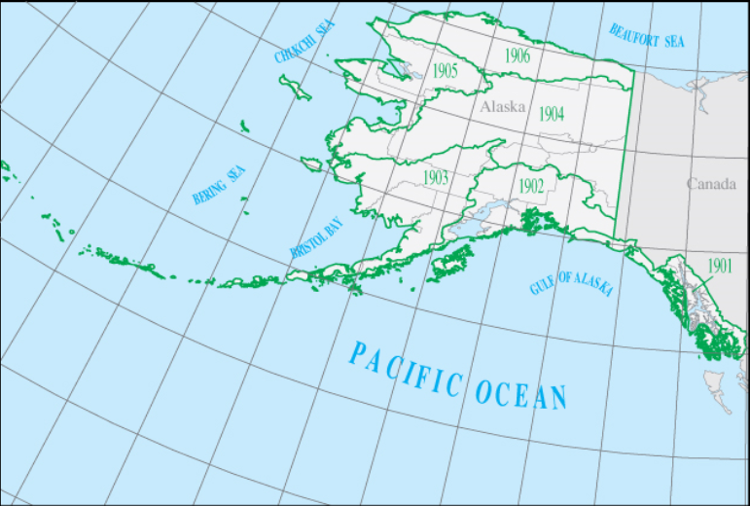

Figure 3: Subsistence Areas and HUC 4 (Tabor, 2016)

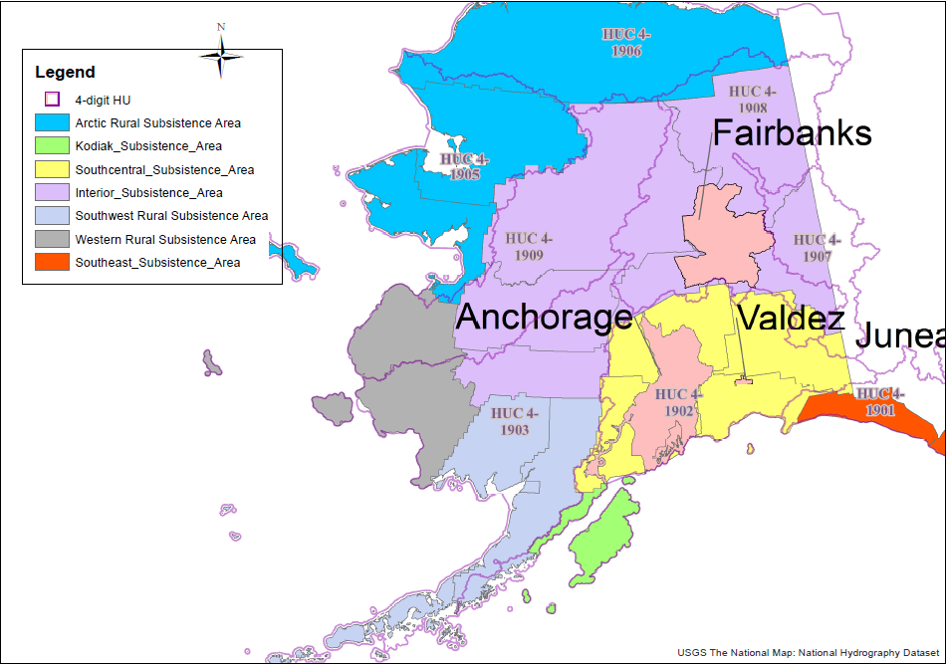
Figure 4: USGS Ecoregion Map

