Substitution Primer

When examining policy mandates for residential energy consumption, price elasticity is an important factor to consider. It is known that there is a close relationship between price elasticity of demand and possibilities to switch between fuel types. The measurement between the substitutability of one good for another with respect to a change in price for one of the goods is the cross-price elasticity of demand. Cross-price elasticity measures the responsiveness in the consumption of one good when the price of anther good changes. Cross-price elasticity is measured as the percent change in quantity demanded of one good divided by the percent change in price of another good. Goods that have a cross price elasticity with a positive value are considered “substitute” goods, and goods with a negative cross-price elasticity are considered “complementary” goods. Cross-price elasticity of demand is important to measure the degree of substitutability between households with two different types of heating appliances.
A household with two heating appliance types will be more sensitive to changes in the price of one fuel type. For example, a household with central oil boiler and a wood stove can substitute between heating oil and wood in the face of higher heating oil prices. If a household with both central oil and wood appliance types sees an increase in heating oil prices, that household will substitute heating oil energy for wood energy. In short, households with one appliance are more insensitive to changes in price than those with two heating appliances. A household with two appliances will be able to substitute oil for wood, thereby shifting the household heating burden onto a cheaper fuel source. For this reason, substitution possibilities vary across individual households and populations. All households do not change their consumption of energy in response to a change in price in the exact same manner, the household’s ability to substitute different energy inputs is important to take into account.
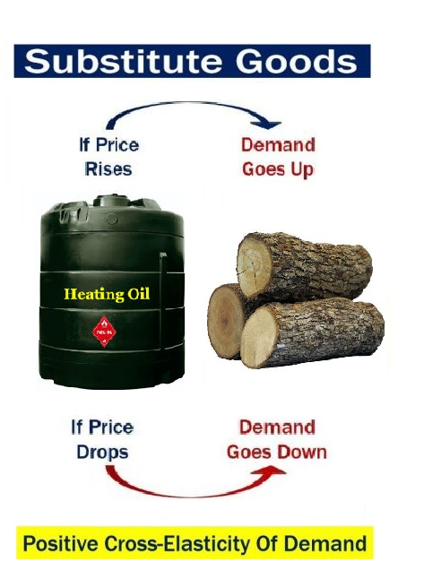

Going back to the example of a household with both a central oil boiler and wood stove, the cross-price elasticity will indicate given an increase in heating oil prices, how much additional wood will be burned from a decrease in oil consumption. Cross-price elasticity would not apply for households with only one heating appliance. Due to many households in the FNSB having both heating oil and wood appliances, the cross-price elasticity of demand is an important measurement to consider when evaluating FNSB home heating policies.

