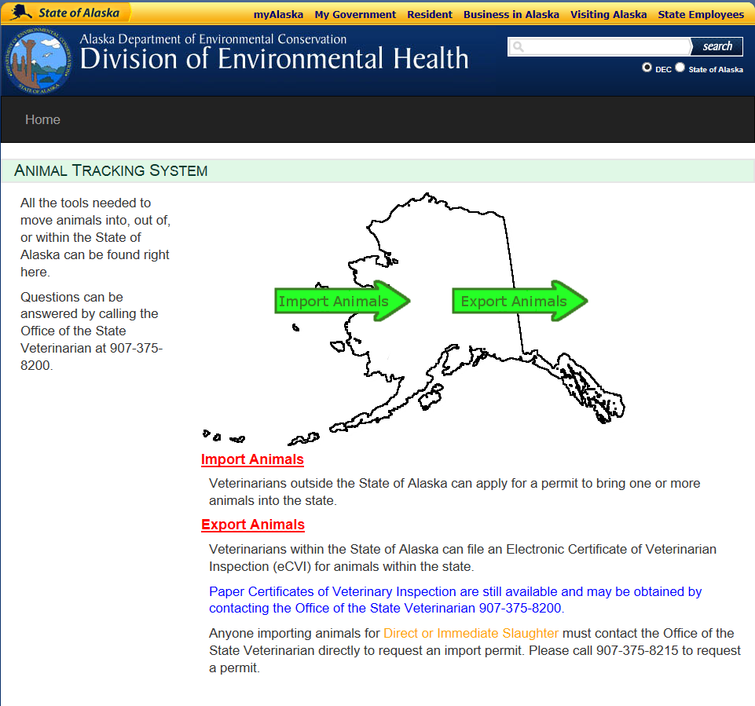

* Go to <https://dec.alaska.gov/Applications/EH/ATS/index.html>
* Click red Export Animals link

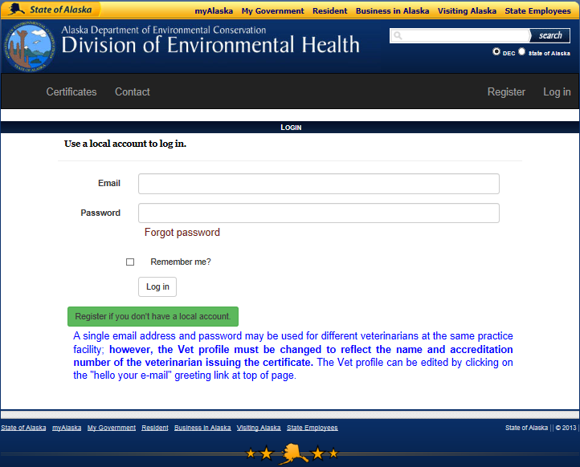

Returning users

New users

* If registered, enter email and password and click Log In and skip to Page 4
* If not registered, click Register and continue to Registration instructions below

**Registration Instructions**

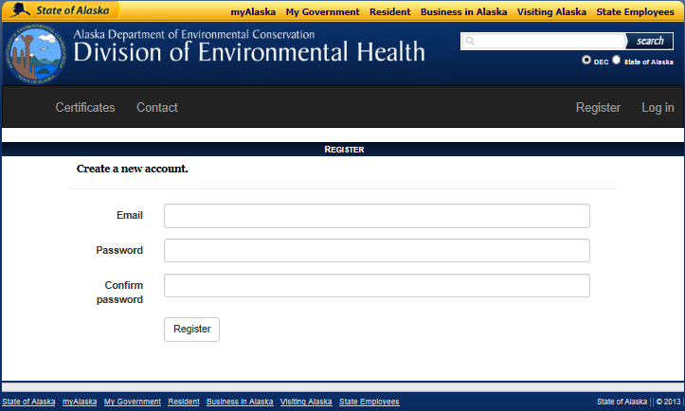

* Enter email address. (A single email address and password may be used for different veterinarians at the same practice facility; **however, the Vet profile must be changed to reflect the name and accreditation number of the veterinarian issuing the certificate.** The Vet profile can be edited by clicking on the "hello your e-mail" greeting link at top of page.)
* Enter and confirm password
* Click Register

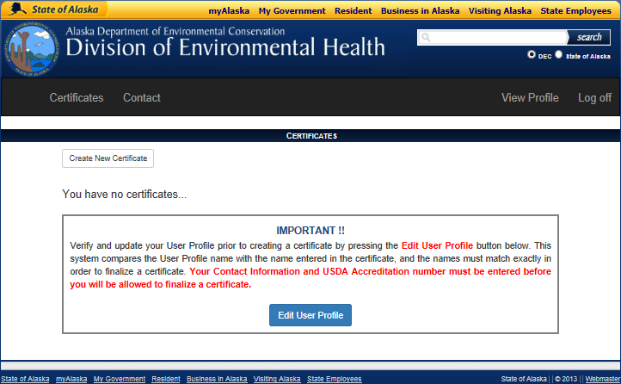

* Click Edit User Profile

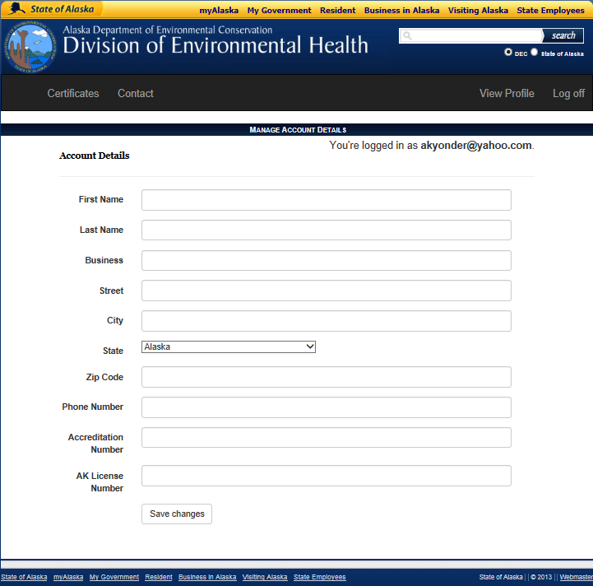

* Enter Veterinarian Information
* This can be edited later if using a shared clinic email address to reflect the veterinarian issuing an individual certificate
* Click Save Changes

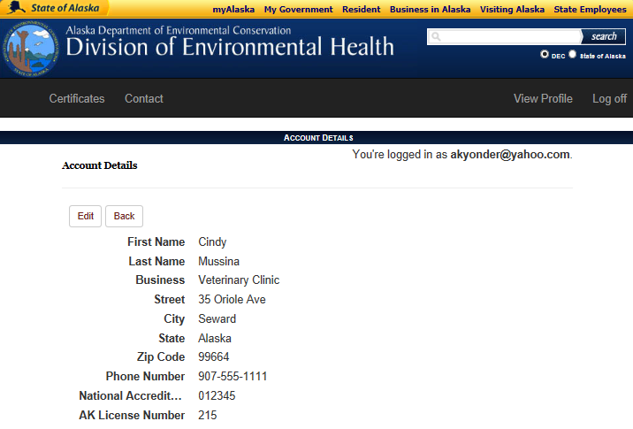

* Click Certificates

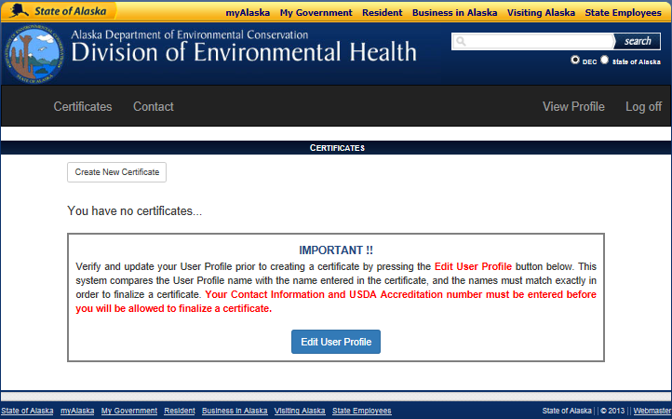 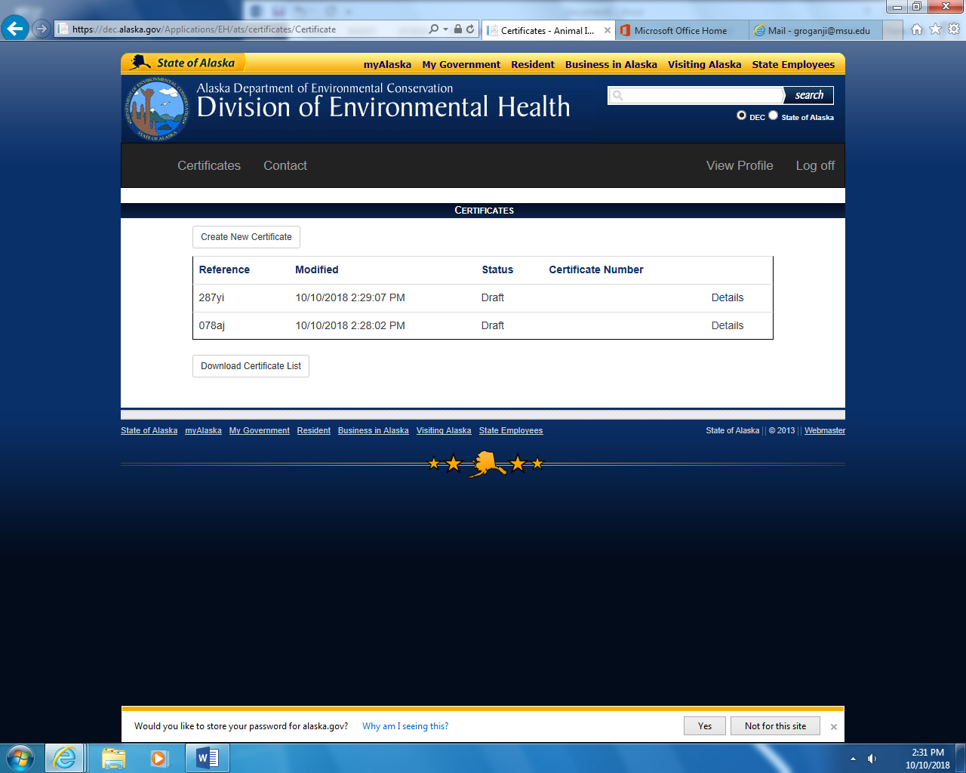

* One of these screens will appear, depending on user status (new or returning)
* Click “Create New Certificate”

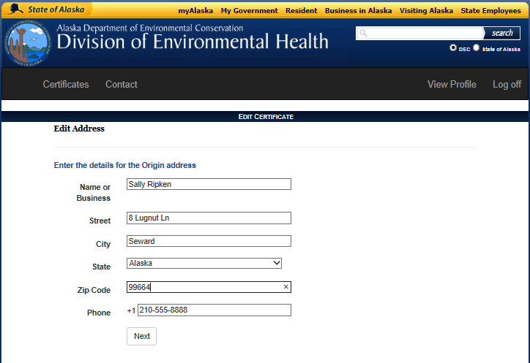

* Enter owner’s address of Origin (Alaskan address)
* **No PO Boxes will be accepted**, must be physical address
* Click Next

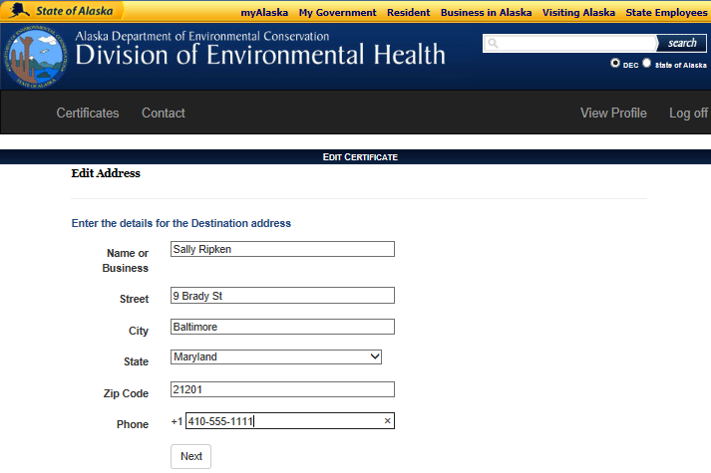

* Enter Destination information.
* **No PO Boxes**, must be physical address. Use of a PO box will result in rejection of document.
* Click Next

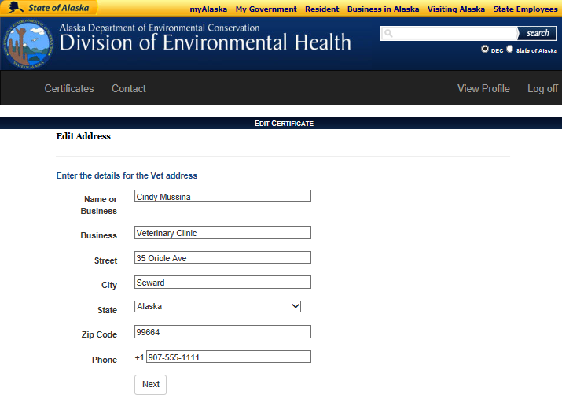

* Veterinarian details will be filled in with information from profile; you may also edit this information.
* Click Next

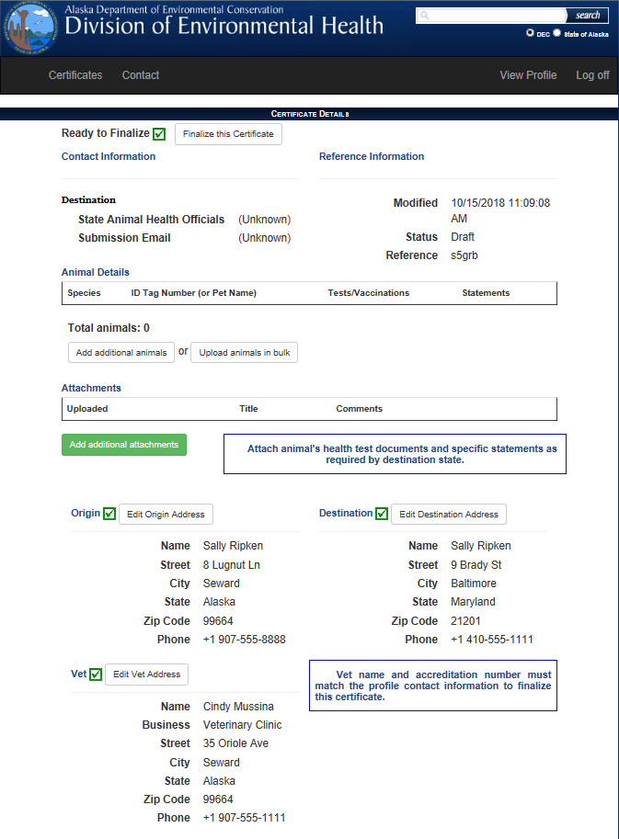

* Destination
  + State Animal Health Officials – Launches contact information for state veterinary officials
  + Submission Email – Launches email link to Alaska State Veterinary Office. [decosvakanimals@alaska.gov](mailto:decosvakanimals@alaska.gov)
* Click Add additional animals

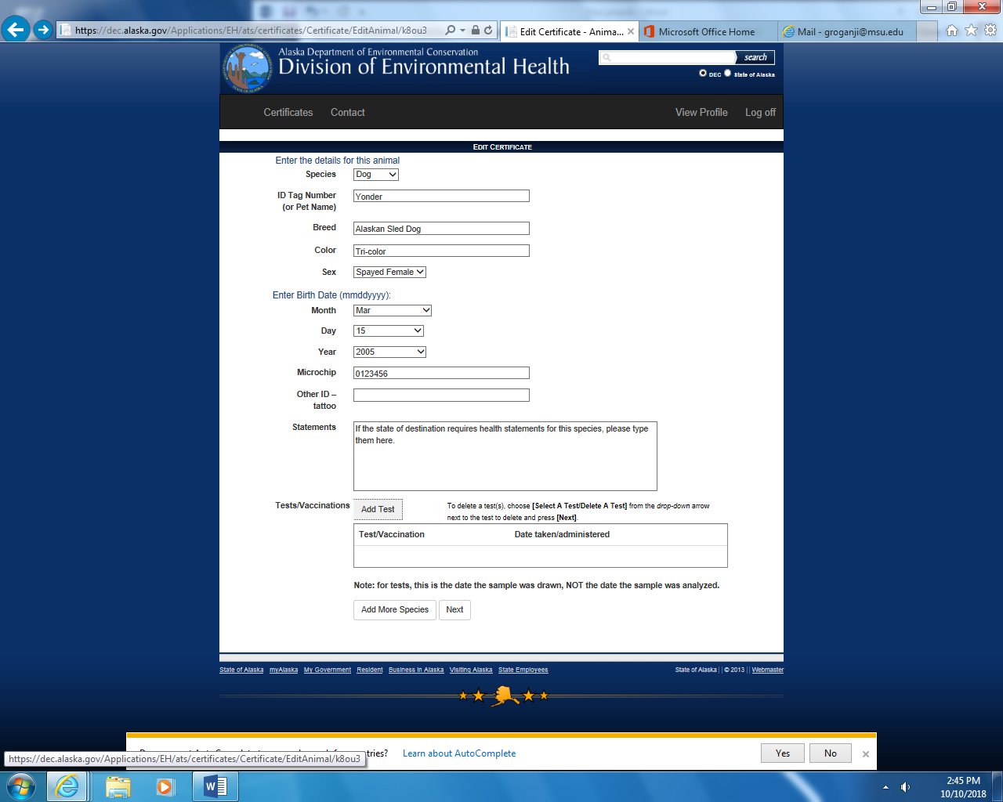

* Fill out pet details
* Type Statements if required by state of destination
  + Check with state of destination for list of required statements
* Click Add Test to add test results or vaccine information for any tests or vaccines required by the state of destination

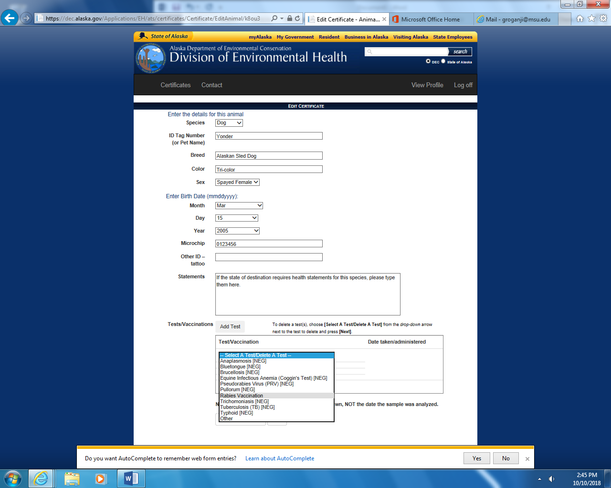

* Select appropriate vaccination and/or test(s) from drop down menu

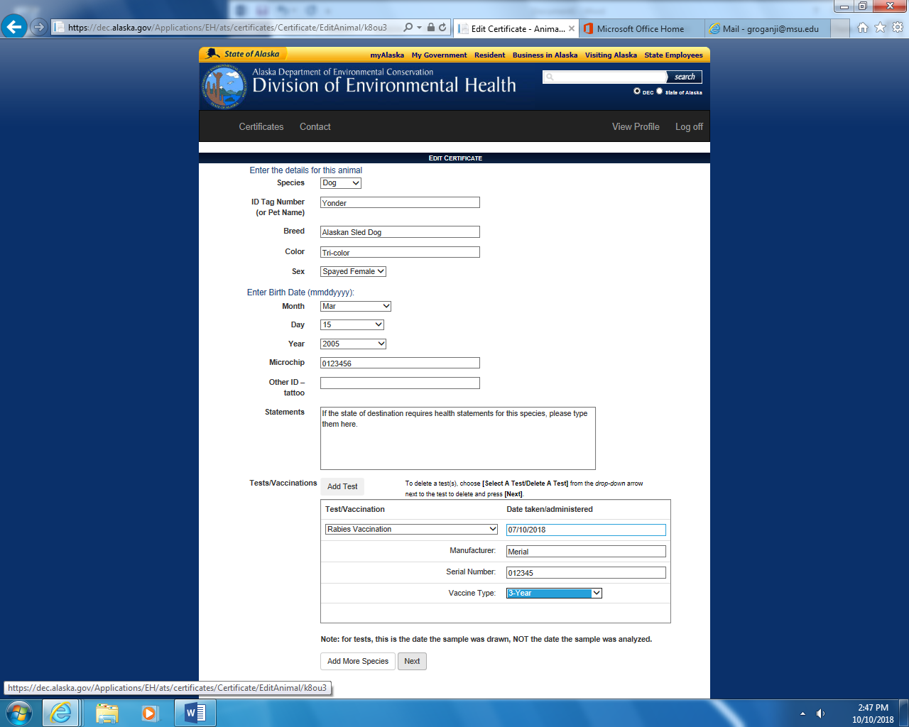

* Enter test or vaccination details
* Repeat this as necessary to complete all required tests
  + Check with state of destination for list of required tests and vaccinations
* Click Next

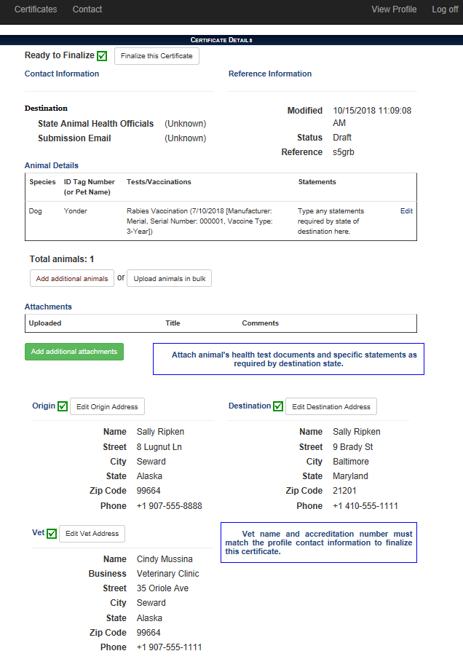

* Add additional pets if necessary
* Click Finalize this Certificate when all pets are entered

If more pets

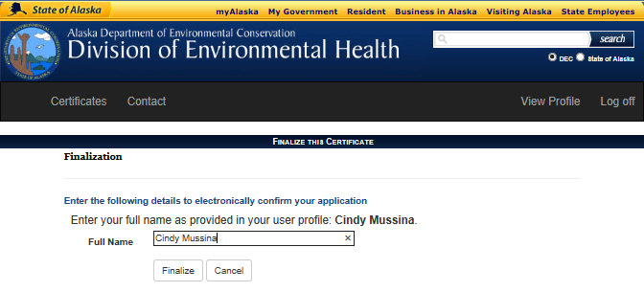

* Type your name
* Click Finalize

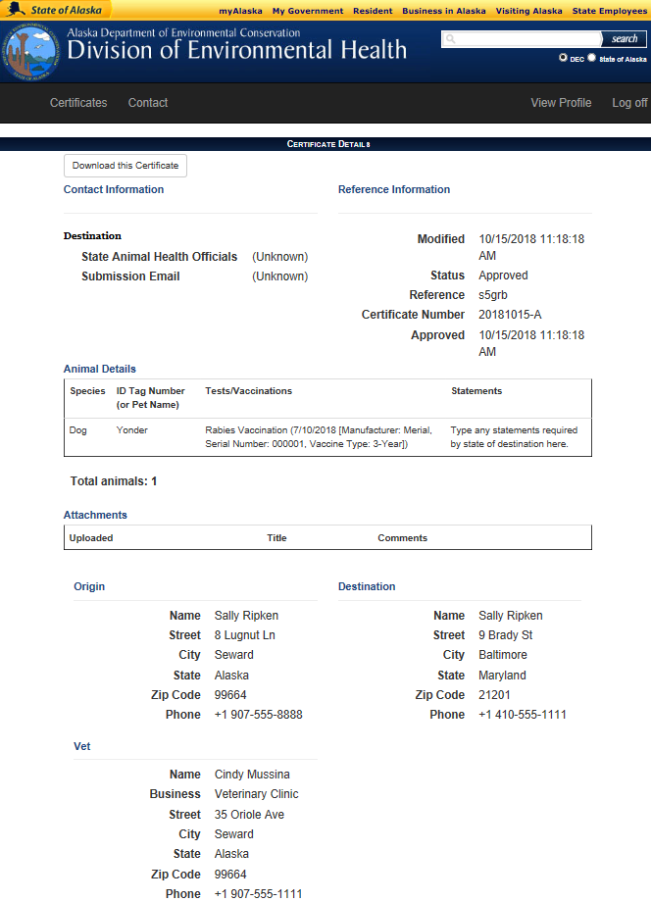

* Click Download the Certificate

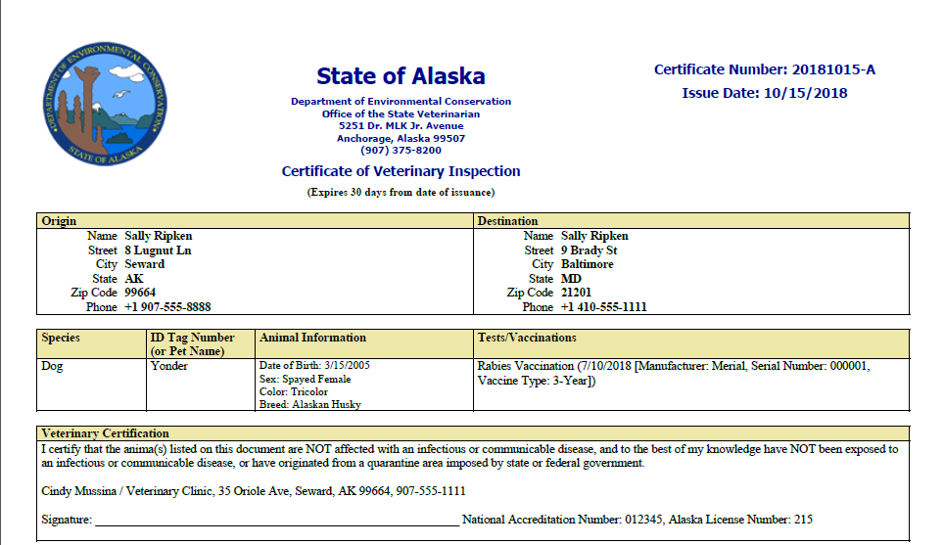

* Email the certificate to the AK State Veterinarian [decosvakanimals@alaska.gov](mailto:decosvakanimals@alaska.gov)
* Email the certificate to Destination State Veterinarian
* Print and give to owner for travel