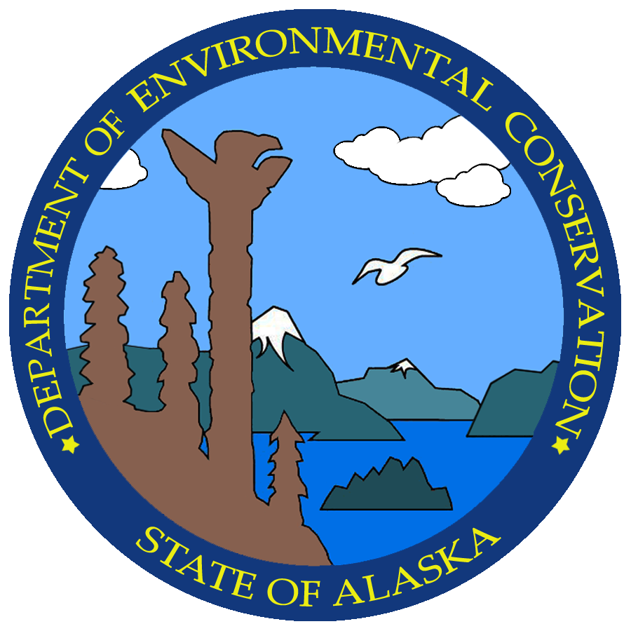
 |  |  | NONCOMPLIANCE NOTIFICATION FORM
GENERAL INFORMATION |  |  |  | PERMIT NO. 2013DB0004
APPLICANT/COMPANY |  |  |  | VESSEL NAME |  |  | VESSEL LOCATION (Lat/Long)
PERSON REPORTING |  |  |  | PHONE NUMBER OF PERSON REPORTING |  |  | REPORTED HOW? (e.g. by phone)
DATE/TIME EVENT WAS NOTICED |  |  |  | DATE/TIME REPORTED |  |  | NAME OF ADEC STAFF CONTACTED
VERBAL NOTIFICATION MUST BE MADE TO ADEC WITHIN 24 HOURS OF DISCOVERY
INCIDENT DETAILS (attach additional sheets, lab reports and photos as necessary)
NATURE OF THE DISCHARGE (e.g. sewage, graywater, etc.)

ESTIMATED QUANTITY INVOLVED (volume or weight) |  |  |  |  |  | ESTIMATED DURATION OF NONCOMPLIANCE
CAUSE OF EVENT (be specific)

PERMIT CONDITION DEVIATION Identify each permit condition exceeded during the event.
Parameter (e.g. BOD₅, pH) |  | Permit Limit |  |  | Exceedence (sample result) |  |  | Sample date
CORRECTIVE ACTIONS Attach a description of corrective actions taken to restore the system to normal operation and to minimize or eliminate chances of recurrence.
ENVIRONMENTAL DAMAGE. YES NO UNKNOWN (If yes, provide details below).

ACTUAL/POTENTIAL IMPACT ON ENVIRONMENT/PUBLIC HEALTH (describe in detail)

ACTIONS TAKEN TO REDUCE OR ELIMINATE ACTUAL/POTENTAIL IMPACT ON ENVIRONMENT/PUBLIC HEALTH (describe in detail)

COMMENTS

I certify under penalty of law that this document and all attachments were prepared under my direction or supervision in accordance with a system designed to assure that qualified personnel properly gather and evaluate the information submitted. Based on my inquiry of the person or persons who manage the system, or those persons directly responsible for gathering the information, the information submitted is, to the best of my knowledge and belief, true, accurate, and complete. I have no personal knowledge that the information submitted is other than true, accurate, and complete. I am aware that there are significant penalties for submitting false information, including the possibility of fines and imprisonment for knowing violations.

NAME:__________________________________________

SIGNATURE:________________________________________

DATE:__________________________________________
FORM MUST BE SENT TO THE DEPARTMENT WITHIN 7 DAYS OF Discovery TO:

Commercial Passenger Vessel Environmental Compliance Program
Division of Water
Alaska Dept. of Environmental Conservation
410 Willoughby Avenue, Suite 303
PO Box 111800
Juneau, AK 99811-1800

