

Alaska BEACH Program

Beach Monitoring Handbook, Project Beach, AK

# Alaska Beach Program Contact Information

Laura Eldred

BEACH Program Manager

DEC DOW WQ NPS Section Manager

907-376-1855

[laura.eldred@alaska.gov](mailto:laura.eldred@alaska.gov)

DEC Beach Project Manager name

BEACH Project Manager

DEC DOW WQ NPS Program Staff

Phone

Email

DEC Quality Assurance Officer name

DEC Quality Assurance Officer

DEC DOW WQ Program Staff

907-269-3066

[john.clark@alaska.gov](mailto:john.clark@alaska.gov)

Grantee Project Manager name

Project Manager and/or Quality Assurance Officer

Grantee Title

Phone

Email

Grantee Lead Field Sampler name

Lead Field Sampler

Grantee Title

Phone

Email

Project Laboratory Manager name

Project Laboratory Manager

Phone

Email

# Beach Monitoring Handbook

This handbook introduces DEC Beach Monitoring Program. The goal of the program is to reduce or eliminate illness and disease due to contact with water at recreational-use beaches that are contaminated by human and animal waste (fecal pollution).

This handbook was designed to provide you with simple instructions for beach assessments, water quality sampling, and public notification in the event recreational water becomes contaminated with fecal pollution. The handbook is divided into four main sections.

**Section 1** provides background information about the Alaska Beach Program, disease-causing organisms (Pathogens) and their indicators, and state and federal water quality standards.

**Section 2** gives you information about how to assess the risk of exposure to fecal contamination at beaches in your area. This section includes detailed information about how to collect, handle, and ship water samples for laboratory bacterial analysis, as well as how to conduct a beach survey.

**Section 3** tells you whom you should notify when your beach assessment indicates marine water quality is unsafe for water contact activities. It also provides information about how best to notify the public about the water quality at your beach(es).

**Section 4** provides water sampling protocols and example field forms, press releases and signage.

Contents

Alaska Beach Program Contact Information 2

Beach Monitoring Handbook 3

Section 1 - Background 6

National BEACH Monitoring Program 7

Alaska BEACH Program 7

Project Beach community name Specific BEACH Information 9

Grantee BEACH Grantee Lead Field Sampler Responsibilities 9

Grantee BEACH Project Manager Responsibilities 10

DEC BEACH Project Manager Responsibilities 10

Water Quality Standards (WQS) 11

EPA’s Water Quality Standards 11

Alaska’s Water Quality Standards 12

Project Beach community name BEACH Program 13

Section 2 – Community Beach Assessments 14

Overview 14

Beach Survey Field Form 15

Beach Survey Schedule and Locations 15

Sample Chain of Custody 16

Laboratory Responsibilities 17

Preliminary Quality Assurance/Quality Control (QA/QC) Review of Beach Sample Data 17

Communicating with DEC 19

Re-Sampling 19

20

Section 3 – Notifying the Public 21

Beach Advisory 21

Beach Signs 22

Fact Sheets or Flyers 22

Press Release 23

Section 4: Protocols and Example Forms 24

Water Sampling Collection Protocols 24

Water Sample Collection 24

Sample Collection Method 24

Additional Environmental Parameters 26

Sample Handling 27

Example Forms 28

Example Site-Specific Beach Sampling Field Form 28

Example Beach Advisory Sign 29

Example DEC Press Release 30

Example Listserv Email 31

Calibration Information 32

HANNA Instruments Combo pH/EC/TDS Tester HI98129 32

List of Tables

Table 1. Alaska Marine Water Quality Indicator Standards 13

Table 2. Contact List for Public Notifications 22

List of Figures

Figure 1. Project Organizational Structure 11

Figure 2. Data Management Flow Chart 18

Figure 3. Sample Decision Tree 20

# Section 1 - Background

Nationwide the greatest cause of coastal water quality impairment is bacteria.[1]

Beaches are a valuable recreational resource in Alaska. They provide access to coastal recreation waters for swimming, surfing, fishing, playing, and many other water contact activities. Alaskans do not limit their recreational activities to sandy beaches; gravelly, rocky, or mud-covered beaches are commonly used for recreation. What Alaskans may not know is that recreational activities involving water contact could make them sick if the water is contaminated with human or animal waste (e.g., sewage or other sources of fecal pollution).

A wide variety of sources can contribute to the presence of pathogens associated with fecal pollution in coastal areas. While some of the sources may be direct, or “point” sources (e.g., discharge from a wastewater treatment plant), others may be “nonpoint” sources which are much harder to track (e.g., failing septic systems).

As rain washes over a watershed, it can gather pathogens from several different sources. Numerous sources make the process of ruling out whether it is human-related difficult. In many cases, birds, wildlife, and dogs have been linked to being the sources of elevated levels of fecal bacteria.

People may get sick from recreating in water near possible fecal pollution sources, such as:

|  |  |
| --- | --- |
| * sewage lagoons | * small boats |
| * honey-bucket dumps | * stormwater runoff |
| * sewage treatment plants | * landfills |
| * septic systems | * wildlife |

Water contaminated with fecal pollution may contain disease-causing microbes (pathogenic bacteria, viruses, and protozoa). If people are directly exposed to or ingest this pollution, it can cause gastrointestinal illness, respiratory illnesses, skin rashes, and ear, eye, and wound infections. Water quality monitoring at beaches near fecal pollution sources can reveal conditions that indicate an elevated risk of becoming ill from water contact.

## National BEACH Monitoring Program

The U.S. Environmental Protection Agency (EPA) developed the concept of a Beach Sanitary Survey as a means for providing State and local beach managers with a technologically sound and consistent approach to identify pollution sources and share information.[2] The survey tool provides a method for documenting historic as well as current records of beach and watershed water quality. It provides baseline information including land use, water quality, and pollutant source data.

The survey document is meant to serve as a living record that is regularly updated and evaluated. The survey can be broken into two formats; routine and annual sanitary surveys, for temporal data to be evaluated in a more organized manner.

The Beach Sanitary Survey information is used by the Alaska Department of Environmental Conservation (DEC) to prioritize beaches for monitoring and assist in development of models to predict daily bathing beach water quality, if appropriate. The survey also provides support for enforcement actions as it establishes a record of conditions and changes over time. The Beach Sanitary Survey helps beach managers meet the requirements of the BEACH Act Grant Program, as described in the 2014 National Beach Guidance and Required Performance Criteria for Grants.

## Alaska BEACH Program

In response to the increasing incidence of water-borne illness at public beaches, the U.S. congress passed the Beaches Environmental Assessment and Coastal Health (BEACH) Act of 2000. The Act provides support for state programs to reduce the risk to beach users from contact with fecal contaminated water.

The Act authorized the EPA to award grants to states and tribes, and DEC Division of Water has used these grants to create an Alaska BEACH Program.

To date, the Alaska BEACH Program has:

* Defined many of the unique aspects of Alaskan recreational beach use.
* Sent surveys to Alaskan coastal communities to assess the likelihood of fecal pollution at their beaches.
* Used the survey data to rank beaches according to their potential exposure risk.
* Developed a generic beach Quality Assurance Project Plan and monitoring plan.
* Developed a generic risk-communication plan.
* Conducted pilot water quality sampling at some Alaskan beaches the community surveys identified as having risks of fecal pollution.

DEC encourages communities to create local beach monitoring programs and work with the beach steward(s)[3] in notifying the public if there is an elevated risk of becoming ill from the water. Local management of water sampling and public notification programs should provide the most effective means of protecting the community from exposure to disease-causing organisms in human and animal waste.

Disease-causing organisms come from a variety of sources and can be complicated to track and monitor. As a result of this, DEC has developed a BEACH Sanitary Survey, based on EPA’s survey tool, to assign levels of risk in coastal areas where recreational activity takes place, to aid in the identification and remediation of pollution sources, and to protect marine water quality on Alaska’s beaches. Use of surveys is just one part of a larger effort to protect water quality through appropriate and relevant management activities. The BEACH Monitoring process includes, and is not necessarily limited to:

* An initial risk assessment of the coastal area of concern.
* Development or improvement of a water quality monitoring plan specific to a particular area.
* A notification plan to communicate levels of risk to the public.
* Conducting a sanitary survey on a routine basis.
* Means for measuring and monitoring results.
* Cooperation amongst landowners and resource managers to resolve or mitigate issues.
* Metrics to measure improvements over time.
* Increase public awareness and cooperation in controlling water pollution.
* The Alaska Beach Program follows requirements set out in the 2014 National Beach Guidance and Required Performance Criteria for Grants.

## Project Beach community name Specific BEACH Information

Every BEACH grant program requires the development of a formal relationship with the landowner of the beach being proposed for monitoring. The Grantee name and city/borough/local/tribal/community partner names and DEC have developed a local beach monitoring program, with the goal of protecting beach users from exposure to water contaminated by fecal pollution. The Project Beach community name BEACH Monitoring Program receives support from DEC in the form of training, limited funding for water quality sampling, Standard Operating Procedures for sampling, a Quality Assurance Project Plan template, a database template for data storage and sharing, and technical assistance.

The Project Beach community name BEACH Monitoring Program will consist of local individuals periodically conducting beach assessments and collecting water quality samples for laboratory analysis. Their work will be coordinated by the Grantee Lead Field Sampler who will coordinate with the DEC and Grantee Project Managers to keep them informed about sampling events.

The roles and responsibilities of the Grantee Lead Field Sampler, and DEC and Grantee Project Managers are described in this section. Details about conducting sanitary surveys, collecting, and shipping samples, and notifying the public about sample results are given in **Section 2** (Community Beach Assessments) and **Section 3** (Notifying the Public) of this handbook. Figure 1 shows a flow chart describing roles in project organizational structure. In many cases, it is likely that one person may fill more than one role.

## Grantee BEACH Grantee Lead Field Sampler Responsibilities

The main roles and responsibilities of the Grantee Lead Field Sampler are to:

* Conduct beach assessments.
* Collect water quality samples.
* Ship samples to a laboratory for bacterial analysis.

The Grantee Lead Field Sampler data analysis responsibilities include:

* Provide beach sampling and sample identification information to the Grantee and DEC BEACH Project Managers and DEC Quality Assurance Officer.

## Grantee BEACH Project Manager Responsibilities

The roles and responsibilities of Grantee Project Manager are to:

* Review laboratory data results to ensure required Quality Assurance/Quality Control (QA/QC) criteria have been met.
* If QA/QC criteria have not been met, notify DEC Project Manager as soon as possible, and in consultation with DEC and other affected parties, develop a corrective action plan to resolve the problem(s).
* Compare the laboratory results to Alaska and EPA water quality standards.
* Confer with DEC BEACH Program Manager regarding water quality standard exceedances and the possible need for resampling.
* Submit laboratory data to DEC, after completing QA/QC protocols, using DEC-provided template or DEC-approved format.
* Provide recommendations for BEACH survey activities.
* Provide recommendations for water quality monitoring.
* Assist with water quality data assessment.
* Prepare data for submission to the EPA/AWQMS.

The Grantee Project Manager is also responsible for keeping a record of activities associated with sampling events. This record will include information on the dates, locations, samplers, and results of the monitoring, and will be used to compile an annual report to the EPA on recreational beach water quality for Alaska.

## DEC BEACH Project Manager Responsibilities

The roles and responsibilities of DEC Project Manager are to:

* Provide recommendations to Grantee for BEACH survey activities.
* Provide recommendations to Grantee for water quality monitoring.
* Assist with water quality data assessment.
* Work with the landowner to notify the public of an exceedance following resampling and data assessment.
* Report beach assessment and sampling data to the EPA.

Most important, DEC Project Manager will have lead responsibility in working with the municipality or responsible landowner to develop a public notice and other press-related information advising the public of the risks from marine water when beach sampling results exceed State or federal Water Quality Standards.

Figure 1. Project Organizational Structure

## Water Quality Standards (WQS)

The BEACH program’s objective is to monitor for fecal contamination. Bacteria can indicate the presence of fecal contamination, which itself may harbor disease-causing (pathogenic) microbes. The indicator bacteria most used are called coliforms and enterococci. Federal and State Water Quality Standards (WQS) set limits for these parameters. Laboratory testing for the presence and abundance of these bacteria is required.

## EPA’s Water Quality Standards

The EPA recommends the use of enterococcus bacteria, or enterococci (pronounced ěn'tə-rō-kŏk'sī') as indicators of fecal pollution in marine water. Enterococcus bacteria are found in the human intestine and warm-blooded animals. They are subgroup of the fecal streptococci. Studies indicate that the enterococci portion of the streptococcus group is the most efficient bacterial indicator of fresh and marine water quality.

Alaska’s single sample criteria is equal to the EPA’s 2012 Recommended Recreational Water Quality Criteria’s Statistical Threshold Value of 130 CFU/100 mL for enterococci [4],[5] . The 130 CFU/100 ml value corresponds to the 90th percentile of the water quality distribution associated with the same level of public health protection (in this case, 36 per 1000 recreators’). This criterion is equivalent to Alaska’s EPA approved water quality standards for marine pathogens, primary contact criteria (18 AAC 70, see Table 1).

## Alaska’s Water Quality Standards

The State of Alaska’s water quality standard also uses enterococcus bacteria as indicators of fecal pollution in marine water for recreational use. Data was compared to the contact recreation standard of “In a 30-day period, the geometric mean of samples may not exceed 35 enterococci CFU/100 ml, and not more than 10% of the samples may exceed a STV of 130 enterococci CFU/100 ml” (18 AAC 70 (14)(B)(i)). The two criteria (i.e., the “geometric mean” and the “10% of samples”) in this standard must both be met. If either criterion is exceeded, then the water at that location fails the standard. The Alaska standard is tabulated below (Table 1).

The most stringent of the criteria for fecal coliform bacteria protects harvesting for consumption of raw mollusks or other raw aquatic life (harvesting use). This harvesting use criteria states that “the geometric mean of samples may not exceed 14 fecal coliform/100 ml” (geometric mean criterion), and “not more than 10% of the samples may exceed 31 colony forming units (CFU) per 100 ml for a membrane filtration test” (10% of samples criterion) in 18 AAC 70 (14)(D). The two criteria (i.e., the “geometric mean” and the “10% of samples”) in this standard must both be met. If either criterion is exceeded, then the water at that location fails the standard.

## Project Beach community name BEACH Program

The program will monitor both types of bacteria against WQS set for Marine Water Recreation- contact recreation. DEC will report in-season exceedances when enterococci levels exceed the 130 CFU/100 m for a single sample.

The program will also report when conditions exceed the WQS for the harvest for consumption of raw mollusks or other raw aquatic life (Table 1, section 14, part D). This information will be provided alongside monitoring results but will not necessitate a separate advisory.

Table 1. Alaska Marine Water Quality Indicator Standards[6]

|  |  |
| --- | --- |
| Designated Use | Description of Criteria |
| (14) Bacteria, For Marine Water Uses  (B) Water Recreation | |
| Contact Recreation | In a 30-day period, the geometric mean of samples may not exceed 35 enterococci CFU / 100 mL, and not more than 10% of the samples may exceed a statistical threshold value (STV) of 130 enterococci CFU / 100 ml. |
| Secondary Contact Recreation | In a 30-day period, the geometric mean of samples may not exceed 200 fecal coliform/100 mL, and not more than 10% of the samples may exceed 400 fecal coliform / 100 ml. |
| (D) Harvesting for Consumption of Raw Mollusks or Other Raw Aquatic Life | The geometric mean of samples may not exceed 14 fecal coliform / 100 mL; and not more than 10% of the samples may exceed.   * 42 MPN per 100 ml for a five-tube decimal dilution test * 49 MPN per 100 ml for a three-tube decimal dilution test * 28 MPN per 100 ml for a twelve-tube single dilution test * 31 CFU per 100 ml for a membrane filtration test (see note 14 in 18 AAC 70.020 Water Quality Standards) |

# Section 2 – Community Beach Assessments

## Overview

A Sanitary Survey is a type of beach assessment used to identify sources of pollution. It can be an effective tool for protecting human health at recreational-use beaches by providing information that can be used to design future or modify existing monitoring programs. The Grantee Lead Field Sampler should conduct surveys in suspected high-risk areas to confirm the presence or absence of fecal pollution. An Annual Survey should be conducted on all newly nominated beaches as well as the beginning of each season of on-going monitoring projects to document seasonal changes or new sources. Routine Surveys will be completed when a sample is collected for water quality testing. Routine surveys are completed using the EPA sanitary survey and the BEACH Survey Field Form provided in Section 4, if needed.

Annual BEACH Surveys collect information from area maps and land use plans, annual and seasonal trends, coastal geomorphic information, and additional potential sources of pollution at a watershed or sub-watershed level. In some cases, Annual BEACH Surveys may be conducted at the end of a sampling season to determine whether changes to the monitoring program should take place in the following year. Information that should be considered during the survey process include:

* Freshwater inputs (river mouth, stream, storm drains).
* Properties with subsurface wastewater disposal systems.
* Significant wildlife habitat/wetlands.
* Agricultural operations.
* Impervious surfaces.
* Marinas/moorages/anchorages.
* Recreational areas and the availability of facilities (restrooms, trash cans, doggie bag disposal stations).

A Routine BEACH survey is conducted by visiting a beach of concern to answer questions and fill in blanks on the BEACH Survey Field Form. Since fecal coliform bacteria may originate from sources other than humans, the assessment will note the number of birds, dogs, or other animals on the beach. Debris, vegetation, tide stage and murky water are also noteworthy. If animal waste sources are identified, Grantee Lead Field Sampler should discuss their observations with DEC and Grantee Project Managers as soon as possible. The survey may include collecting a water quality sample if DEC and Grantee Project Managers decide that beach users may be exposed to fecal pollution.

## Beach Survey Field Form

The BEACH Survey Field Form is a data sheet used for collecting field information as part of the Routine and Annual BEACH survey process. It is designed to gather information that the Grantee Lead Field Sampler and the Grantee and DEC Project Managers can use to make annual and routine comparisons of physical characteristics. It documents the physical conditions present during sampling events. These forms will be created and managed in a manner that will facilitate easy data entry into the Ambient Water Quality Monitoring System (AWQMS).

The BEACH Survey Field Form is made up of three parts:

1. The first part asks for a description of the beach including its location and the name of the person performing the assessment.
2. The second part asks for details about the water quality sample, if collected. These details include date, time sample number(s), water temperature, and other field parameters.
3. The third part asks for information about the condition of the beach at the time of the assessment including the weather, levels of activity, and potential pollution sources.

The remainder of the form may ask for additional environmental parameters, including air and water temperature. These parameters are collected with a handheld probe. See section 4 for more information on these devices.

To complete a BEACH survey, field staff must fill out all the information on the Beach Survey Field Form. An example Beach Survey Field Form is in Section 4.

## Beach Survey Schedule and Locations

The Grantee Lead Field Sampler should conduct BEACH surveys using the BEACH Survey Field Form at designated locations at the beginning of the sampling season and each time a water sample is collected for water quality testing. These observations can help the Grantee and DEC Project Managers assess changes from year to year and modify the existing monitoring program by identifying times during the season with the highest risk of people getting sick from water contact.

The Grantee Lead Field Sampler may also conduct BEACH surveys at other suspected high-risk beaches to identify any persistent problems that may warrant a need for water quality testing. The information gathered can be used by the Grantee and DEC Project Managers to design future monitoring programs to protect human health during the recreation season. Additional sampling must be discussed and approved by the DEC Project Manager before water samples are collected.

Sampling location data should be collected using a calibrated GPS unit to ensure accuracy. All latitude/longitude data should be collected and recorded in decimal form (12.3456) using the Horizontal Collection System datum NAD83. All future sampling events should take place within 100 feet of that site unless the Grantee and DEC Project Managers determine that the site does not accurately represent background conditions of beach water quality.

The Grantee Lead Field Sampler will determine the sampling location and schedule in coordination with the Grantee and DEC Project Managers. Once a sampling site has been determined, Project and Sampling Location ID numbers will be provided by DEC Project Manager to ensure that the site has an EPA assigned PRAWN code and consistent with the AWQMS template.

Samples must be sent to a laboratory that is approved by DEC for Fecal Coliform Bacteria (Method 9222D) and Enterococci by MPN (Method ASTMD-6503-99). A list of approved laboratories can be found on the DEC website (<https://dec.alaska.gov/eh/lab/micro-lab-cert-status>).

The sample collection should follow the tide/sampling schedule provided by the Grantee Project Manager, to target low tides, and be transported to DEC-approved laboratory within the 6-hour sample holding time. The Grantee Lead Field Sampler will need to coordinate with the laboratory to make sure someone is at the laboratory and able to process the samples as soon as they arrive.

See the current site-specific Beach QAPP and sampling plan for information on sample frequency, locations, and any special instructions.

## Sample Chain of Custody

The sample chain of custody form documents actions taken to ensure that samples are traceable from the time they are collected at the beach to the time the analytical laboratory reports the results. The laboratory usually supplies these forms with their field sampling kit. Generally, a completed chain-of-custody form will identify the samples, request analysis from the laboratory, note any special instructions, and document who handled the samples from the time they were shipped from the field to the time they reach the laboratory. The Grantee Lead Field Sampler is responsible for filling out the chain-of-custody form and keeping a copy for reference. The form must include the following information:

* Name and contact information of the person taking the samples.
* Sample identification, including the sample number, and date and time the sample was collected.
* The sample preservation method(s).
* The type of sample (e.g., water sample, sample replicates, field and temperature blanks) and the number of jars being submitted for analysis.
* The requested analysis (enterococcus and fecal coliform bacteria).
* The requested turn-around time (Note: the laboratory is requested to analyze the samples and **present the results within 36 hours of sampling**).
* Name and contact information for delivery of results (Note: the results should be sent to the Grantee Lead Field Sampler and the Grantee and DEC Project Managers; and
* A relinquishment signature including printed name, date, and time.

In addition to completing the chain-of-custody form the Grantee Lead Field Sampler needs to:

1. Put the completed chain-of-custody form into a plastic bag taped to the inside lid of the cooler.
2. Attach two completed chain-of-custody seals (stickers) to cross over the cooler lid seams.
3. Attach a clearly marked label with laboratory contact information on the top of the sample cooler.
4. Hand-deliver the samples to the airlines or local laboratory.
5. Keep a copy of the airlines’ transportation documentation or other means of delivery for reference.
6. Contact the courier service to ensure pick-up and delivery of sample.
7. Contact the laboratory, again, to verify that someone will be there when the samples arrive; and
8. Email a copy of the BEACH Survey Field Form to the Grantee and DEC Project Managers.

## Laboratory Responsibilities

The Grantee Lead Field Sampler will work with the pre-determined laboratory to complete analysis of samples and data submission. Laboratories are responsible to comply with the data quality objectives specified in the QAPP and as specified in the laboratory QAP and method specific Standard Operating Procedures (SOPs). Validated sample laboratory data results are reported to the Grantee Lead Field Sampler and the Grantee and DEC Project Managers. Electronic project data will be stored on a secure computer or on a removable hard drive that can be secured. All records will be retained by the contract laboratory for five years.

## Preliminary Quality Assurance/Quality Control (QA/QC) Review of Beach Sample Data

When the Grantee Lead Field Sampler receives sample results from the laboratory, the results need to be compared to the marine Water Quality Standards that are referenced in Section 1 of this handbook. The Grantee Lead Field Sampler should check to make sure the sample was analyzed within the 8-hour holding time and that the temperature was within the allowed range when the samples were received at the laboratory. Secondary reviewers (Grantee Project Manager/DEC Project Manager/DEC Program Manager) are responsible for the review, verification and validation of field and laboratory data and data reformatting as appropriate for reporting to AWQMS.

The data management task will include keeping accurate records of field and laboratory QA/QC samples so that project managers and technical staff who use the data will have appropriate documentation to show that the required minimum data quality standards have been met. DEC Project Manager will provide a sample data submission template to the Grantee Project Manager. DEC Beach Program Manager, DEC QA Officer and AWQMS data entry staff conduct final data reviews (tertiary review) and submits the validated data to AWQMS. See the flow chart in Figure 2 for detailed information on data management responsibilities.

Figure 2. Data Management Flow Chart

## Communicating with DEC

After collecting and shipping samples to the laboratory, the Grantee Lead Field Sampler will let the Grantee and DEC Project Managers know that the samples are on their way to the laboratory and send the completed BEACH Survey Field Form.

After reviewing the sampling results from the laboratory, the Grantee Lead Field Sampler will need to talk to the Grantee and DEC Project Managers to decide if additional sampling or public notification procedures should be initiated.

## Re-Sampling

If a sample, after undergoing quality assurance review, is found to exceed BEACH program Water Quality Standards (WQS; Table 1), an additional sampling event to confirm that the exceedance may be performed (See Figure 3). Re-sample protocols will be consistent with those of routine events. If the re-sample event determines that the exceedance is on-going, a Beach Advisory (see Section 3) will be issued by the landowner and DEC. Routine sampling events will continue according to schedule and the Beach Advisory will remain in place until samples are below WQS or as determined by DEC Project Manager in coordination with the Grantee Project Manager.

## 

Figure 3. Sample Decision Tree

# Section 3 – Notifying the Public

Communicating with the public regarding the nature of the BEACH program, sampling results, and potential responses to Water Quality Standards exceedances is very important. DEC will work with the respective landowner to distribute public information about sampling results that may require actions such as a Beach Advisory or Beach Closure. Communication plans and specific actions taken will be developed between DEC, landowner(s) and the Grantee on a case-by-case basis.

## Beach Advisory

DEC will post monitoring results on our webpage (beaches.alaska.gov) after each sampling event. DEC will send a beach advisory when beach sampling results indicate potential fecal bacteria contamination above recreational water quality criteria. This advisory will be based on the bacterial counts and the information from the Beach Survey Field Form. Posting may consist of press releases, social media post, listserv notices, and/or website updates.

A beach advisory provides recommendations to the public to avoid contact with water that has exceeded the WQS referenced in Section 1 (Table 1) of this handbook. A beach advisory may be issued by DEC upon receipt of water quality sampling results that demonstrate a continued exceedance of water quality standards for bacteria. Proposed advisories require consultation with DEC Public Information Officer and DEC Program Manager.

DEC utilizes the Alaska BEACH Program Listserv and social media to distribute advisory notices to key stakeholders and the members of the public. Anyone can sign up to receive notifications by visiting the Alaska Beach Program webpage and clicking on the listserv link. All DEC social media posts must receive approval from DEC Public Information Officer before being posted online. DEC encourages sharing of DEC’s post on Grantee social media groups.

The advisory should include:

* General heading (“ADVISORY” or “WARNING”).
* Reason for the advisory
* Time of the advisory
* Duration of the advisory
* Location of the affected beach
* Number to contact beach manager for further information

Advisories should be issued in the form of press releases, signs at the affected beach, and fact sheets (informative flyers). DEC will act as the lead in developing advisory information and signage. The press releases should be distributed to local media outlets, government offices, and emergency response entities, and advisory signs should be posted at the beach until additional assessments (sampling) indicate the water quality is acceptable. Contacts for public notification are developed and verified at the beginning of each season and reported in the Beach Communication Plan. Table 2 is a framework for organizing possible contacts.

Table 2. Contact List for Public Notifications

|  |  |  |  |
| --- | --- | --- | --- |
| Community Entity | Contact | Phone Number | Email |
| Borough Manager | *Add local information…* |  |  |
| City Manager |  |  |  |
| Local Tribal Entity |  |  |  |
| Emergency Services |  |  |  |
| Public Health Office |  |  |  |
| Radio Station |  |  |  |

These media outlets, local governments and emergency response entities can initiate their existing communication protocols to notify the public of potential health risks at the local beach(es). A standard-format press release public service announcement is included in Section 4.

## Beach Signs

If sampling events continue to show exceedances of water quality standards, signs should be posted at major beach access points to alert beach users of their risk of illness from water contact recreation. This advisory should recommend that the public avoid water contact activities at the beach until further analyses reveal safe conditions. Signs will be in place until sampling determines that water quality standards are being met. An example of a Beach advisory sign is in Section 4.

## Fact Sheets or Flyers

Distributing informative flyers in public areas can also communicate potential health risks to local beach users. A flyer could be used as an advisory by passing out press release information to people in public places. It also could be used to educate the community about the BEACH Project. The Alaska BEACH Program produced flyers, posters, and fact sheets that can be used to inform the public. These can be found on DEC [beaches.alaska.gov](http://beaches.alaska.gov) under the respective sub-page for each beach.

## Press Release

A press release is likely the fastest way to spread the news about water quality at recreational use beaches in Alaskan communities. DEC and landowner will act as the lead agents in providing public information. DEC staff will work with DEC Public Information officer on all press releases.

# Section 4: Protocols and Example Forms

## Water Sampling Collection Protocols

### Water Sample Collection

Water sampling involves wading into the water adjacent to a beach commonly used for water recreation to collect water from below the surface into sample jars. The sample should be collected in the general recreational beach area, or near locations expected to be influenced by fecal contamination (e.g., adjacent to sewage lagoons, near small boat harbors, etc.). The Grantee Lead Field Sampler will complete sampling after the following steps have been accomplished:

* Each sample jar is filled with water.
* Each sample jar is labeled.
* Each sample jar is placed in a cooler kept chilled with artificial ice (artificial ice reduces potential for cross contamination).
* The Beach Survey Field Form is filled out.
* A chain-of-custody form is filled out.
* The cooler is transported to the laboratory responsible for determining fecal coliform and enterococcus populations.
* A copy of the Beach Survey Field Form and chain-of-custody form is sent to the Grantee and DEC Project Managers.

Detailed directions for water sample collection, sample handling and delivery are given in the following subsections.

### Sample Collection Method

A good water sample is collected by avoiding cross-contamination, which can happen when the sampler inadvertently contaminates the sample. To reduce the potential for cross-contamination the sampler must follow a standard sample-collection method. Step-by-step sample-collection instructions are provided below:

1. Request a sample kit from the laboratory. The kit should include:

* A cooler.
* The appropriate sample bottles for marine water quality sampling (enterococci and fecal coliform bacteria).
* Artificial ice to keep the cooler chilled to the appropriate temperature (<10°C).
* Temperature blank.
* Chain-of custody form.
* Custody seal.
* Sample jar labels.
* An extra set of sample bottles.
* An extra set of sample bottles for a replicate sample.
* Shipping labels.
* Packing material.

1. **Call the laboratory prior to sampling to make sure there will be someone at the laboratory to receive and process the samples within 6 hours of sampling.**
2. **If shipping the samples, consult flight schedules to make sure there will be a flight that can get the samples to the laboratory within 6 hours of sampling.**
3. Write the beach sampling location on the bottle label and Beach Survey Field Form.
4. Put on clean waders and gloves. Wade into the water to a depth of approximately 3 feet. Try to avoid kicking up sediment or wait until any sediment that has been kicked up settles. Stand downstream of the water current (if any) and wait for sediment to clear.
5. Remove the bottle cap just before collecting the sample. Protect the cap from contamination. Do not touch the inside of the bottle, or the inside of the cap.
6. Open the sampling bottle and hold onto the base with one hand. Plunge the top of the bottle downward into the water. Avoid introducing surface water scum or debris. Point the mouth of the bottle into the current. Hold the bottle about one (1) foot below the water surface and tip it slightly upward to allow air to exit and the bottle to fill.
7. Remove the bottle from the water. Pour out a little water to leave airspace at the top of the jar.
8. Tightly close each bottle.
9. Place the bottle into a clean zip-lock bag.
10. Complete bottle labels and attach them to each sample jar. Labels should be clean, waterproof, non-smearing, and large enough for all the information. Information on the label should include:
    * Sample location (e.g., beach name, KB-HerringCove)
    * Sampling date and time
    * Laboratory method for analysis
    * Name of sampler

Collect one replicate for each analyte per sampling event. To collect a replicate sample, you must first have requested extra bottles from the laboratory. Repeat Steps 2 through 9 at the same location and at the same time as the regular sample.

1. When finished sampling, wash your hands and arms with soap and water or waterless antimicrobial cleanser, or disinfectant lotion to reduce exposure to potentially harmful bacteria or microorganisms.

### Additional Environmental Parameters

Environmental parameters will be collected with DEC provided equipment. A handheld probe (HANNA Instruments combo tester HI98129, or similar) will be used to collect air and water temperature, and other in situ parameters. Calibrate the handheld probe before heading to the field (see calibration instructions in the appendices). Always make sure devices are fully charged and/or bring additional batteries.

13. Handheld Probe

* If water sample collection increased suspended sediment, wait until water settles or move 1-2 steps to the side to take measurements. Stand downstream of the location where you will take the measurements.
* Turn on device. Submerge measurement probe end of the handheld probe in water (do not submerge entire device), and swirl gently to remove air bubbles.
* Hold probe until reading has stabilized (indicated by a stability tag on the HANNA model).
* Record measurement value, type, and time of collection on data sheet.
* Repeat process for remaining parameters. HANNA device measurements include pH, conductivity, total dissolved solids, and air/water temperature.

When finished sampling, wash your hands and arms with soap and water or waterless antimicrobial cleanser, or disinfectant lotion to reduce exposure to potentially harmful bacteria or microorganisms. Rinse probe with deionized water before storing. Use HANNA HI70300 Storage solution for pH probe.

### Sample Handling

Sample handling involves packing the samples in a cooler and shipping them to the laboratory. After sample collection is complete the samples must be handled with care so that they arrive to the laboratory in good condition. Step-by-step sample handling instructions are provided below:

1. Place the sample(s) in a pre-chilled cooler containing artificial ice to maintain a temperature from 1° to 10°C. Ask the laboratory ahead of time how much ice will be needed. **Do not allow the samples to freeze. Samples must remain below 10°C until receipt by qualified staff at the laboratory, otherwise samples are determined invalid.**
2. Place enough packing material inside the cooler to protect the sample bottles from breaking during transport to the laboratory. Wrapping clean paper towels around the bottle and placing in a separate clean zip-lock bag works well.
3. Complete the chain-of-custody form. Put the form in a plastic bag and tape it to the inside of the cooler lid.

• Write a note in the “Special Instructions” box requesting that the laboratory results be sent without delay (within 36 hours of sampling) to three people: Grantee Lead Field Sampler, Grantee Project Manager, and DEC Project Manager.

1. If the cooler will be out of your immediate control (such as on an airplane or courier), fill out two custody seals and attach one to the front and one to the back of the cooler to span the lid seam. You want them to tear when the cooler is opened.
2. Securely tape the cooler shut prior to shipment. Attach shipping labels that identify the shipping destination and say: “keep cool,” “do not freeze,” and “fragile.”
3. Ship/drop off the samples to DEC-certified laboratory.
4. **Remember that samples must be collected, shipped, and received by the laboratory in 6 hours. Consult flight schedules and call the laboratory prior to sampling to make sure there will be a flight that can get the samples to the laboratory within 6 hours of sampling, and that there will be someone at the laboratory to receive the samples and begin the analyses**.

## Example Forms

### Example Site-Specific Beach Sampling Field Form

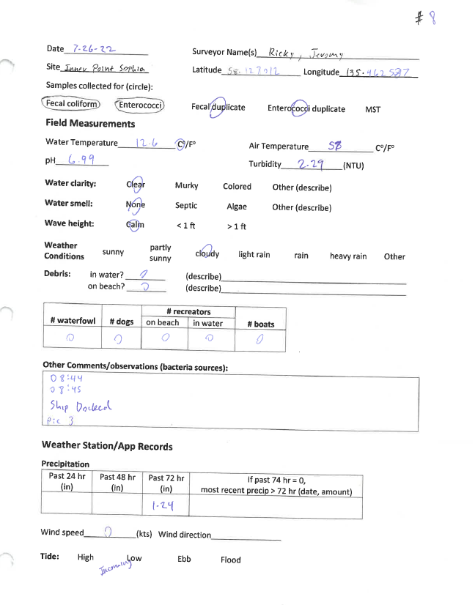

### Example Beach Advisory Sign

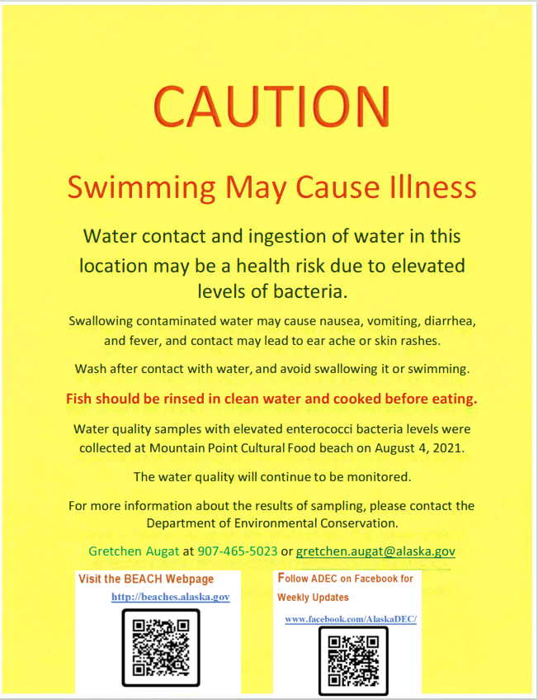

### Example DEC Press Release

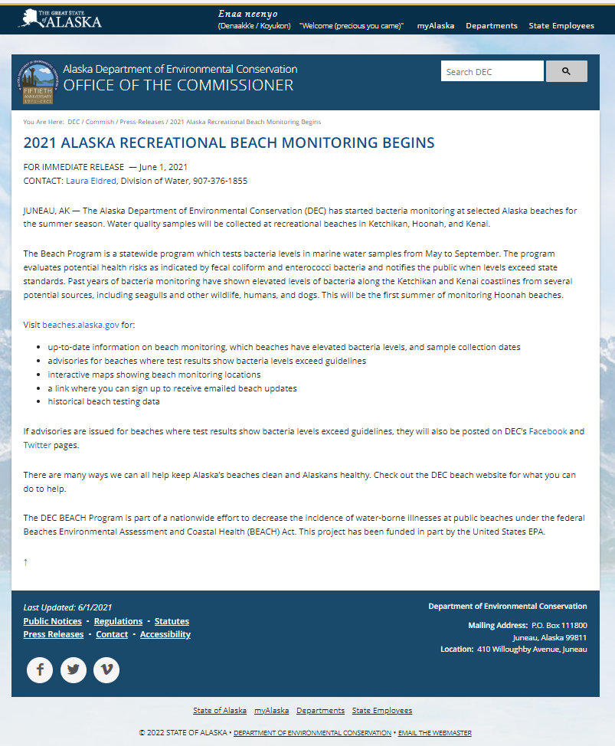

### Example Listserv Email

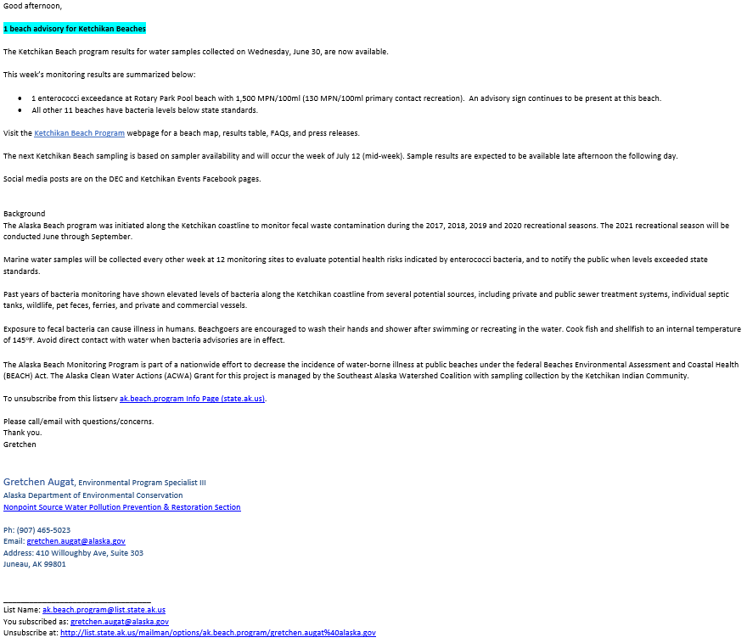

## Calibration Information

### HANNA Instruments Combo pH/EC/TDS Tester HI98129

DEC will provide HANNA handheld probes. Each probe comes with its own calibration and storage solution.

Each device must be calibrated before each monitoring, or more frequently if values are outside normal range.

The instruction manual is available online: [https://cdn2.hubspot.net/hubfs/2134380/product-](https://cdn2.hubspot.net/hubfs/2134380/product-manuals/manhi_98129_98130.pdf) [manuals/manhi_98129_98130.pdf](https://cdn2.hubspot.net/hubfs/2134380/product-manuals/manhi_98129_98130.pdf). Please carefully read through the device manual before operating. It is the responsibility of the person monitoring to make sure device has been calibrated and operating properly.

Use deionized water to clean device between monitoring events. Use provided storage solution for between monitoring events. Do not touch the pH probe membrane.





1. US EPA. 2002. National Water Quality Inventory 2000 Report. EPA-841-R-02-001. Washington DC: Environmental

   Protection Agency.
2. US EPA. 2008. Great Lakes Beach Sanitary Survey User Manual. EPA-823-B-06-001 Washington DC. Environmental Protection Agency.
3. Stewards may include local landowners, resource managers, non-governmental organizations, etc.
4. U.S. EPA. 2014. National Beach Guidance and Required Performance Criteria for Grants, 2014 Edition. EPA-823-B-14-001. Environmental Protection Agency. Washington, D.C.
5. U.S. EPA. 2012. Recreational Water Quality Criteria. 820-F-12-058. Office of Water. Environmental Protection Agency. Washington, D.C.
6. Source: 18 AAC 70.020 Water Quality Standards, amended as of November 13, 2022