Generic BEACH Water Quality Monitoring Program

Quality Assurance Project Plan, Rev. 3
March 2023
Prepared by:
Grantee Name and Organization Information
Prepared for:
Nonpoint Source Pollution Program
Division of Water
Alaska Department of Environmental Conservation
State of Alaska

Project Management Elements

Title and Approvals
Title: Quality Assurance Project Plan for Timeframe in Years, Community name BEACH Program

DEC Staff Beach Program Manager name  BEACH Program Manager  DEC DOW WQ NPS Section Manager  Signature: | Phone:  Email:  Date:
DEC Staff Beach Project Manager name  (Beach community name) Beach Project Manager  DEC DOW WQ NPS Program Staff  Signature: | Phone:  Email:  Date:
Grantee Staff Project Manager name  Project Manager and/or Quality Assurance Officer  Grantee Title  Signature: | Phone:  Email:  Date:
Grantee Lead Field Sampler name  Lead Field Sampler  Grantee Title  Signature: | Phone:  email:  Date:
DEC Quality Assurance Officer name  DEC Quality Assurance Officer  DEC DOW WQ Program Staff  Signature: | Phone:  email:  Date:
Grantee Staff Project Manager and/or Quality Assurance Officer alternate name  Project Manager and/or Quality Assurance Officer Alternate  Grantee Title  Signature: | Phone:  email:  Date:
Laboratory Manager name  Laboratory Manager  Grantee Title  Signature: | Phone:  email:  Date:

Table of Contents
A. Project Management Elements 2
A.1 Title and Approvals 2
Table of Tables 5
Table of Figures 5
A.2 Distribution List 6
A.3 Project Task/Organization 7
A.3.1 DEC Staff 7
A.3.2 Grantee 7
A.3.3 Grantee Subcontractor 7
A.4 Project Definition/Background and Project Objectives 8
A.4.1 Project Definition 8
A.4.2 Project Background 9
A.4.3 Project Objective(s) 9
A.5 Project/Task Description and Schedule 10
A.5.1 Project Description 10
A.5.2 Project Implementation Schedule 10
A.6 Data Quality Objectives and criteria for Measurement Data 11
A.6.1 Data Quality Objectives (DQOs) 11
A.6.2 Measurement Quality Objectives (MQOs) 11
A.6.3 Data Validation and Verification 14
A.7 Special Training Requirements/Certification add staff training info and qualifications 15
A.8 Documents and Records 16
B. Data Generation and Acquisition 18
B.1 Sampling Process Design (Experimental Design) 18
B.1.1 Define Monitoring Objective(s) and Appropriate Data Quality Objective(s) 18
B.1.2 Identify the Site-Specific Sample Collection Location(s), Parameters to be Measured, and Frequencies of Collection 18
B.2 Sampling Method Requirements 19
B.2.1 Sampling Method Requirements 19
B.2.2 Sample Containers and Equipment 19
B.3 Sample Handling and Custody Requirements 20
B.3.1 Sample Custody Procedures 20
B.3.2 Shipping Requirements 21
B.4 Analytical Methods and Requirements 21
B.4.1 Sampling Parameters 21
B.5 Quality Control Requirements 22
B.5.1 Field Quality Control 23
B.5.2 Laboratory Quality Control (QC) Measures 24
B.5.3 QA Reports to Management 25
B.6 Instrument Calibration and Frequency 25
B.7 Inspection/Acceptance of Supplies and Consumables 26
B.8 Data Acquisition Requirements (Non-Direct Measurements) 26
B.9 Data Management 26
C. Assessment and Oversight 28
C.1 Assessment and Response Actions 28
C.1.1 On-Site assessments to be performed 28
C.1.2 Project Data Assessments 28
C.2 Revisions to QAPP 29
D. References 30
A. Appendix A: Sample Site Locations Examples 31
B. Appendix B: Standard Operating Procedure for Ambient Water Collection for Pathogen Monitoring 34
B.1 Standard Operating Procedures Alaska BEACH Program 34
B.1.1 Sample Collection Method 34
B.1.2 Sample Handling 36
C. Appendix C: Example Chain of Custody Form 37
D. Appendix D: Site-Specific Field Data Sheet 39

Table of Tables
Table 1: Distribution List 6
Table 2. Monitoring Locations 9
Table 3. Implementation Schedule for Selected Parameters and methods 10
Table 4. Project Measurement Quality Objectives 13
Table 5. Training and Certification Requirements 16
Table 6. Project Documents and Records 18
Table 7. Site Location and Rationale 18
Table 8. Preservation and Holding Times for the Analysis of Samples 20
Table 9. Sample Transport and Lab Information 21
Table 10. Quality Assurance Reports to Management 25

Table of Figures
Figure 1. Project Organizational Structure 8
Figure 2. Data Management Flow Chart 23

Distribution List
This list includes the names and addresses of those who receive copies of the approved QAPP and subsequent revisions.
Table 1: Distribution List
NAME | POSITION | AGENCY/  Company | DIVISION/BRANCH/  SECTION | CONTACT INFORMATION
Name | DEC Beach Program Manager | DEC | Division of Water/ WQ / Non-Point Source | Phone number  Email address
 | DEC Beach Project Manager | DEC | Division of Water/WQ/ Non-Point Source/ (Specific) Region
 | Grantee Project Manager and/or QA Officer
 | Grantee Project Lead Field Sampler
 | Grantee Project Manager and/or QA Officer alternate | DEC | Division of Water/ WQ/QA
 | DEC QA Officer | DEC | Division of Water/ WQ/QA
 | Grant Project DEC-Approved Laboratory Manager

Project Task/Organization
Duties and responsibilities of key individuals are listed below.

DEC Staff
- DEC Beach Program Manager – Responsible for overall technical and contractual management of the project.
- DEC Beach Project Manager – Responsible for overall technical and contractual management of the project. If DEC staff have direct responsibility for sample collection and analysis of data results, the DEC Project Manager assumes the responsibilities of the Lead Field Sampler/Project Manager.
- DEC QA Officer – Responsible for QA review and approval of plan and oversight of QA activities ensuring collected data meets project’s stated data quality goals. Conducts field audits, data audits, QA review of blind lab performance, evaluation of samples, and lab audits.

Grantee
- Grantee Project Manager and/or QA Officer – Responsible for overall technical and contractual management of the project. If Grantee staff have direct responsibility for sample collection and analysis of data results, the Grantee Project Manager assumes the responsibilities of the Lead Field Sampler/Project Manager. Responsible to ensure all monitoring complies with the QAPP specified criteria. This is accomplished through routine technical assessments of the sample collection, analysis, and data reporting process. Assessments may include but are not limited to activities such as: on-site field audits, data audits, QA review of blind lab performance evaluation samples, and lab audits. These assessments are performed independent of overall project management.

Grantee Subcontractor
- Grantee Subcontractor Lead Field Sampler – Responsible for sampling preparation, sample collection, sample preservation, transportation of samples to laboratory for analysis, receipt of data and transmittal of data to Grantee Project Manager. The individual will procure personal equipment of field personnel, coordinate with laboratories in planning sampling equipment needs, obtain supplies for and prepare daily sampling kits prior to departure for field location, travel to the field location, prepare necessary preservatives while in the field, perform site reconnaissance, collect site specific parameters, collect water samples, prepare samples for shipping, transport samples to laboratory, alert laboratory of successful sampling event, receive data from laboratory, verify sample result data is reliable and submit the data and all applicable Quality Assurance/ Quality Control (QA/QC) results to the DEC and Grantee Project Managers.
- Grantee Subcontractor Field Support Staff - Responsible for accompanying Grantee Lead Field Sampler into the field and supporting Grantee Lead Field Sampler during sampling.
- Grant Project DEC-Approved Laboratory name Laboratory Manager – Responsible for the overall review and approval of contracted laboratory analytical work, responding to sample result inquiries and method specific details. Responsible for QA/QC of laboratory analysis as specified in the QAPP and reviews and verifies the validity of sample data results as specified in the QAPP and appropriate EPA approved analytical methods.

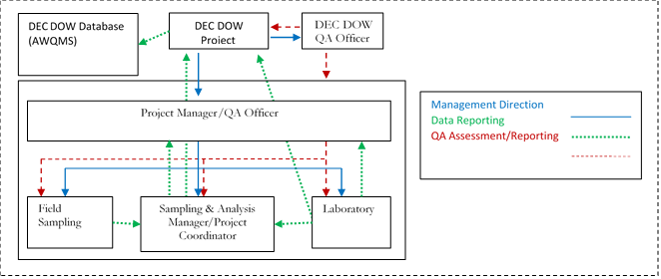
Figure 1. Project Organizational Structure

Project Definition/Background and Project Objectives

Project Definition
The purpose of this sampling effort is to conduct pathogen monitoring at Name Beach(es). Data gathered under this project may be used to inform the public of in-season exceedances of the Alaska Water Quality Criteria (18 AAC 70 (14)) for primary contact recreation for marine waters. Management decisions for public health and safety should be based on specific data (e.g., activities, sanitary surveys). Data must be indicative of water quality conditions to adequately assess the conditions of a waterbody to make the appropriate management decision.
Name Beach(es) were identified as Tier 1 beaches under the Environmental Protection Agency (EPA) Beaches Environmental Assessment and Coastal Health (BEACH) Act Program (Table 2). The Name Beach(es) monitored under this project were nominated by members of the public through an EPA Recreational Beach Survey. Tier 1 includes high priority beaches that pose the greatest threat of human contact with contaminated waters during recreational use. Contact with waters containing fecal contamination increases the risk of becoming ill due to pathogens contained in feces. In Alaska, Tier 1 beaches are usually on the road system, near population centers, and may host fishing or other recreational activities. These communities also can use local or ship samples to Department of Environmental Conservation (DEC)-approved laboratories within the 6-hour EPA analytical method holding time.
Table 2. Monitoring Locations
Site Name/  EPA ID | Latitude | Longitude | Site Description | Assessment Unit (EPA AK ID) | Years  Monitored
Example:  South Point Higgins Beach | 55.44864 | -131.83136 | South of South Point Higgins Beach, approx. 8.3 miles north of downtown. | AK_B_1010204_001  (21AKBCH - AK909574) | 2017, 2018, 2019, 2020, 2021
Beach at Sunset Drive | 55.41261 | -131.76505 | On Sunset Peninsula approx. 4.7 miles north of downtown. South of Mud Bay. | AK_B_1010204_003  (21AKBCH - AK212340) | 2017, 2018, 2019, 2020, 2021
Thomas Basin Harbor | 55.34125 | -131.64179 | Small boat harbor at mouth of Ketchikan Creek, approx. 2.5 miles south of downtown. | AK_B_1010204_005  (21AKBCH - AK508635) | 2017, 2018, 2019, 2020, 2021

Project Background
The Beaches Environmental Assessment and Coastal Health (BEACH) Act was passed by the U.S. Congress in 2002 in response to increased occurrences of water-borne illnesses at recreational beaches. The EPA administers grant funds to states, tribes, and territories under the BEACH Act to establish monitoring and public notification programs, such as the Alaska BEACH Program. The BEACH program has established national marine water quality monitoring and reporting standards for fecal waste contamination and notifies the public when levels exceed state standards.
DEC has and continues to implement a Beach Grant monitoring model which partners with local interested organizations and the general public to monitor levels of fecal contamination and evaluate the potential risks associated with recreational beach use. Data associated with monitoring efforts at Alaskan beaches are on file and can be obtained by contacting the DEC Project Managers.
Add brief description of this beach project from the grant workplan.

Project Objective(s)
The objectives for this project are to:
- Monitor selected beaches for fecal indicator organisms (i.e., fecal coliform and enterococci bacteria) during periods of high recreational use.
- Notify the public when indicator organisms exceed Alaska Water Quality Standards (WQS).
The first objective will be achieved through designing a monitoring plan that samples at identified beaches during periods of high recreation activity by the public.
The secondary objective will be achieved by distributing data to the public and stakeholders through DEC’s Beach Program webpage, local news articles and radio spots, posters, handouts, listserv updates, and social media posts.

Project/Task Description and Schedule

Project Description
The DEC and Project Grantee will collect beach water samples from (# of beaches and community name) beaches during the [collection year (s)] recreation season. A DEC-approved laboratory will analyze samples for presence of fecal coliforms by SM 9222 D and Enterococci by ASTM D6503. The goal of this project is to gather enough data to determine whether these beaches are meeting the water quality standards for fecal coliforms and enterococci based on single sample and/or geometric mean calculations. A list of DEC-approved microbiological laboratories is available at: Laboratories Certified to Perform Microbiological Analyses of Drinking Water (alaska.gov).

Project Implementation Schedule
Table 3 includes the implementation schedule and sampling frequency for selected parameters and methods.
Table 3. Implementation Schedule for Selected Parameters and methods
Product | Measurement/ Parameter(s) | Sampling Site | Sampling Frequency | Time Frame
Field Sampling | Ambient air temperature, Marine water temperature, site conditions and in-situ measurements reported on field data sheet, photos | All sites | Each sample event | Sampling timeframe in months
Lab Analysis | Fecal coliform (SM 9222 D), Enterococci (ASTM D6503)  Microbial Source Tracking | All sites | Each sample event  Once per recreation season | Sampling timeframe in months
Field Audit | Audit of field monitoring operations | All sites | At least once per field season | Sampling timeframe in months
Field Replicate | Fecal coliform (SM 9222 D), Enterococci (ASTM D6503) | One site, alternate location | Each sample event | Sampling timeframe in months

Data Quality Objectives and criteria for Measurement Data

Data Quality Objectives (DQOs)
Data Quality Objectives (DQOs) are qualitative and quantitative statements which are derived from the DQO Process that:
- Determine ambient water concentrations of pathogens (fecal coliforms and enterococci) and compare these values to marine water quality standards (18 AAC 70).
- The goal of the project is to monitor Tier 1 beaches to determine current conditions and if the beaches meet regulatory limits for contact recreational marine water quality standards.

Measurement Quality Objectives (MQOs)
Measurement Quality Objectives (MQOs) are a subset of DQOs. MQOs are designed to evaluate and control various phases (sampling, preparation, and analysis) of the measurement process to ensure that total measurement uncertainty is within the range prescribed by the project’s DQOs. MQOs define the acceptable quality (data validity) of field and laboratory data for the project. MQOs are defined in terms of the following data quality indicators.
- Detectability
- Precision
- Bias/Accuracy
- Completeness
- Representativeness
- Comparability
Detectability is the ability of the method to reliably measure a pollutant concentration above background. DEC Division of Water (DOW) uses two components to define detectability: method detection limit (MDL) and practical quantification limit (PQL) or reporting limit (RL).
- The MDL is the minimum value which the instrument can discern above background but no certainty to the accuracy of the measured value. For field measurements the manufacturer’s listed instrument detection limit (IDL) can be used.
- The PQL or RL is the minimum value that can be reported with confidence (usually some multiple of the MDL).
Note: The measurement method of choice should at a minimum have a practical quantification limit or reporting limit 3 times more sensitive than the respective DEC WQS.
Sample data measured below the MDL is reported as ND or non-detect. Sample data measured ≥ MDL but ≤ PQL or RL is reported as estimated data. Sample data measured above the PQL or RL is reported as reliable data unless otherwise qualified per the specific sample analysis.
Precision is the degree of agreement among repeated measurements of the same parameter and provides information about the consistency of methods. Precision is expressed in terms of the relative percent difference (RPD) between two measurements (A and B).
For field measurements, precision is assessed by measuring replicate (paired) samples at the same locations and as soon as possible to limit temporal variance in sample results. Field and laboratory precision is measured by collecting blind (to the laboratory) field replicate or duplicate lab samples. For paired and small data sets project precision is calculated using the following formula:
$$Precision = \frac{\left(A-B\right)}{\left(\left(A+B\right)/2\right)}×100$$
For larger sets of paired precision data sets (e.g., overall project precision) or multiple replicate precision data, the following formula may be used:
RSD = 100*(standard deviation/mean)

Note: Precision assessed only when both paired values ≥:
- 5 times PQL (fecal coliforms SM 9222D)
- 2 times PQL (E. coli SM 9222B)
Bias (Accuracy) is a measure of confidence that describes how close a measurement is to its “true” value. Methods to determine and assess accuracy of field and laboratory measurements include, instrument calibrations, various types of QC checks (e.g., sample split measurements, sample spike recoveries, matrix spike duplicates, continuing calibration verification checks, internal standards, sample blank measurements (field and lab blanks), external standards), performance audit samples (DMRQA, blind Water Supply or Water Pollution PE samples from A2LA certified, etc.), Bias/Accuracy is usually assessed using the following formula:
$$Accuracy = \frac{Measured Value}{True Value}×100$$
Completeness is a measure of the percentage of valid samples collected and analyzed to yield sufficient information to make informed decisions with statistical confidence. As with representativeness, data completeness is determined during project development and specified in the QAPP. Project completeness is determined for each pollutant parameter using the following formula:
$$\frac{T- \left(I+NC\right)}{T}×100\%=Completness$$
Where: T = Total number of expected sample measurements.
I = Number of invalid samples measured results.
NC = Number of sample measurements not produced (e.g., spilled sample, etc.).
This project has a goal of 80% data completeness. In Project Timeframe in Years, # sampling events are planned. The data collected is intended to provide members of the public with pertinent recreation information.
Representativeness is determined during project development and specified in the QAPP. Representativeness assigns what parameters to sample for, where to sample, type of sample (grab, continuous, composite, etc.) and frequency of sample collection.
Comparability is a measure that shows how data can be compared to other data collected by using standardized methods of sampling and analysis.
Monitoring shall be conducted in accordance with EPA-approved analytical procedures by state certified or equivalent laboratories and in compliance with 40 CFR Part 136, Guidelines Establishing Test Procedures for Analysis of Pollutants, as listed in Table 4. Field parameters will be measured using a HANNA® handheld probe, or an equivalent sonde (minimum resolution of 0.1 °C or better) as a point measurement. The device used must be verified prior to each sampling event.
Each sampling location is fixed and located by a GPS coordinate. The locations do not change throughout the sampling season, but the area of sampling may change due to targeted parameters, field conditions, and tides during a sampling event. Sampling is conducted in accordance with the Community name BEACH Monitoring Handbook (ADEC 2022.a).

Table 4. Project Measurement Quality Objectives
Group | Analyte | Method | MDL | PQL | Precision (RPD) | Accuracy
Pathogens | Fecal coliform | SM 9222 D, Membrane filtration (MF) | 1.0 CFU/100 mL | 2.0 CFU/100 mL | ±60% | NA
 | Enterococci | D6503-99, Enterococci by Enterolert | 1.0 MPN/100 mL | 10 MPN/100 mL | ±60% | NA
 | Microbial Source Tracking | Human_HF183, Dog_BacCanUCD, Gull_Gull-4, Bird_GFD | NA | NA | ±60% | NA
Field | Temperature air and water, pH, turbidity, dissolved oxygen | EPA 170.1, 150.2, 180.1, 360.1 | NA | 0.1°C | ±0.2°C | ± 0.2 °C

Data Validation and Verification
All data generated shall be validated in accordance with the QA/QC requirements specified in the methods and the technical specification outlined in this QAPP. Raw field data will be maintained by the Program staff who collect it. Raw laboratory data shall be maintained by the laboratory. The laboratory may archive the analytical data into their laboratory data management system. All data will be kept a minimum of 5 years.
The summary of all laboratories analytical results will be reported to the DEC and Grantee Beach Project Manager staff. Protocols for laboratory data validation and verification are listed in Section B.4.2 and as specified in the laboratory’s QAPP and SOPs.
Grantee and/or Subcontractors staff will verify that equipment used to collect field data is reading within acceptable limits before each sampling event using calibration solution. After sampling is completed, staff will complete a post verification check on equipment using calibration solution. Staff will record the date, name of equipment operator, calibration solution lot number and expiration date, reading of the standard solution, and verification pass/fail in a logbook kept with the field instrument.
Unacceptable data (i.e., data that do not meet the QA measurement criteria of precision, accuracy, representativeness, comparability, and completeness) will not be used for further analyses but will be documented. Any problems with the data will be clearly defined, flagged appropriately and data use clearly delimited and justified. Any action taken to correct QA/QC problems in sampling, sample handling, and analysis must be noted. Under the direction of the DEC and Grantee Beach Project Managers, project staff will document all QA/QC corrective actions taken.
The Grantee Project Manager is responsible for reviewing electronic or paper data sheets for accuracy and completeness within 48 hours of each sample collection activity, if possible. The Grantee Project Manager will compare the sample information in the electronic or paper field sheets with the laboratory analytical results to ensure that no transcription errors have occurred, and to verify project QC criteria have been met (e.g., samples preserved, and sample hold times met as required by QAPP and method, relative percent difference (RPD) results for blind sample replicates).
RPD’s greater than the project requirements will be noted. The Grantee Project Manager, along with supervisors and/or the Project QA Officer, if necessary, will decide if any QA/QC corrective action will be taken if the precision, accuracy (bias) and data completeness values exceed the project’s MQO goals.
The DEC and Grantee Beach Project Managers and the QA Officer will review and validate data against the Project’s defined MQOs prior to final reporting stages. If there are any problems with quality sampling and analysis, these issues will be addressed immediately, and methods will be modified to ensure that data quality objectives are being met. Modifications to monitoring will require notification to DEC and subsequent edits to the approved QAPP.
Only data that have been validated and qualified, as necessary, shall be provided to DEC Division of Water and entered in the applicable database (AWQMS, WQX).

Special Training Requirements/Certification add staff training info and qualifications
DEC Beach Program Manager is responsible for overall technical and contractual management of the project. The current manager is up to date on current management training(s) and has over 20+ years’ experience in the Nonpoint Source (NPS) Section.
DEC Beach Project Manager is responsible for overall technical and contractual management of the project. She currently serves as DEC BEACH Grant coordinator and has experience in administrating BEACH Grant Monitoring Program grants. The experience associated with their duties allows them to be effective in carrying out duties as Project Manager.
DEC QA Officer is responsible to ensure that all QA requirements for sample collection and data analyses are met for the project. The current QA Officer has over 20 years of experience in the water quality.
For BEACH monitoring projects, the grantee is responsible to provide a knowledgeable and competent grant manager, project QA Officer and Lead Field Sampler.
Grantee Project Manager and/or QA Officer is responsible for coordinating efforts for field sampling, including equipment and supplies procurement, planning and leading field sampling events. The Project Manager is also responsible for preliminary QA/QC of field data.
Grantee Subcontractor Lead Field Sampler will assist the Grantee Project Manager with field sampling, including equipment and supplies procurement, equipment maintenance, data organization, and other tasks as needed.
Grant Project DEC-approved Laboratory is responsible for performing analytical work and must have the requisite knowledge and skills in execution of the analytical methods being required. Information on laboratory staff competence is usually provided in each lab’s Quality Management (QMP) and/or Quality Assurance Plan (QAP). The laboratories to be used for this project will be Alaska Drinking Water certified microbiological laboratories or maintain equivalent certification. It is the responsibility of the contracted lab to maintain a current copy of the laboratory’s QA Plan and attendant method specific SOPs on file with the DEC’s Beach Program Manager, Project Manager, and DOW QA Officer during the duration of laboratory use.
DEC Beach Program Manager: List staff name and title
DEC Beach Project Manager: List staff name and title
DEC QA Officer: List staff name and title
Grantee Project Manager and/or QA Officer: List staff name and title
Grantee Project Lead Field Sampler: List staff name and title
Grantee Project Lead Support Staff: List staff name and title
Table 5. Training and Certification Requirements
Specialized Training/Certification | Grantee Project Lead Field Sampler | Grantee Project Lead Support Staff | Grantee Project Manager and/or QA Officer
Safety training | X | X | X
Water sampling techniques | X | X | X
Instrument calibration and QC activities for field measurements | X | X | X
QA principles |  |  | X
Chain of Custody procedures for samples and data | X | X | X

Documents and Records
Paper field data sheets will be provided to all field crews (Appendix A). An electronic tablet may be used to digitally record field measurement as well. The lead field sampler is responsible for ensuring that all field data forms are correct.
Field activities and observations will be recorded on paper data sheets (or electronic, if available). Any comments or descriptions will be noted in the comments with enough detail so that participants can reconstruct events later if necessary. Survey results and field data sheets will include descriptions of any changes at the site personnel and responsibilities or deviations from the QAPP/SAP as well as the reasons for the changes. Requirements for the field survey and field data sheet entries will include the following.
- Entries will be made while activities are in progress or as soon afterward as possible (the date and time that the notation is made should be included, as well as the time of the observation itself).
- Each entry will have its own unique identifier for the sampling event.
- Unbiased, accurate language will be used.
- If paper copies of the field data sheets are submitted, entries will be made legibly with black (or dark) waterproof ink.
  - Data or other information that has been entered incorrectly will be corrected by drawing a line through the incorrect entry and initialing and dating the lined- through entry. Under no circumstances should the incorrect material be erased, made illegible or obscured so that it cannot be read.
- Any deviation from the sampling plan will be included in the comments of the field data form.
- When field activity is complete, the electronic field survey form will be submitted and saved to the digital project file.
In addition to the preceding requirements, the person recording the information must have an additional field crew member review the data entry, either on the electronic survey application or the paper copy of the data sheets. After data review is complete, the Grantee Project Manager or Grantee Project Lead Field Sampler will record the data electronically in an excel workbook. The DEC Beach Project Manager will conduct the first round of quality assurance reviews, including field and laboratory datasets, and then request a QA review from the DEC Beach Program Manager. The data will then be submitted to the DEC QA Officer for review. After the final QA review is completed, data will be uploaded electronically into state and federal databases (e.g., AWQMS, EPA BEACON, WQP). The type of information that may be included in the electronic survey and/or paper field data forms includes the following.
- Names of all field staff
- A record of site health and safety meetings, updates, and related monitoring
- Station name and location
- Date and collection time of each sample
- Observations made during sample collection, including weather conditions, environmental conditions, complications, potential bacteria sources, and other details associated with the sampling effort
- Photo log
Field logbooks/field data sheets and sample chain-of-custody forms will be completed for all samples and kept in the project file. Laboratory data results from the laboratories are recorded on laboratory data sheets, bench sheets and/or in laboratory logbooks for each sampling event. These records as well as control charts, logbook records of equipment maintenance records, calibration, and quality control checks, such as preparation and use of standard solutions, inventory of supplies and consumables, check in of equipment, equipment parts and chemicals are kept on file at the laboratory.
Any procedural or equipment problems are recorded in the field notebooks/field data sheets. Any deviation from this Quality Assurance Project Plan will also be noted in the field notebooks/field data sheets. Data results will include information on field and/or laboratory QA/QC problems and corrective actions.
In addition to any written report, data collected for the project will be provided electronically in an AWQMS compatible format, which will be provide by DEC.
All records will be retained according to state records retention schedule. Table 5 includes a description of types of records/documents that may be included.
Table 6. Project Documents and Records
Categories | Record/Document Types
Site Information | Site maps
 | Site pictures
Environmental Data Operations | QA Project Plan
 | Field Method SOPs
 | Field Notebooks/Field Data Sheets
 | Sample collection/measurement records
 | Sample Handling & Custody Records
 | Inspection/Maintenance Records
Raw Data | Lab data (sample, QC, and calibration) including data entry forms
Data Reporting | Progress reports
 | Project data/summary reports
 | Lab analysis reports
Data Management | Data quality assessments
 | Site audits
 | Lab audits
 | QA reports/corrective action reports
 | Corrective Action Response

Data Generation and Acquisition

Sampling Process Design (Experimental Design)
Monitoring will be conducted at preselected locations.
Add the Monitoring Water Quality task from the Grant project workplan.

Define Monitoring Objective(s) and Appropriate Data Quality Objective(s)
Project schedule and tasks may be adjusted as needed due to unplanned or unavoidable events.
Add all task narratives and deliverable tables from the Grant project workplan.

Identify the Site-Specific Sample Collection Location(s), Parameters to be Measured, and Frequencies of Collection
Table 7. Site Location and Rationale
Site ID | Latitude | Longitude | Site Description
Add info | Add info | Add info | Add info
Note: GIS maps of sampling locations are shown in the Appendix.

Sampling Method Requirements
Methodology for specific sampling protocols can be found in:
- Generic Beach Monitoring Handbook (which will be revised using Name Beach(es) project site specific information)
- Appendix B: Standard Operating Procedure for Ambient Water Collection for Pathogen

Sampling Method Requirements
Laboratory samples will be listed as “grab” on the Chain-of-Custody forms and data sheets while field samples will be listed as “In situ” as defined below.
Grab Samples – Sample bottles will be filled sequentially, normally being filled to the shoulder of the bottle, leave a small space for expansion and mixing. The laboratory will provide sampling instructions with the sample bottles for specific samples.
In Situ Samples – In situ water measurements will be taken as point readings HANNA® Handheld probe. In situ measurements include air and water temperature and depending on the instrument other parameters such as pH, specific conductivity, and dissolved oxygen.
Turbidity – The sample bottles provided with the HACH® Turbidimeter will be used. Bottles will be rinsed with ambient water, and then filled to the level recommended by the manufacturer. Follow manufacturer’s instructions for operating the Turbidimeter. Check that all calibration standards are not expired before use. See Beach Monitoring Handbook for more information.

Sample Containers and Equipment
The sample container, preservation, and holding time requirements are tabulated below.
Table 8. Preservation and Holding Times for the Analysis of Samples
Analyte | Matrix | Container | Necessary Volume | Preservation and Filtration | Maximum Holding Time
Temperature  Air and Water, pH, turbidity, dissolved oxygen | Surface Water | NA, direct measurement
Fecal coliform | Surface Water | PA | 150 mL | Cool 4 to 10°C, do not freeze | 8 hours total, (6 hrs. field, 2 hrs. lab)
Enterococci | Surface Water | PA | 150 mL | Cool 4 to 10°C, do not freeze | 8 hours total, (6 hrs. field, 2 hrs. lab)
Microbial Source Tracking | Surface Water | PA | 100 ml | Cool 4 to 10°C, do not freeze | 48 hours
Notes:
G = glass, PA = autoclavable plastic, PC = polycarbonate

Sample Handling and Custody Requirements

Sample Custody Procedures
Samples and sample containers will be maintained in a secure environment from the time the bottles leave the field until the samples are received at the laboratory. The laboratory will maintain custody of bottles and samples using their normal custody procedures.
Samples must be in the sampler’s possession or in a cooler sealed with signed and dated friable evidence tape on opposing sides of the cooler. When the cooler is sealed, the method of securing the samples must be such that tampering with samples or bottles is not possible. The cooler must be secured so that the lid cannot be removed without breaking the evidence tape or cutting the lock.
Transfer of samples will be accomplished using the laboratory’s Chain-of-Custody (COC) form. When samples are transferred between personnel, such transfer will be indicated on the COC form with signature, date, and time of transfer. The COC will remain with the samples, sealed inside the cooler, until received by the laboratory. DEC will provide a copy of the contracted lab COC for staff to use during field work.
If custody is broken at any time during sample transfer, a note must be made on the COC form accompanying the sample. Upon receipt at the laboratory, the laboratory sample custodian will make note if a breach of custody has occurred (for example, if a custody seal has broken during transport).

Shipping Requirements
Packaging, marking, labeling, and shipping of samples will comply with all regulations promulgated by the U. S. Department of Transportation in 49 CFR 171-177. Staff should receive the necessary training for shipping samples or consult with the contracted laboratory for shipping instructions.
Samples collected in plastic bottles may be placed in the cooler with sufficient padding (e.g., bubble wrap, cardboard, etc.) to limit movement of the bottles in the cooler during transport. The sealed plastic bags and plastic sample bottles will be placed into a cooler with gel-ice/blue-ice in plastic bags to maintain a temperature of <4 °C. A temperature blank, 250 or 500 mL in size, will be placed in the cooler. Temperature will be measured upon receipt at the lab. The chain of custody (COC) form will be placed in a plastic bag within the cooler. The cooler will be taped closed securely using packing tape at the last sampling site. If the cooler is being transported by the field crew member directly to the laboratory, tape is not mandatory.
Table 9. Sample Transport and Lab Information
Transport | Lab Name | Lab Address | Lab Hours | Lab Contact Information | Estimated Transit Time
Examples: Deliver directly by motor vehicle, air carrier, courier

Analytical Methods and Requirements
Water quality analytical methods that will be used throughout this project are outlined below. All analysis methods used for this program are EPA-approved. The contracted laboratory will be a currently DEC Drinking Water certified laboratory, though the lab will be using methods specified for water/wastewater analysis. The contracted laboratory’s current Quality Assurance Plan will be on file with DEC Division of Water Quality Assurance Office detailing their quality assurance procedures. Laboratory turnaround time is 36 hours. Any issues regarding analytical data quality will be resolved by the DEC project manager in consultation with any or all the following: DEC QA Officer, sampling staff and the laboratory project manager.

Sampling Parameters
- Temperature will be reported in °C for air and water and will be measured using a Hanna handheld meter or an equivalent meter (minimum resolution of 0.1 degree C or better). The thermometer will have current NIST traceable certification.
- Fecal Coliform Standard Method 9222D will be used to determine the fecal coliform concentration in surface water. Filter sample through a membrane filter. Place membrane on mFC agar containing aniline blue as indicator. Incubate at 44.5°C for 22-24 h. Colonies that are various shades of blue are positive for fecal coliforms. The blue color indicates the capability to ferment lactose to acid.
- Enterococci ASTM Method D6503-99 will be used to determine the most probable number enterococci concentration in surface water. Add reagent to the sample, pour into Quanti-Tray® or Quanti-Tray® /2000, seal in Quanti-Tray® Sealer and incubated for 24 hours at 41°C. Count fluorescent wells and refer to most probable number table.
- Microbial Source Tracking Detection and quantification of the fecal host associated gene biomarker by quantitative Polymerase Chain Reaction (qPCR) DNA analytical technology. Host markers may include Human HF183, Dog BacCan-UCD, Gull Gull-4, Bird GFD.
Monitoring shall be conducted in accordance with EPA-approved analytical procedures and in compliance with 40 CFR Part 136, Guidelines Establishing Test Procedures for Analysis of Pollutants. Reference the Project’s MQO Table 3(section A.6.2) of this QAPP for list of parameters of concern, approved analytical methods, method-specific detection and reporting limits, accuracy and precision values applicable to this project.
An expedited reporting turnaround time after sampling will be required for laboratory microbiological analyses to obtain results quickly for decision-making purposes. As pathogen exposure remains a risk to beach users during the period between sample analysis and reporting sample results, a short reporting time is recommended; a period of 36 hours following sample submission should be used for reporting results to the QAO, the BPM, and local community point of contact.

Quality Control Requirements
Table 4 lists the relative percent difference of field and laboratory replicates to be used for quality control (see section A.6.2 for discussion on calculation of precision and accuracy). The precision of field and laboratory measures will be calculated using the equation in section A.6.2. Data measurements that do not meet the limits described in A.6.2 may or may not be used in the final report depending on degree to which limits are not met. However, the report will clearly flag all data of questionable value along with a brief description of the problem and any justification why data should be considered for use. Daily field records (a combination of electronic and paper field data sheets) will make up the main documentation for field activities. As soon after collection as possible, field notes, data sheets, and chain-of-custody forms will be scanned to create an electronic record. Field data will be hand-entered or electronically transferred into the database.
An example Data Management Flow Chart (Figure 2) provides a visual summary description of the data flow/management process for environmental data collected in support of DEC’s Division of Water decision making processes. Revisions may be made as appropriate for the monitoring project.
Field Data
Data is collected and recorded on forms, logbooks computer files and concentrations calculated.
Figure 2. Data Management Flow Chart

Grantee Field Staff Data Management Responsibilities
Maintains all logbooks, field data sheets, QC forms. Calculates concentrations as needed, Conducts preventative maintenance, calibrations, and QC checks. Ensures all test equipment is in certification and all SOPs are followed.
DEC QA Officer
Conduct minimum 10% random check of all data, 100% check of all elevated values and outlier values. Verify QAPP & SOP compliance. Verify and validate flags, SOP procedural adjustment &recommendations. Assess attainment of overall project required MQOs.
Field Staff
100% check of all data, logbooks, field data sheets & initial data flags, providing flag rationale.
Project Manager
Review Data. Report sample data results per QAPP requirements.
ADEC Division of Water
Project Manager/QA Officer
Reviews Data for acceptability.
AWQMS database
Analytical Laboratory
100% check of all field sample request data sheets, sample integrity checks (preservation, temperature and holding times met). Samples analyzed according to QAPP approved methods. Sample analysis and relevant QC results reported.
Data Management Legend
Data reporting
QA Assessments
Data not okay or needs more info
Grantee Project Manager
Data review and 10% check of all field and laboratory data (field notes, sample field and lab results, QC data verification/validation and appropriate use of data flags).
Figure 2. Data Management Flow Cart
One field sample replicate (i.e., duplicate) will be collected once each sampling event, at alternating sample locations, for both fecal coliform and enterococci bacteria. The purpose of field sample replicate is to assess sampling and laboratory precision for the monitoring project.
For laboratory analyses, contract laboratories will submit quality control results along with sample analytical results. Laboratory Quality Control will include duplicates, holding times, sample temperatures upon receipt of sample at lab and blanks. Laboratory precision criteria should be within MQO criteria provided in Section A.6.

Field Quality Control
Quality control activities in the field will include adherence to documented procedures and the comprehensive documentation of sample collection information included in the field survey (electronic or paper). A rigidly enforced chain-of-custody program will ensure sample integrity and identification. The chain-of-custody procedure documents the handling of each sample from the time the sample was collected to the arrival of the sample at the laboratory.
Quality Control measures in the field include but are not limited to.
- Proper handling of sampling equipment.
- Maintenance, cleaning, and calibration of field equipment/ kits per the manufacturers and/or laboratory’s specifications, and field Standard Operating Procedures (SOPs).
- Chemical reagents and standard reference materials are used prior to expiration dates.
- Proper field sample collection and analysis techniques, including but not limited to: Utilization of clean hands, dirty hands techniques; use of powder free nitrile gloves.
- Ensuring all sample equipment and sample containers are in proper condition (i.e., no cracks or broken bottle caps, tamperproof seals are intact before sampling).
- Correct sample labeling and data entry.
- Proper sample handling and shipping/transport techniques, including the use of a temperature blank in each cooler containing samples to be shipped.
- Field replicate measurements at a minimum of one sample for each analyte per sampling event.
Analytical methods used on the project have been approved and documented by EPA, Standard Methods, or ASTM. These methods will be used as project-specific protocols to document and guide analytical procedures. Adherence to these documented procedures will ensure that analytical results are properly obtained and reported.

Laboratory Quality Control (QC) Measures
Contracted and sub-contracted laboratories will follow the testing, inspection, maintenance, and quality control procedures required by EPA Clean Water Act approved methods and as stated in the respective laboratory’s QAP and SOPs including the following.
Laboratories detail QC procedures used in their laboratory Quality Assurance Plan and method specific SOPs Quality Control in laboratories includes the following.
- Laboratory instrumentation calibrated with the analytical procedure.
- Laboratory instrumentation maintained in accordance with the instrument manufacturer’s specifications, the laboratory’s QAP and Standard Operating Procedures (SOPs).
- Specific QC activities prescribed in the project’s QAPP.
- Laboratory data verification and validation prior to sending data results to DEC.
Contracted and sub-contracted laboratories will provide analytical results after verification and validation by the laboratory QA Officer. The laboratory must provide all relevant QC information with its summary of data results so that the DEC Project Manager and QA Officer can perform field data verification and validation and review the laboratory reports. The DEC Project Manager reviews these data to ensure that the required QC measurement criteria have been met. If a QC concern is identified in the review process, the DEC Project Manager and QA Officer will seek additional information from the sub-contracted laboratory to resolve the issue and take appropriate corrective action(s).

QA Reports to Management
Following field and laboratory quality control measurements, quality analysis reports will be filed with the DEC and/or Grantee Project Manager. Table 9 details the report requirements for submittal to the DEC and/or Grantee Project Manager.

Table 10. Quality Assurance Reports to Management
QA Report Type | Contents | Presentation Method | Report Issued by | Reporting Frequency
 |  |  |  | As Required | Annual
On-site Field Inspection Audit Report | Description of audit results, audit methods and standards/ equipment used and any recommendations | Checklist or written text and tables, charts, graphs displaying results | Grantee Project Manager or QA Officer/ DEC Project Manager
Corrective Action Recommendation | Description of problem(s); recommended action(s) required; time frame for feedback on resolution of problem(s) | Written text/table | Grantee Project Manager or QA Officer/ DEC Project Manager
Response to Corrective Action Report | Description of problem(s), description/date corrective action(s) implemented and/or scheduled to be implemented | Written text/table | Grantee Project Manager or QA Officer overseeing sampling and analysis
Data Quality Audit | Independent review and recalculation of sample collection/analysis (including calculations, etc.) to determine sample result. Summary of data audit results; findings; and any recommendations | Written text and charts, graphs displaying results | Grantee QA Officer
Quality Assurance Report to Management | Project executive summary: data completeness, precision, bias/ accuracy | Written text and charts, graphs displaying results | Grantee QA Officer

Instrument Calibration and Frequency
Field instruments shall be calibrated prior to using the instruments. The Grantee Subcontractor Lead Field Sampler will ensure that instruments are calibrated correctly, and appropriate documents recorded and retained. Sensors for field equipment (i.e., air and water temperature) will be replaced according to manufacturer’s recommendations. If abnormal readings occur, the manufacturer will be contacted for assistance or replacement of field equipment.
Contracted and sub-contracted laboratories will follow the calibration procedures found in its QAP and the laboratory’s Standard Operating Procedures (SOPs). Specific calibration procedures for regulated pollutants will agree with the respective “EPA Approved” Clean Water Act Pollutant methods of analysis. Field and/or Laboratory calibration records will be made available to DEC upon request.

Inspection/Acceptance of Supplies and Consumables
Pre-cleaned sample containers will be obtained from the lab with the appropriate preservation method included. Coolers, gel ice, temperature blanks, and chain-of-custody forms will be provided by the contract laboratory prior to field mobilization. Qualified grantee staff will check all field equipment and supplies to ensure that their technical specifications have been met before use. Any deviances during inspection procedures will be remedied by the grantee staff and recorded in the electronic or paper field data sheets. If re-sampling becomes necessary, replacements will be made.
No standards, solutions, buffers, or other chemical additives will be used if the expiration date has passed. It is the responsibility of the grantee lead sampler or his/her designee to keep appropriate records, such as logbook entries or field data sheets, to verify the inspection/acceptance of supplies and consumables and restock these supplies and consumables when necessary.
Contracted and sub-contracted laboratories will follow procedures in their laboratory’s QAP and SOPs for inspection/acceptance of supplies and consumables.

Data Acquisition Requirements (Non-Direct Measurements)
Topographic non-direct measurements (e.g., maps, charts) will be conducted using USGS derived materials. All geographical materials will be listed according to their source, year, and scale. GPS information will be documented by including collection device make and model number, geographic coordinate system, degree of accuracy (minimum of three satellite signals), and calibration information. GIS information will include GIS software program and model, source information, and geographic coordinate system.

Data Management
Various people are responsible for separate or discrete parts of the data management process.
The grantee field samplers are responsible field measurements/sample collection and recording of data and subsequent shipment of samples to laboratories for analyses. They assemble data files, which includes raw data, calibration information and certificates, QC checks (routine checks), data flags, sampler comments and metadata where available. These files are assembled and forwarded for secondary data review by the Grantee Project Manager.
Laboratories are responsible to comply with the data quality objectives specified in the QAPP and as specified in the laboratory QAP and method specific SOPs. Validated sample laboratory data results are reported to the Grantee Lead Field Sampler and Project Manager.
Secondary reviewers (DEC Beach Project Manager and Program Manager) are responsible for the QC the review, verification and validation of field and laboratory data and data reformatting as appropriate for reporting to AWQMS and reporting validated data to the DEC Project Manager.
The Grantee QA officer is responsible for performing routine independent reviews of data to ensure the monitoring projects data quality objectives are being met. Findings and recommended corrective actions (as appropriate) are reported directly to project management.
The DEC and Grantee Project Managers are responsible for final data certification.
DEC Beach Program Manager and QA Officer conducts a final review (tertiary review) and submits the validated data to AWQMS.
Daily field records (a combination of field and core logbooks data sheets) will make up the main documentation for field activities. As soon after collection as possible, field notes, data sheets, core logs, and chain-of-custody forms will be scanned to create an electronic record. Field data will be hand-entered or electronically transferred onto excel workbooks to be submitted into the database. One hundred percent of the transferred data will be verified based on hard copy records. Electronic QA checks to identify anomalous values will also be conducted following entry.
Data obtained during sampling activities will be entered into field data sheet and/or notebooks.
The following is a list of data information that will be kept and submitted to DEC.
- Field equipment and chemicals maintenance, cleaning, and calibration records
- Field notebooks
- Sample Data Sheets
- Photographs of sampling stations and events
- Chain-of-Custody forms
- Laboratory equipment maintenance, cleaning, and calibration records
- Laboratory bench sheets, control charts, and SOPs
- Records of QA/QC problems and corrective actions (field and/or laboratory)
- Laboratory data QC records
- Records of data review sheets
- Replicate, performance evaluation records and other QA/QC control records (field and laboratory)
- Data review, verification, and validation records
Sample Numbering
All samples will be assigned a unique identification code based on a sample designation scheme designed to suit the needs of the field personnel, data management, and data users. Sample identifiers will consist of two components separated by a dash. The first component is used to identify the area to which the sample originated, for example: KB = Ketchikan Beach for KB-HerringCove.

Laboratory Data
The contract laboratory will submit data in electronic format to DEC. Written documentation will be used to clarify how field replicates and laboratory duplicates and QA/QC samples were recorded in the data meta tables and to provide explanations of other issues that may arise. The data management task will include keeping accurate records of field and laboratory QA/QC samples so that DEC Project Managers and technical staff who use the data will have appropriate documentation. Data management files will be stored on a secure computer or on a removable hard drive that can be secured. All records will be retained by the contract laboratory for five years.
Data Storage and Retention
Data management files will be stored on a secure computer or on a removable hard drive that can be secured. Laboratory Records will be retained by the contract laboratory for a minimum of five years. Project records will be retained by the lead organization conducting the monitoring operations for a minimum of five years, preferably longer. Site location and retention period for the stored data will be specified in each QAPP.

Assessment and Oversight

Assessment and Response Actions
Assessment audits are independent evaluations of the monitoring project that are performed by the Project’s QA Officer or his/her designee. These audits may include (but are not limited to) any of the following: on-site field surveillance, on-site laboratory audits, performance evaluation samples, blind sample duplicates/ replicates (precision samples), field split samples, data quality audits, and/or data reviews. The number and types of assessments are dependent upon the monitoring project’s intended data uses.

On-Site assessments to be performed
- One on-site field audit will be completed to evaluate sampling protocols and survey techniques. Audits will evaluate whether procedures used for sample collection, preservation, shipping and hold times, and sample receipt at lab follow QAPP requirements.

Project Data Assessments
- Audits of Monitoring Data for reproducibility of results from recalculation/reconstruction of field/lab data.
- Calculation of monitoring project’s overall achieved precision, accuracy, and data completeness compared to QAPP defined precision, accuracy, and data completeness goals. Method specific precision, accuracy, and data completeness criteria are specified in the Project MQO Table 3 of section A.6.2.
- Complete the data review checklist. Describes whether project data quality objectives and measurement quality objectives were obtained, and corrective actions that were taken if any.
- Water Quality Field Report will be completed at the end of the project. Summarizes project methods and results and whether exceedances of Alaska’s Water Quality Standards were measured.

Revisions to QAPP
This QAPP will be reviewed and revised annually or earlier as needed. Minor revisions may be made without formal comment. Such minor revisions may include changes to identified project staff, QAPP distribution list, and or minor editorial changes.
Revisions to the QAPP that affect state monitoring Data Quality Objectives, Method Quality Objectives, method specific data validation “critical” criteria and/or inclusion of new monitoring methods must solicit input/ and pre-approval by DEC DOW QA Officer/DEC Project Manager before being implemented.

References
ADEC (Alaska Department of Environmental Conservation). 2023. Generic Beach Monitoring Handbook. Water Quality, Division of Water. Juneau, AK.
ADEC (Alaska Department of Environmental Conservation). 2022. 18 AAC 70. Water Quality Standards. 73 pg.
Bureau of Land Management. 2017. AIM National Aquatic Monitoring Framework: Field Protocol for Wadeable Lotic Systems. Tech Ref 1735-2. U.S. Department of the Interior, Bureau of Land Management, National Operations Center, Denver, CO.
USEPA (U.S. Environmental Protection Agency). 2013. Great Lakes Beach Sanitary Survey User Manual. EPA-823-B-06-001. U.S. Environmental Protection Agency, Office of Water. Washington, DC
USEPA (U.S. Environmental Protection Agency). 2014. National Beach Guidance and Required Performance Criteria for Grant, 2014 Edition. EPA-823-B-14-001. U.S. Environmental Protection Agency, Office of Water. Washington, DC.

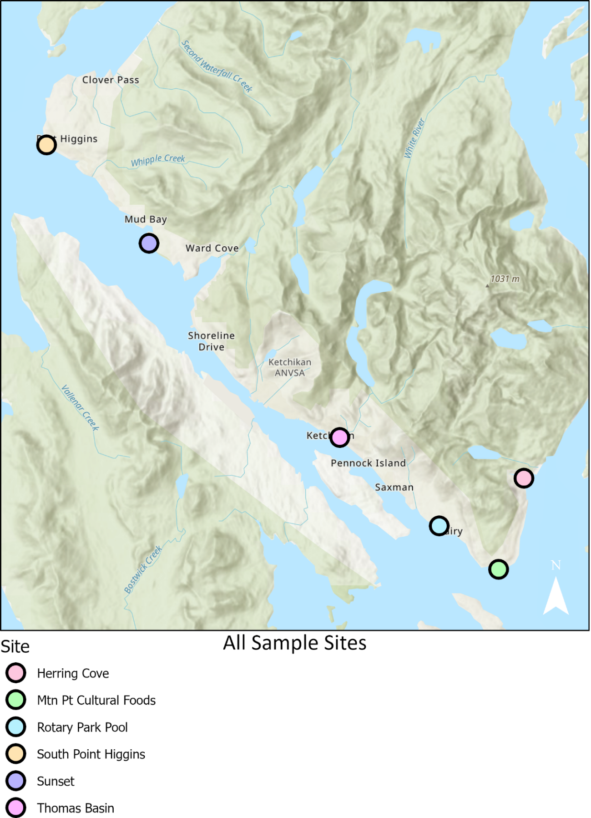
Appendix A: Sample Site Locations Examples

Appendix B: Standard Operating Procedure for Ambient Water Collection for Pathogen Monitoring

Standard Operating Procedures Alaska BEACH Program
Sampling for the Alaska BEACH Program involves wading into the water adjacent to a beach commonly used for recreation to collect water from below the surface into sample jars. The sample should be collected in the general recreational beach area, or near locations expected to be influenced by fecal contamination (e.g., adjacent to sewage lagoons, near small boat harbors, etc.). Field staff will have completed sampling after the following steps have been accomplished:
- Each sample jar is filled with water,
- Each sample jar is labeled,
- Each sample jar is placed in a cooler kept chilled with artificial ice,
- The Beach Sampling Data Sheet is filled out,
- A chain-of-custody form is filled out,
- The cooler is transported to the laboratory responsible for determining fecal coliform and enterococcus populations,
- A copy of the Beach Sampling Data Sheet is sent to the respective DEC Project Manager, and a copy of the Beach sampling Data Sheet is kept by the Grantee Project Manager.
Detailed directions for collecting good water samples, shipping the samples to the laboratory, and providing beach assessment information to DEC are given in the following subsections.

Sample Collection Method
A good water sample is collected by avoiding cross-contamination, which can happen when the sampler inadvertently contaminates the sample. To reduce the potential for cross-contamination the sampler must follow a standard sample-collection method. Step-by-step sample-collection instructions are provided below:
- Request a sample kit from the laboratory. The kit should include the following.
- A cooler
- The appropriate sample containers for marine water quality sampling (enterococcus and fecal coliform bacteria)
- Artificial ice to keep the cooler chilled to the appropriate temperature
- The appropriate container for the duplicate sample
- Temperature blank
- Chain-of custody form
- Custody seals
- Sample jar labels
- An extra set of Sample bottles
- An extra set of sample bottles for a duplicate sample
- Shipping labels
- Packing material
- Call the laboratory prior to sampling to make sure there will be someone at the laboratory to receive and process the samples within 6 hours of sampling.
- Consult flight schedules to make sure there will be a flight that can get the samples to the laboratory within 6 hours of sampling.
- Calibrate equipment to be used for in situ measurements.
- Write the beach sampling location on the bottle label and Beach Sampling Data Sheet.
- Put on clean waders and gloves. Wade into the water to a depth of approximately 3 feet. Try to avoid kicking up sediment or wait until any sediment that has been kicked up settles. Stand downstream of the water current and wait for sediment to clear.
- Remove the bottle cap just before collecting the sample. Protect the cap from contamination. Do not to touch the inside of the bottle, or the inside of the cap.
- Open the sampling bottle and hold onto the base with one hand. Plunge the top of the bottle downward into the water. Avoid introducing surface scum. Point the mouth of the bottle into the current. Hold the bottle about 1 foot below the water surface and tip it slightly upward to allow air to exit and the bottle to fill.
- Remove the bottle from the water. Pour out a little water to leave airspace at the top of the jar. Fill two 250-mL bottles at each sampling location.
- Tightly close each bottle.
- Collect in situ field measurements using a handheld probe or similar. Collect in situ samples immediately after collecting grab samples. Face upstream or into the current, allow any disturbed sediment to settle before submerging the probe to the manufacturer’s suggested depth. Swirl the probe gently to allow good contact with the sensors. Wait for numbers to stabilize. Record results on field datasheets. Note that handheld probes must be calibrated prior to use in the field.
Collect replicates for half of the samples collected during the sampling season. To collect a replicate sample, you must first have requested extra jars from the laboratory. Repeat Steps 2 through 8 at the same location.
- Complete bottle labels and attach them to each sample jar; some sample jar labeling can be done prior to sample collection. Labels should be clean, waterproof, non-smearing, and large enough for all the information. Information on the label should include the following.
- Sample identifier (e.g., “site name-date-sample” = “KB-HerringCove-0515023-01”)
- Sample location (e.g., beach name)
- Sampling date and time
- Name of sampler
- Wash your hands and arms with soap and water or waterless antimicrobial cleanser, or disinfectant lotion to reduce exposure to potentially harmful bacteria or microorganisms.

Sample Handling
Sample handling involves packing the samples in a cooler and shipping them to the laboratory. After sample collection is complete the samples must be handled with care so that they arrive to the laboratory in good condition. Step-by-step sample handling instructions are provided below.
- Place the sample(s) in a pre-chilled cooler containing artificial ice to maintain a temperature from 1° to 10°C. Ask the laboratory ahead of time how much ice will be needed. Do not allow the samples to freeze.
- Place enough packing material inside the cooler to protect the sample jars from breaking during transport to the laboratory.
- Complete the chain-of-custody form. Put the form in a plastic bag and tape it to the inside of the cooler lid.
- Write a note in the “Special Instructions” box requesting that the laboratory results be sent without delay (within 36 hours of sampling) to two people: the DEC Project Manager, the Grantee Project Manager.
- Fill out two custody seals and attach one to the front and one to the back of the cooler to span the lid seam. You want them to tear when the cooler is opened.
- Securely tape the cooler shut prior to shipment. Attach shipping labels that identify the shipping destination and say: “keep cool,” “do not freeze,” and “fragile.”
- Ship the samples to (Laboratory Name and Phone Number).
Remember that samples must be collected, shipped, and received by the laboratory in 6 hours. Samples that exceed the 6-hour holding time may not be analyzed. Consult flight schedules and call the laboratory prior to sampling to make sure there will be a flight that can get the samples to the laboratory within 6 hours of sampling, and that there will be someone at the laboratory to receive the samples.

Appendix C: Example Chain of Custody Form

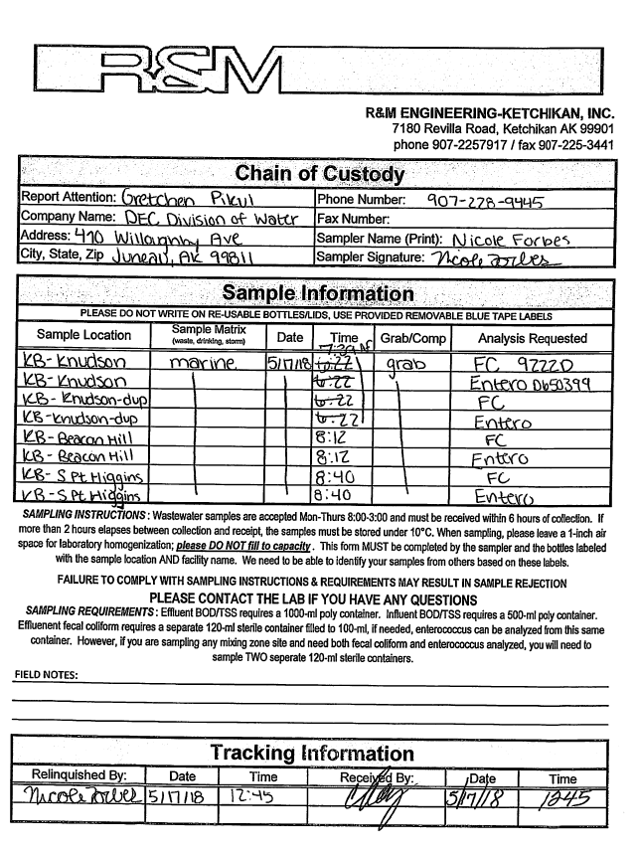
Figure C. 1. Example Chain of Custody form.

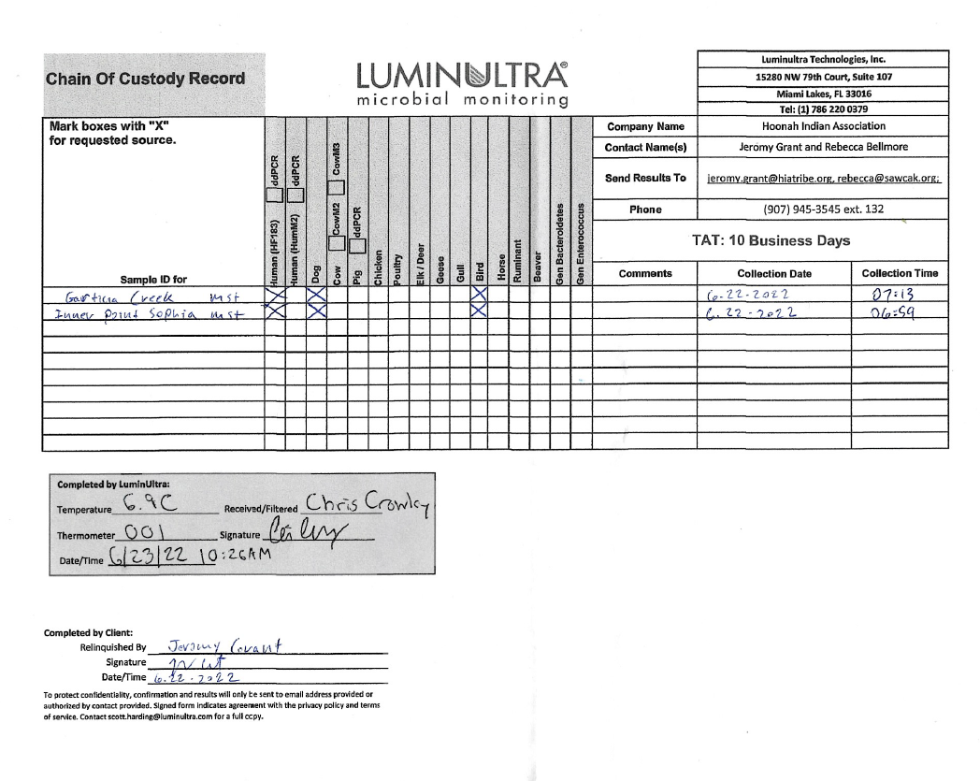
Figure C. 1. Example Chain of Custody form.

Appendix D: Site-Specific Field Data Sheet

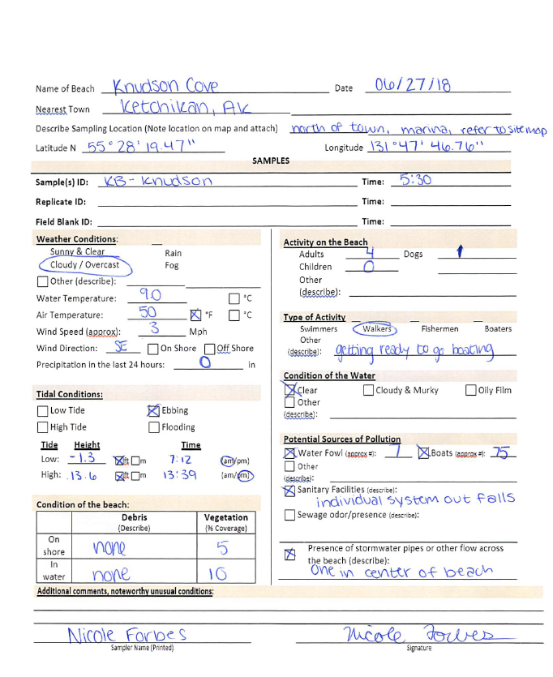

Lat/long coordinates may be revised based on specific field sample location.
High use periods for this project are defined as ice-free months between June and September, with the highest use periods occurring in June through August within sample collection and shipping to DEC-approved laboratories restrictions.
See Appendix B: Standard Operating Procedure for Ambient Water Collection for Pathogen Monitoring and the Community name BEACH monitoring handbook for more information on equipment calibration and maintenance schedules.
In 2021 the EPA released a digital version of the BEACH Sanitary Survey. The digital version is accessed through ESRI 123 App. The survey may be used for the project monitoring seasons; however, paper field sheets should still be filled out as backup documentation.
See Appendix F: Unmanned Aerial Vehicle Technology Use for specific information on data requirements for drone use.

