The Compliance Monitoring Data Portal (CMDP) Training Materials

Module 8: Manual File Upload Using CMDP Templates
There are three ways to submit samples and results into the Compliance Monitoring Data Portal (CMDP) in order to report them to your primacy agency:
- Uploading the sample information as an XML file using web-services;
- Manually uploading sample information in XML files (including XML files for CMDP, which can be generated by using the Excel templates that are available in CMDP, or, if desired, generated by some other application); and
- Entering the information directly into the CMDP using the data entry screens that are part of the CMDP application.
In this training module, the second method will be presented, including using the CMDP templates to generate the XML file.
After logging into the CMDP, which is covered in Module 1, the steps are as follows:
- Download the CMDP Template.
- Prepare a Sample Job Using a CMDP Template.
- Generate an XML file from a CMDP Template.
- Create a new job in CMDP and upload the XML file.
- Review the Validations reports for the Job
Let’s look at each step in more detail.

Download the CMDP Template
Users can elect to upload XML files into CMDP manually by using the File Upload method. The focus of this training video is using XML files, which can be generated by using the MS Excel Templates (spreadsheets) available for each sample category. These templates can be downloaded from the CMDP Home Page by selecting a template using the dropdown field under Templates and clicking on the Download button (see below).
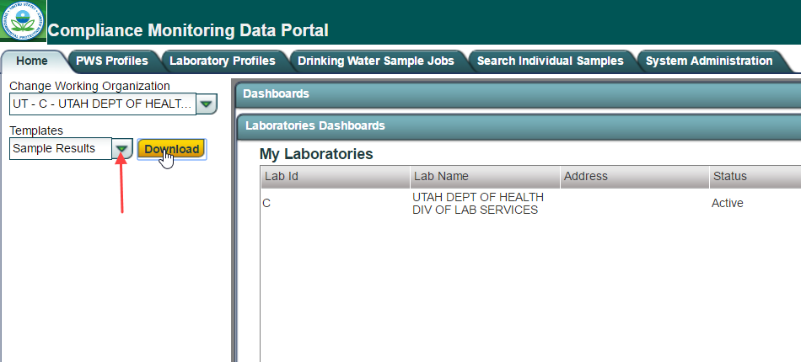
Save the template to a desired location.
About the Available Excel Templates
There are two (2) master Workbooks that contain MS Excel Templates for CMDP sample results:

Workbook 1: CMDP_ Sample_Result_Template.xlsm
This workbook contains three (3) templates; each is in a separate sheet.
- Microbiological
- Chems-Rads
- Cryptosporidium

Workbook 2: CMDP_Operational_Data_Template.xlsm
This workbook contains nine (9) templates; each is in a separate sheet.
- CFE Turbidity
- IFE Turbidity
- Chlorine Dioxide and Chlorite
- Chlorine Chloramine Entering DS (Distribution System)
- Chlorine Chloramine in DS (Distribution System)
- LCR WQP (Water Quality Parameters)
- TOC (Total Organic Carbon)
- Ozone Treatment (Bromate)
- TTHM and HAA5

Prepare a Sample Job Using a CMDP Template
To use the File Upload functionality in CMDP you first enter the data into the appropriate CMDP Template.
You may want to make a copy of the template you'll use and name the file to reflect the data you'll be entering into it. You likely will want to use the same name when you generate an XML file from the template, so have it handy. The name you give to the XML file will be recorded in CMDP when you upload the XML file.
Keep the following in mind when using the templates:
- Some data validations are included in the templates to help ensure that the data are valid and will be accepted by CMDP.
- Be sure to enter valid data in appropriate formats in each cell so that a record is not rejected. If any cell contains invalid data or formats, the record will be rejected. Please refer to the CMDP Web Services Sample Data Dictionary for valid values for the fields used by CMDP.
- It is critical that users take into consideration the stored reference data in CMDP and that data are case-sensitive. For example, entering “oh0000001” as a Water System ID is not a valid value; the correct value is “OH0000001.”
If a record contains a value not stored in CMDP as reference data for these fields, then the value will not be considered valid, and CMDP will reject the record. To help avoid these kinds of errors, please log into CMDP and view the PWS Profiles or Laboratory Profiles to check for the reference data stored in CMDP for critical fields such as: Water System ID, Water System Facility ID, Sampling Point ID, and Laboratory ID. Alternatively your state primacy agency may already provide a reference for submitters, for example, Drinking Water Watch, or another state website, where these values are stored.
- Because the CMDP templates are in MS Excel, copy and paste features are available for use. If multiple samples share the same information (same collection date, sample time, etc.), you can copy the information contained in a row and paste it in the next row.
- When entering repeat samples, make sure that you populate the routine (Original) Sample ID and optionally the Repeat Location field. It is important that the value (ID) entered in the Original Sample ID field exists in CMDP before the associated repeat samples are reported, otherwise the repeat samples will be rejected. To ensure this works correctly when CMDP processes the content of the Template, enter the routine sample into a row in the template and then enter any associated repeat samples in the rows below.
- Save your progress regularly when using Excel. Also, save your template prior to clicking the “Generate XML” button on each tab.
- While it is possible to use the CMDP_ Sample_Result_Template.xlsm to enter multiple samples (Microbial, Chem/Radionuclides, and Crypto) for different water systems if needed, the CMDP_Operational_Data_Template.xlsm for CFE, IFE, and Disinfectant Residuals will only allow reports for one particular water system facility at a time.
- The Excel Templates cannot be uploaded as Excel files to the CMDP application; only the XML files created using the “Generate XML” button can be uploaded.
- Once an XML file is uploaded successfully, a draft Sample Job number will be created, and the contents will appear to the user in CMDP as web forms for each sample result, so that you can edit the data and submit just as if you had entered the results as web forms.
- The following features are available in the CMDP user interface for uploaded jobs (as long as the user has the appropriate permissions): Add/Remove Attachments, View Job History (any actions will be recorded when Job is in Draft with Reviewer Status and forward), View Validations, and Add/Remove Samples for a Job.
- Some of the columns contain pick-lists where you can search for a specific value (e.g., Analytes). In that case, you can double-click the cell and enter the value to look up; the field will be populated with the result of your search when you press Enter.

Workbook 1: CMDP_Sample_Result_Template
In Workbook 1: CMDP_ Sample_Result_Template.xlsm, each row in the template represents a sample result in the sample. And so, if there is more than one result for a single sample, each result should be entered into a separate row in the template (see below).
If invalid data are entered for any row (result) in the template, that row will not be added to the CMDP database when uploading the XML file. All rows containing valid data for sample results will be added to the Sample Job even if some of them fail.
The red box in the snapshot below shows how a sample (1002754-01-SRP) with 5 results should be entered into the template. If there is a dropdown for a cell, use it to select a valid entry (e.g., use the dropdown under "Sample Type").
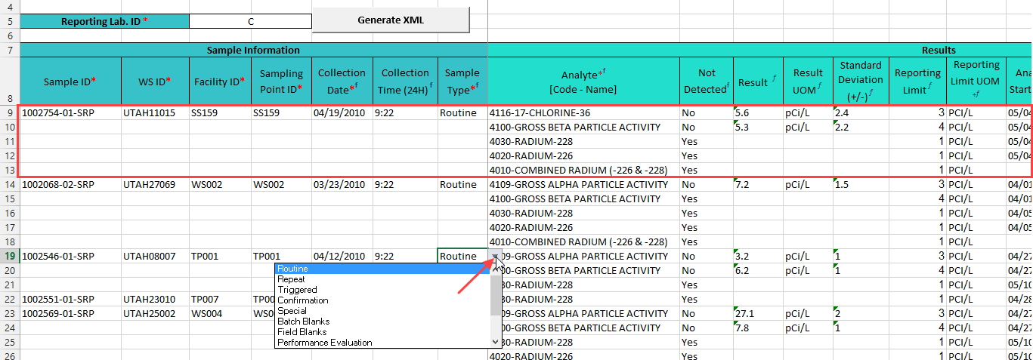
The snapshot below shows how to enter RTCR repeat samples that also include field results.
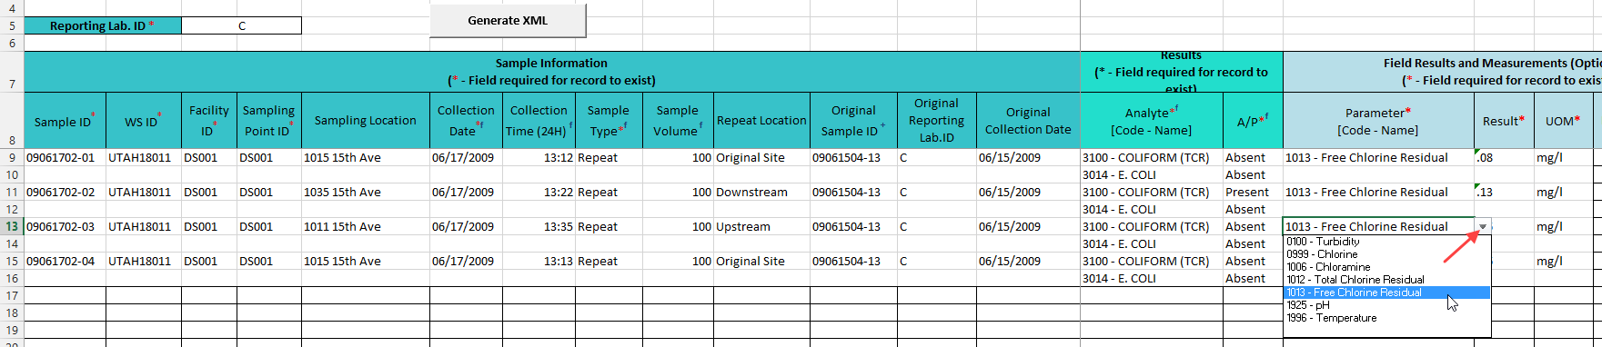

Workbook 2: CMDP_Operational_Data_Template
In Workbook 2: CMDP_Operational_Data_Template.xlsm, for CFE, IFE, Residuals Entering DS, and Residuals in DS, each tab represents a single monthly report for the operational data.
On several of the sheet/tabs, you can enter summary information for the operational data and detailed information. For example, in the CFE Turbidity sheet, you enter the required summary information at the top and can enter details about combined filter turbidity readings for each day at the bottom (see below).
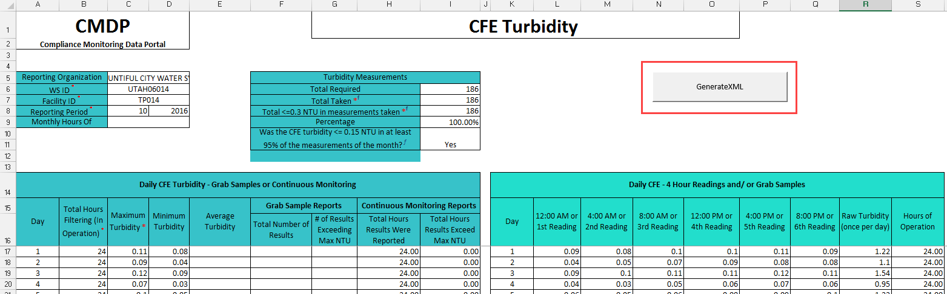
There are some calculations in the templates, but details entered generally are not used to calculate summary information.
If invalid data are entered for a report, none of the contents for the tab will be added to the CMDP database when uploading the file. However, all other tabs that have 100% valid data within the workbook will be added to the CMDP database.

Generate an XML File from a CMDP Template
Once all the results data to be reported to the primacy agency have been entered into the CMDP Template, save the file and click any “Generate XML” button available on any sheet in the template (see above) to create the XML file. Save the XML file so that it can be found when you go to the next step.

Create a New Job in CMDP and Upload the XML File
The next step is to log into CMDP, create a new Job, and upload the XML file that was generated.

Select the “Drinking Water Sample Jobs” Module Tab
To create a new job, select the Drinking Water Sample Jobs module tab.
On the Drinking Water Sample Jobs tab, you’ll initially see a list of all the jobs you’ve entered. Each row represents a separate job.
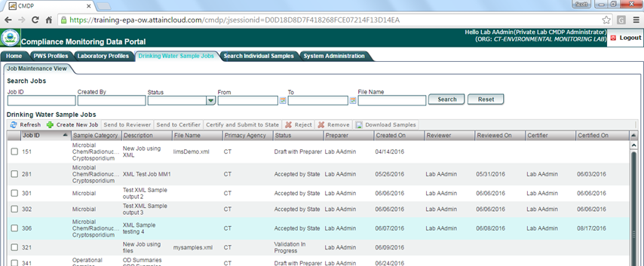

Create a New Job
To create a new job, click on the Create New Job button on the menu (see the box outlined in red below).
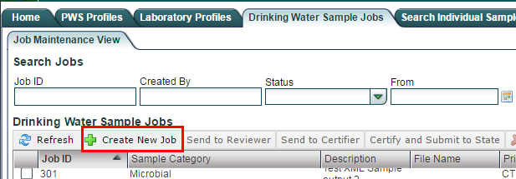
A popup dialog box called “Create New Job Options” will appear.
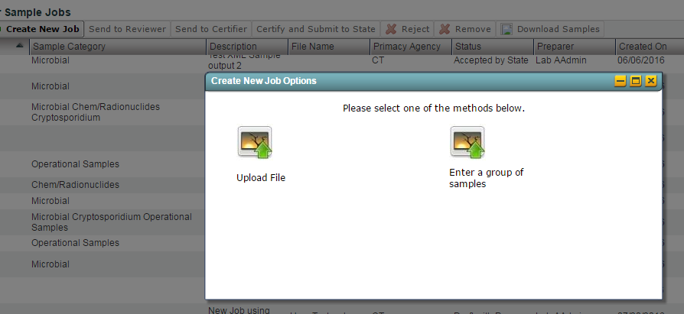
Click on “Upload File." Another popup, Create New Job - Upload Sample File will appear.
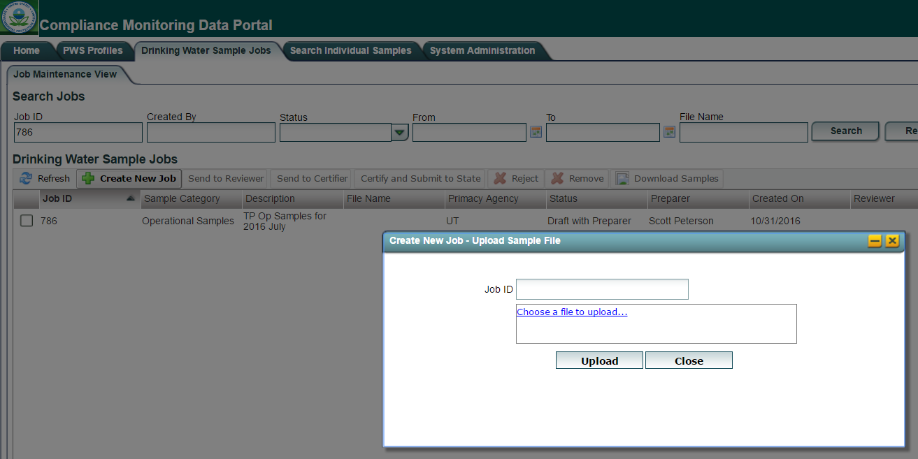
Click the Choose a file to upload… hyperlink to select the XML file. It is very important for the user to wait for the “Done” flag to be displayed before clicking the Upload button, otherwise the file upload will fail.
When the upload is done, the message "Information saved successfully" will appear at the top of the dialog box and a Job ID will be listed, which was automatically assigned by CMDP (see below).
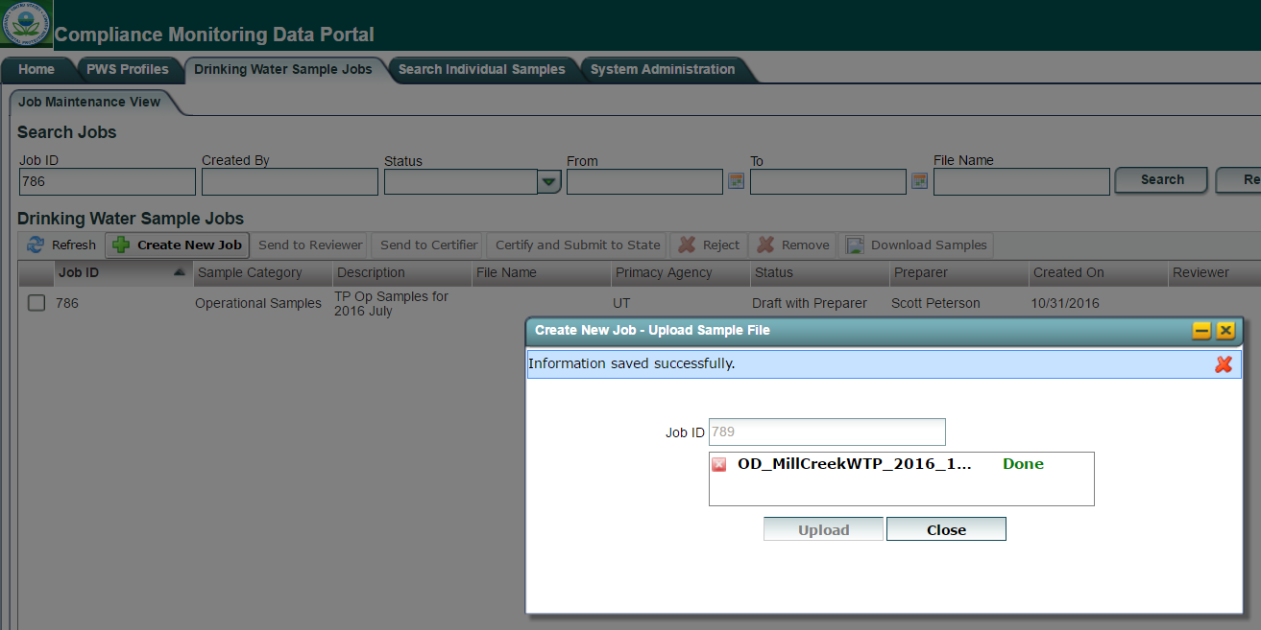
The file is now uploaded. After you click the Close button, you'll return to the Drinking Water Sample Jobs tab where the new Job will appear on the list of Jobs (unless you were previously looking at another Job or applied a filter before selecting Create New Job - see below).
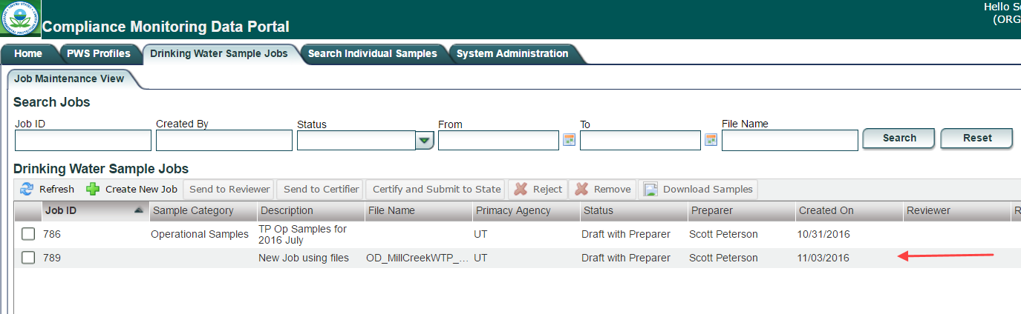
If the Status field says “Validation in Progress,” click the Refresh button and the status should change to “Draft with Preparer."

Review the Validations reports for the Job
Once the XML file has been uploaded, you should review the validations report and perhaps the data in the job to ensure it was properly uploaded. To review the validations report, click on the row for the job on the Drinking Water Sample Jobs tab (see above) to open the Job Summary View for the Job. Then click on the Validations sub-tab (see below).
The Validations sub-tab consists of three sections:
- Federal Reporting Validation Results
- XML Submittal Validation Summary
- XML Submittal Validation Error Details
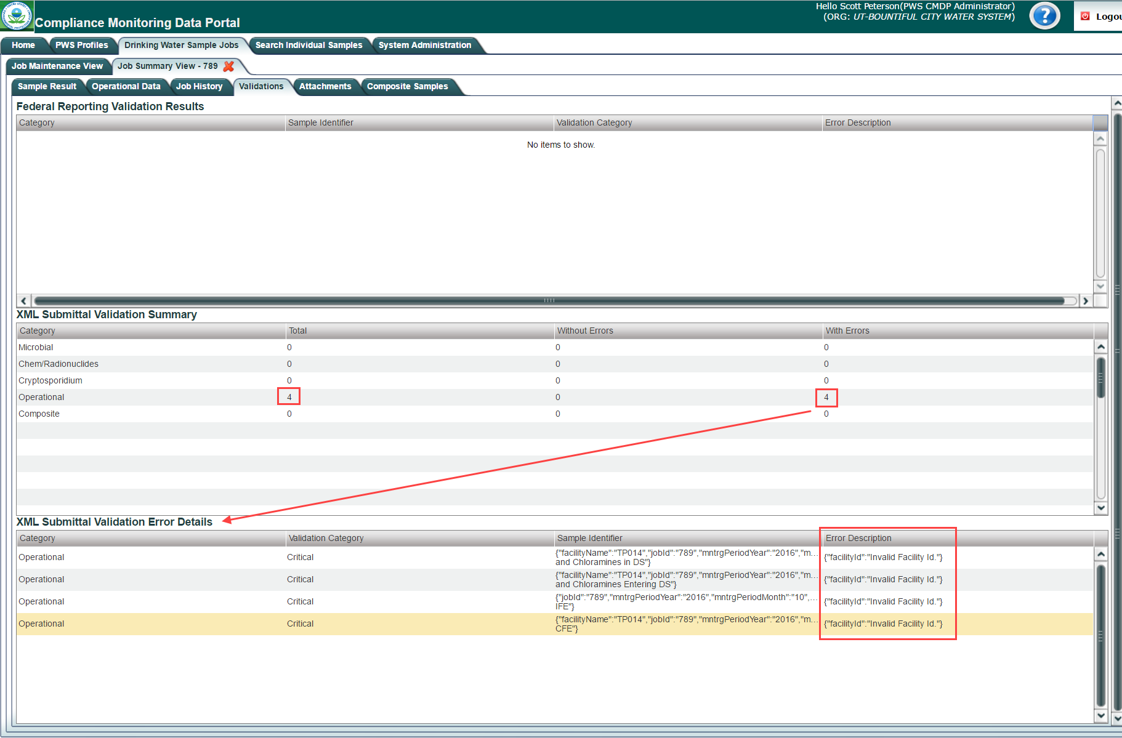

XML Submittal Validations
First check the second section, the XML Submittal Validation Summary to make sure all the data was successfully uploaded by comparing the "Total" number of records to the number "With Errors." If there are some with errors, click on that row in the second section to see the details in the third section, XML Submittal Validation Error Details. In this example, all four of the operational data records had the same error: {"facilityId"."Invalid Facility Id."}. Because of these XML validation errors, none of the four operational data records were uploaded.
To resolve this, you may first want to remove the Job from CMDP (especially if some of the data were uploaded and you don't want to create two different Jobs for the same data: one containing the data that was initially uploaded correctly and the other containing the data that was not uploaded due to the errors). To remove the Job, click on the Job Maintenance View tab, check the box at the left end of the row with the Job (be careful to select the correct Job), and then click Remove (see below).
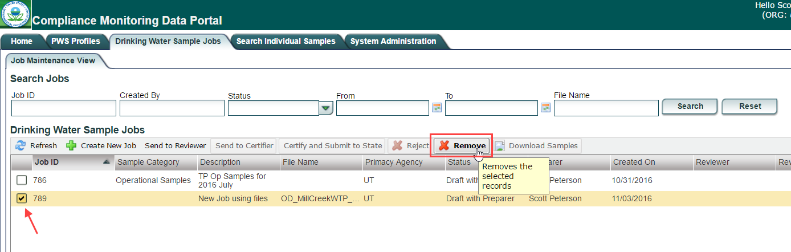
Then, go back to your MS Excel application to open the Excel spreadsheet into which you originally entered the data. Make the corrections needed to prevent the same errors from occurring (in this case, you'd compare the PWS Profile information for the facility in CMDP to the information entered in the template. And then go back to Step 3 to re-generate the XML file and upload it to CMDP again.

Federal Reporting Validations
If there are no XML Submittal Validation errors, you should review the Federal Reporting Validation Results in the first section on the Validations sub-tab. If there are federal reporting validation issues, a row will be displayed for each one.
So, for example, in the snapshot below, there are two federal reporting issues for Sample ID "SRP-Rad-002" (highlighted in yellow - note that Sample ID is labeled 'labSampleCd' in this report).
The type (Category) of sample is listed in the first column, information to identify the sample is listed in the second column, the third column provides the validation category, and the fourth column provides a description of the validation error.
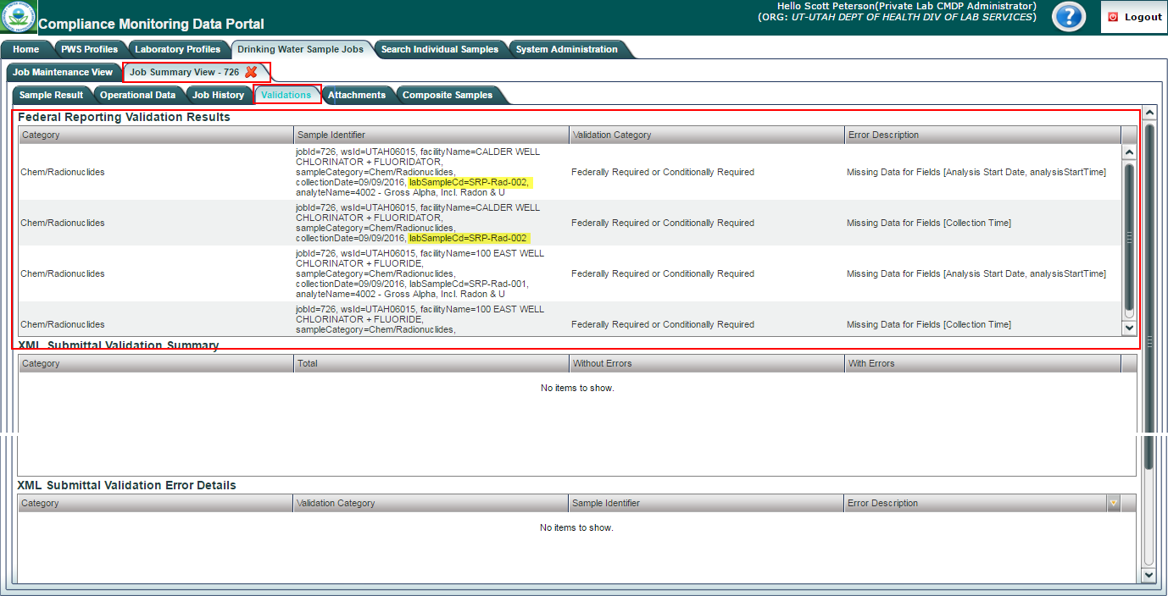
CMDP is designed to allow you to fix an error from within the application, because these errors are not as critical as the XML errors. To fix an error, on can click on the row and you'll be redirected to the web form for that sample, where you can then fix it (so long as you haven't already submitted the Job). After saving your change and clicking on the Close button on the form, you'll be redirected back to the above Validations tab.
Note that, when you flow back to the Validation tab, the validation you thought you fixed may still be listed. If this happens, click on the Job Maintenance View tab, check the box to the left of the Job (in the Drinking Water Sample Jobs grid) and then click on the "Refresh" button, which fetches data for the Job from the server.
Alternatively, if there are a lot of federal reporting errors and you'd rather correct them in the template, remove the Job as described above and proceed to make the corrections in the template. After which, you would then start over at Step 3 above.
Also, federally required fields missing in the Job will not prevent you from submitting the Job. However, please note that the primacy agency will have access to the job validations tab and will be able to determine all federally required fields that are missing from the submitted Job.
Once an XML file is uploaded, the Job needs to go through the submission workflow to be reported to a primacy agency. The submission workflow is described in Module 9 of these training materials as well as in the CMDP User Manual.

Attachment One: Sample Category to use to Enter Samples and Results
The following table lists the sub-tabs and web forms to use for the types of samples and results you want to enter along with the module to refer to.
Sub-Tab Name | Types of Samples and Results | Module Number
Sample Result | Chemical | Five (5)
 | Radionuclide
 | Microbial
 | Cryptosporidium
Operational Data | Combined Filter Effluent (CFE) Turbidity | Seven (7)
 | Individual Filter Effluent (IFE) Turbidity
 | Chlorine Dioxide/Chlorite
 | Chlorine Chloramines Entering the Distribution System
 | Chlorine Chloramines In the Distribution System
 | Lead and Copper Water Quality Parameters (LCR WQP)
 | Total Organic Carbon (TOC)
 | TTHM and HAA5
 | Ozone Treatment (Bromate)
Composite Samples | Chemical | Six (6)
 | Radionuclide
Version 1.0 of CMDP will upload XML files for all of the sample types above. However, XML files containing yellow highlighted sample types will not be migrated to SDWIS/STATE until a future version of CMDP is released. Please be sure to review the user manual for more information and the ZenDesk for regular updates on CMDP software updates.

