The Compliance Monitoring Data Portal (CMDP) Training Materials

Module 7: Search Samples
In this training unit, we focus on using the Search Individual Samples Module. This module allows a user to search for and view one or more Sample Jobs in both the Sample Result Category and Operational Data Category in CMDP. To use this module, after you've logged into CMDP, you click on the Search Individual Samples Module Tab. This Module Tab includes two subtabs: Search Samples and Search Operational Data (see below).

Search Samples
Users can search for the categories of samples shown below using the Search Samples tab.
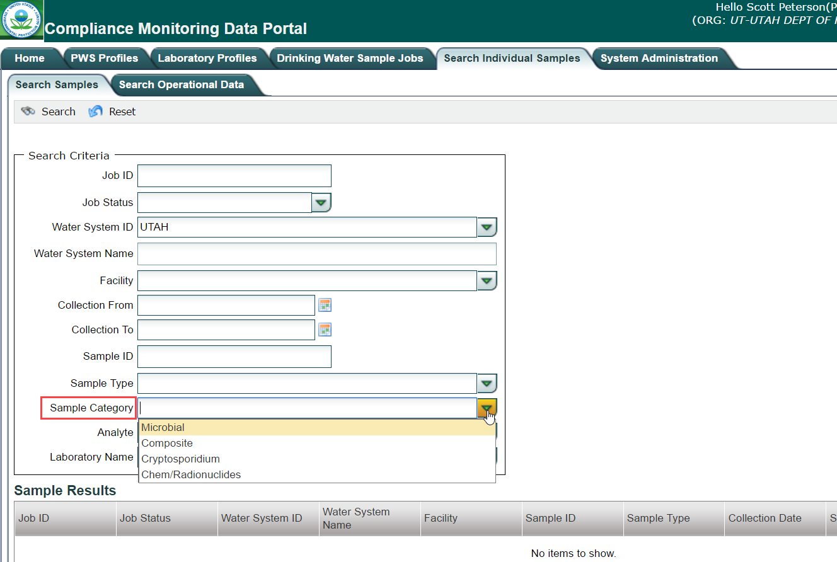
To search for one or more samples, select one or more of the search criteria. To select a value in a dropdown with a long list of choices (e.g., Water System Id, Analyte) you can use a filtering function. In the filtering function, as a user enters characters into a search field, for example “bount” (see below), the CMDP auto-populates the pick-list below with values that match the values of the characters.
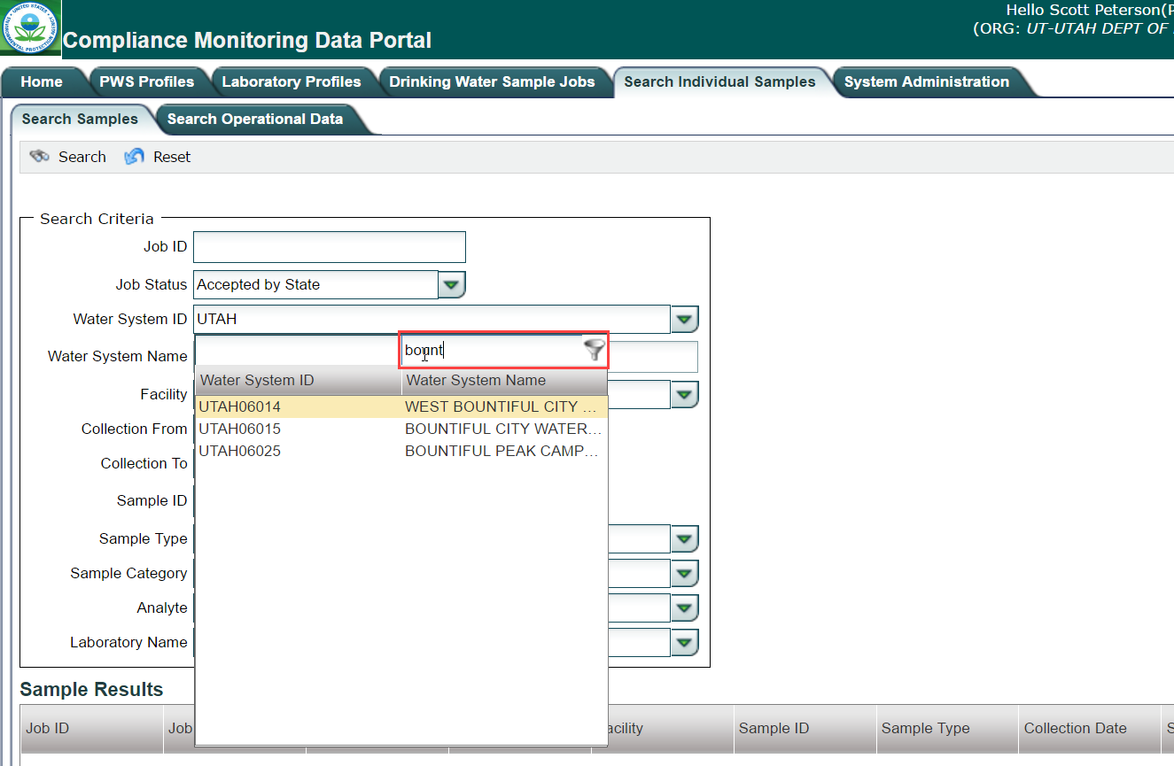
Once you've entered your criteria, click the “Search” button at the top of the page to get a list of results that satisfy the search. Notice that each row in the list is for an analytical result. So, if a Sample Job has multiple results that satisfy the search criteria, the sample Job will be repeated for each unique result in the sample. Notice also that you can see the "Job ID" and "Job Status" for each result, which may be your primary reason for using this feature.
If too many results are returned, you can enter additional criteria and then click the Search button again. To clear the "Search Criteria" fields, click on the Reset button.
As with all the grids/tables in CMDP, you can sort on any column in the grid and can sort on more than one column at a time. To do so, click at the right end of any column header to access the sort, columns, group by dialog box (see below). If you want to hide some columns, use the "Columns" feature in the dialog box.
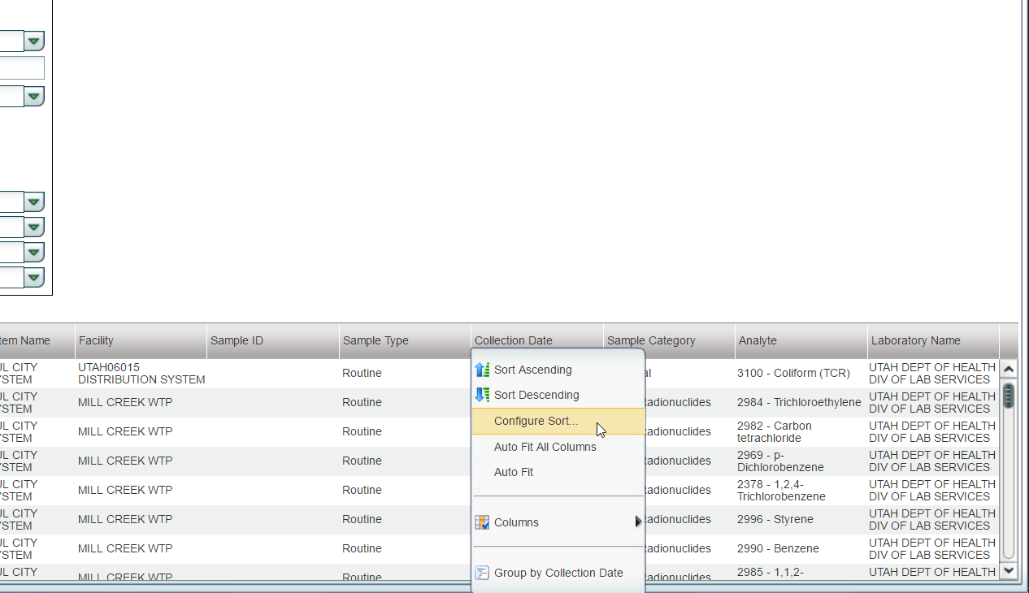
When you click on a result in the Sample Results list, the sample and its results are displayed in the form that corresponds to the Sample Category for the result (i.e., Microbial, Chem/Radionuclides, Cryptosporidium, or Composite). For example, the Chem Rads form was opened below when I clicked on a row in the grid.
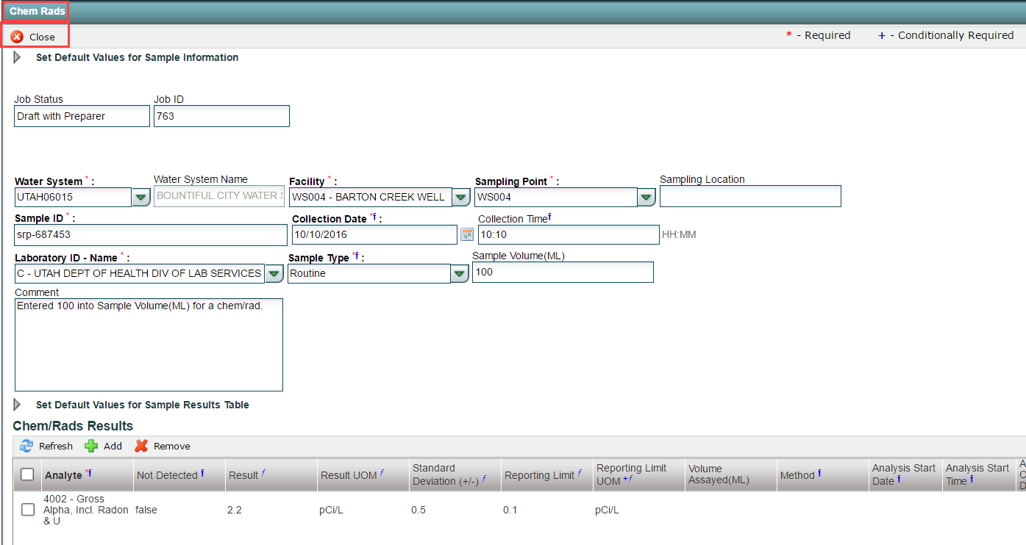
Notice that you cannot save any changes to data in views of Sample Jobs that are accessed from the Search Individual Samples Module Tab.

Search Operational Data
Users can search for operational data using the Search Operational Data tab, which is shown below with the "Operational Sample Type" dropdown list shown.
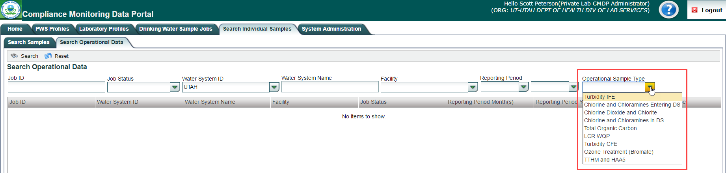
To search for one or more records, select one or more of the search criteria. To select a value in a dropdown with a long list of choices (e.g., Water System Id) you can use a filtering function (see under Search Samples for more information).
Once you've entered your criteria, click the “Search” button to get the list of operational data records that satisfy the search. Notice that you can see the "Job ID" and "Job Status" for each record, which may be the primary reason to use this capability.
If too many rows are returned, you can enter additional criteria and then click the Search button again. To clear the "Search Criteria" fields, click on the Reset button.
As with all the grids/tables in CMDP, you can sort on any column in the grid and can sort on more than one column at a time. To do so, click at the right end of any column header to access the sort, columns, group by dialog box (see below). If you want to hide some columns, use the "Columns" feature in the dialog box.
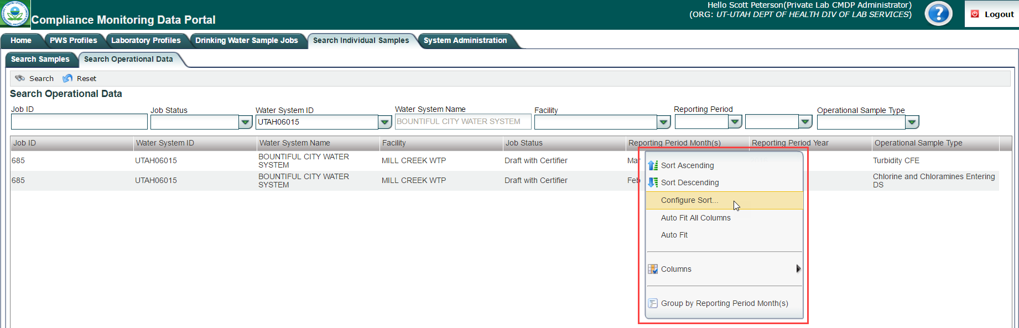
When you click on a row in the list, the operational data record is displayed in the form that corresponds to it (e.g., Turbidity CFE, Chlorine Chloramine Entering DS, etc.). For example, the Operational Data - Turbidity CFE form was opened when I clicked on the first row above (see below).
Notice that you cannot save any changes to data in views of Sample Jobs that are accessed from the Search Individual Samples Module Tab.

