The Compliance Monitoring Data Portal (CMDP) Training Materials

Module 9: Submission Workflow
This training module provides information about CMDP Job submissions to primacy agencies. Only Laboratory and Water System Users can submit a Job to a primacy agency (i.e., State Users do not submit Jobs).
A Job is a group of samples with microbial, chemical, radionuclide, or cryptosporidium results; and/or composite samples with chemical or radionuclide results; and/or operational data (aka Operational Samples in CMDP), e.g., turbidity, residual disinfectant. A Job can be in one of the following statuses:
- Draft with Preparer
This status means that the Job is currently maintained by a Preparer (Reviewer and Certifier roles also may act as Preparers and edit when the Job is in this status). Modifications can still occur (add/edit/remove) and validations will be executed when job is saved
- Draft with Reviewer
This status means that the Job is currently under review (only Reviewer and Certifier roles have edit rights when the Job is in this status). Modifications can still occur (add/edit/remove) and validations will be executed when job is saved
- Draft with Certifier
This status means that the Job is currently awaiting certification (only Certifier role have edit rights). Modifications can still occur (add/edit/remove) and validations will be executed when job is saved
- Submitted
Job is submitted by reporting organization to primacy agency. No edits allowed.
- Accepted by State
Job data are migrated to primacy agency compliance system. No edits allowed.
The submission workflow is as follows:
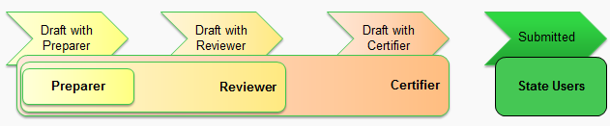

Draft with Preparer
When a job is created, its first status is Draft with Preparer, whether the job was created by uploading an XML file (see Module 8), created using the CMDP interface (see Module 4), or using Web-services (see Module 10). The Dashboard for Laboratory and Water System users includes a "My Work in Progress" group box. In this group box are all the jobs that have not yet been "Submitted."

Send Job to Reviewer
To take the next step in the workflow, i.e., to have the Job reviewed, click one-time on the Job row (in the screenshot of the Laboratory Dashboard below, Job 711 has been selected in the “My Work in Progress” pane).
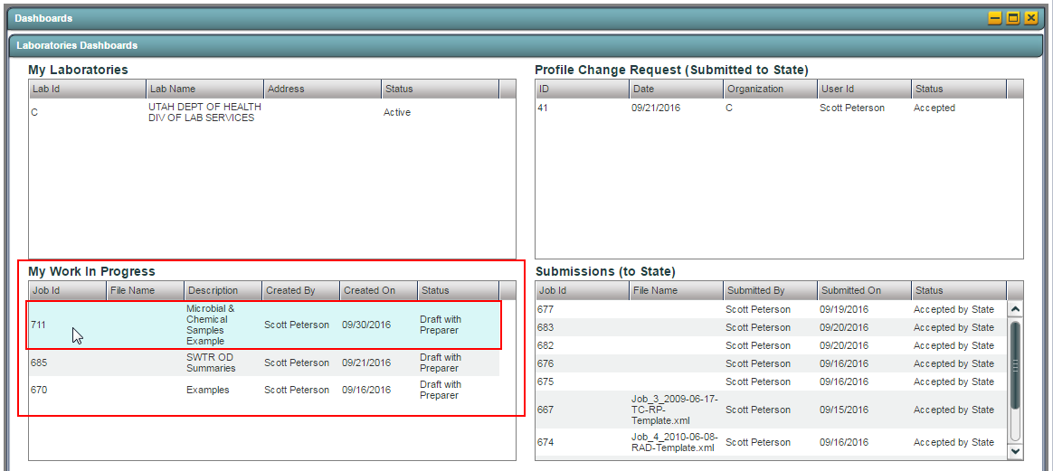
The CMDP opens the Job in the "Job Summary View" (see blue highlighted tab in the screen shot below).
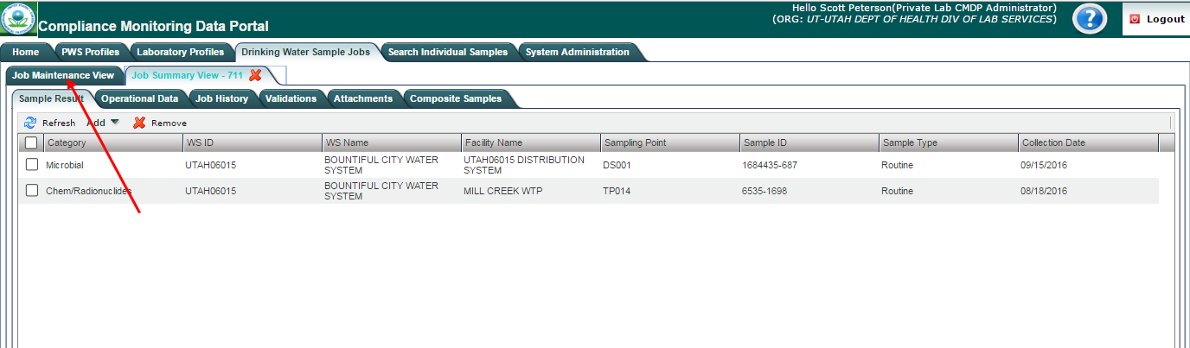

To take the next step, click on the "Job Maintenance View" tab as shown by the red arrow in the screen shot below.
(Note that you can also get to the "Job Maintenance View" by clicking on the Drinking Water Sample Jobs from the Home page. When you take this approach, all the Jobs are listed with the most recent one(s), the one(s) you want to review and submit, at the bottom of the list. There is more than one way to get to the Job(s) you want, when you take this approach - for example, change the sort to descending on column "Job ID" or "Created On.")
From the "Job Maintenance View," you can send the job to a Reviewer by checking the box to the left of the Job ID (see below). When you check this box, the "Send to Reviewer" button is enabled (in the red box below).
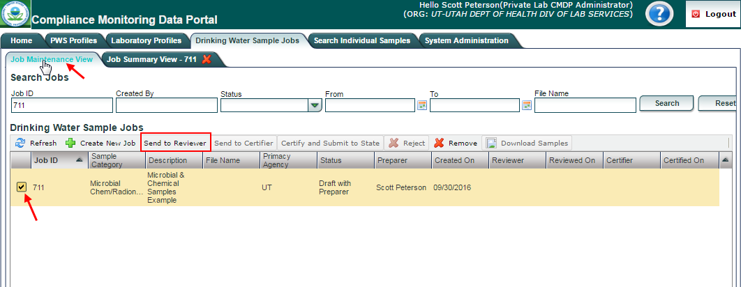
When you click on the "Send to Reviewer" button, a “Send Data to Reviewer” pop-up box is presented (see below).
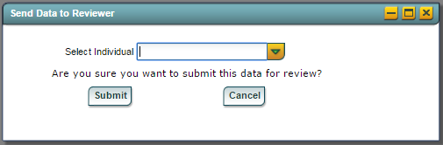
On the pop-up, select the name of the individual to whom the Job will be sent using the dropdown for the "Select Individual" field and then click on the “Submit” button. A confirmation message will be displayed. Click “OK” to close the window.
The Status of the Job will then be updated to “Draft with Reviewer” and the Reviewer column will be updated with the Reviewer's name.
Note that, if you only have one individual who processes Jobs through all or some of the submission workflow, you'll only have one listing in the dropdown. If you need to authorize others for any of these steps, you need to register them (see the CMDP Role Registration User Guide).
Also note that, if a user fails to select an individual from the pick list, the workflow will still work. In this case, the “Reviewer” column will be remain empty until a registered Reviewer completes the review and sends it to the Certifier. However, please note that other CMDP users will not know who is currently managing the draft Job in Reviewer status while this column remains empty.

Review the Job - Validations Results
CMDP performs validation checks when an XML file is submitted or when web forms are used. Some of the data fields in each category of samples supported by CMDP are federally required or federally conditionally required. These fields are not required to be entered in order to save and submit samples within a Job. However, any records with missing values for federally required or conditionally required fields are considered validation errors.
In addition to reviewing the individual samples and results in the Job (i.e., Sample Result, Operational Data, and/or Composite Sample records), the reviewer should also look at the results of these validation checks for the Job.
To review the results of the validation checks performed by CMDP, click on the Job Summary View tab and then the Validations tab (see below on the next page). The tab includes three different tables:
- Federal Reporting Validation Results
- XML Submittal Validation Summary
- XML Submittal Validation Error Details
The Middle Table and Bottom Table are only relevant for Jobs that were created using the XML File Upload method or LIMS method of reporting.
Top Table - Federal Reporting Validation Results: This table contains results of validations check against fields that are federally required or federally conditionally required to see if there is a value. If those fields are left blank, they will be listed as errors in this table. Any errors displayed in this table, however, will not prevent a Laboratory or Water System User from certifying and submitting a Job to State.
Middle Table - XML Submittal Validation Summary: This table contains a summary count of all sample records found in an XML file. Based on this summary count, the user can identify the number of samples that contain no errors and the number that contain errors. Errors used for the count are:
- invalid data entries for federally required, federally conditionally required, or software required fields;
- missing values for software required fields for each sample; and
- business rule validation errors in the XML file.
Any sample records with XML Submittal Validation errors need to be corrected in order to be certified and submitted to a state primacy agency. Errors need to be corrected and re-uploaded to CMDP using XML file upload (or LIMS).
To see the specific errors, click on the row with an error count that is > 0 and look in the Bottom Table.
Bottom Table - XML Submittal Validation Error Details: This table contains details of the errors counted in the XML Submittal Validation Summary. The "Sample Identifier" column provides the information you need to identify the sample in the XML file that contains the error. The "Error Description" column provides the information you need to know what needs to be fixed.
So, for example, in the snapshot below, there are two federal reporting issues for Sample ID "SRP-Rad-002" (highlighted in yellow - note that Sample ID is labeled 'labSampleCd' in this report).
The type (Category) of sample is listed in the first column, information to identify the sample are listed in the second column, the third column provides the validation category, and the fourth column provides a description of the validation error.
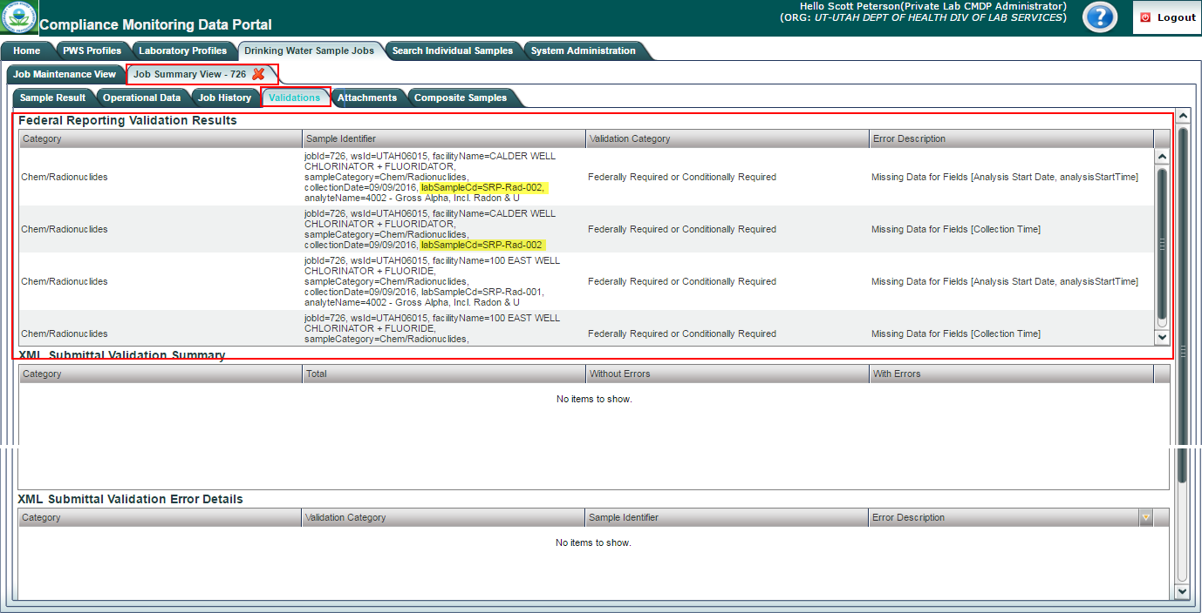
If you want to fix a federal reporting validation error without sending it back to the preparer, click on the row (in the top table) and you'll be redirected to the web form for that sample and can then fix it (so long as you haven't already submitted it). After saving your change and clicking on the Close button on the form, you'll be redirected back to the above Validations tab. Note that, when you flow back to the Validation tab, the validation you thought you fixed may still be listed. If this happens, click on the Job Maintenance View tab, check the box to the left of the Job (in the Drinking Water Sample Jobs grid) and then click on the "Refresh" button, which fetches data for the Job from the server.
However, as a reviewer, you may want the person who originally entered the record to fix it. In that case, you would Reject the Job in order to send it back to the Preparer. See the CMDP User Manual for more on rejecting a Job.

Review/Add Attachments to a Job
Users can add any additional documents to a Job before submission to state at any stage in the submission workflow. This feature allows reporting organizations to add any non-structured data (pictures, pdfs, word documents, etc.) to a Job and submit it to the state primacy agency if needed. As a reviewer, you may want to review any attachments made by the preparer or you may want add an attachment. To add an attachment:
- Go to attachments in the Job Summary View (see below).
- Click “Choose a file to upload”. This will open an explorer window that will allow you to locate the file.
- Click the “Upload” button
The file will then be added to the Attachments table.
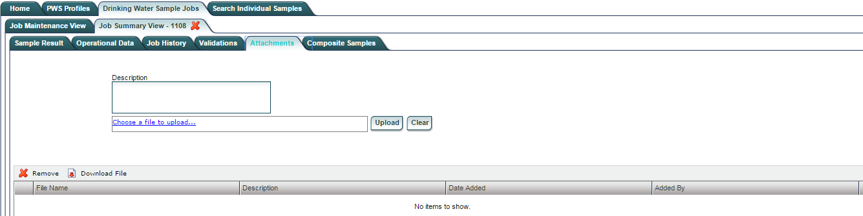

Send Job to Certifier
Once the job is reviewed, it can be sent to a Certifier. To do that, return to the Job Maintenance View for the Job. Check the box to the left of the Job ID (see below). When you check this box, the button for the next step is enabled - in this case, the "Send to Certifier" button (in the red box below).
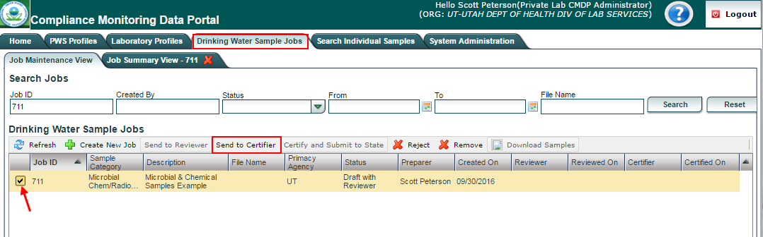
Click on “Send to Certifier” to send the job to the Certifier.

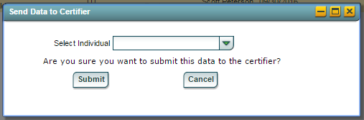
On the pop-up, select the individual to whom the Job will be sent using the dropdown for the "Select Individual" field and then click on the “Submit” button. A confirmation message will be displayed. Click “OK” to close the window.
The Status of the Job will then be updated to “Draft with Certifier”, the “Reviewed On” column will be updated with the date on which the Reviewer completed his or her review (by sending to Certifier), and the Certifier column will be updated with the Certifier's name. The notes given above for sending a Job to a Reviewer apply here as well.
As a Certifier, you may want the person who originally entered the record to fix it. In that case, you would Reject the Job in order to send it back to the preparer. See the CMDP User Guide for more on rejecting a Job.

Job History
The Job History Sub Tab shows any modifications made by a user to the samples included in the Job during the Sample Job workflow. Information recorded and shown here includes:
- Job Status change (Sent to Reviewer, Sent to Certifier, Submitted, Rejected)
- Samples added, edited, or removed
To see the history for a Job (see below):
- click the “Job Maintenance View” tab under the “Drinking Water Sample Jobs” tab.
- Select a Job from the Jobs search list to view Job details in a new tab.
- Click the “Job History” tab to view the history details of the Job selected.
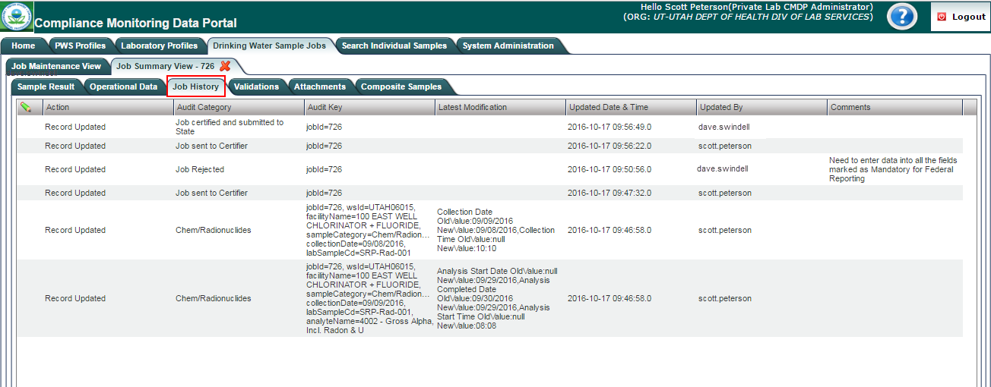

The history for the above Job is as follows:
- The reviewer, scott.peterson, modified the collection date and time for labSampleCd (i.e., Sample ID) "SRP-Rad-001" and he modified the result by adding the analysis start time and date (see the bottom two rows).
- He then sent it to the certifier, dave.swindell.
- The certifier rejected the Job and instructed the preparer to "…enter data into all fields marked as Mandatory for Federal Reporting."
- The preparer, who's changes are not shown, made the changes (which one can figure out by looking at the Validations tab - see below) and sent back through the workflow.
- The Job was then certified and sent to the state by the certifier.

Certify and Submit Job to the State
Once the Job has been received and reviewed by the Certifier, he or she can electronically sign the Job and submit it to the primacy agency.
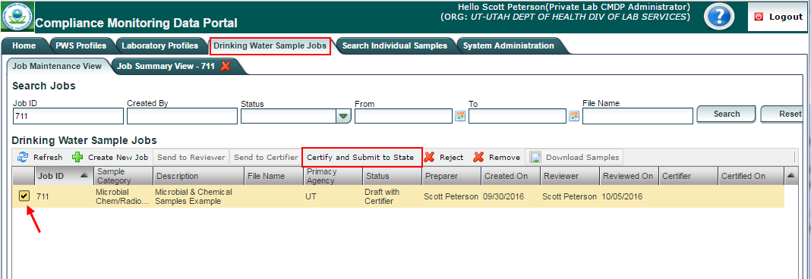
To do so, the Certifier clicks on the check box to the left of a Job to submit and then clicks on the Certify and Submit to State button.
The following pop-up appears for the Certifier to authenticate. Enter your User Name and Password and click the Submit button.

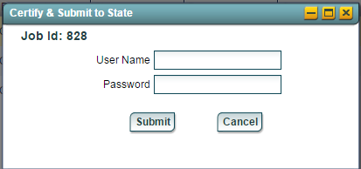
The "Challenge Question" pop-up will appear (see below). This Challenge Question is one of the five questions that the user selected in Shared CROMERR Services (SCS) during registration for a role that allows certification in CMDP. Note that the question(s) you see may be different than the one shown in the screen shot.
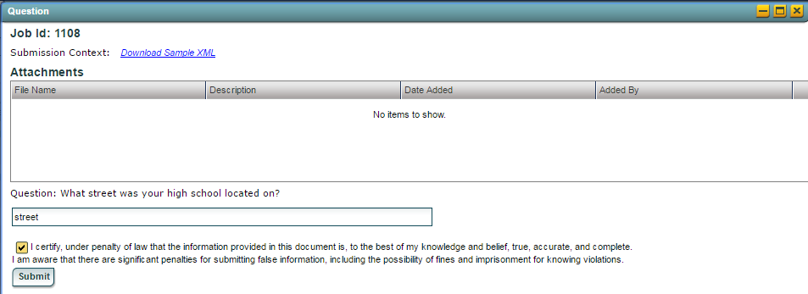
Answer the challenge question(s) displayed, check the certification statement box, and then click “Submit.”
A confirmation message will be displayed. Click "OK” to close the window. The Job Status in the Maintenance View will be updated to “Submitted.”
Note that a State Laboratory does not have to electronically sign a Job, if the State Laboratory User was properly setup when registered to use CMDP. A State Laboratory Certifier will not have to answer personal questions in order to submit a Job. Please refer to the CMDP Role Registration User Guide for further information.
The Certifier can download an HTML file that contains all samples before submitting to State. Click the Download Sample XML link on the above pop-up to save the file. The file can be opened in any web browser as an HTML page.
On the dashboard, the Job will be moved from the My Work in Progress to Submissions (to State) group box.

Migrate Job to State Compliance System
Until SDWIS Prime is fully operational and used by all primacy agencies using SDWIS/State, after the Job is submitted by a laboratory or water system, for those primacy agencies that use SDWIS/STATE, the data is automatically migrated to SDWIS/STATE using the Data Synch Engine (DSE), which is another CMDP system component. Once the Job has been successfully migrated to SDWIS/STATE, the Job Status will change from “Submitted” to “Accepted by State.” A Job in "Submitted" or "Accepted by State" status cannot be modified.

Download a Job File as HTML
Users can download an HTML file that contains all samples within a submitted Job using the download button in the Job Maintenance View. The Job must be in “Submitted” or “Accepted by State” status (see picture below).
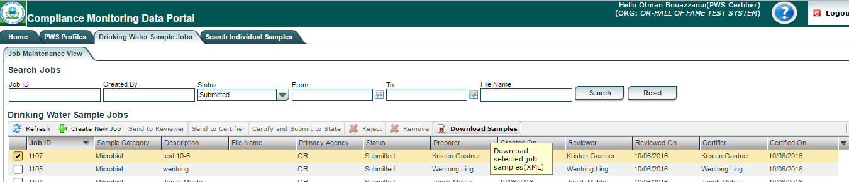
For more information on submitting jobs, please refer to the CMDP User Manual.

