1.0 Summary
The Department of Environmental Conservation (DEC) is working to update Alaska’s human health criteria (HHC) in state water quality standards (WQS). In some cases, implementation of the criteria in discharge permits or water quality monitoring programs will be complicated due to technical or administrative challenges. As a result, DEC has identified existing regulations and potential opportunities to craft new regulatory tools to help facilitate implementation of revised HHC.

2.0 HHC Criteria Components

2.1 Magnitude, Duration and Frequency
Water quality criteria include three different components - magnitude, duration, and frequency. For HHC, these components determine the procedures used to develop assessments of human health in determining water quality criteria. A more complete human health effects discussion is included in the Guidelines and Methodology Used in the Preparation of Health Effects Assessment Chapters of the Consent Decree Water Documents (45 FR 79347, 1980).
Magnitude and Duration
Water quality criteria for human health contain only a single expression of allowable magnitude; a criterion concentration generally to protect against long-term (chronic) human health effects.
Currently, national policy and prevailing opinion in the expert community establish that the duration for human health criteria for carcinogens should be derived assuming lifetime exposure, taken to be a 70-year time period. The duration of exposure assumed in deriving criteria for noncarcinogens is more complicated owing to a wide variety of endpoints: some developmental (and thus age-specific and perhaps gender-specific), some lifetime, and some, such as organoleptic effects, not duration- related at all. Thus, appropriate durations depend on the individual noncarcinogenic pollutants and the endpoints or adverse effects being considered.
Frequency
To predict or ascertain the attainment of criteria, it is necessary to specify the allowable frequency for exceeding the criteria. This is because it is statistically impossible to project that criteria will never be exceeded. Criterion-frequency is the number of times the criteria can be exceeded within a specified time period before a return to baseline conditions.
The frequency determination varies between carcinogens and non-carcinogens. For example, for carcinogens, the duration of the averaging period is 70 years (or a lifetime); and therefore, exceedances cannot be allowed as the system does not have time to return to baseline. Instead, small variations about the numeric magnitude may be allowed (so long as the average is below the magnitude) but no average exceedances are allowed. For non-carcinogens, frequency is a determination of time it takes a system to return to baseline and whether the system is more or less resistant to the toxin following that exposure. The frequency of exceedances for non-carcinogens will likely need to be determined case-by-case.
EPA recommends using the arithmetic (for skewed datasets) or geometric mean for measuring central tendencies when establishing allowable concentrations of contaminants in ambient water.

2.1.1 Treatment of magnitude, duration, and frequency in Alaska
The DEC water quality standards and 2008 Toxics Manual includes references to magnitude but not duration or frequency for HHC. DEC has recently applied a long-term arithmetic mean when establishing a duration averaging period for a non-carcinogenic pollutant (manganese) in a site-specific criteria rulemaking.

3.0 Application of HHC in the Assessment Process
The water quality assessment process relies upon the collection of water column data to measure chemical concentrations and compare those results against state WQS. There is concern that existing technological issues such as detection and quantification limits being accurate enough to measure at the proposed HHC values, laboratory variability, and sampling data found to be above detection limits but below quantification limits have the potential to add uncertainty to the assessment process.
Concerns regarding the accuracy and reliability of water column data for certain pollutants (i.e. methylmercury (MeHg) and selenium) has led EPA to recommend fish tissue data be collected when assessing concentrations rather than using water column data. Sample variability has been noted as a point of concern when conducting fish tissue sampling due to:
- Low number of samples collected and processed
- Inconsistent contaminant levels in the species sampled
- Nature of species and sample collection sites
Sample variability has the potential to lead to high uncertainty regarding the statistical analysis and results. DEC has the ability to perform both water column as well as tissue-based assessments but has yet to apply the latter for purposes other than issuing Fish Consumption Advisories.
Washington Department of Ecology (Ecology) is currently reviewing its HHC assessment protocols and considering how to incorporate multiple lines of evidence (MLE) into the decision making process. Ecology is considering assessment of all HHC using tissue exposure concentrations (TEC) and drinking water exposure concentrations (DWEC) data derived from the HHC formula.
- Tissue-only exposure pathway:
  - Non-carcinogens- (Reference dose)*(Body Weight)/Fish consumption rate= TEC
  - Carcinogen- (Risk Level)*(Body weight)/(Cancer slope factor)*(Fish consumption rate)=TEC

- Drinking water-only exposure pathway:
  - Non-carcinogen: (Reference dose)*(Body Weight)/Drinking water rate= DWEC
  - Carcinogen: (Risk Level)*(Body weight)/(Cancer slope factor)*(Drinking water rate)= DWEC
Such an approach could be used to verify that bioaccumulation in fish tissue is in fact occurring and contribute to better application of multiple lines of evidence in the water quality assessment process.

3.1 Impaired Waters/Total Maximum Daily Load (TMDL)
The process of making an Impaired Waters determination and subsequent TMDL is expected to be a fairly complicated process as certain pollutants in Alaska’s waters may be widespread (e.g., arsenic, methylmercury) The creation of numerous or statewide listings may result in a misconception by the public that Alaska’s fish are dangerous to consume. DEC does not currently have a formal listing methodology for toxic pollutants, including those pollutants with HHC.
Ecology does have a formal policy (WQP Policy 1-11) for conducting listing determinations that addresses toxics. This policy references use of both water column and fish tissue data. Ecology is currently considering amending the policy to specifically address HHC. The following table describes the data requirements with reference to the designated use of human health. Proposed revisions to the text are noted in red.
Table 1: Ecology Listing Determination Process
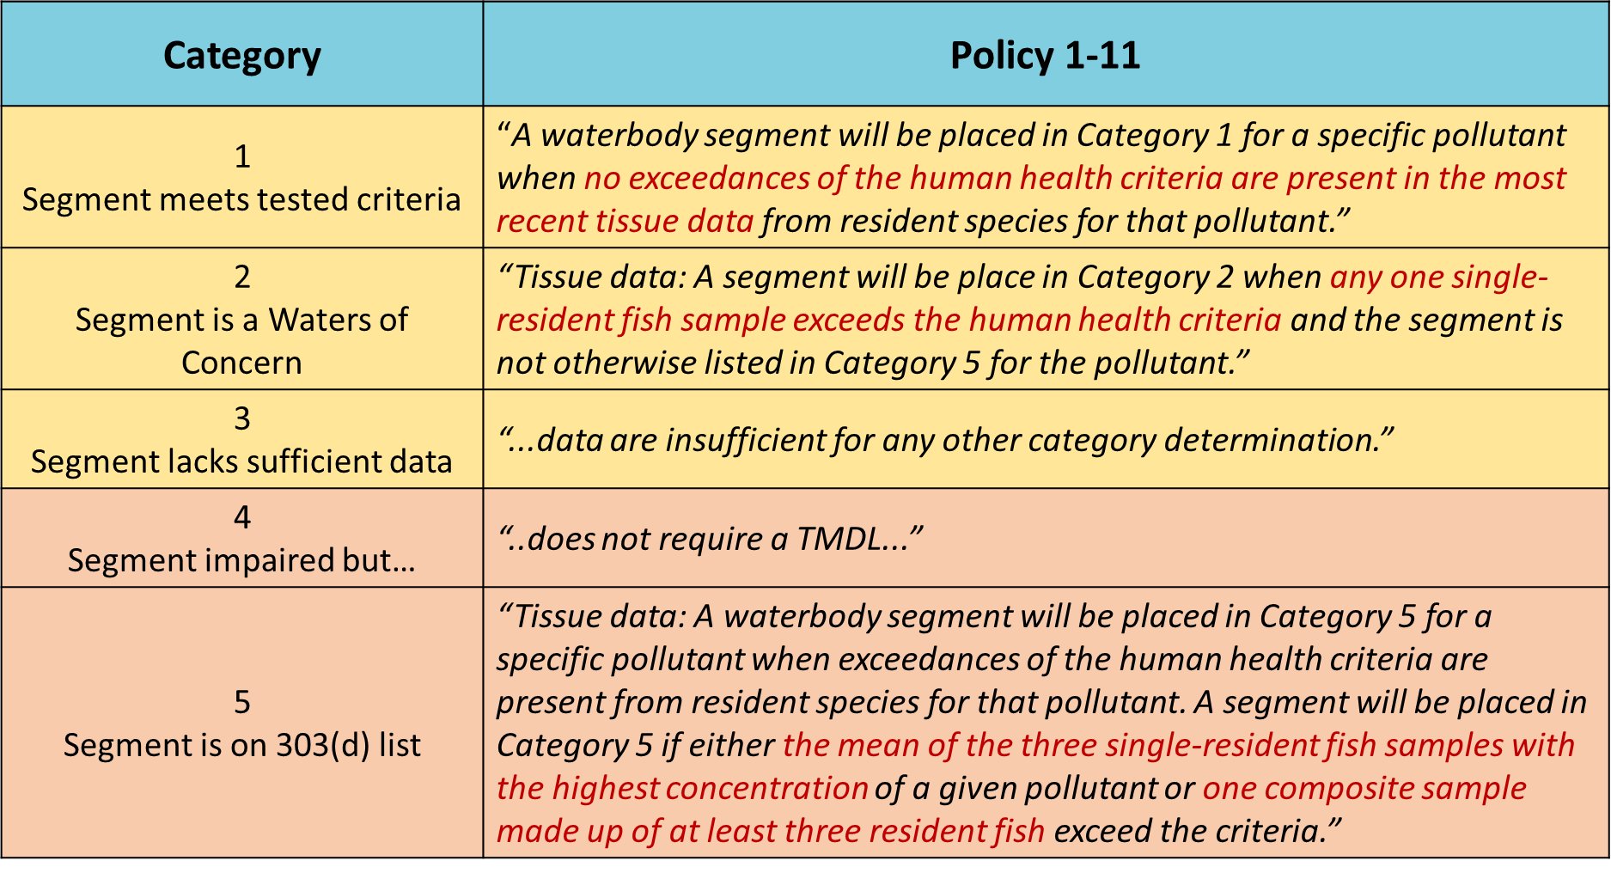
When the criterion or fish tissue-to-criterion equivalent concentration is less than the detection value, these data will not be used for assessment purposes because the detection level is not sensitive enough to ensure compliance with the criterion. Non-detect values will also be excluded from the assessment process.
Alaska sees merit in Ecology’s approach but may consider certain modifications such as limited use of single sample data and increasing the number of composite samples used in the assessment process (e.g., raising the number from one composite with three species to three composite with three species). Further discussion about the impairment determination process and how the fish tissue and a multiple-lines-of evidence approach may be incorporated will be addressed once HHC exposure values have been finalized and DEC has actual criteria to propose.

4.0 Application of HHC in the Discharge Permitting Process
The Alaska Pollutant Discharge Elimination System (APDES) wastewater discharge authorization process and permits will be affected by the HHC revision effort. DEC has yet to fully determine how criteria revisions will affect those discharges that may have HHC pollutants in their waste stream or are discharged in quantities required to monitor for those pollutants as part of their APDES discharge permit.

4.1 Reasonable Potential Analysis
In deciding whether a permit must provide a water quality based effluent limit(s) for a particular pollutant, a reasonable potential analysis (RPA) process must occur. The RPA specifically answers whether there is reasonable potential for a discharge to cause, or contribute to an exceedance of numeric or narrative water quality criteria. This process is challenging when exposure can occur over a lifetime (~70 years) and certain pollutants are known to bioaccumulate in aquatic organisms. The current RPA process looks exclusively at the quality of discharge and that of the receiving water. Fish tissue data have not previously been a part of this process. As discussed in section 4.0 there is potential for DEC to consider using TEC or DWEC concentrations when determining potential risk of exposure posed by ambient waters and the aquatic organisms that reside there.
Oregon: Reasonable Potential Analysis (RPA) and Methylmercury (MeHg)
Oregon has determined that it will use total mercury as an indicator to trigger a facility’s need to address methylmercury (MeHg) through a mercury minimization plan in-lieu of traditional concentration based effluent limits. While total mercury is easier to detect, the fraction of total mercury that is MeHg is not static over time. In 2011, EPA issued implementation guidance specific to methylmercury which it determined:

If there is not a quantifiable amount of total mercury in the discharge, “…the permitting authority may reasonably conclude that the discharge does not have reasonable potential (for MeHg) (to cause an exceedance of water quality criteria) and that no water quality based limits are necessary.”

Oregon used the EPA (2011) guidance to develop the following protocol:

Reasonable Potential Determination: Where quantifiable concentrations of total mercury are identified in a discharge, it is necessary to determine whether fish tissue concentrations of MeHg in the receiving water are close to or exceeding the human health water quality criterion. Normally, EPA recommends that state water quality programs include special permit conditions into their permits that require the permittees to conduct a fish tissue survey of the receiving waterbody along with a re-opener clause to complete the reasonable potential evaluation once the survey is complete. Recognizing the substantial costs associated with these surveys and the assumption that a majority of the state’s waters routinely exceed the water quality criterion for mercury, DEQ has chosen an alternative (although allowable per EPA Guidance) pathway and directs the following:
• Any facility contributing significant and consistent concentrations of total mercury to the receiving waterbody is considered to have the reasonable potential to exceed the water quality criterion unless a site-specific survey determines otherwise.
DEC finds that the Oregon RPA process is permissible in Alaska for methylmercury but further consideration will need to take place when considering similar approaches to other pollutants with HHC.

4.2 Permit limits
The majority of states indicate that they rely upon the USEPA 1991 Technical Support Document to develop permit limits. The guidance sets HHC equal to the average monthly effluent limitation. Other states interpret the HHC as single sample maximums with do not exceed values or as a mass-based monthly limit with a 99% compliance expectation.
Use of flow data when deriving HHC permit limits also vary among states. While the majority of states use single flow 7Q10 data to calculate chronic values, several states use 30Q3, 30 day average low flow, harmonic mean, or some percentage of average annual flow. States that use multiple flows to calculate chronic limits apply harmonic mean, 7Q10, or 30Q5 depending on whether a chemical is a carcinogen or non-carcinogen.
EPA has indicatedthat the preference is to use the annual harmonic mean for the purposes of deriving frequency and duration values for both carcinogenic and non-carcinogenic chemicals. This is consistent with EPA 2000 methodology and revisions to the methodology.
EPA has issued recommended criteria (not yet adopted by Alaska) for MeHg and selenium based on fish issue concentrations. A review of implementation data specific to methylmercury indicates that it is feasible to translate the fish tissue criterion (0.3 mg/kg) into a water column concentration through the use of a bioaccumulation (BAF) model. States are allowed to utilize EPA national BAF values in the modeling process until more appropriate BAF values using local data and/or alternative approaches are available. Developing site-specific data is one possible approach EPA recommends permitting authorities consider to help develop discharge permits in watersheds where mercury loadings from point sources are relatively high (USEPA 2009). This approach to developing permit-specific BAFs has the potential to be incredibly resource intensive as EPA openly admits that calibration and application of the models is challenging. However, development of a SSC BAF may be better than application of the national BAF since a SSC BAF may vary from national by up to two orders of magnitude.
DEC anticipates that these concerns regarding application of national BAFs and derivation of site-specific BAFs in permits extends to all of the pollutants with HHC values. Thus, DEC will need to further consider how fish tissue data will be used in the permitting and assessment process.

4.3 Permitting Tools
DEC currently has some tools at its disposal to alleviate some of the concerns regulators and permittees have regarding implementation of new HHC. EPA has expressed general support for the application of such tools when working to address ‘challenging’ issues associated with HHC rather than choosing to adopt a less stringent criterion. DEC currently implements HHC through a number of different permitting mechanisms.

4.4 Mixing Zones
DEC previously considered use of the 30Q5 (non-carcinogens) and harmonic mean flow (carcinogens) for conducting mixing zone analyses. Harmonic mean flow is a long-term mean flow value calculated by dividing the number of daily flows analyzed by the sum of the reciprocals of those daily flows (EPA 2016, Response to Comments). Dilution at the boundary should be based on average pollutant concentrations of both ambient water and proposed effluent as the actual boundary of the mixing zone is determined based on near-worst-case flow conditions (i.e. low river flow and max effluent flow). EPA’s final rule for Washington includes a requirement to use the harmonic mean flow for both carcinogens and non-carcinogens when developing associated permit limits. It is likely that EPA would not prohibit the use of the 30Q5 approach provided that the value results in a criterion at least as stringent as that calculated using the harmonic value.

4.5 Compliance Schedules
Compliance schedules are authorized at 18 AAC 70.910 and provide facilities with temporary relief for compliance purposes. See Figure 1 for a generic example of the compliance schedule process. There are certain requirements that need to be met before either the regulatory agency or facility can request a compliance schedule. An example could be, the technology has been identified and is currently available to meet water quality criteria however the facility requires additional time to employ the technology available. DEC regulations currently do not set a ‘cap’ on how long a compliance schedule may be in effect but does require at 18 AAC 70.910(b)(4):
if compliance is not achievable in one year, include a schedule for the permittee to submit regular progress reports to the department
In general, DEC issues compliance schedules for 1-5 years; however, longer compliance schedules are possible, but require significant basis for the extension passed five years. In certain cases there may also be cause to develop pollutant minimization plans to help identify and reduce specific sources of toxics with HHC. This could be achieved via best management practices if a source was isolated or specific watershed-scale actions were to take place.

Figure 1: Compliance Schedule Timeline
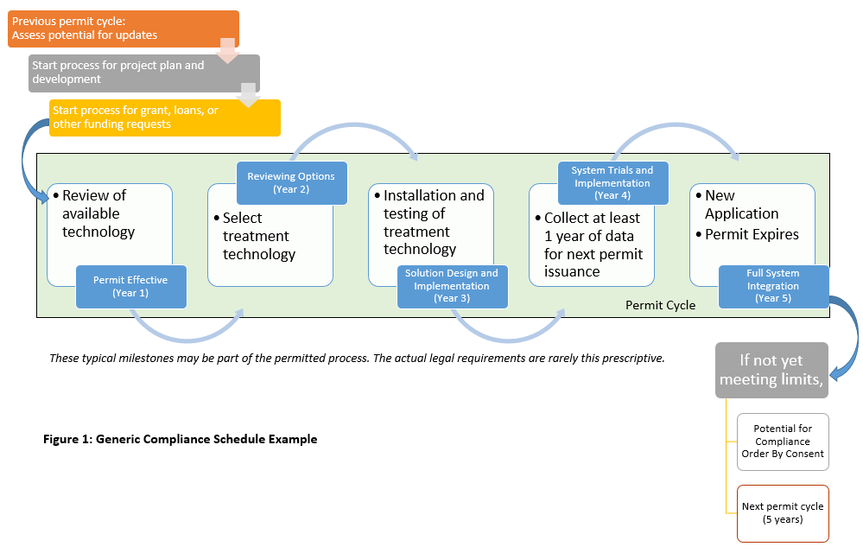

4.6 Intake Credits
Intake credits are a permitting tool that allow for a discharge limit to be calculated but do not require dischargers to treat those pollutants that may exist in the intake water that are not generated by the discharger. This tool can be used to calculate technology-based limits as well as limits based on water quality (WQBELs).
The use of intake credits is currently allowable in regulation pertaining to the APDES wastewater discharge authorization process. However, most APDES facilities discharge process water, so intake credit can’t be applied to most permits.
18 AAC 83.315: Permit application requirements for manufacturing, commercial, mining, and silvercultural facilities that discharge only non-process wastewater.
Under 18 AAC 83.315(g) Exemption:
An applicant’s duty, under (b) and (e) of this section to provide quantitative data or estimates of certain pollutants does not apply to pollutants present in a discharge solely as a result of their presence in intake water. However, an applicant shall report the presence of those pollutants. If the requirements of 18 AAC 83.545 are met, net credit may be provided for the presence of pollutants in intake water.

18 AAC 83.360: Permit application requirements for new sources and new discharges provides similar information, but again only applies to a small portion of APDES permits.
(d) The effluent characteristics requirements in 18 AAC 83.315(b), (d), and (e) that an applicant must provide estimates of certain pollutants expected to be present do not apply to pollutants present in a discharge solely as a result of their presence in intake water. However, an applicant must report that a pollutant is present. For purposes of this subsection,
(1) net credits may be provided for the presence of pollutants in intake water if the requirements of 18 AAC 83.545 are met; and
(2) except for discharge flow, temperature, and pH, all levels must be estimated as concentration and as total mass.
18 AAC 83.545 Credits for pollutants in intake water:
(a) Except as provided in (b) – (e) of this section, upon request of a discharger, the department will adjust technology based effluent limitations or standards to reflect credit for pollutants in the discharger’s intake water if
(1) the applicable effluent limitations and standards contained in
40 C.F.R. Part 401 - 40 C.F.R. Part 471, adopted by reference in 18 AAC 83.010, specifically provide that those limitations and standards must be applied on a net basis; or
(2) the discharger demonstrates that the control system it uses or proposes to use
to meet applicable technology-based limitations and standards would, if properly installed and operated, meet the limitations and standards in the absence of pollutants in the intake waters.

Precedent in Washington indicates that application of intake credits is not considered a water quality standards action, therefore not reviewable under the CWA.

4.7 New Tools: Pollutant Minimization Plan
Use of a Pollutant Minimization Plan (PMP) has recommended by EPA as part of the 2009 Methylmercury implementation guidance and applied in Oregon as a fundamental requirement of the permitting process for MeHg. As a condition of the permit, a PMP is a plan that provides specific details on practices that originate with and are under reasonable control of the facility, and not on the pollutants in the rainwater or source water. Plans are designed to result in:
- Reduction or elimination of potential sources of MeHg and total mercury within the production process or collection area
- Improved public and business awareness of mercury issues
- Reduction in the transfer of mercury from effluent to the watershed or airshed via biosolids
- Quantification of the effectiveness of the PMP to eliminate or reduce mercury in the discharge
At a minimum, the PMP should include:
- Identification and evaluation of current and potential mercury (both MeHg and total) sources;
- Identification and evaluation of conditions (i.e. anaerobic conditions) that contribute to the methylation of elemental mercury in the collection and treatment systems;
- For publicly owned treatment works (POTW), identification of both large industrial sources and other commercial or residential sources that could contribute significant mercury loads to the POTW;
- If applicable, monitoring to confirm current or potential sources of mercury (Monitoring Plan);
- Identification of potential methods for reducing or eliminating mercury, including requiring BMPs or assigning limits to potential industrial and commercial sources of mercury to a collection system, material substitution, material recovery, spill control and collection, waste recycling, process modifications, housekeeping and laboratory use and disposal practices, and public education (Action Plan);
- Identification of potential methods for reducing or eliminating conditions that contribute to the methylation of elemental mercury (Action Plan);
Actions Plans may include trigger levels, reduction goals, or enforceable numeric level (e.g., existing effluent quality) to ensure discharges remain within permitted limits. Plans are required to monitor using EPA-approved methods with enough sensitivity to ensure compliance and implementation with the plan. Plans may also include a re-opener clause to modify permit conditions should the plan not prove to be effective or if a water column translation of the fish tissue criterion is developed.

Use of PMPs may be very useful for implementation of other pollutants with HHC that are considered to be legacy in nature (e.g., certain pesticides, PCBs) and/or contain limits that pose technological challenges. Rather than relying upon standard treatment practices, which may or may not be scientifically/economically practicable for the treatment of these challenging pollutants, PMPs provide a means towards reducing the presence of these pollutants while continuing to allow a facility to operate. This also alleviates the need to modify water quality standards either on a temporary (i.e., variance) or permanent basis (i.e., reclassification).

5.0 Regulatory Exceptions for Specific Waters

5.1 Natural Conditions
EPA guidance states,
For human uses, where the natural background concentration is documented, this new information should result in, at a minimum, a re-evaluation of the human health use designation. (USEPA 1997).
EPA has since clarified that demonstrating a water quality condition is natural does not provide the necessary information needed to demonstrate that the criteria is protective of the designated use of human health. The result is that an applicant would need to follow the site-specific criteria protocols rather than apply natural conditions via a permit when a pollutant with HHC is concerned. Application of the revised criterion constitutes a water quality standards change and must be approved of by the EPA prior to application in state water pollution control programs (e.g., permits, assessment/ monitoring).

5.2 Waterbody Reclassification
Reclassification or modification of a designated use is allowable under 18 AAC 70.230. Such an action is considered to be a WQS change and must be approved by EPA before application in state water pollution control programs. Reclassification requests must include a Use Attainability Analysis (UAA) if a use is specified under 101(a)(2) of the Clean Water Act- typically referred to as the fishable-swimmable uses. Removal of the designated use is not allowable if it is an existing use. However, the designated and existing use can be modified to reflect a sub-category which demonstrates the highest attainable use if the designated use is not attainable due to:
- Naturally occurring pollutant concentrations;
- Flow conditions do not allow for attainment;
- Human-caused conditions or sources of pollution prevent attainment of the use and cannot be remedied or would cause more environmental damage to correct than to leave in place;
- Dams, diversions, or other types of hydrologic modifications prevent attainment;
- Physical conditions related to the natural features of the waterbody preclude attainment of aquatic life protection uses; or
- Controls more stringent than those required by sections 301(b) and 306 of the CWA would result in widespread economic and social impact.
For the purposes of addressing challenging HHC (e.g. methylmercury) on a waterbody scale, a reclassification proposal may be a feasible option under condition 6 (economic and social impact) with reference to condition 3 (cannot be remedied). Application of this tool on a regional scale (i.e., coastal waters) but has yet to be implemented by DEC.

5.3 Site-Specific Criteria (SSC)
DEC has the authority to recalculate a HHC based on site specific exposure values. Such a recalculation is considered to be a water quality standard change and must be approved by EPA prior to application in state water pollution control programs. The establishment of a SSC based on local fish consumption may be challenging in light of data requirements and EPA policy interpretation that fish consumption represents consumption from a variety of sources/waters.

5.4 New Tools: Water Quality Standard Variances
WQS variances are a tool available to states in the federal WQS regulations. States and EPA regions are putting them into practice with different degrees of success. DEC is currently in the process of developing variance procedures in state water quality standards. Alaska WQS currently include short-term variances for CWA section 404 (dredge and fill) allowable actions, but these types of variances do not apply to wastewater discharge permits and are quite different from federal WQS variances.
A WQS variance is a time-limited modification of a designated use and criterion as defined in 40 CFR 131.1. A WQS variance defines the ‘highest attainable use’ and associated criterion. WQS variances can apply to individual discharges, multiple discharges, or for specified surface waters (e.g., reach of a river, lake, estuary, etc.).
WQS variances may be applicable when it has been determined that:
- A discharge has the potential to meet a permit limit or waterbody meet the designed use and criterion but additional time is needed than identified in a compliance schedule; or
- It is not known whether it is feasible for a discharge to meet a permit limit due to technology limitations; or
- It is not known whether a waterbody will ever meet a designated use and/or criterion.
EPA has placed a five-year limit on WQS variances in federal rule. Dischargers may apply for renewal provided that the need continues to exist and dischargers are able to demonstrate efforts to facilitate compliance with the original use and criterion.
WQS variances have been identified by EPA as well as Pacific Northwest states as a means of implementing challenging HHC. However, the amount of documentation to actually develop an EPA-approvable WQS variance may be substantial and resource intensive to an individual discharger, multiple dischargers, or a waterbody or even to the state. WQS variances would be required to meet one of the six criteria required during the Use Attainability Analysis process. EPA approval is required prior to application in water pollution control programs. Such a review may also require involvement of other federal agencies per the NEPA process. While DEC acknowledges the utility of WQS variances in dealing with certain pollutants, development is likely to be no less of an arduous process than the development of a use reclassification or site-specific criterion from a business practice perspective.

6.0 Reconciling HHC with Fish Consumption Advisories
The fish consumption advisories issued by the Alaska Department of Health and Human Services (DHSS) are response-based tools based on a risk-benefit analysis. Such analysis considers the degree of risk of exposure to contaminants when consuming fish, but also the documented health benefits when consuming fish. DHSS offers advice to the public on how to make informed decisions that take into account the actual contamination levels measured in Alaska fish and the different contaminant specific risks, mainly from mercury. This means the DHSS advice can be different for vulnerable populations (e.g. childbearing and nursing women) than the general population. Due to the health benefits however, DHSS also promotes fish consumption up to levels considered “safe”, which for many fish is unlimited consumption.
HHC on the other hand, are intended to be preventative tools aimed at keeping pollution out of the fish in the first place, so that unlimited consumption by the target population can take place. As a preventative measure, HHC will be set at a lower concentration than the DHSS fish advisories. The lower HHC is driven by the safety factors introduced in the HHC to keep contamination levels well below the “no observable effect level” to prevent even the potential for adverse effects in the most vulnerable populations. Communicating what is “safe” for consumption when you have conflicting programmatic goals is anticipated to be a challenge to DEC.

7.0 Cost of Implementation
House Bill 140 requires state agencies to approximate regulatory costs to the state when rulemaking is proposed. However, DEC is not required to conduct a formal cost-benefit analysis of the effects of a rulemaking on the regulated public. That said, DEC did review certain documentation available as part of the Washington rulemaking process and is including key points for workgroup consideration.
At this time DEC anticipates that the administrative costs to DEC will be equal to that currently incurred. This is based on the fact that adoption and implementation of the new HHC will be at least as stringent for the majority of pollutants for which revised criteria are proposed.

7.1 Potential Benefits
Given the purpose for which HHC are being proposed (protection of human health), DEC assumes that the probable benefits are improvements to the health of the general public and subsequent reduction in healthcare costs. With that said however, actual calculation of said benefits may be extremely hard to measure due to the limited epidemiological data given the low incidence of documented pollutant exposures in Alaska. In fact, the actual benefits may be hypothetical rather than tangible due to the duration and frequency values for HHC (see section 2).

7.2 Potential Costs
DEC currently anticipates the following costs to be incurred by industries and municipalities:
- Cost to existing industrial and municipal dischargers to apply updated sampling and testing practices
- Cost to new industrial and municipal facilities and those who now meet reasonable potential analysis requirements to implement new treatment practices to meet revised permit limits.
  - Cost of compliance actions if a facility chooses to continue operations rather than curtailing them
- Cost to those in-water projects seeking Section 401 Certification should DEC determine that BMPs do not sufficiently control sources of pollutants with HHC
- Cost to those liable parties who are conducting soil and/or groundwater cleanup

Over time it is anticipated that technology advances in the measurement and treatment of pollutants will ultimately reduce costs and implementation uncertainty for the new HHC.

8.0 Conclusion
Implementation of revised HHC derived from state specific information will require the use of a mixture of existing and new permitting and WQS tools and practices. DEC anticipates that different facilities (or industrial sectors) are going to require assistance at different times due to the fact that revised HHC are implemented only at the time of the next permit renewal. For some operations the appropriate implementation steps may be obvious while less so for others.
The TWG discussions to date have primarily focused on the technical and scientific policy issues associated with deriving revised HHC. It is anticipated that implementation will be challenging as dischargers and management of waters. Since the vast majority of the pollutants with HHC are neither manufactured nor released in Alaska, a select group of pollutants are likely to require the greatest amount of attention. It is expected that tools like WQS variances may be perceived as stalling tactics to certain individuals who question DEC’s ability to ensure the protection of designated uses. Communities that face utility cost increases will question the necessity of such technology as well as the pricing practices. Those parties conducting water quality assessments rely upon DEC to provide clear, concise guidance on how best to apply the new criteria; much of which has yet to be developed.

Appendix

Challenging Chemicals present in Alaskan Permits.

Arsenic
In 1998 EPA approved Alaska’s determination that Safe Drinking Water Act Maximum Contaminant Levels (MCL) for arsenic is the appropriate criterion to apply for the protection of human health in WQS.
Washington and Idaho attempted a similar approach as part of their 2016 rulemakings but were disapprove by EPA based the fact that MCLs do not factor in routes of exposure other than drinking water and that MCLs take technology and cost into consideration while water quality standards do not. EPA directed Washington to apply the National Toxics Rule criterion while reevaluate toxicity values noted in the EPA Integrated Risk Information System (IRIS). A new criterion for arsenic may be forthcoming as a result of this review.

Cyanide
Adoption of revised HHC for cyanide is anticipated to be challenging due to technological issues associated with monitoring for cyanide at such low levels. DEC has not identified a specific means of addressing this issue although consideration of a variance may be in order once DEC has adopted the authority to administer them.

Methylmercury
Adoption of methylmercury (MeHg) criteria is anticipated to be one of the more challenging chemicals as the criterion is fish tissue instead of water column based. DEC has identified several tools that may be useful in the implementation of MeHg including application of PMPs in the permitting process and use of variances. Issues associated with development of a site-specific BAF is located at Section 5.2

Polychlorinated Biphenyls (PCBs)
PCBs are legacy pollutants that continue to exist although not currently generated by industry in Alaska. PCBs bioaccumulate in species that may reside in waters outside of Alaska for extended periods of time and are difficult to monitor at very low levels. Studies of aquatic life in remote Alaskan locations indicate PCBs to occur in significant concentrations. Adoption of a high fish consumption rate further exasperates this issue as people may be given the impression that the presence of PCBs in aquatic life is higher and more dangerous than actually may be to humans. While Alaska has the ability to utilize existing resources like the fish tissue monitoring and fish consumption guidelines, this does not alleviate the fact that suggesting Alaska’s waters are impaired for PCBs has the potential to negatively affect a multi-million dollar fishery and the lives of thousands of residents. Implementation tools applicable to implementation of MeHg criteria may also be appropriate for addressing PCBs.

Persistent Organic Pollutants (POPs)
The presence of POPs has been noted in subsistence foods as well as discharges in Alaska. The majority of these pollutants have been outlawed due to concerns regarding human and wildlife health. Studies of aquatic life in remote parts of Alaska have indicated that several historic compounds chemicals are observed in concentrations higher than other remote locations in Pacific Northwest.
Table x. Permitted pollutants with HHC implementation issues
Chemical with HHC- proposed method detection limit (MDL) not technically achievable. | Chemical with HHC- Unknown if present/MDL?
Aldrin (insecticide) | Alpha-BHC* (insecticide)
Benzidine* (Used in production of dyes) | Beta BHC* (insecticide)
Chlordane* (insecticide) | Bis (Chloromethyl) Ether (Chemical manufacture)
Dibenzo(a,h)Anthracene* (byproduct of hydrocarbon burning) | Bis (2-Chloro-1-Methlyethyl) Ether (pesticide, manufacture of dyes, solvent)
Dieldrin* (insecticide) | Hexachlorocyclohexane, Technical* (pesticide)
Hexachlorobenzene* (fungicide) | Pentachlorobenzene (pesticide, byproduct of hydrocarbon burning)
Toxaphene (insecticide) | 1,2,4,5 Tetrachlorobenzene (herbicide, insecticide)
4,4 DDD (pesticide) | 2,4 Dichlorophenol (herbicide)
4,4 DDT (pesticide) | 2,4,5 Trichlorophenol (fungicide, herbicide, pesticide)
Orange indicates bioaccumulation or bioconcentration factor > 5,000
* Carcinogen

EPA Water Quality Standards Handbook Chapter 3.
EPA Comments on Idaho’s Proposed HHC. November 6, 2015.
Method used should be sufficiently sensitive with a minimum Quantitation Level of 0.005 μg/l (5 ng/l) for total mercury (for example Methods 1631 E or 245.7). At the time that this directive was issued, DEQ is in the process of evaluating the regional availability of analytical methods and their readily achievable performance levels. This process is expected to be completed by the end of 2013 and may result in a further reduction of the QL for total mercury to a level around 0.0005 μg/l (0.5 ng/l).
EPA’s Guidance for Implementing the January 2011 Methyl-Mercury Water Quality Criterion, page 95.
Oregon characterizes this as concentrations with results greater than the Quantification Level of the method. Permit writers are encouraged to use a minimum of four (4) sample results to determine presence/absence and take seasonal variations into consideration.
USEPA. 1991 Technical Support Document for Water Quality-based Toxics Control. EPA-505-2-90-001. Office of Water. U.S. Environmental Protection Agency, Washington D.C.
EPA Comments on Idaho’s Proposed HHC. November 6, 2015
Revisions to the Methodology for Deriving Ambient Water Quality Criteria for the Protection of Human Health. 2000. (https://www.gpo.gov/fdsys/pkg/FR-2000-11-03/pdf/00-27924.pdf)
EPA. 2010. Guidance for Implementing the January 2001 Methylmercury Water Quality Criterion. EPA 823-R-10-001. U.S. Environmental Protection Agency, Office of Water, Washington, DC.
Pritz et al. 2014. Contaminates of Emerging Concern in Fish from Western U.S. and Alaskan National Parks- Spatial Distribution and Health Thresholds. Journal of American Water Resources Association. Vol 50, No.2

