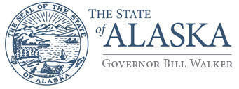

Department of Environmental Conservation

DIVISION OF WATER
Water Quality Standards

410 Willoughby Ave, Suite 303
Juneau, Alaska 99811-1800
Main: 907.465.5185
Fax: 907.465.5274
www.dec.alaska.gov

DEVELOPMENT OF HUMAN HEALTH CRITERIA IN WATER QUALITY STANDARDS

Public Workshop

The Alaska Department of Environmental Conversation (DEC) will host a public workshop on proposed revisions to human health criteria in state water quality standards. The goal of the workshop is to inform Alaska Pollutant Discharge Elimination System permit holders and applicants and the interested public regarding the role of human health criteria in water quality standards (18 AAC 70), how human health criteria are derived, and how revisions to the criteria may be implemented in Alaska’s regulatory programs and practices.

The workshop will be technical in nature. Interested parties should have a basic understanding of the federal Clean Water Act and the role of water quality standards in environmental regulation.

This workshop is informational only and no regulations are being proposed at this time.

Limited space is available. REGISTRATION IS REQUIRED.

When?
October 29 & 30, 2015

Where?
Alaska Center for the Performing Arts
Voth Hall
621 West 6th Ave
Anchorage

Registration and Information:
For registration and additional information see:
http://dec.alaska.gov/water/FCWQS/index.html

Staff Contact
Brock Tabor: (907) 465-5185 or email brock.tabor@alaska.gov

