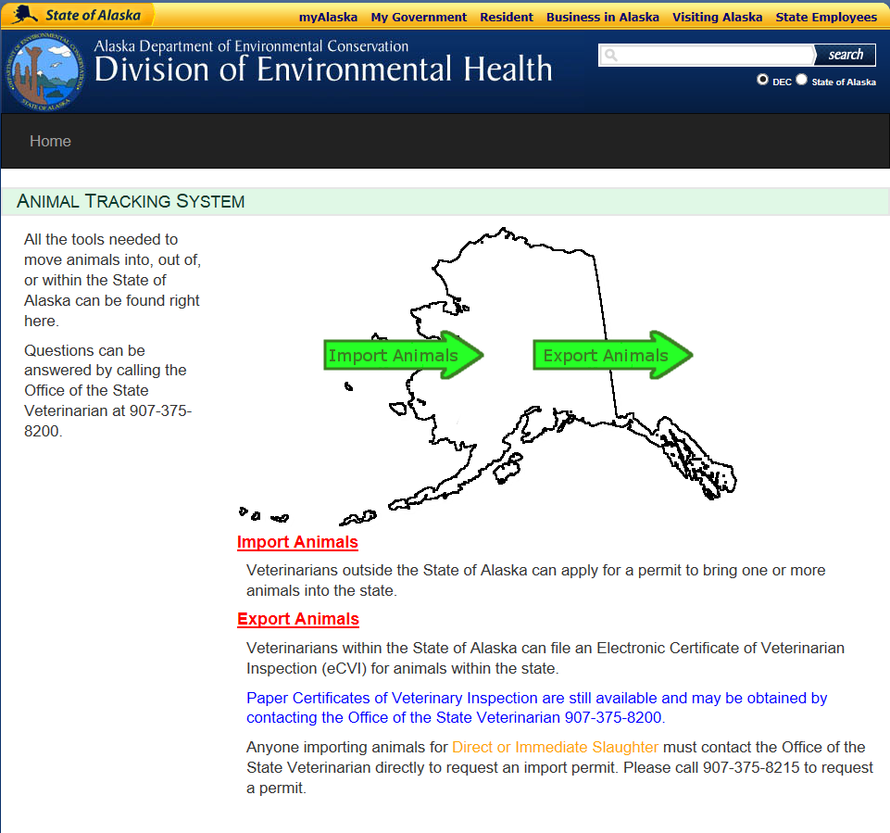

* Click red Import Animals link

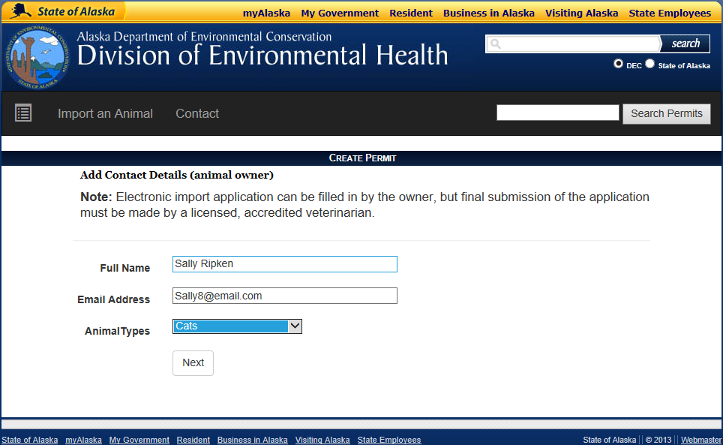

* Fill out owner information
* Click drop-down box to select animal type

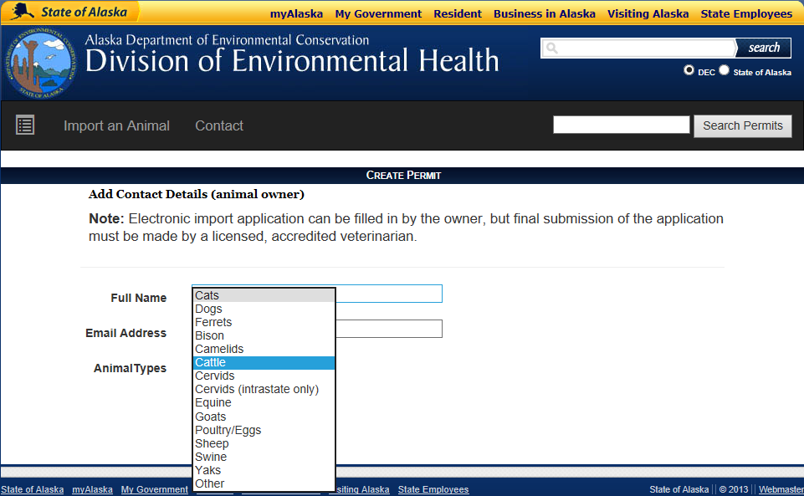

* Select animal type from drop down menu
* Click Next

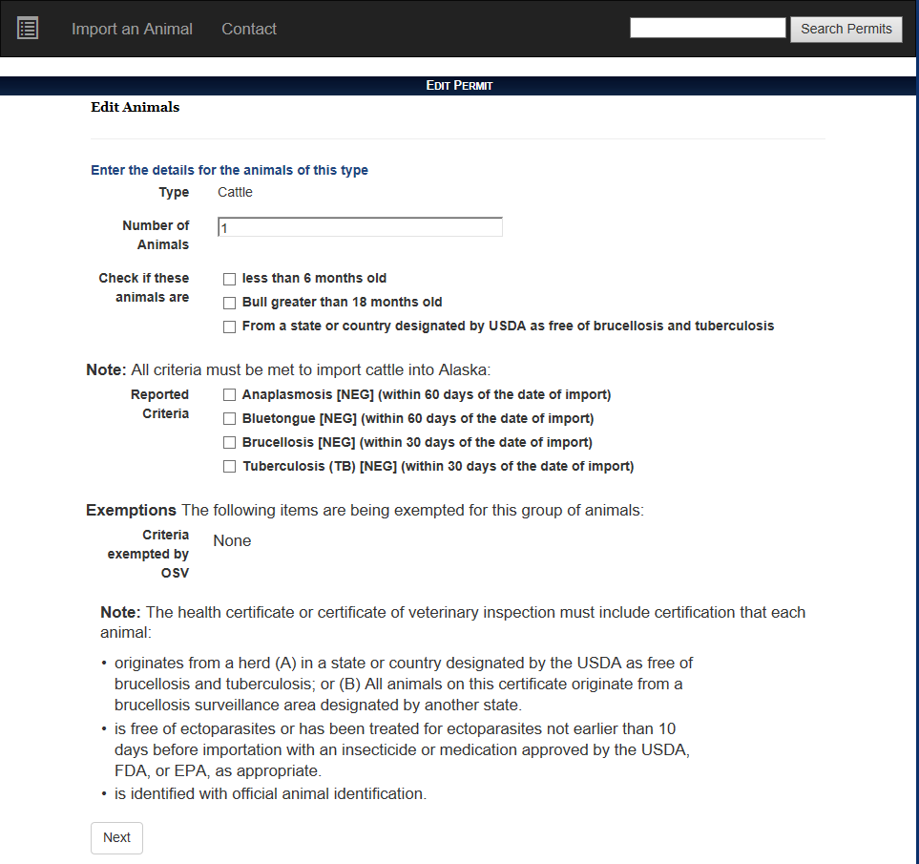

* Check Alaska’s import requirements at <http://dec.alaska.gov/eh/vet>
* Enter number of animals
* Click/Check any applicable boxes for age, TB, or brucellosis status (if a mixed shipment, each subset will need a separate certificate)
* Confirm that all criteria are met
* Make note of statements that must be recorded on Certificate of Veterinary Inspection (CVI)
* Click Next

CVI Statements

* Examples:

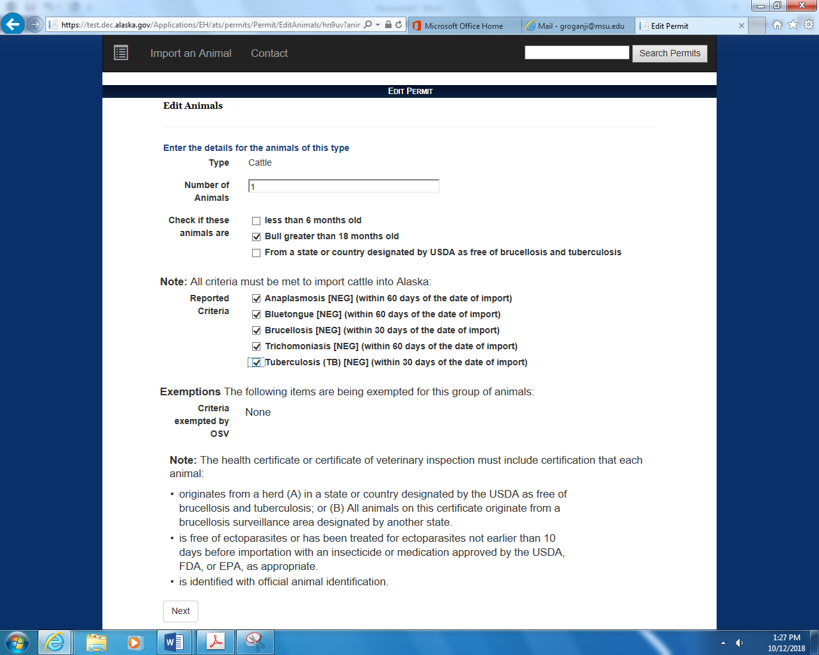 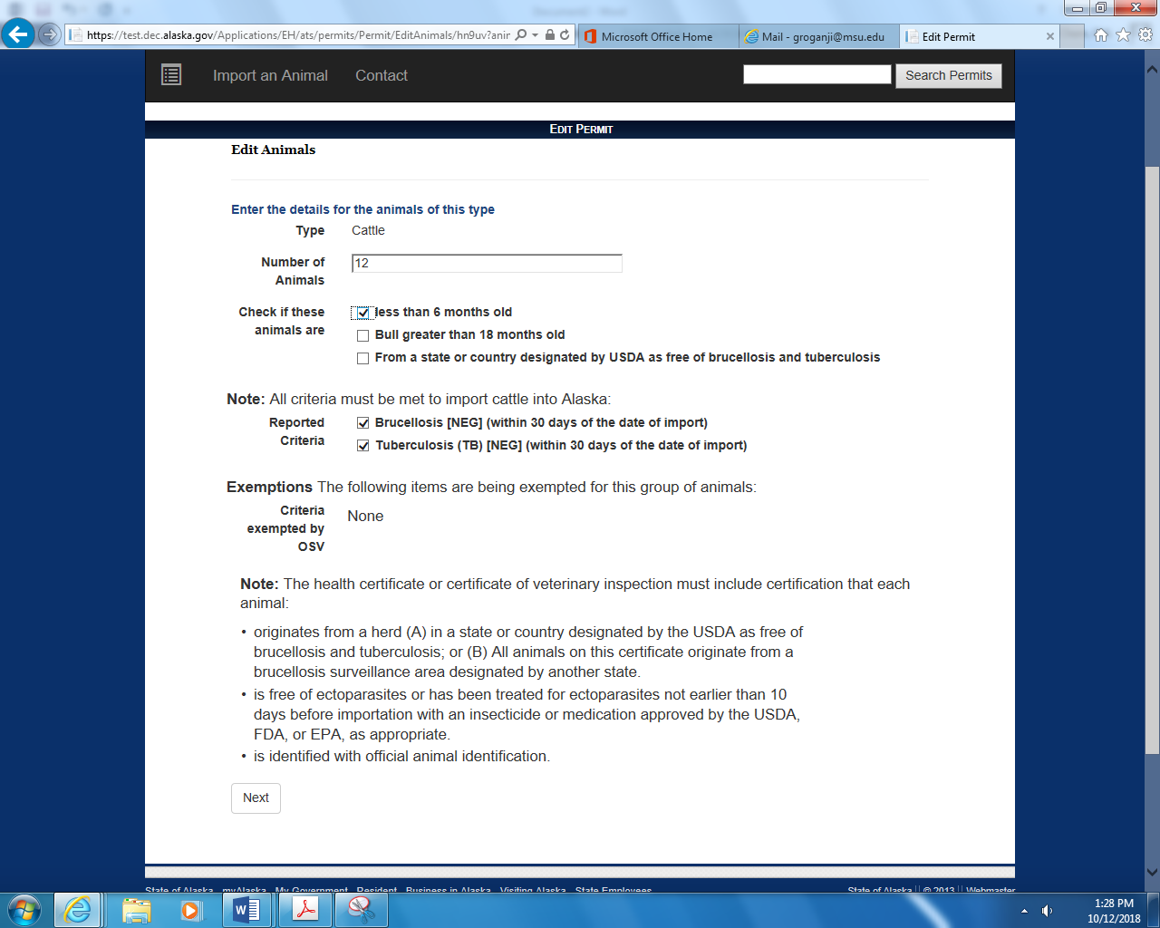

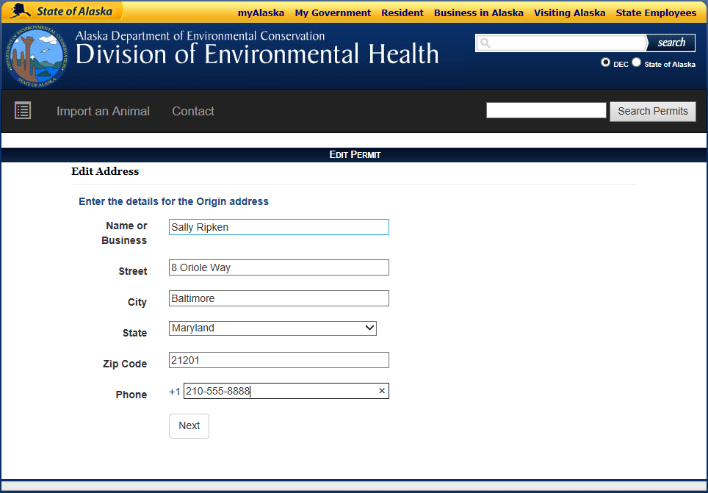

* Enter contact information for the person in the state of origin who is financially responsible for the animals
* Click Next

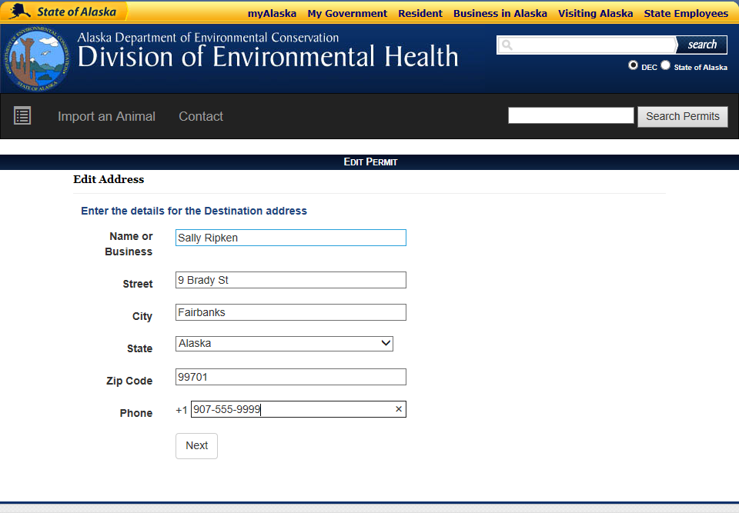

* Enter contact information for person in AK who will be financially responsible for the animals
* Click Next

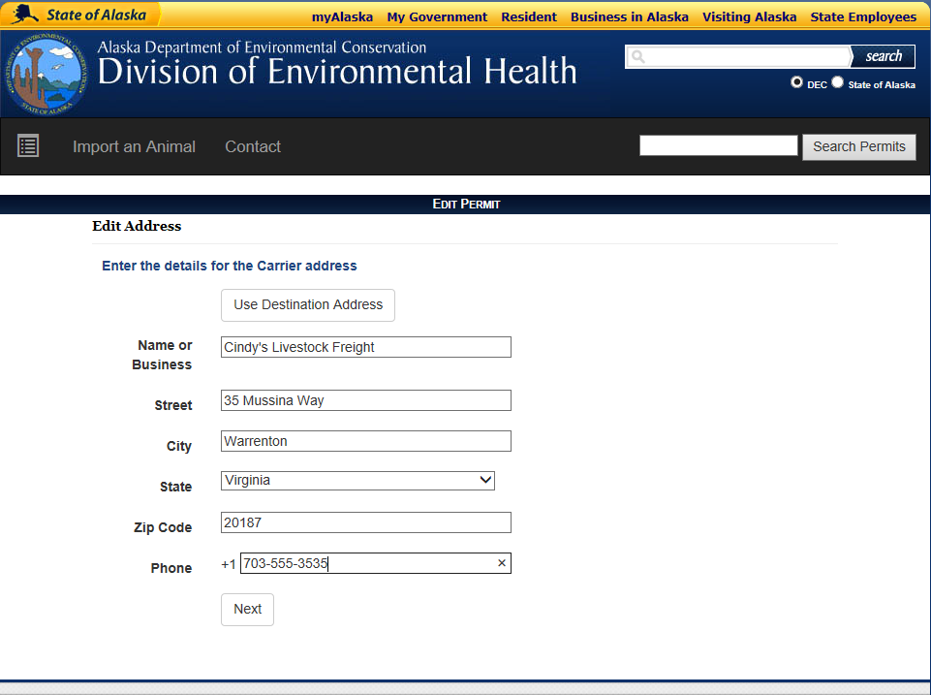

* If a private carrier or transporter is being used to move the animals, enter the contact information for this person
* If Alaskan owner of the animals is transporting the pet, enter their information or click Use Destination Address
* Click Next

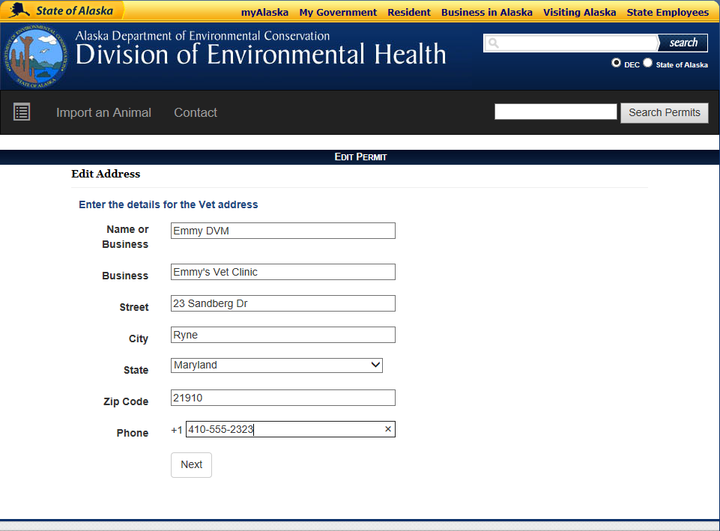

* Enter the contact information for the veterinarian who will be examining the animals and filling out the health papers for this shipment
* The owner may fill out all the sections of the import permit up to this point. The final sections are filled out by the accredited veterinarian who will be examining the animals for the shipment.
* Click Next

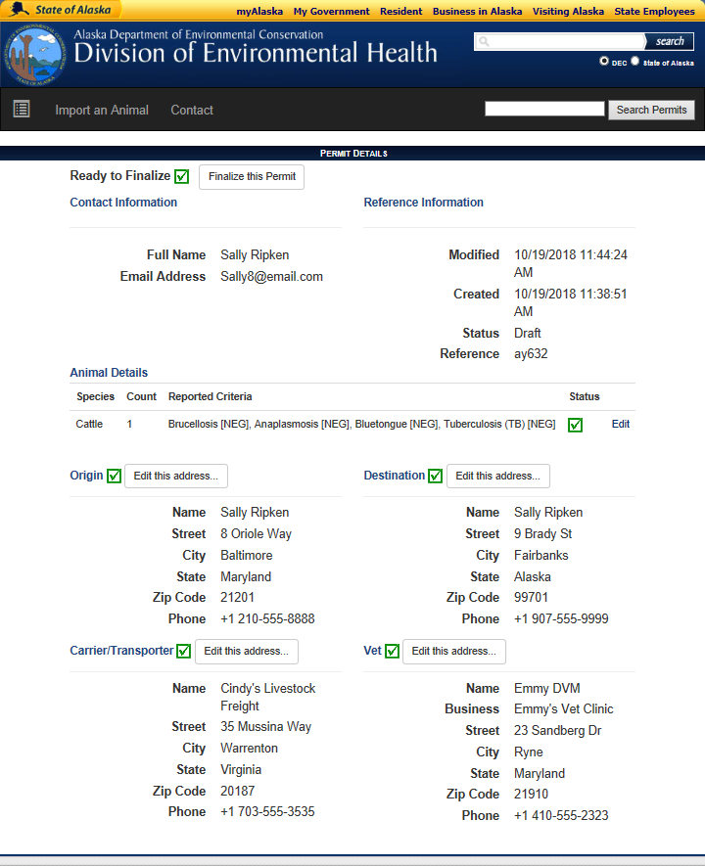

* Confirm details are complete and accurate
* Click Finalize the Permit

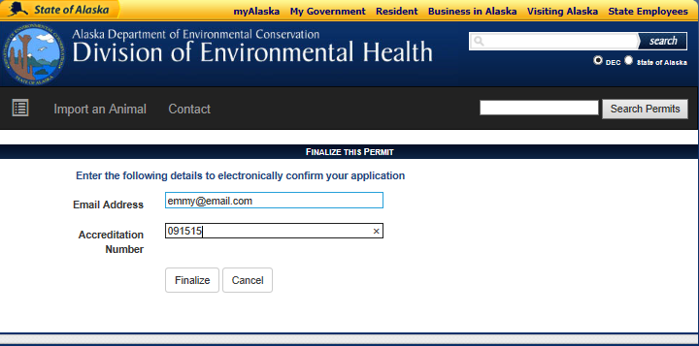

* Enter veterinarian or clinic email address
* Enter veterinarian USDA Accreditation Number (6 digits). If animals originating from a foreign country (Canada) use the accreditation number issued by the country of origin.

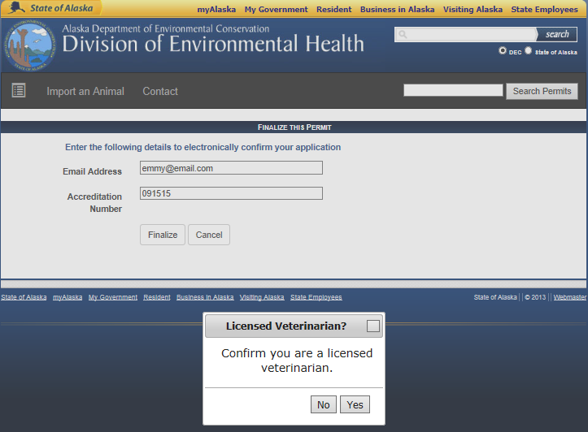

* Click Yes to confirm that you are a licensed veterinarian

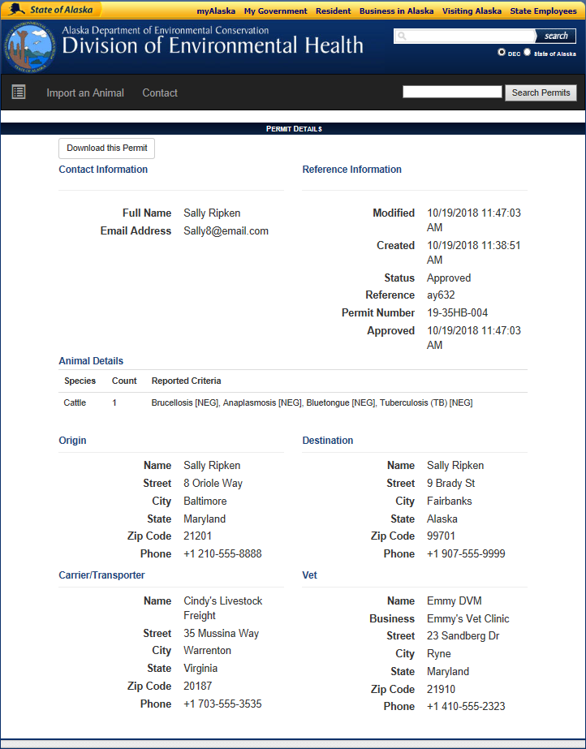

* A PDF of the permit will be generated. Print the certificate and give to client.
* Client should have this permit and CVI/Health Certificate with them during travel
* Click Download this Permit
* An Open or Save option may appear. Save this file

Print and give to client for transport

