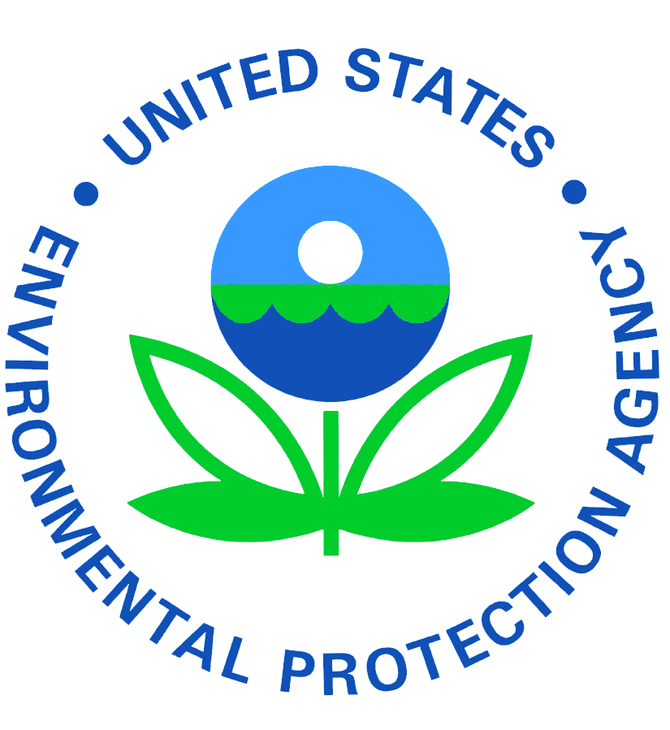

**SMALL-BIZ @EPA**

**A MONTHLY NEWSLETTER FOR THE**

**SMALL BUSINESS COMMUNITY**

**DECEMBER 2019**

**Environmental Compliance Assistance Programs**

**SmallBiz@EPA Bulletin Welcomes your Submissions**

**Topics:**

* **Upcoming Events**
* **Success Stories**
* **New Assistance Tools**
* **Technical Updates**
* **Regulatory Updates**
* **Stories to Reach the Small Business Community**
* **Updated Contact Info.**

**Submission Guidelines**

* **150 words or less**
* **A suggested title**
* **Include a link to more information on the topic**
* **Always include a contact name and phone number or email**
* **Articles should be submitted by the 15th of each month.**

**The EPA Asbestos and Small Business Ombudsman (ASBO) Program serves as an advocate and liaison for small businesses in the rule development and compliance assistance process at EPA. ASBO regularly partners with a variety of stakeholders to address small business questions and concerns, including; the state Small Business Ombudsmen and Small Business Environmental Assistance Programs (SBEAPs), small business trade associations, headquarters and regional EPA programs offices, as well as federal agencies like the Small Business Administration.  These partnerships provide the perspective and collaboration EPA requires to support small businesses in achieving their environmental performance goals. The SmallBiz@EPA Bulletin strives to provide EPA and the small business community access to the necessary environmental news, regulatory updates and resources that may impact or assist small businesses. Please send us your updates!**



**Improving Accessibility**

**Fostering Partnerships**

**DO YOU HAVE ARTICLES FOR THE SMALLBIZ@EPA NEWSLETTER?**

**FORWARD TO:**

**SHEILA SHEPHERD AT: SHEPHERD.SHEILA@EPA.GOV**

**OR**

**ELNORA THOMPSON AT: THOMPSON.ELNORA@EPA.GOV**

# **EPA Fall 2019 Unified Agenda and Regulatory Plan Underscores Commitment to Strong Environmental Protection and Regulatory Reform**

The U.S. Environmental Protection Agency (EPA), along with the rest of the federal government, released the Fall 2019 Unified Agenda of Regulatory and Deregulatory Actions and Regulatory Plan (Fall Regulatory Agenda and Annual Regulatory Plan), which provides updates to the public about regulatory activity.

“EPA’s Fall Regulatory Agenda and Annual Regulatory Plan continue to advance the agency’s core mission of protecting human health and the environment through regulatory reform and modernization,” **said EPA Administrator Andrew Wheeler.** “Under President Trump, EPA has finalized 47 deregulatory actions, saving Americans nearly $5 billion in regulatory costs. By creating a climate of regulatory certainty, we’re able to breathe new life into local economies around the country.”

EPA’s Fall Regulatory Agenda includes information on the agency’s regulatory and deregulatory activities under development within the next 12 months. The Agenda includes 56 actions that are expected to be deregulatory and 37 actions appearing for the first time.

The Annual Regulatory Plan includes EPA’s statement of regulatory priorities and additional information about 34 priority actions that the agency plans to propose or complete in the coming year. Among those are multiple actions focused on emerging contaminants, including Per- and Polyfluoroalkyl Substances (PFAS). Other priority actions include the following:

* Revised Definition of “Waters of the United States” (Step 2);
* Oil and Gas NSPS Reconsideration; and
* Updating Regulations on Water Quality Certification.

To access EPA’s Fall 2019 Unified Agenda of Regulatory and Deregulatory Actions and Regulatory Plan <https://www.reginfo.gov/public/do/eAgendaMain>.

For more information about regulatory reform at EPA:  
[https://www.epa.gov/laws-regulations/epa-deregulatory-actions](https://usenvironmentalprotectionagency.cmail20.com/t/d-l-xdtdjdy-yukulttkit-y/)

**EPA Wraps Historic Recycling Innovation Fair**

The U.S. Environmental Protection Agency (EPA), hosted the first-ever America Recycles Innovation Fair on November 14, 2019, featuring entrepreneurs from across the recycling system showcasing their innovative products, services, outreach, and technologies. At the fair, EPA Administrator Andrew Wheeler, the National Waste and Recycling Association (NWRA) President Darrell Smith and NWRA Board Chair Ben Harvey presented challenge coins to veterans recognizing their service to the environment. During the Innovation Fair, youth leaders from One More Generation spoke about their campaign to reduce plastic straws.

The innovation fair was hosted by EPA in partnership with the Institute for Scrap Recycling Industries, Keep America Beautiful, the Solid Waste Association of North America, and The Recycling Partnership. EPA is collaborating with stakeholders from across the recycling system to identify specific actions to address the challenges and opportunities facing the U.S. recycling system. These organizations are committed to leveraging their collective expertise, strengths, and resources to address these challenges and opportunities.

EPA will also convene the second America Recycles Day Summit by bringing together organizations from across the recycling system and all levels of government to build on their success over the last year and commit to continuing to work together. Participants will include the original forty-five organizations that signed the [America Recycles Pledge](https://usenvironmentalprotectionagency.cmail19.com/t/d-l-xdrkuz-yukulttkit-r/) on America Recycles Day 2018, along with the over 120 additional organizations that signed the pledge in 2019. Pledge signers represent all aspects of the U.S. recycling system, including representatives from government, the recycling industry, non-profits, corporations and brands, and industry trade associations. Participants will hear from America Recycles workgroup members on progress made to date, have an opportunity to provide input on future actions, and join the America Recycles effort moving forward.

Learn more about EPA’s ongoing America Recycles work at [www.epa.gov/AmericaRecycles](http://www.epa.gov/AmericaRecycles).

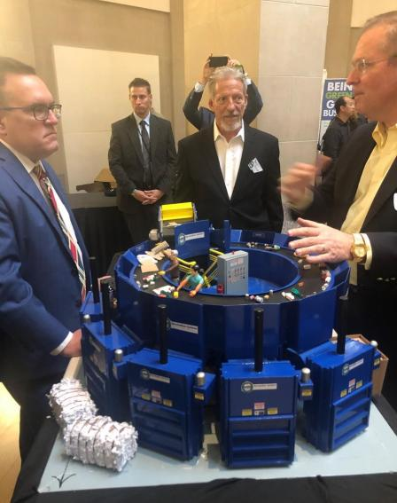

Administrator Wheeler tours booths at the America Recycles Innovation Fair.

**Kansas Launches Online Data Management Tool**

The Kansas Department of Health and Environment, or KDHE, has recently launched its new online data management system, the Kansas Environmental Information Management System, or [KEIMS](http://www.kdheks.gov/bar/keims-BOA.html). The system shares site information and increases the ease of business between various KDHE regulatory programs and the regulated community. Multiple databases under the KDHE Division of Environment are combined to create efficiency that will benefit both state employees and the public. The system is also CROMERR compatible.

Beginning Jan. 1, 2020, the KDHE Bureau of Air will fully implement this tool to allow sources to submit their permit applications online; review inspections reports; and submit compliance reports, performance stack-testing results and other important continuance compliance documents required by permits and regulations.

For more information, contact the [Kansas Small Business Environmental Assistance Program](mailto:lladd@ksu.edu).

**EPA Awards $1.8 Million to Cut Marine Diesel Emissions in New York**

The U.S. Environmental Protection Agency has awarded a $1,832,567 Diesel Emissions Reduction Act (DERA) grant to the Connecticut Maritime Foundation, Inc. to curb harmful pollution from ferries in the greater New York and New Jersey area.

EPA’s funding to the Connecticut Maritime Foundation will replace six marine diesel engines on a SeaStreak passenger ferry that operates in the waterways between New Jersey and New York City metropolitan area. The ferry, which has a capacity to carry 505 passengers, currently operates approximately 4,500 hours per year and transports an estimated 50,000 – 100,000 passengers annually between Highlands, NJ and Manhattan. Replacement of the vessel engines is expected to be completed by the end of June 2021. The replacement of existing marine diesel engines with new, cleaner engines will reduce emissions of diesel particulate matter and other pollutants such as nitrogen oxides, carbon monoxide, hydrocarbons and carbon dioxide, providing important public health and air quality benefits. Exposure to diesel exhaust can lead to serious health conditions, like asthma and respiratory illnesses and can worsen existing heart and lung disease, especially in children and the elderly. EPA’s [Diesel Emission Quantifier](https://cfpub.epa.gov/quantifier/index.cfm?action=main.home) estimates the health benefit of this project as avoiding approximately $21.2 million in annual health care related costs attributable to diesel emissions. In FY 2019, EPA awarded over $89 million in DERA funding for state, national, and tribal grants to reduce emissions from a variety of diesel emission sources, including school buses, trucks, locomotive, marine engines, and other nonroad equipment.

For more information about EPA's National Clean Diesel campaign and DERA program, visit [www.epa.gov/cleandiesel](https://www.epa.gov/cleandiesel).

**EPA Advances PFAS Action Plan, Requests Public Input on Adding PFAS Chemicals to the Toxics Release Inventory**

The U.S. Environmental Protection Agency (EPA) is asking the public for input on potentially adding certain per- and polyfluoroalkyl substances (PFAS) to the list of chemicals companies are required to report to the agency as part of the Toxics Release Inventory (TRI). This action supports the agency’s February 2019 [PFAS Action Plan](https://usenvironmentalprotectionagency.cmail19.com/t/d-l-xdkydit-jdlujyyhkr-r/), which describes EPA’s long- and short-term actions to address PFAS. EPA’s TRI is an important tool that provides the public with information about the use of certain chemicals by tracking their management. U.S. facilities in different industry sectors must report annually how much of each chemical is released to the environment and/or managed through recycling, energy recovery, and treatment. TRI helps support informed decision-making by companies, government agencies, non-governmental organizations and the public. Currently, no PFAS chemicals are included on the list of chemicals required to report to TRI. As EPA considers whether to add these chemicals, the agency will use public comments and information received in response to today’s [Advance Notice of Proposed Rulemaking (ANPRM)](https://usenvironmentalprotectionagency.cmail19.com/t/d-l-xdkydit-jdlujyyhkr-y/) for two purposes. First, the public input will help the agency determine whether data and information are available to fulfill the TRI chemical listing criteria. Second, EPA will use the input to help evaluate the extent and usefulness of the data that would be gathered under TRI.

All comments and information received in response to this ANPRM will be evaluated along with previously collected and assembled studies. If EPA decides to move forward with adding PFAS chemicals to the TRI, the agency will publish a proposed rule and seek public comment on the proposal.

For more information on TRI, visit [www.epa.gov/tri](https://usenvironmentalprotectionagency.cmail19.com/t/d-l-xdkydit-jdlujyyhkr-i/)

**EPA Takes Further Actions to Improve the New Source Review (NSR) Permitting Program**

The Administrator signed final guidance titled, *Revised Policy on Exclusions from “Ambient Air”* that revises the Agency’s 1980 policy on the exclusion of certain areas from the scope of “ambient air” under the Clean Air Act and EPA’s regulations. This guidance updates EPA’s policy to recognize that an industrial facility owner or operator may use a variety of measures to keep the public off facility property. These measures, which account for advances in surveillance and monitoring, depend on site-specific circumstances

For more information on these actions and other NSR improvements are available at: [https://www.epa.gov/nsr](https://usenvironmentalprotectionagency.cmail20.com/t/d-l-xdkuhtt-alydlulij-r/)



# **EPA Awards $7.8 Million to New Jersey to Improve Air Quality**

The U.S. Environmental Protection Agency (EPA) has awarded the New Jersey Department of Environmental Protection (NJDEP) $7.8 million to support the state’s air pollution control and air monitoring programs.

**$6,521,869 for Air Pollution Control Program Support**

EPA provided NJDEP with the award as part of a performance partnership grant (PPG) to assist New Jersey in its efforts to implement air pollution control programs.

**$739,057 for PM 2.5 Ambient Air Monitoring Network**

This grant will help NJDEP operate an air monitoring network for very fine particulate pollution, PM 2.5, which are less than 2.5 micrometers or about 1/30th the diameter of a human hair. PM 2.5 is the main cause of reduced visibility (haze) in parts of the U.S., including many national parks and wilderness areas.

EPA continues to work with states, local governments, tribes, and citizens – to further improve air quality for all Americans. EPA’s annual report titled [***Our Nation's Air***](https://gispub.epa.gov/air/trendsreport/2019/) summarizes the nation's air quality status and trends through 2018. The report includes interactive graphics that enable citizens, policymakers, and stakeholders to view and download detailed information by pollutant, geographic location, and year.

For more information contact: Elias Rodriguez ([rodriguez.elias@epa.gov](mailto:rodriguez.elias@epa.gov)) 212-637-3664

[**Small Business Environmental Assistance Program**](https://nationalsbeap.org/states)



**SBEAP**

**Q’s & A’s**

Dear Ask SBEAP:

I am getting ready to start a new business of growing hemp and manufacturing CBD oil. I have obtained my zoning and growers licensing but have yet to submit plans for the operation to my environmental government agency. What kinds of permits might I need and what environmental impact might the state agency be concerned about from my process?

Sincerely, Mary Jane Potsworth

Dear Mary Jane,

Cannabis products are an emerging industry and since you have not yet begun your operations, you are in a good position to learn about common environmental concerns within the industry, as well as identify ways you can build your operations based on best practices and good environmental stewardship. Asking questions early will also help you meet compliance requirements for air emissions, wastewater, and solid and hazardous wastes. NSBEAP has published a presentation called “[Environmental Impacts of Cannabis](https://nationalsbeap.org/sbeap/resources/subcommittees/technical).” In it, Kaitlin Urso, Environmental Protection Specialist for the Colorado Small Business Assistance Program, provides an overview of environmental issues of the cannabis industry that include marijuana and hemp production, as well as by-products from production. The presentation focuses mainly air emissions related to CBD oil processing operations, but also includes information related to wastewater, and solid and hazardous wastes. Because production of CBD oils produces air emissions, you will likely need to obtain appropriate air permits from your air regulatory and permitting agency before you install your equipment or start operations.

Also, you will need to provide information about any combustion devices that will be installed such as generator engines, boilers, heaters, flares or thermal oxidizers for odor/VOC control, or other equipment that fires gaseous or liquid fossil fuels or alternative fuels like fossil fuels. To receive specialized assistance calculating your PTE and to determine what paperwork needs to be submitted to your state environmental regulatory agency, find your state SBEAP contact at https://nationalsbeap .org/states.



**SUBJECT: Promulgation of State Implementation Plan Revisions; Infrastructure Requirements for the 2015 Ozone National Ambient Air Quality Standards; Wyoming**

Wednesday, Dec. 4, 2019/ Proposed Rules

AGENCY: EPA

ACTION: Proposed Rules

**SUMMARY:**  On October 1, 2015, EPA

promulgated the 2015 ozone NAAQS, revising the standard to 0.070 parts per million. Whenever a new or revised National Ambient Air Quality Standard (NAAQS) is promulgated, the Clean Air Act requires each state to submit a State Implementation Plan (SIP) revision for the implementation, maintenance and enforcement of the new standard. This submission is commonly referred to as an infrastructure SIP. In this action we are proposing to act on multiple elements of the Wyoming infrastructure SIP submission with respect to infrastructure requirements for the 2015 ozone NAAQS, which was submitted to the EPA on January 3, 2019

For further information contact: Clayton Bean (303)312–6143 email at bean.clayton@epa.gov

**EPA FEDERAL REGISTER NOTICES**

**SUBJECT:** **Hazardous and Solid Waste Management System: Disposal of Coal Combustion Residuals from Electric Utilities; A Holistic Approach to Closure Part A: Deadline to Initiate**

**Closure**

<http://www.epa.gov/dockets/contacts.htm>

Federal Register: Vol. 84, No. 231,

Monday, December 2, 2019/Proposed Rules

AGENCY: EPA

ACTION: Proposed Rules

**SUMMARY:** On April 17, 2015, the Environmental Protection Agency (EPA or the Agency) promulgated national minimum criteria for existing and new coal combustion residuals (CCR) landfills and existing and new CCR surface impoundments. On August 21, 2018, the D.C. Circuit Court of Appeals issued its opinion in the case of Utility Solid Waste Activities Group, et al. v. EPA (USWAG). This rule proposes regulations to implement the court’s vacatur of the provisions that allow unlined impoundments to continue receiving coal ash unless they leak, and that classify ‘‘clay-lined’’ impoundments as lined, thereby allowing such units to operate indefinitely. In addition, EPA is proposing to establish a revised date by which unlined surface impoundments must cease receiving waste and initiate closure, following its reconsideration of those dates in light of the USWAG decision. Comments must be received on or before January 31, 2020. Public Hearing. The EPA will hold a public hearing on January 7, 2020.

For further information contact: Kirsten Hillyer ((703)347–0369; email at *illyer.Kirsten@epa.gov*