Alaska Department of Environmental Conservation
Questions and Responses
2022 Draft Integrated Report

Questions asked during the 2022 Integrated Report public comment period, and DEC’s response
- Question (Benjamin Meyer, Kenai Watershed Forum): A map or description of the Assessment Unit ID areas overlaid for the Kenai River area. I'm curious to know where the boundaries start and stop for different assessment areas.
Response: Table 1 describes the boundaries by river mile, and Figures 1 and 2 show the three Kenai River assessment units, labeled by assessment unit ID.

Table 1 Kenai River assessment units for the draft 2022 Integrated Report
Assessment Unit ID | Description | River Mile
AK_R_2030218_002_001 | Mouth upstream to Slikok Creek | 0 – 19
AK_R_2030218_002_002 | Slikok Creek upstream to Skilak Lake | 19 – 50
AK_R_2030214_007 | Skilak Lake upstream to Kenai Lake | 65 - 82
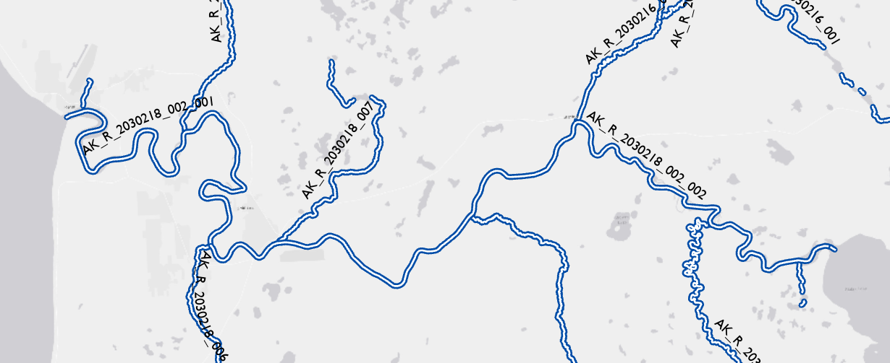
Figure 1 Kenai River assessment units from the mouth upstream to Skilak Lake

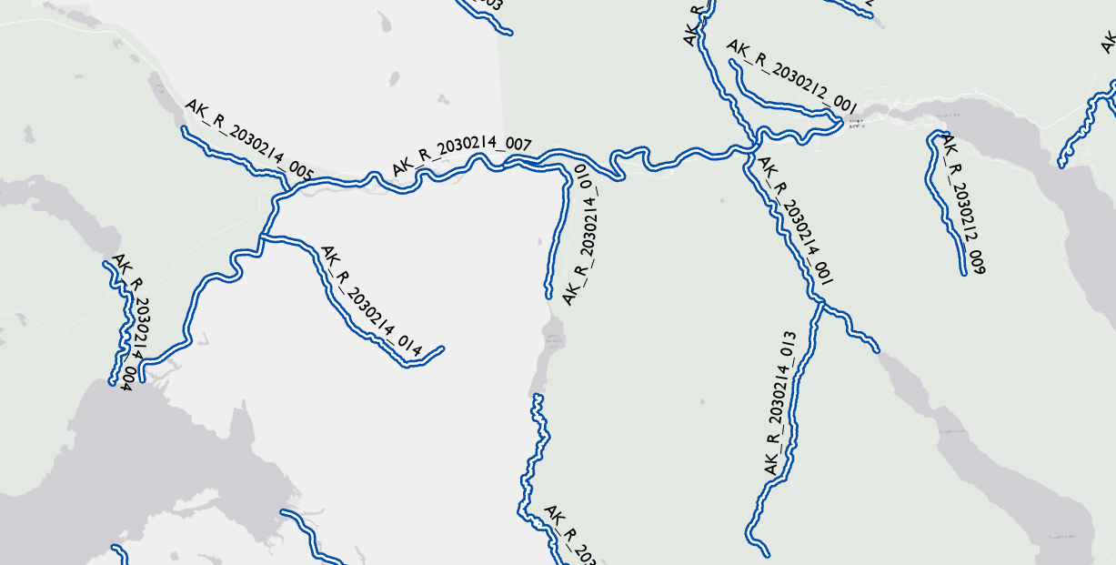
Figure 2 Kenai River assessment units from Skilak Lake upstream to Kenai Lake

- Question (Benjamin Meyer, Kenai Watershed Forum): In the Appendix A, Category 2 Section, I'm interested to see the calculation/evaluation specifics for one particular row. I've attached a screenshot of the row, and I'll also post the details below here:

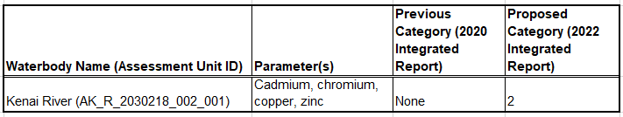
Response: No data evaluation or calculations were conducted for this assessment unit for the 2022 IR because the data reviewed was considered screening level only. The category status for all parameters remains the same as for the 2020 IR. The error in the table has been corrected as shown in Figures 3 and 4 (see updated Factsheet, Appendix B). This unit is in Category 2 for arsenic, cadmium, chromium and lead; and in Category 3 for copper, zinc and iron.

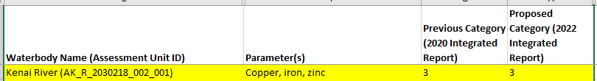
Figure 3 As shown in Appendix B, the Kenai River assessment unit AK_R_2030218_002_001 remains in Category 3 for copper, iron, and zinc
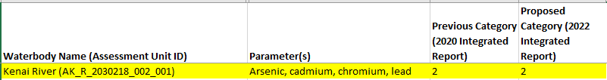
Figure 1 As shown in Appendix B, the Kenai River assessment unit AK_R_2030218_002_001 remains in Category 2 for arsenic, cadmium, chromium and lead

Question (Tom Waldo, Earthjustice Alaska): One of the proposed changes listed in Appendix A, Category 3, is the addition of Crooked Creek (AK_R_3050108_005) for Temperature (page 11 of the Fact Sheet). I would like to see the information DEC relied on when including this stream on the draft list

Response: Data for the Kuskokwim watershed including Crooked Creek was received from the Environmental Protection Agency. The dataset is available from the Water Quality Portal (https://www.waterqualitydata.us/), and is also provided as an attachment on our website. Crooked Creek is not named in the dataset, the associated Monitoring Location Identifier is “USGS-15304010”.

