2019 Air Compliance Annual Report

COMMERCIAL PASSENGER VESSEL

ENVIRONMENTAL COMPLIANCE (CPVEC) PROGRAM

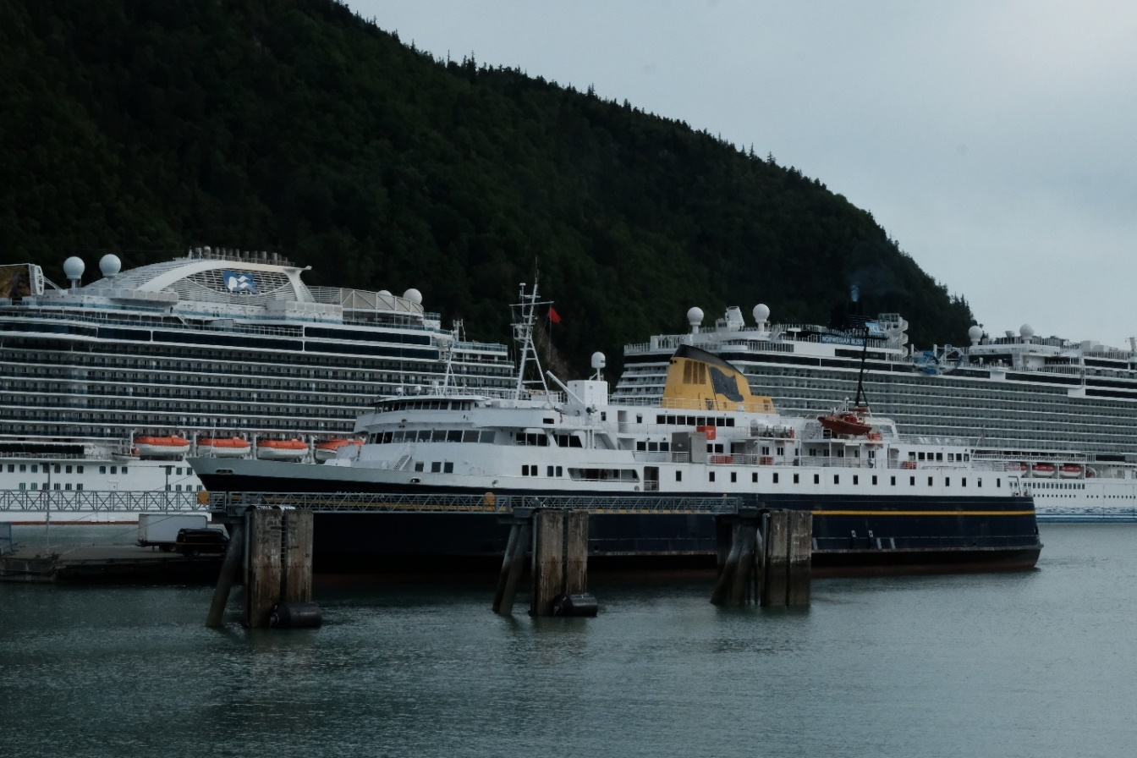
AMHS Malaspina, along with NCL Norwegian Bliss, and the PCL Royal Princess docked in Skagway 6/26/2019

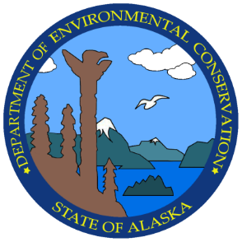

Alaska Department of Environmental Conservation

Table of Contents
INTRODUCTION 2
AIR QUALITY SUMMARY 3
TABLES 6

Abbreviations and Acronyms
AAC: Alaska Administrative Code
ADEC: Alaska Department of Environmental Conservation
AS: Alaska Statute
CFR: Code of Federal Regulations
CPVEC: Commercial Passenger Vessel Environmental Compliance (Program)
DG: Diesel Generator
ECA: Emissions Control Area
EGCS: Exhaust Gas Cleaning System
EPA: United States Environmental Protection Agency
EU: Emission Unit
GT: Gas Turbine
HFO: Heavy Fuel Oil
IMO: International Maritime Organization
LCPV: Large Commercial Passenger Vessel
MGO: Marine gas oil, a distillate fuel
MOU: Memorandum of Understanding
PM: Particulate Matter
SO_{X}: Sulfur oxides
USFS: United States Forest Service
UW: Underway

INTRODUCTION

This report is prepared annually by the Alaska Department of Environmental Conservations (ADEC, or the Department) Division of Water Commercial Passenger Vessel Environmental Compliance Program (CPVEC or the Program). The intent of this report is to provide information on the Program’s monitoring and compliance efforts with cruise ship air pollution.

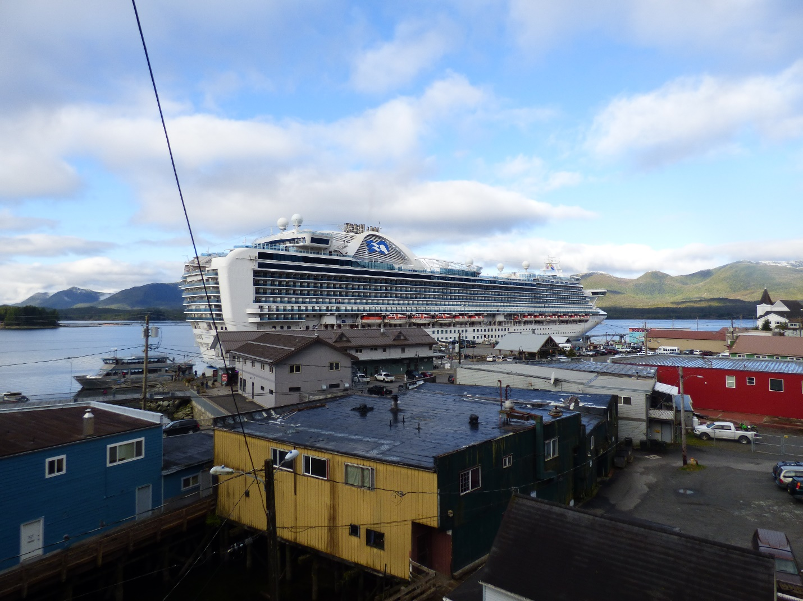
PCL Ruby Princess docked in Ketchikan 4/27/2019

AIR QUALITY SUMMARY
Objective: Maintain an effective environmental compliance program that engages in the direct monitoring of the opacity of air emissions from commercial passenger vessels to ensure the prevention of air pollution and the protection of public health.

Authority. AS 46.03.488. 18 AAC 50.070 establishes marine vessel visible emission standards.

Implementation. The regulation is applied to visible emissions, excluding water vapor, of marine vessels within three miles of the Alaska coastline. The CPVEC program uses EPA Reference Method 9 readings to provide the source of data for determining compliance with marine vessel visible emission standards. This method has been approved by the US Environmental Protection Agency (EPA) as part of the Federally Enforceable Air Quality Control State Implementation Plan under 40 CFR §52.70(28)(i). The CPVEC program monitors environmental compliance, as well as the direct and indirect environmental effects of commercial passenger vessels.

Results. Summaries of opacity results are available in Tables 1 to 5.

Readings: 447 opacity readings performed (EPA Method 9)
Compliance: 6 Notices of Violation Issued; 1 Notice of Violation Pending
Enforcement: 1 Notice of Violation settled
In addition to monitoring for opacity and initiating enforcement actions for noncompliance, the Program is actively monitoring and studying the following significant points of interest to monitor for direct or indirect environmental effects, as required under AS 46.03.488:
- EGCSs: Commissioning and operation of exhaust gas control systems (EGCSs) on select vessels.
- Fuels: change in fuel use on those ships operating EGCS units, and on ships without EGCS to comply with more stringent sulfur emissions standards in the North American Emissions Control Area (since 2012).

Compliance and Monitoring. Compliance with opacity requirements is determined through use of EPA Reference Method 9 observations. Observations are made by trained staff and contracted opacity readers. The current contractor for opacity readings is FLAT LAKE Engineering LLC, based in Ketchikan, AK with additional staff in Juneau, AK. The US Forest Service (USFS) signed on to a Memorandum of Understanding (MOU) with CPVEC to monitor air emissions and wastewater discharges from marine vessels. The latest MOU was executed May 21, 2018 and is effective through April 30, 2023. The USFS submits Method 9 observations made while vessels are underway in Tracy Arm.

The Program goal in monitoring opacity is to conduct consistent opacity readings primarily within Alaska’s three busiest cruise ship ports: Juneau, Ketchikan, and Skagway. Both staff and the contractor will travel to other ports during the season to conduct readings. Reasonable efforts will be made to conduct opacity readings of small cruise ships and state ferries. Summary data for reading counts are found on Tables 1 to 5.

Enforcement.

- Norwegian Cruise Line Holding Ltd. (NCL) Compliance Order by Consent (COBC) – Effective December 11, 2015. NCL is the operator of the marine vessels Norwegian Jewel, Norwegian Pearl, and Norwegian Sun. Details: NCL entered into a COBC settlement agreement December 2015 based on seventeen (17) counts of noncompliance by exceeding the visible emission standards while operating in Alaskan waters spanning the 2012-2014 seasons. The COBC requires NCL to fully and timely comply with and/or complete remedial measures and corrective actions as required by the Order. Stipulated Penalties: For each vessel owned, operated, or chartered by NCL, a penalty of $37,500 for each non-compliance event under 18 AAC 50.070 that occurs while this Order is effective and that is listed in an ADEC Notice of Violation (NOV).

2018 Action: NOV issued September 7, 2018 on the Norwegian Jewel for July 11, 2018 non-compliance in Ketchikan. Demand Letter of Stipulated Penalties issued October 5, 2018. Stipulated penalties of $37,500 paid by NCL.

2019 Action: NOV issued June 7, 2019 on the Norwegian Joy for a May 21, 2019 non-compliance event in Juneau. Demand Letter of Stipulated Penalties issued December 11, 2019.

- Royal Caribbean Cruises Ltd. (Respondent) Compliance Order by Consent (COBC) – Effective February 3, 2017. The Respondent is the owner of the cruise line brands Royal Caribbean International (RCL), operator of the marine vessels Radiance of the Seas and Rhapsody of the Seas and Celebrity Cruises (Celebrity), operator of the marine vessels Celebrity Century and Celebrity Millennium. Details: The Respondent entered into a COBC settlement Agreement February 2017 based on eight (8) counts of noncompliance by exceeding the visible emission standards while operating in Alaskan waters spanning the 2010, 2013, and 2014 seasons. The COBC requires the Respondent to fully and timely perform, comply with and/or complete remedial measures and corrective actions as required by the Order. Stipulated Penalties: For each vessel owned, operated, or chartered, a penalty of $37,500 for each non-complaint event under 18 AAC 50.070 that occurs while the Order is effective and that is listed in an ADEC Notice of Violation.

2018 Action: Two (2) NOVs issued September 7, 2018 on the Radiance of the Seas for August 8, 2018 non-compliance in Ketchikan and on the Radiance of the Seas for August 17, 2018 non-compliance in Seward. Demand Letter for Stipulated Penalties issued October 5, 2018. Settlement pending. 2019 Update: Settlement pending.

- Holland American Line (HAL) Settlement Agreement signed May 22, 2017. HAL signed a Settlement Agreement for years 2009-2014 alleged visible air emission violations. HAL chose to resolve the alleged violations by a Settlement Agreement versus a Compliance Order by Consent. The State of Alaska collected a total civil assessment of $180,000.

2018 Action: Four (4) NOVs issued September 7, 2018 on the Nieuw Amsterdam for June 19, 2018 non-compliance in Skagway, on the Westerdam for June 20, 2018 non-compliance in Haines, on the Eurodam for August 2, 2018 non-compliance in Ketchikan, and on the Amsterdam for August 24, 2018 non-compliance in Ketchikan. Settlement Agreement to HAL “Year 2018 Visible Air Emissions” issued October 17, 2018. 2019 Update: Settlement pending.

- Princess Cruise Line, Ltd. (PCL) Settlement Agreement signed May 22, 2017. PCL signed a Settlement Agreement for years 2009-2014 alleged visible air emission violations. PCL chose to resolve the alleged violations by a Settlement Agreement versus a Compliance Order by Consent. The State of Alaska collected the total assessment of $110,125.

2018 Action: Two (2) NOVs issued September 7, 2018 on the Emerald Princess for July 31, 2018 non-compliance in Ketchikan and on the Golden Princess for July 31, 2018 non-compliance in Juneau. Settlement Agreement to PCL “Year 2018 Visible Air Emissions” issued October 17, 2018. 2019 Update: Settlement pending.

2019 Action: NOV issued July 15, 2019 on the Royal Princess for a May 29, 2019 non-compliance event in Skagway.
- NOV issued July 15, 2019 on the Oceania Regatta for an August 21, 2019 non-compliance event in Sitka.
- NOV issued October 15, 2019 on the AMHS Kennicott for an August 21, 2019 non-compliance event in Juneau.
- NOV issued September 9, 2019 on the Carnival Legend for a June 29, 2019 non-compliance event in Juneau.
- NOV issued October 22, 2019 on the SilverSeas Silver Muse for a September 8, 2019 non-compliance event in Juneau.

Public Complaints. The Department responds to public complaints regarding cruise ship pollution. Although complaints, photographs, or other evidence of emissions exceedances are sometimes not provided according to Reference Method 9 requirements, the Program will often follow up complaints with an opacity reading by Department staff or the contractor. In any case of a complaint, vessel operators or owners are notified as soon as possible so that mitigating steps may be taken. The number of public complaints received by the Department each year can be found in Figure 1.

In prior years, many complaints did not mention a particular vessel, but were concerning the overall air quality in Juneau when cruise ships were present. There was a dramatic increase in complaints over the 2017 and 2018 seasons where more complainants were identifying vessels by their name. The increase in public complaints coincides with an increase in the number of ships operating Exhaust Gas Cleaning Systems (EGCSs or Scrubbers). 2018 also brought a new dynamic positioning procedure to Juneau where a vessel would hold its position within the turning basin upwards of an hour prior to docking. This procedure requires multiple engines operating to hold position versus one engine in operation while docked. Complaints showed a weekly trend with certain vessels, reporting excess smoke, smell of exhaust and a blue haze settling over downtown Juneau. In 2017 and 2018, the Department had also seen an increase in complaints from communities outside of Juneau. These communities include Ketchikan, Skagway, and Hoonah. The Department saw a decrease in public complaints during the 2019 season. This decrease in public complaints corresponds with industry implementing a fuel management program prior to entering port and, specifically for Juneau, reducing time holding in the turning basin prior to docking.

Figure 1

Ambient Air Monitoring. The Program is working with the Division of Air Quality on a preliminary ambient air monitoring saturation study during the 2019 cruise ship season in downtown Juneau. A saturation study is a type of investigation that utilizes a lot of samplers in a small geographic area over a limited amount of time. By using a tightly-spaced grid of Purple Air low-cost particulate monitors (PM_{2.5}) and several Ogawa passive sulfur dioxide monitors (SO₂), the objectives of the saturation study are:
- to address ambient air quality complaints centered on the cruise ship industry emissions;
- to determine which areas of downtown Juneau are most affected (maximum impact locations); and
- to assess if the scale in terms of frequency, duration, spatial variability and severity of these impacts has the potential to significantly affect public health and/or violate Clean Air Act air quality standards.
Ambient air was monitored in downtown Juneau for sulfur dioxide, nitrogen oxides, and PM_{2.5} during 2000 and 2001. The pollutant levels in 2001 were below federal and state health standards. Since the 2000/2001 study, tourism in Juneau has grown and the number of cruise ships calling to Juneau’s port has increased. In addition, many cruise ships have installed EGCSs to meet International Maritime Organization’s (IMO) and ECA SOx regulations. The EGCSs allow cruise ships to operate on fuels with higher levels of sulfur than ECA limits by “scrubbing” exhaust gas with seawater or an alkali to reduce the SOx emissions exiting the stack; Because of these changes, there is an increased interest in how it has effected PM_{2.5} levels. The department expects to release the 2019 Juneau air monitoring study report in April 2020. It will be posted on the department web site at: http://dec.alaska.gov/air/air-monitoring/juneau-cruise-ship-monitoring-project/

TABLES

Table 1: 2019 Contractor Opacity Readings
Location | Readings
Juneau | 178
Ketchikan | 189
Skagway | 31
Haines | 3
Hoonah | 0
Sitka | 10
Seward | 0
Anchorage | 2
Total Opacity Readings | 413

Table 2: 2019 ADEC Staff Opacity Readings
Location | Readings
Juneau | 1
Ketchikan | 4
Skagway | 13
Haines | 2
Hoonah | 6
Sitka | 6
Anchorage | 0
Tracy Arm | 2
Total Opacity Readings | 34

Table 3: Opacity Readings Per Year Summary
Year | 2014 | 2015 | 2016 | 2017 | 2018 | 2019
Number of Readings | 382 | 343 | 388 | 552 | 480 | 447

Table 4: Opacity Violations Issued (2018)
Vessel | Date | Port | Status
HAL Nieuw Amsterdam | 6/19/2018 | Skagway | Pending
HAL Westerdam | 6/20/2018 | Haines | Pending
NCL Norwegian Jewel | 7/11/2018 | Ketchikan | Settled
PCL Emerald Princess | 7/31/2018 | Ketchikan | Pending
PCL Golden Princess | 7/31/2018 | Juneau | Pending
HAL Eurodam | 8/2/2018 | Ketchikan | Pending
RCL Radiance of the Seas | 8/8/2018 | Ketchikan | Pending
RCL Radiance of the Seas | 8/17/2018 | Seward | Pending
HAL Amsterdam | 8/24/2018 | Ketchikan | Pending
-Pending indicates a case is currently under negotiation
-Settled indicates an enforcement settlement has been reached
-Resolved indicates a case has been closed without formal enforcement

Table 5: Opacity Notice of Violations Issued (2019)
Vessel | Date | Port | Status
PCL Norwegian Joy | 5/21/2019 | Juneau | Settled
Oceania Regatta | 6/1/2019 | Sitka | Pending
PCL Royal Princess | 5/29/2019 | Skagway | Pending
Carnival Legend | 6/29/2019 | Juneau | Pending
AMHS Kennicott | 8/21/2019 | Juneau | Pending
Silver Seas Silver Muse | 9/8/2019 | Juneau | Pending

Table 6: Opacity Reading Count by Port (2019)
Port | Readings
Juneau, AK | 179
Ketchikan, AK | 193
Skagway, AK | 44
Haines, AK | 5
Hoonah, AK | 6
Sitka, AK | 16
Anchorage, AK | 2
Tracy Arm | 2

Table 7: Violations Per Year Summary
Year | 2008 | 2009 | 2010 | 2011 | 2012 | 2013 | 2014 | 2015 | 2016 | 2017 | 2018 | 2019
Violations | 10 | 3 | 7 | 4 | 2 | 5 | 25 | 0 | 0 | 2 | 9 | 6*
* One 2019 Opacity Notice of Violation pending issuance

Table 8: Vessel Emissions Units (EU) and EGCS Details
Line | Vessel | EGCS/ EU | EU Inventory [EGCS EU] |  |  |  |  |  | EGCS | Port Fuel | UW Fuel
SOx Controls / MGO Fuel
Ponant | Le Soleal | N/A | DG1 | DG2 | DG3 | DG4 | X | X | None | MGO
Azamara | Quest | N/A | DG1 | DG2 | DG3 | DG4 | X | X | None
Crystal | Symphony | N/A | DG1 | DG2 | DG3 | DG4 | DG5 | DG6 | None
Disney | Wonder | N/A | DG1 | DG2 | DG3 | DG4 | DG5 | X | None
Seabourn | Sojourn | N/A | DG1 | DG2 | DG3 | DG4 | X | X | None
Oceania | Seven Seas Mariner | N/A | DG1 | DG2 | DG3 | DG4 | X | X | None
Oceania | Regatta | N/A | DG1 | DG2 | DG3 | DG4 | X | X | None
Silversea | Silver Muse | N/A | DG1 | DG2 | DG3 | DG4 | X | X | None
PCL | Sun Princess | N/A | DG1 | DG2 | DG3 | DG4 | X | X | None
SOx Controls EGCS Systems / HFO Fuel
CCL | Carnival Legend | 3:6 | DG1 | DG2 | DG3 | DG4 | DG5 | DG6 | OL | HFO
Cunard | Queen Elizabeth | 5:6 | DG1 | DG2 | DG3 | DG4 | DG5 | DG6 | OL | HFO
CEL | Eclipse | 4:4 | DG1 | DG2 | DG3 | DG4 | X | X | CL / OL | HFO+ | HFO
CEL | Millennium ∆ | 1:3 | DG1 | GT1 | GT2 | X | X | X | CL / OL | MGO ∆
CEL | Solstice | 4:4 | DG1 | DG2 | DG3 | DG4 | X | X | CL / OL | HFO+ | HFO
HAL | Amsterdam | 3:5 | DG1 | DG2 | DG3 | DG4 | DG5 | X | OL | HFO+ | HFO
HAL | Eurodam | 4:6 | DG1 | DG2 | DG3 | DG4 | DG5 | DG6 | OL | HFO+ | HFO
HAL | Nieuw Amsterdam | 4:6 | DG1 | DG2 | DG3 | DG4 | DG5 | DG6 | OL | HFO+ | HFO
HAL | Noordam | 3:6 | DG1 | DG2 | DG3 | DG4 | DG5 | GT | OL | HFO+ | HFO
HAL | Oosterdam | 4:6 | DG1 | DG2 | DG3 | DG4 | DG5 | GT | OL | HFO+ | HFO
HAL | Volendam | 3:5 | DG1 | DG2 | DG3 | DG4 | DG5 | X | OL | HFO+ | HFO
HAL | Westerdam | 4:6 | DG1 | DG2 | DG3 | DG4 | DG5 | GT | OL | HFO+ | HFO
HAL | Maasdam | 3:5 | DG1 | DG2 | DG3 | DG4 | DG5 | X | OL | HFO+ | HFO
NCL | Norwegian Bliss | 5:5 | DG1 | DG2 | DG3 | DG4 | DG5 | X | CL / OL | HFO+ | HFO
NCL | Norwegian Joy | 5:5 | DG1 | DG2 | DG3 | DG4 | DG5 | X | CL / OL | HFO+ | HFO
NCL | Norwegian Jewel | 5:5 | DG1 | DG2 | DG3 | DG4 | DG5 | X | CL / OL | HFO+ | HFO
PCL | Coral Princess | 3:4 | DG1 | DG2 | DG3 | GT1 | X | X | OL | HFO+ | HFO
PCL | Golden Princess | 2:6 | DG1 | DG2 | DG3 | DG4 | DG5 | DG6 | OL | HFO+ | HFO
PCL | Grand Princess | 4:6 | DG1 | DG2 | DG3 | DG4 | DG5 | DG6 | OL | HFO+ | HFO
PCL | Island Princess | 3:4 | DG1 | DG2 | DG3 | GT1 | X | X | OL | HFO+ | HFO
PCL | Royal Princess | 4:4 | DG1 | DG2 | DG3 | DG4 | X | X | OL | HFO+ | HFO
PCL | Ruby Princess | 4:6 | DG1 | DG2 | DG3 | DG4 | DG5 | DG6 | OL | HFO+ | HFO
PCL | Star Princess | 4:6 | DG1 | DG2 | DG3 | DG4 | DG5 | DG6 | OL | HFO+ | HFO
RCL | Ovation of the Seas | 4:4 | DG1 | DG2 | DG3 | DG4 | X | X | CL / OL | HFO+ | HFO
RCL | Radiance of the Seas | 1:3 | DG1 | GT1 | GT2 | X | X | X | CL / OL | HFO / MGO*
Viking | Viking Orion | 4:4 | DG1 | DG2 | DG3 | DG4 | X | X | CL / OL | MGO | HFO
Notes:
DG = Diesel Engine / Diesel Electric Generator (DGs connected to ECGS system = Bold + Underscore)
EU = Emission Unit (Combustion Source) Power / Propulsion
CL = Closed Loop EGCS Process
OL = Open Loop EGCS Process
* = HFO only used in combination with DG + EGCS | MGO for GTs only
+ = Fuel preference HFO DG + EGCS | GT (if operated) always on MGO | 2019: Vessels operated on MGO in Port of Juneau / Skagway
∆ = Millennium → EGCS system DG1 not operated in AK 2019.
EGCS Hybrid Systems (CL & OL). 2019: operated ECGS in CL in AK waters and OL outside AK.

