State of Alaska, Department of Environmental Conservation
Division of Environmental Health, Drinking Water Program

Alaska’s Capacity Development Strategy

Improving the Technical, Managerial, and Financial Capacity of Alaska Public Water Systems. |  | 2011
2008 - 2011  Significant Achievements  Updated Capacity Development Strategy  Development and Implementation of a Status Component Inspection Program  Contents  Background 1  Strategy Update 2  Strategy Elements 2  Status Component Inspections 3  Kongiganak 5  Noatak 6  Review of Operational 7 Data  Outreach & 8  Special Projects  Conclusion 8 | 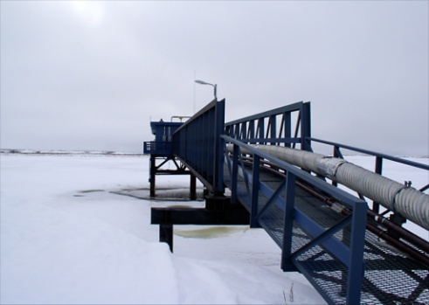

Background
Kotzebue Water Source
The 1996 Safe Drinking Water Act Amendments included requirements to prevent the creation of new, nonviable waterworks serving communities and non-transient non-communities (including schools, offices, and work-camps), and to develop a strategy to address the capacity of all existing waterworks. This is a report on Alaska’s efforts to improve the technical, managerial, and financial capacity of Alaska Public Water Systems for 2008-2011.
The initial Capacity Development Strategy was finalized in 2000. Since that time there have been new federal rules, decreased funding for infrastructure upgrades, increased operational costs, and growing communities. Public water systems have struggled to keep up with the associated challenges of maintaining a sustainable public water system.
Many communities were unsure of their status after the final phase in of new federal rules. The Department of Environmental Conservation‘s (DEC) written documentation of system components was often inaccurate or incomplete. Providing guidance without accurate knowledge of system information was ineffective.
Therefore, DEC has spent much of the past three years making needed updates to the existing Capacity Development Strategy, updating the infrastructure information on public water systems, and advising systems of the current status of their waterworks based on engineering inspections. This report provides a summary of these efforts.

Public Water Systems in Alaska
Community and Non-Transient Non-Community

“By 1936 simple filtration and chlorination of city water supplies reduced overall mortality in the U.S. cities by 13 percent. Clean water cut child mortality in half. “  Cutler and Stanford, Harvard  Noorvik Pressure Filter  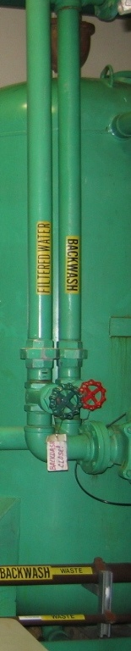 | Strategy Update
An update to the original Capacity Development Strategy was initiated in 2009. Public meetings were held to discuss the original “Report of Findings” which was produced by a 1999 Citizens Advisory Board, and to identify areas of needed updates. Many of the recommendations from the original report were still valid. Many of these goals were accomplished. However, changes in regulatory requirements, agency structure, and community resources supported a need for an update to the original Strategy.
A final draft for the updated Strategy was completed in 2011, and is currently being finalized by DEC and EPA.
This updated Strategy focuses on prioritizing water systems based on risk, targeting water system assistance based on primary need (technical, managerial, and financial), optimizing the performance of existing systems, and assessing the effectiveness of the Drinking Water Program’s Capacity Development initiatives on an ongoing basis.
The updated Capacity Development Strategy does not duplicate technical, managerial, and financial tools already provided by others, but seeks to supplement and support those efforts. Tracking mechanisms are being developed to allow assessments over time, to identify strategy elements that are working well, and to rethink those that seem less effective.
The Capacity Development Strategy will be posted on the web once finalized. The current version is available upon request.

 | Strategy Elements
Sustainability is the goal for all water systems. Guidelines and outreach materials continue to be developed for improving the technical, managerial, and financial capacity of all systems. However, more intensive efforts are implemented based on public health protection and risk prevention.
All new public water systems are reviewed prior to construction, to address and avoid long term sustainability issues. Engineering reviews are expanded to include more detailed financial and managerial information for new systems serving communities and non-transient non-communities. Since these types of systems serve the same people daily, and the water served is a primary source of drinking water, these systems are considered a higher priority.
All existing public water systems are addressed through inspection programs and the review of operational data on treatment components. Systems that appear to be struggling based on operational data are contacted in an effort to prevent excceedences of maximum contaminant levels (MCLs). Public water systems utilizing surface water sources have a higher potential risk of microbial contamination than systems using a groundwater source. Therefore, surface water treatment systems receive a higher priority.
Other factors that are considered in the risk prioritization include treatment techniques used, type of water system operation, history of exceedences of drinking water MCLs, and population served.
A primary goal in implementing all activities is to support efforts that are currently underway by others. Many outreach efforts are coordinated between agencies, groups, and community representatives.
Groundwater vs. Surface Water Treatment Systems in Alaska

** Community and Non-Transient Non-Community Water Systems based on available July 2011 data.

Inspections
A critical element in providing effective regulatory guidance and assistance is accurately knowing the current status of a water system. The Drinking Water Program has several types of inspections with different objectives. However, all of these inspections include technical, managerial and financial components.
“Sanitary Surveys” are required on public water systems every 3 years. The objective of these surveys is to identify issues that present a risk to public health. This is a broad inspection, covering many aspects of a system. These inspections are completed by 1-2 DEC-approved inspectors (not necessarily Drinking Water Program staff) and typically take 2-8 hours onsite.
“Comprehensive Performance Evaluations” (CPEs) are required if a surface water treatment system exceeds allowable turbidity levels. This is an in-depth review of the design, management and operations of a water treatment facility. These inspections are completed by a team of Drinking Water Program engineers (3-10), and take 4-5 days onsite. These inspections are also used as a training exercise for communities and Drinking Water Program staff.
“Comprehensive Technical Assistances” (CTAs) address a specific system issue. These inspections typically take one Drinking Water Program engineer 4-8 hours onsite.
“Filter Assessments” are required if a surface water treatment system exceeds allowable turbidity levels. These inspections focus on the operations of a filtration system. They require 4-8 hours onsite of one Drinking Water Program engineer’s time.
In conducting the above inspections, it became apparent that file information on basic surface water system treatment components was inaccurate or insufficient. There was a need for a short engineering inspection, focused specifically on surface water treatment rule requirements, regardless of reported turbidity levels.
A new inspection program, “Status Component Inspections” (SCIs), was developed to support the operational capacity of small systems. The objective of this inspection is evaluate the disinfection and filtration treatment components, to award a specific credit for these processes, and to obtain updated information used in the risk prioritization of surface water treatment systems. SCIs take 1-2 Drinking Water Program engineers 4-8 hours to complete. Following an inspection, communities are notified of their status, and are provided with an estimation of the severity of the problem.
A Status Component Inspection Program was started in 2010, with a goal to inspect all surface water treatment systems by the end of 2011. The following maps summarize inspections conducted to date.
Preliminary results of these inspections indicate that many surface water treatment systems have the following basic problems:
- Inadequate disinfection due to low levels of chlorine, high flows, or system design.
- Turbidimeters are in the wrong location or are not maintained. Chlorine samples are taken in the wrong location.
- No coagulant is added, as required to achieve adequate filtration.
- Filters are not maintained.
These issues can roughly be grouped into three categories: systems meeting current treatment requirements; systems with mostly operation and maintenance issues; and systems requiring more significant upgrades.
Maps showing basic findings are provided below. These are followed by two short site summaries from Status Component Inspections in Kongiganak and Noatak.

Status Component Inspections in Alaska
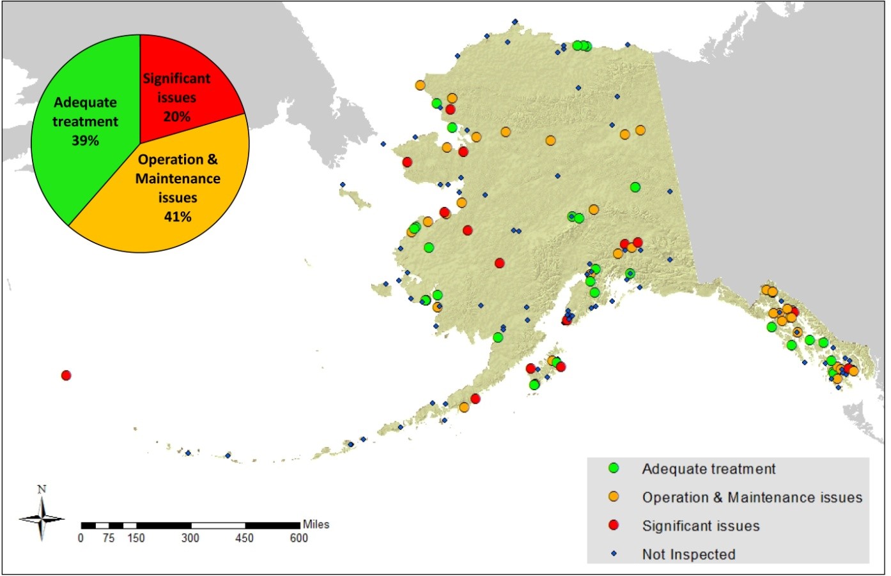

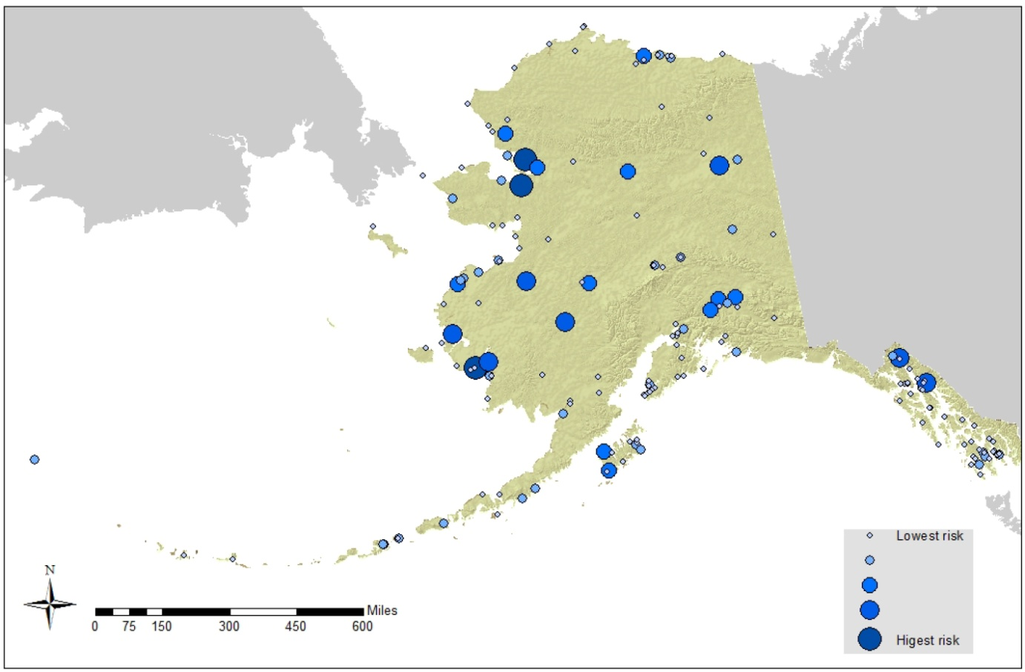

 | Kongiganak
 | 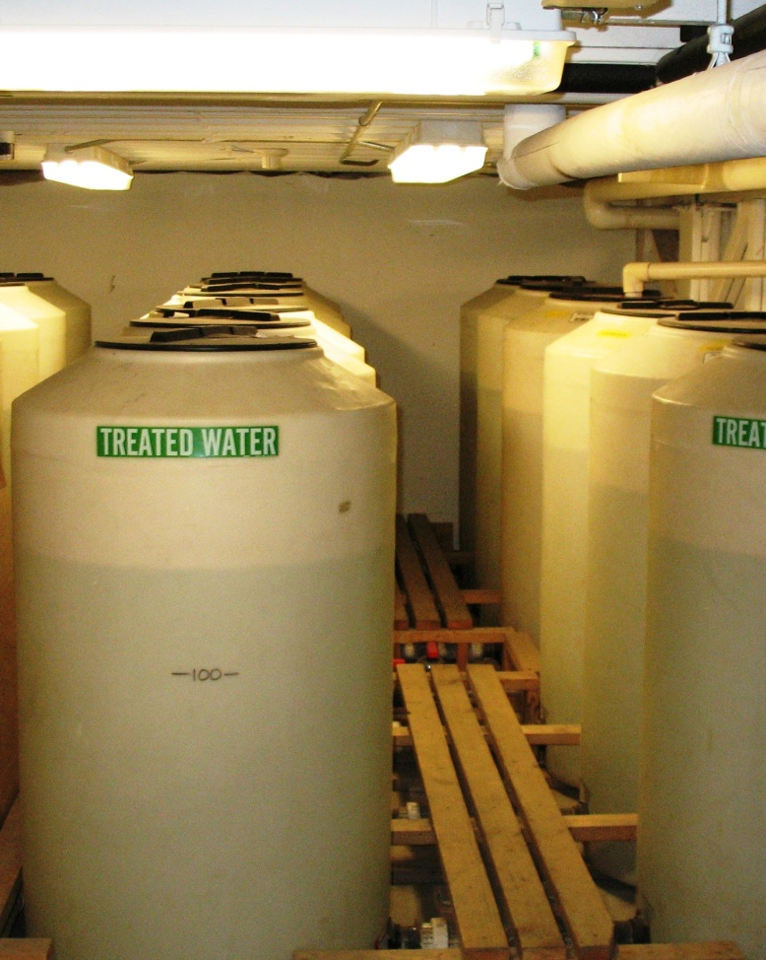  Chlorinated Water Storage  (chlorine enters tank on upper right)  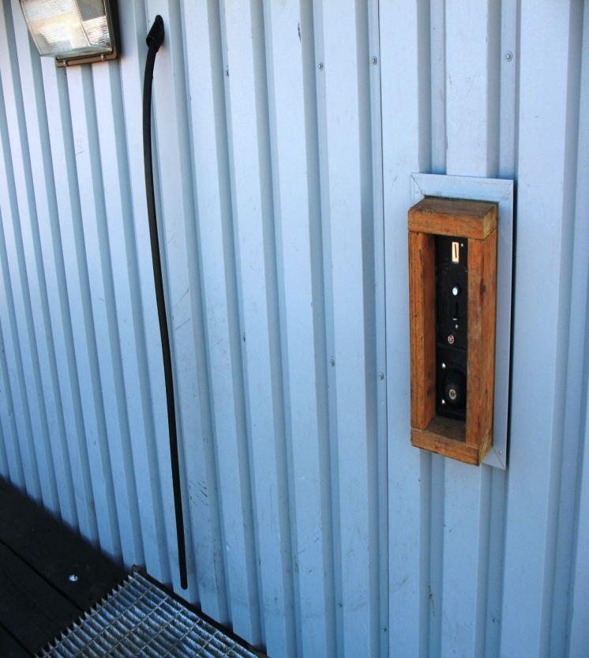 Community Watering Point | A Status Component Inspection was conducted in Kongiganak on May 25, 2010. The Kongiganak water system serves a central community watering point located at the washeteria. Residents bring their own water jugs and fill them from the hose located outside the building. There is no piped public water distribution.  Surface water is obtained from Contractor Lake, and then sent to a “direct treatment” water system where it is coagulated (to make sediment particles stick together), filtered, and then disinfected. Each of these treatment steps is important to effectively remove pathogens. The system also included bag filters which were not in use at the time of the inspection.  Prior reports received by DEC indicated that the system used a 5,000 gallon storage tank in the disinfection process. There was no mention of issues with the filtration system.  At the time of our inspection, the water storage consisted of 64 parallel 150 gallon tanks, connected at the base by a common manifold. Chlorination entered one of these tanks. The filtration system was not well maintained, and the instruments (turbidimeters) that are used to evaluate the effectiveness of filtration were also not maintained. Kongiganak will not be able to meet minimum Surface Water Treatment Rule requirements without upgrading or replacing their existing treatment infrastructure. The water storage component of the system will need to be modified. Operations and maintenance of the filtration system will need to be addressed.  The DEC Village Safe Water Program will be working with the community to address their drinking water needs.  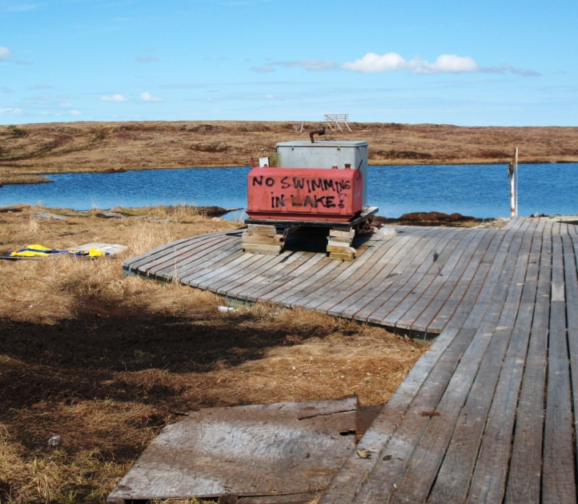  Contractor Lake

Noatak | A Status Component Inspection was conducted in Noatak on November 11, 2010. The Noatak water system serves 485 residents through a piped distribution system.  The water source for Noatak is two wells on an island in the Noatak River. Based on submitted information, the wells were assumed to be “Ground Water Under the Direct Influence of Surface Water” (GWUDISW) at the time they were installed. As a GWUDISW source they represent a similar risk of contamination as surface water and are required to have the same treatment. The current treatment system for Noatak is bag and cartridge filtration followed by disinfection.  The filtration system consists of three stages. The first stage of bag filtration is intended to remove the larger particles. This is followed by a second stage of cartridge filtration which is intended to remove smaller particles and protect the third and final stage. The final cartridge is intended to remove Giardia and Cryptosporidium sized particles. This final cartridge is easily plugged with sediment and is relatively expensive. Following filtration, chlorine is added to disinfect the water. The water is then stored in a 97,000 gallon storage tank.  At the time of the inspection the third stage cartridge filters were not being used because there was only one set of filters remaining and the City was not able to afford more replacements. Without these cartridge filters the system was not meeting Surface Water Treatment Rule requirements and was relying on the disinfection system as the only barrier to contamination (chlorine is effective on Giardia, but not on Cryptosporidium).  Turbidimeters are used to evaluate the effectiveness of filtration systems and as indicators of surface water contamination. Noatak has very low source water turbidity, much less than the regulatory limit even before treatment. The design engineer assumed the source wells were GWUDISW at the time they were installed. However, site conditions and the low turbidity of the source water indicate that these wells may be true groundwater. As a groundwater system they would not need to operate and maintain an expensive surface water treatment system. An accurate determination of the source water could be made based on a more thorough engineering evaluation.  Noatak needs to either conduct an evaluation of their wells to determine if they are actually groundwater, or provide treatment to meet current surface water treatment requirements. A new surface water treatment system which will include coagulation and media filtration was designed by the Alaska Native Tribal Health Consortium (ANTHC) and was approved for construction in October 2009. It has not been constructed. No evaluation of their source wells has been initiated.
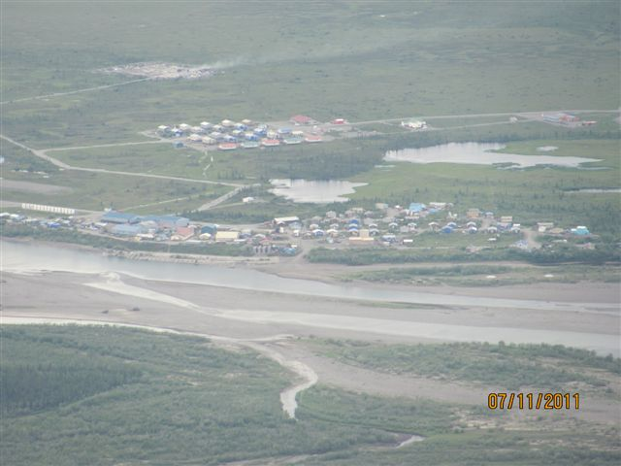
Noatak – 2 wells visible on island in center right of photo
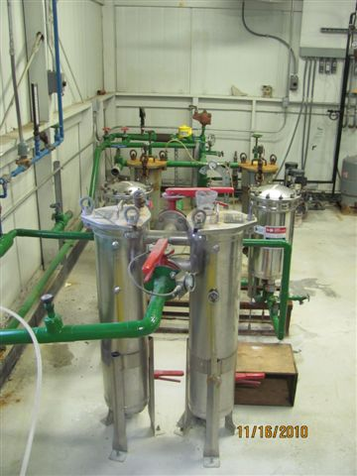
Noatak Filtration System

Review of Operational Data
Water treatment systems collect data that provides information on the operations of water treatment components. Turbidity (the cloudiness of the water) is the primary indicator of the effectiveness of surface water treatment. Turbidity can be easily monitored onsite, unlike microbiologic contaminants. Turbidity is directly associated with pathogens. Higher turbidity water is more likely to contain higher, and possibly unsafe, levels of microorganisms.
Turbidity in the source water can vary significantly seasonally, weekly, daily and even hourly, due to precipitation, snowmelt, and changes in runoff. Typically high turbidity periods occur in the spring (due to high snowmelt runoff), and in the fall (due to high precipitation runoff). The lowest raw water turbidities typically occur in the winter.
A surface water treatment system should be able to produce finished water with minimal variation in finished water turbidity, even with fluctuations in the raw source water. The effectiveness of turbidity removal varies with the chosen water treatment technology and the operations of that technology.
There is a maximum allowable turbidity level that water systems are not allowed to exceed. Water systems are also required to submit daily turbidity data. Although a system may not be exceeding a maximum contaminant level for turbidity, graphs of the turbidity will often indicate that the system is struggling before an exceedence of the maximum level occurs.
The following graph presents turbidity data from Saint Mary’s. Saint Mary’s has a small surface water source that reacts rapidly to runoff. The system has a very proactive operator, but a review of operational data indicated that they were still struggling to treat water associated with spring and fall runoff events. A Comprehensive Performance Evaluation (CPE) was conducted in 2007. Several factors were identified during these inspections that were limiting the optimum performance of the system.
One important factor was the coagulant dosage. The appropriate coagulant dose is critical for optimum sediment removal. Too little, or too much coagulant, will result in less than optimum sedimentation and filtration. In this instance the coagulant dose was too high. Immediate improvements were observable upon adjusting the dose.
A follow-up Comprehensive Technical Assistance (CTA) was conducted in 2008. This visit checked on the system’s progress in addressing the identified performance limiting factors identified in the 2007 CPE. The system has made substantial improvements and is mostly operating in an optimized state. They are still planning on a needed replacement of the filter media.

Saint Mary’s Turbidity
Comprehensive Performance Evaluation conducted in 2007
Comprehensive Technical Assistance follow-up conducted in 2008
0.3 NTU max finished water turbidity limit
Nephelometer Turbidity Units (NTUs)

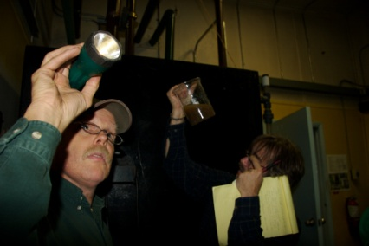
Outreach & Special Projects |  |  | Bill Chamberlain, EPA  Lee Johnson, DEC
The Drinking Water Program continues to seek opportunities to coordinate activities with other agencies and organizations that also provide services to public water systems. A monthly meeting is held with Technical Assistance Providers (TAPs) to address common issues.  There were also concerns that the data quality issues found in surface water systems might also be present in groundwater systems. A grant funded by the American Recovery and Reinvestment Act (ARRA) provided resources for an engineering review and summary of all public water system file information. This project will provide needed information for prioritization and planning the appropriate follow-up activities for groundwater systems.  A second ARRA grant was obtained to provide engineering services to update the Drinking Water Regulations (18 AAC 80) to address needed treatment and capacity development issues. The contracting engineer has coordinated public open- house meetings in Anchorage, Fairbanks and Juneau in order to obtain the public’s perspective of existing requirements, as we plan needed updates. |  |  | Bill Chamberlain, EPA  Lee Johnson, DEC

Conclusion
For the past three years the Drinking Water Program has been focused on data quality and data assurance; on gaining better information on the status of existing public water systems in Alaska and how well they are meeting the final versions of new rules. Because of the higher potential health risks, surface water treatment systems have been a primary focus. Most of the surface water treatment systems will be inspected by the end of 2011. Inspections will be postponed for a few systems that are under construction, or are not currently operating. A review of the documentation on groundwater systems will be completed, along with the associated prioritization list of engineering issues.
The next three years will focus on responding to the data obtained in these efforts. Solutions will have to address technical, managerial and financial issues. In some instances, solutions seem easy and obvious. Others are much more difficult. Some of the most challenged water treatment systems have social and economic issues that significantly limit possible water system improvements. The growing public awareness of the need for sustainable infrastructure has resulted in prioritizing limited funding resources to the most viable communities. There are a growing number of communities that have limited economic resources and are falling further behind in their ability to provide safe drinking water.
During the next three years we will develop methods to address technical issues that have been identified, establish better partnerships and training opportunities with operators, reach out to water system management and inform them of the results of these inspections, coordinate with agencies already providing financial support, and we will provide system specific information to funding agencies to notify them of serious deficiencies that are preventing systems from being able to provide adequate treatment.
This is a report covering our efforts to improve the technical, managerial, and financial capacity of water treatment systems in Alaska for the past three years, 2008-2011. Specific tasks for the next three years will be developed in February 2012, based on water system data, risk prioritization, and Drinking Water Program resources.
DEC Drinking Water Program
555 Cordova St.
Anchorage, AK 99501

Vanessa Wike, PE
Capacity Development Coordinator

Phone
(907) 269-7696

E-mail
vanessa.wike@alaska.gov

DEC Drinking Water Program:
http://www.dec.state.ak.us/eh/dw/index.htm

