WORKGROUP FOR GLOBAL AIR PERMIT POLICY DEVELOPMENT FOR TEMPORARY OIL AND GAS DRILL RIGS

Technical Subgroup

Ambient Demonstration

for the

North Slope Portable Oil and Gas Operation Simulation

FINAL

TABLE OF CONTENTS

1. INTRODUCTION 7
1.1 Background Information Regarding the Workgroup 7
1.2 Modeling Analysis Summary 8
2. BACKGROUND 9
2.1 Project Location and Description 9
2.2 Project Classification 12
2.3 Modeling Protocol Submittal 12
3. SOURCE IMPACT ANALYSIS 12
3.1 Modeling Approach 13
3.2 Model Selection 16
3.3 Meteorological Data 16
3.4 Coordinate System 17
3.5 EU Inventory 17
3.6 Non-Modeled EUs 18
3.7 EU Release Parameters 23
3.7.1 Emission Rates 23
3.7.1.1 Sulfur Compound Emissions 23
3.7.1.2 Operational Limits 23
3.7.1.3 Short-Term Emission Rates 23
3.7.1.4 Application of Temporally-Varying Emissions 24
3.7.2 Point Source Parameters 25
3.8 Pollutant-Specific Considerations 31
3.8.1 Ambient NO₂ Modeling 31
3.8.1.1 USEPA and ADEC Approval 31
3.8.1.2 Public Comment 31
3.8.1.3 In-Stack NO₂-to-NO_{X} Ratio 31
3.8.1.4 Ozone Data 33
3.8.2 Qualitative Assessment of Secondary PM_{2.5} Impacts 33
3.9 Downwash 35
3.10 Ambient Air Boundary 35
3.11 Receptor Grid 36
3.12 Off-Site Source Impacts and Characterization 36
3.13 Ambient Background Concentrations 38
3.13.1 A-Pad Ambient Air and Meteorological Monitoring Station 41
3.13.2 CD1 Ambient Air and Meteorological Monitoring Station 46
3.14 Design Concentrations 47
3.15 Post-Processing 47
4. RESULTS AND DISCUSSION 49
4.1 Conservatism in the Modeling Demonstration 49
5. CONCLUSIONS 53
5.1 Summary of Key Parameters and Assumptions 53
5.2 Summary of Conclusions 54

TABLE OF APPENDICES

APPENDIX A AERMOD Sensitivity Analyses

APPENDIX B Drill Rig Equipment Inventory Survey

APPENDIX C Transportable Source Variability Processor (TRANSVAP)

APPENDIX D Second Tier Approach to Combining Model-Predicted Impacts with a Monitored NO₂ Background Concentration

APPENDIX E Hydraulic Fracturing in Alaska

TABLE OF TABLES

Table 1 POGO Categories 8
Table 2 Maximum Modeled Quantity of Fuel That a North Slope POGO Could Consume Without Violating an AAAQS (Gallons per Day) 9
Table 3 Modeled EU Inventory 19
Table 4 Example Non-Modeled EUs 22
Table 5 Base Emission Rates (Grams per Second) for a Drill Rig Operating at 10,000 Gallons per Day 26
Table 6 Nominal Emissions Scaling Factor Used as Input to AERMOD 26
Table 7 Stack Parameters during Nominal Operation 28
Table 8 Stack Parameters during Excursions from Nominal Operation 29
Table 9 Location of Emission Releases at Each Drilling Location (Plant Coordinates) 30
Table 10 Summary of the Background Concentrations Used in the North Slope POGO Simulation 39
Table 11 Summary of Direct Representativeness of Four North Slope Datasets 43
Table 12 Allowed Design Concentrations and Applicable AAAQS and NAAQS 48
Table 13 Summary of Results 52
Table 14 Maximum Modeled Quantity of Fuel That a North Slope POGO Could Consume Without Violating an AAAQS (Gallons per Day) 54

TABLE OF FIGURES

Figure 1 Alaskan North Slope 11
Figure 2 Generalized Approach for Determining the Maximum Daily Fuel Consumption 14
Figure 3 Placement of the Emissions Units on the Representative Modeled Drill Rig 20
Figure 4 Configuration of the Representative Well Pad with Five Modeled Well (Drill Rig) Locations 21
Figure 5 Normalized 1-hour NO₂ Seasonally-Varying Emission Rates with Transient Hourly Excursions for (a) Heaters and Boilers and (b) Engines for a Typical Year 27
Figure 6 Full AERMOD Receptor Grid 37
Figure 7 Meteorological and Ambient Air Monitoring Stations Used for the North Slope POGO Simulation 40
Figure 8 Comparison of A-Pad Ambient Data and Drill Rig Activity Onsite 45
Figure 9 Visualization of the Frequency of an Actual Hydraulic Fracturing Operation at the CD1 Pad 46
Figure 10 (a) 1-hour NO₂ and (b) 1-hour SO₂ Model-Predicted Impacts after TRANSVAP Post-Processing 51

This report was reviewed and approved by the Technical Subgroup of the Workgroup for Global Air Permit Policy Development for Temporary Oil and Gas Drill Rigs. The following members of the Technical Subgroup signed the report on behalf of their affiliation:
Josh Kindred  Alaska Oil and Gas Association | Date
Brad Thomas  ConocoPhillips Alaska, Inc.  Alaska Support Industry Alliance | Date
Alan E. Schuler, P.E.  Alaska Department of Environmental Conservation | Date

INTRODUCTION
This report was prepared by the Technical Subgroup of the Workgroup for Global Air Permit Policy Development for Temporary Oil and Gas Drill Rigs (Workgroup). This report describes the air quality modeling approach and assumptions used for assessing air quality impacts from North Slope portable oil and gas operations (POGOs). The analysis demonstrates that operating a North Slope POGO within the constraints described in this report will not cause or contribute to a violation of the following Alaska Ambient Air Quality Standards (AAAQS) listed in 18 AAC 50.010:
- Sulfur dioxide (SO₂): 1-hour, 3-hour, 24-hour, and annual averaging periods.
- Carbon monoxide (CO): 1-hour and 8-hour averaging periods.
- Nitrogen dioxide (NO₂): 1-hour and annual averaging periods.
- Particulate matter having an aerodynamic diameter of 10 microns or less (PM₁₀): 24-hour averaging period.
- Particulate matter having an aerodynamic diameter of 2.5 microns or less (PM_{2.5}): 24-hour and annual averaging periods.

Background Information Regarding the Workgroup
The Workgroup was organized to develop recommendations for streamlining the air permitting process for POGOs within the State of Alaska. The Workgroup consists of representatives from the following interested parties:
- Alaska Department of Environmental Conservation (ADEC), Division of Air Quality.
- Alaska Department of Natural Resources (ADNR), Division of Oil and Gas.
- Alaska Oil and Gas Association (AOGA).
- Cook Inlet Regional Citizens Advisory Council (CIRCAC).
- Alaska Support Industry Alliance (ASIA).
- North Slope Borough (NSB).

The Workgroup created and engaged the Technical Subgroup to address the technical issues associated with the Workgroup’s goals. The Workgroup also created a Policy Subgroup to address regulatory and policy matters. This report only addresses an air quality modeling assessment conducted for North Slope POGOs by the Technical Subgroup. Regulatory and policy matters associated with these findings are not directly addressed in this report.

Modeling Analysis Summary
The Technical Subgroup developed a quantitative modeling approach for assessing four categories of onshore POGO activity that typically occur on the Alaskan North Slope. These four POGO categories are described in Table 1. Using the techniques described in this modeling report, the Technical Subgroup developed a generic North Slope POGO simulation (North Slope POGO Simulation) for each category that represent drill rig operations powered by liquid-fired reciprocating internal combustion engines (RICE) and other support equipment and activities. Based on the results of the modeling analysis, the Technical Subgroup concluded that North Slope POGOs could consume up to the fuel levels shown in Table 2 without causing or contributing to a violation of the AAAQS.

Table 1 POGO Categories
POGO Category | Description
RDi | Routine Infill Drilling at an Isolated Well Pad: Onshore drilling that lasts less than 24 consecutive months at a well pad that is not adjacent to, adjoining, or abutting a major stationary source.
RDc | Routine Infill Drilling at a Collocated Well Pad: Onshore drilling that lasts less than 24 consecutive months at a well pad that is adjacent to, adjoining, or abutting a major stationary source.
DDi | Developmental Drilling at an Isolated Well Pad: Onshore drilling that lasts greater than 24 consecutive months at a well pad that is not adjacent to, adjoining, or abutting a major stationary source.
DDc | Developmental Drilling at a Collocated Well Pad: Onshore drilling that lasts greater than 24 consecutive months at a well pad that is adjacent to, adjoining, or abutting a major stationary source.

Table 2 Maximum^{b} Modeled Quantity of Fuel That a North Slope POGO ª Could Consume Without Violating an AAAQS (Gallons per Day)
Allowable Onshore Drill Rig Operation | RDi ^{b} | RDc ^{b} | DDi ^{b} | DDc ^{b}
POGO Without Concurrent Hydraulic Fracturing Activities ^{c} | 14,700 | 11,400 | 14,700 | 10,700
POGO With Concurrent Hydraulic Fracturing Activities ^{c} | 11,400 | 11,400 | 10,700 | 10,700
ª Daily fuel consumption thresholds apply to the drill rig only and do not apply to other emissions units that may be a part of the POGO or operating on the well pad, such as stationary well pad equipment, portable power generators, or well servicing equipment (as defined in 18 AAC 50.990(125)) – these activities are represented by the background values added to the modeled impacts. An example list of this equipment is outlined in Table 4.
^{b} Daily fuel consumption thresholds can be exceeded by 25 percent, 20 percent of the days in a year (73 days per year), which is equivalent to the following daily volumes:
14,700 x 1.25 = 18,375 gallons per day.
11,400 x 1.25 = 14,250 gallons per day.
10,700 x 1.25 = 13,375 gallons per day.
^{c} Hydraulic fracturing in Alaska is discussed in Appendix E.

BACKGROUND
The following subsections provide additional background on the development of the North Slope POGO Simulation.

Project Location and Description
Drill rigs have been operating on the North Slope of Alaska since the 1940’s but did not have a continuous presence until the mid-1960’s when an economically viable oil pool was first discovered at Prudhoe Bay in 1967. The Technical Subgroup reviewed POGOs operating on the North Slope for the last decade to develop a dispersion modeling simulation for this analysis.

POGOs consist of equipment associated with drill rigs and drilling operations, well test flares, camps, and equipment associated with camps. This equipment is typically owned and operated by contractors working for North Slope Operators and not the operators themselves.

Equipment associated with a drill rig consists of the primary drilling engines, large and small utility engines, and heaters and boilers. The primary drilling and large utility engines are typically large engines ranging from approximately 600 brake-horsepower (bhp) to 2,200 bhp each. The small utility engines are typically less than 600 bhp, and the heaters and boilers are typically less than 10 million British thermal units per hour (MMBtu/hr) each. Equipment associated with camps typically include portable power generators rated from between 400 to 750 kilowatts-electric (kWe). POGOs are also often accompanied by an array of small portable engines and heaters and other mobile equipment supporting the operation, such as trucks, light plants, welders, construction equipment, and/or snow removal equipment. However, these types of equipment only operate intermittently and do not accompany a POGO at all times. Portable flares may accompany POGOs on the North Slope and are used when there is either a lack of infrastructure in place to capture excess gas or in emergency upset conditions.

POGOs can move from one site to another to drill new wells. A site may be either gravel well pads with year-round access or temporary ice pads used to drill exploration wells. The amount of time a POGO is located at a particular site can vary from as short as a month or less when drilling single wells to as long as several years for sustained development drilling. On average, a particular POGO is at a North Slope well pad for approximately 30 consecutive days. Typically, a well pad will be devoid of a POGO for approximately 160 days in the case of infill drilling.⁵ However, depending on the pad it can be years, before a POGO returns to a well pad. In the case of developmental drilling, a particular POGO may also move from one location to another while at a well pad and it may do this for an extended period of time. However, even in this case, a drill rig will not generally operate at a single location for more than 30 to 60 days.

At any given time, there are likely multiple POGOs on the North Slope. Based on data collected from 1990 to 2012, there are typically less than 10 drill rigs engaged in drilling wells across the entire State of Alaska during any given week of the year. This stands in stark contrast to the number of active drilling rigs nationwide, which have numbered in the thousands over the same time period.

Equipment associated with POGOs are powered by either (1) burning a liquid fuel, (2) burning a gaseous fuel, (3) electrically, or “highline” power, from an off-site source, or (4) a combination of all of these. Small, intermittently-used, and/or emergency equipment typically burn liquid fuel, while the power source for other larger equipment may vary based on location and availability. Due to cost considerations, however, highline electricity is often the preferred source of power for these operations whenever available. When equipment burns a liquid fuel, nonroad engines are required to burn Ultra-Low Sulfur Diesel (ULSD) under Federal regulations. ULSD has a maximum sulfur content of 0.0015 percent by weight. There are no similar Federal requirements for heaters and boilers, therefore, North Slope operators typically operate these emissions units (EUs) on either ULSD or an Arctic grade fuel called Low End Point Diesel (LEPD). LEPD has a maximum sulfur content of 0.15 percent by weight. Similar to highline, the use of LEPD varies based on location and availability.

The aforementioned characteristics of POGOs are generally applicable to all onshore operations across the North Slope. The North Slope of Alaska is generally considered to range from the Brooks Range Mountains, extending north to the Beaufort Sea and west to the Chukchi Sea. For the purposes of this report, the North Slope is approximately defined as north of 69 degrees, 30 minutes North latitude in the State of Alaska, consistent with the definition in ADEC’s Minor General Permit 1 (MG1). Figure 1 illustrates the approximate coverage area.
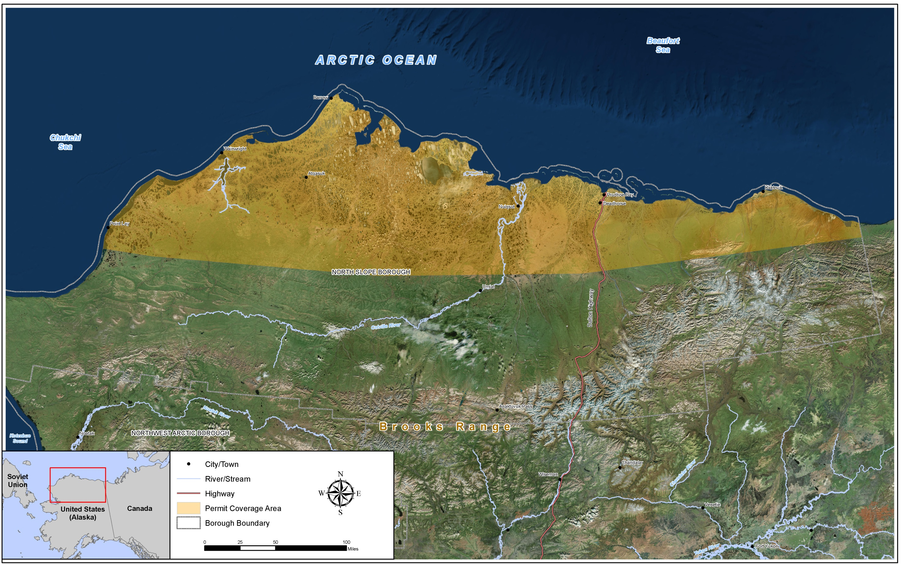
Figure 1 Alaskan North Slope

Project Classification
The Technical Subgroup assumed that the North Slope POGOs under consideration would only be subject to minor source New Source Review (NSR), rather than Prevention of Significant Deterioration (PSD) review. Therefore, this modeling demonstration for the North Slope POGO Simulation was prepared to satisfy ambient air quality demonstration requirements under Alaska’s minor source permitting program in 18 AAC 50.502. With this objective in mind, the Technical Subgroup compared the simulated impacts to just the AAAQS, rather than the AAAQS and PSD increments. However, the Technical Subgroup went beyond the requirements in 18 AAC 50.502 by assessing compliance with all applicable AAAQS, rather than only the AAAQS triggered by a POGO minor permit classification under 18 AAC 50.502(c)(2)(A).

Modeling Protocol Submittal
The Technical Subgroup did not develop a modeling protocol for the North Slope POGO Simulation because all approaches and methods were developed collaboratively with ADEC throughout the modeling process.

SOURCE IMPACT ANALYSIS
The Technical Subgroup used a computer analysis (modeling) to predict the ambient air quality impacts for the pollutants outlined in the Introduction of this report. A modeling analysis for lead (Pb), ammonia (NH₃), or secondary pollutants, including ozone (O₃) and secondary PM_{2.5}, was not conducted.

Lead is not a concern because it is not an additive in fuels used in North Slope POGOs. Lead would only be present at trace element levels as a result of engine lubricant constituents or as a result of engine wear and is negligible. Therefore, lead emissions from equipment associated with POGOs will be negligible and would not cause or contribute to an exceedance of the lead AAAQS.

Ammonia is not emitted by equipment or activities associated with POGOs, and concentrations have been shown to be low on the North Slope. Therefore, ammonia is not a concern.

Although O₃ is a criteria pollutant, it is not emitted directly into the atmosphere but rather formed by chemical reactions of precursor pollutants, primarily nitrogen oxides (NO_{X}) and volatile organic compounds (VOCs). Based on current regional air quality monitoring data (i.e. measured ground-level O₃ concentrations are well below the AAAQS) and the low magnitude of POGO emissions of precursors compared to the total precursor loading in the air shed, POGOs are not expected to have a significant impact on ambient O₃ generation on the North Slope. No evidence exists to suggest net O₃ production on the North Slope, but evidence does suggest scavenging, i.e. ozone decrease due to chemical reactions.

Modeling Approach
The North Slope POGO Simulation was designed to quantitatively assess air quality impacts using dispersion modeling for any POGO on the North Slope. Explicit modeling focused on that portion of the POGO that remains stationary while a well is being drilled, operates at a reasonably defined location, and therefore, could be reasonably simulated (i.e. the drill rig). The Technical Subgroup used the concept of a generic model simulation similar to the approach used by ADEC to support the MG1. In the MG1 analysis, ADEC modeled a limited number of generic drill rigs that reflected the typical configuration for the given area, rather than modeling the large number of specific drill rigs that were operating at the time within Alaska. The Technical Subgroup used the MG1 generic rig module configuration but updated rig module structure height and stack characterizations based on a reanalysis of drill rigs currently operating on the North Slope. Another departure from the MG1 approach was related to the applicability of the fuel use limits. In order to restrict the limits developed under the current effort to the drill rig, the Technical Subgroup did not explicitly model combustion equipment that are portable and not permanently attached to the drill rig. Furthermore, this equipment was eliminated because it is difficult to accurately simulate, leading to questionable results. Therefore, the Technical Subgroup included the impacts from these non-modeled sources through the use of representative background concentrations. This approach is consistent with modeling supporting the Transportable Drill Rig Title V permits, which accounted for the impacts from portable light plants through background concentrations. Not surprisingly, the current analysis used updated meteorological data and modeling techniques, which are described in this report, since the MG1 was developed over a decade ago.

The Technical Subgroup modeled each pollutant and averaging period listed in Section 1 to determine the maximum amount of fuel that could be consumed without violating the AAAQS. The Technical Subgroup found the maximum fuel consumption for each pollutant and averaging period, by making multiple model iterations and then scaling the daily fuel consumption and associated emission rates of the drill rig equipment. The generic drill rig was modeled at various liquid fuel consumptions ranging up to at least 20,000 gallons per day. Using the model-predicted impacts for each fuel consumption, linear interpolation or extrapolation was used to find the maximum fuel consumption at which operations do not violate the AAAQS. Figure 2 presents a flow chart describing this modeling approach, including the process for optimizing the drill rig nominal daily fuel consumption for each pollutant and averaging period modeled.

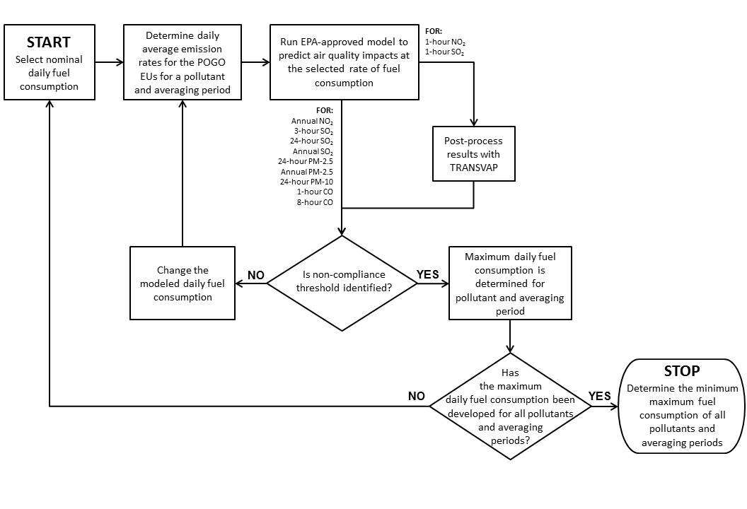
Figure 2 Generalized Approach for Determining the Maximum Daily Fuel Consumption

To determine the maximum allowable drill rig operation that complies with the AAAQS, the maximum allowable fuel consumption was determined on a daily basis. The Technical Subgroup used a daily basis because it is not reasonable to track drill rig fuel consumption on a timeframe less than a day. In addition, the daily limit is directly applicable to protecting critical limiting pollutants with short-term averaging periods, such as PM₁₀ and PM_{2.5}. However, a daily fuel consumption may not necessarily be protective of critical pollutants with 1-hour averaging periods, such as NO₂ and SO₂. To address this, for 1-hour NO₂, 1-hour SO₂, and 1-hour CO, the Technical Subgroup applied a 1.15 factor to daily average emission rates associated with the daily fuel consumption. This approach was used to account for short-term, transient operation above the daily fuel consumption rate which is likely only to occur during abnormal operations such as drilling through a particularly hard formation or freeing a stuck drill string. This “safety” factor was designed to allow a daily limit to be protective of a short-term standard under atypical conditions. This factor was not applied to other short-term averaging periods, such as 3-hour SO₂ and 8-hour CO, because these pollutants did not limit the analysis given the large compliance margins.

For assessing compliance with all but two of the applicable AAAQS, the Technical Subgroup used a highly simplified and conservative approach when estimating impacts with an U.S. Environmental Protection Agency (USEPA)-approved steady-state model. This technique entails modeling the drill rig operating at one location, year-round at 8,760 hours per year. While drill rigs do not operate in this manner, simulating their operation in this way simplifies the model execution and analysis.

For assessing compliance with the 1-hour NO₂ and 1-hour SO₂ probabilistic AAAQS, the Technical Subgroup used a statistical technique to take into account the transitory, temporary, and intermittent nature of equipment associated with POGOs. This statistical technique was used for 1-hour NO₂ and 1-hour SO₂ only because the simplified approach was sufficient to demonstrate compliance with the AAAQS for all other pollutants and averaging periods.

To apply this statistical technique for 1-hour NO₂ and 1-hour SO₂, modeling was conducted for various temporally and spatially varying drill rig scenarios using the North Slope POGO Simulation. A Monte Carlo technique was then applied to the modeling by post-processing 1-hour NO₂ and 1-hour SO₂ model-predicted impacts with the Transportable Source Variability Processor (TRANSVAP). Because this post-processing technique better simulates the transitory nature of POGOs and other portable sources, it reduces over-conservatism and predicts more realistic concentrations for assessing compliance with the probabilistic and multi-year form of the 1-hour NO₂ and SO₂ AAAQS. A detailed description of the TRANSVAP post-processor is included in Appendix C of this report.

Model Selection
There are a number of air dispersion models available to permit applicants and regulators. The USEPA lists these models in their Guideline on Air Quality Models (Guideline), which ADEC has adopted by reference in 18 AAC 50.040(f). The Technical Subgroup used USEPA’s AERMOD Modeling System (AERMOD) for the North Slope POGO Simulation.

The AERMOD Modeling System consists of three major components:
- AERMAP to process terrain data for receptor grid and EU elevations.
- AERMET to process the meteorological data.
- AERMOD to estimate the ambient pollutant concentrations.

The Technical Subgroup modeled most of the North Slope POGO Simulation with the version of AERMOD and AERMET current at the time of modeling (version 14134). However, USEPA released updated versions of AERMOD (versions 15181 and 16216r) and AERMET (versions 15181 and 16216) before all efforts were finalized.

The Technical Subgroup used the 15181 version of AERMOD and AERMET for the final 1-hour NO₂, annual NO₂, and 24-hour PM_{2.5} runs and version 14134 for all other pollutants and averaging periods. The Technical Subgroup also conducted sensitivity analyses for critical pollutants and averaging periods (i.e. 1-hour NO_{X}, 1-hour SO₂, and 24-hour PM_{2.5}) to determine if the subsequent AERMOD 16216r and AERMET 16216 updates would change the results previously predicted. These sensitivity analyses are summarized in Appendix A and indicate that versions 14134, 15181, and 16216r all predict the same results for 1-hour NO_{X}, 1-hour SO₂, and 24-hour PM_{2.5} analyses. The sensitivity analysis was conducted for NO_{X} rather than NO₂ because the PVMRM chemical algorithms in AERMOD version 15181, are no longer available with version 16216r. Therefore, a direct comparison is not possible.

The Technical Subgroup assumed no terrain relief and set the elevation for all receptors to zero meters, which is common practice for sources located on the North Slope coastal plan. This obviated the need to run AERMAP for the North Slope POGO Simulation.

Meteorological Data
AERMOD requires hourly meteorological data to estimate plume dispersion. A minimum of one-year of site-specific data, or five years of representative National Weather Service (NWS) data, should be used per Section 8.3 of the Guideline (Section 8.4 of the 2017 Guideline). When modeling with site-specific data, the Guideline states that up to five years should be used, when available, to account for year-to-year variation in meteorological conditions.
The North Slope POGO Simulation was modeled with five years of site-specific hourly surface meteorological data collected by BP Exploration Alaska, Inc. (BPXA) at the Prudhoe Bay Unit (PBU) A-Pad Meteorological Monitoring Station from 2006 through 2010. Being centrally located, the meteorological data collected at the A-Pad Monitoring Station is considered representative of meteorological conditions in the project area. The A-Pad surface meteorological data was supplemented with upper air data collected at the NWS station located in Barrow, Alaska (WBAN #27502).

The use of A-Pad meteorological surface data and Barrow upper air data has been approved by ADEC for use in numerous Alaskan North Slope permit applications. The 2006-2010 dataset and processing methods, which includes selection of the local surface characteristics, were originally approved for use in BPXA’s minor permit application for Gathering Center #3 (Air Quality Control Minor Permit AQ0184MSS02, issued October 24, 2012). For the North Slope POGO Simulation, this meteorological dataset was reprocessed with AERMET (versions 14134, 15181, and 16216) using the processing methods previously approved by ADEC. The meteorological dataset was not refreshed with more recent years of data to avoid repeated redesign of the simulation as a result of the multi-year aspect of the Workgroup efforts.

Coordinate System
Air quality models must understand the relative location of emission releases and structures in order to properly estimate the dispersion of pollutants and ambient pollutant concentrations at receptors. For the North Slope POGO Simulation, plant coordinates were used for all modeled EUs and receptor locations because this simulation was designed to be a generic representation of any North Slope POGO.

EU Inventory
The modeled EUs for the North Slope POGO Simulation consist of RICE, heaters, and boilers directly supporting the drill rig. The RICE associated with drill rigs and support equipment would be classified as nonroad engines (NREs). The North Slope POGO Simulation was designed to be representative of any POGO with various sizes and numbers of liquid-fired EUs directly supporting a typical drill rig. Other support equipment and activities potentially associated with the POGO but not directly supporting the drill rig, including well servicing activities, were accounted for through the selection of representative background concentrations. By doing this, any limits on allowable fuel consumption developed with the North Slope POGO Simulation are applicable to only the drill rig.

The modeling approach, described in Section 1, involves modeling a drill rig at various sizes by varying the amount of fuel consumed by the drill rig. This approach allows the model simulation to represent the operation of various sizes of drill rigs or any number of drill rigs operating concurrently. Therefore, the actual equipment ratings are not important to this analysis. Instead, the sizes of different RICE, heaters, and boilers on the drill rig relative to each other were taken into consideration. The relative sizes of the drill rig equipment determine how the fuel is apportioned among the EUs, which is important to characterizing emissions and impacts.

To support the North Slope POGO Simulation, a typical inventory of equipment directly supporting the drill rig was developed from a survey of 22 drill rigs operating on the North Slope. The results of this analysis are included in Appendix B and were used to apportion fuel and calculate emissions for each stack modeled for each total rig fuel use modeled. A high-level description of the modeled drill rig EUs is provided in Table 3.

To further describe the modeled EU inventory, the locations of the EUs relative to drill rig modules, or structures, are illustrated in Figure 3. Figure 4 depicts the proximity of modeled EUs to drill rig modules and the ambient boundary for each well location modeled. The drill rig and EUs are arranged for operation along an oil and gas well line. North Slope oil and gas well lines are often oriented parallel with the prevailing meteorological conditions to facilitate snow removal.

Non-Modeled EUs
Table 4 presents examples of EUs that are not explicitly modeled but could occupy the pad and operate at the same time as the POGO. Some may indirectly support the drilling operation, and others are equipment permanently located at the pad, such as freeze protection pumps and production or line heaters. The EUs in Table 4 represent typical examples of this type of combustion equipment.

Rather than explicit modeling, the Technical Subgroup represented most of the EUs in Table 4 with representative ambient background data. The selection of monitored ambient data to develop representative background concentrations is discussed in Section 3.13. In addition, the Technical Subgroup also determined that it was not necessary to model permanent production heaters or flares as part of the North Slope POGO Simulation but rather address their influence through a sensitivity modeling analysis. Because of their placement on the pad relative to the POGO and their stack exit characteristics, these types of equipment are unlikely to produce plumes of emissions that overlap with the dominate sources of emissions when a POGO is operating on a well pad. This conclusion was borne out by the sensitivity modeling analysis conducted; therefore, it was concluded that impacts from a natural gas-fired production heater and a portable flare do not change the results of the North Slope POGO Simulation, and these EUs are included as non-modeled sources in Table 4. This sensitivity analysis for a permanent production heater and portable flare is discussed in detail in Appendix A.

Table 3 Modeled EU Inventory
Modeled Stack ID | Description | Typical Size/Rating
RIG1_1 | Primary Drilling Engines | Large (greater than 600 bhp) diesel-fired RICE used for power generation for rig top drive, rotary table and draw works, or other electrified equipment.
RIG1_2 | Primary Drilling Engines
GEN1_2 | Large Utility Engines | Large (greater than 600 bhp) diesel-fired RICE used for miscellaneous power generation or in mechanical service driving equipment such as mud pumps, cement pumps, or grind and inject units.
AUX1 | Small Utility Engines | Small (less than 600 bhp) diesel-fired RICE used for miscellaneous power generation or mechanical power.
ST1_1 | Drill Rig Heaters and Boilers | Diesel-fired boilers and air heaters used to provide general utility heat to the drill rig.
ST1_2 | Drill Rig Heaters and Boilers

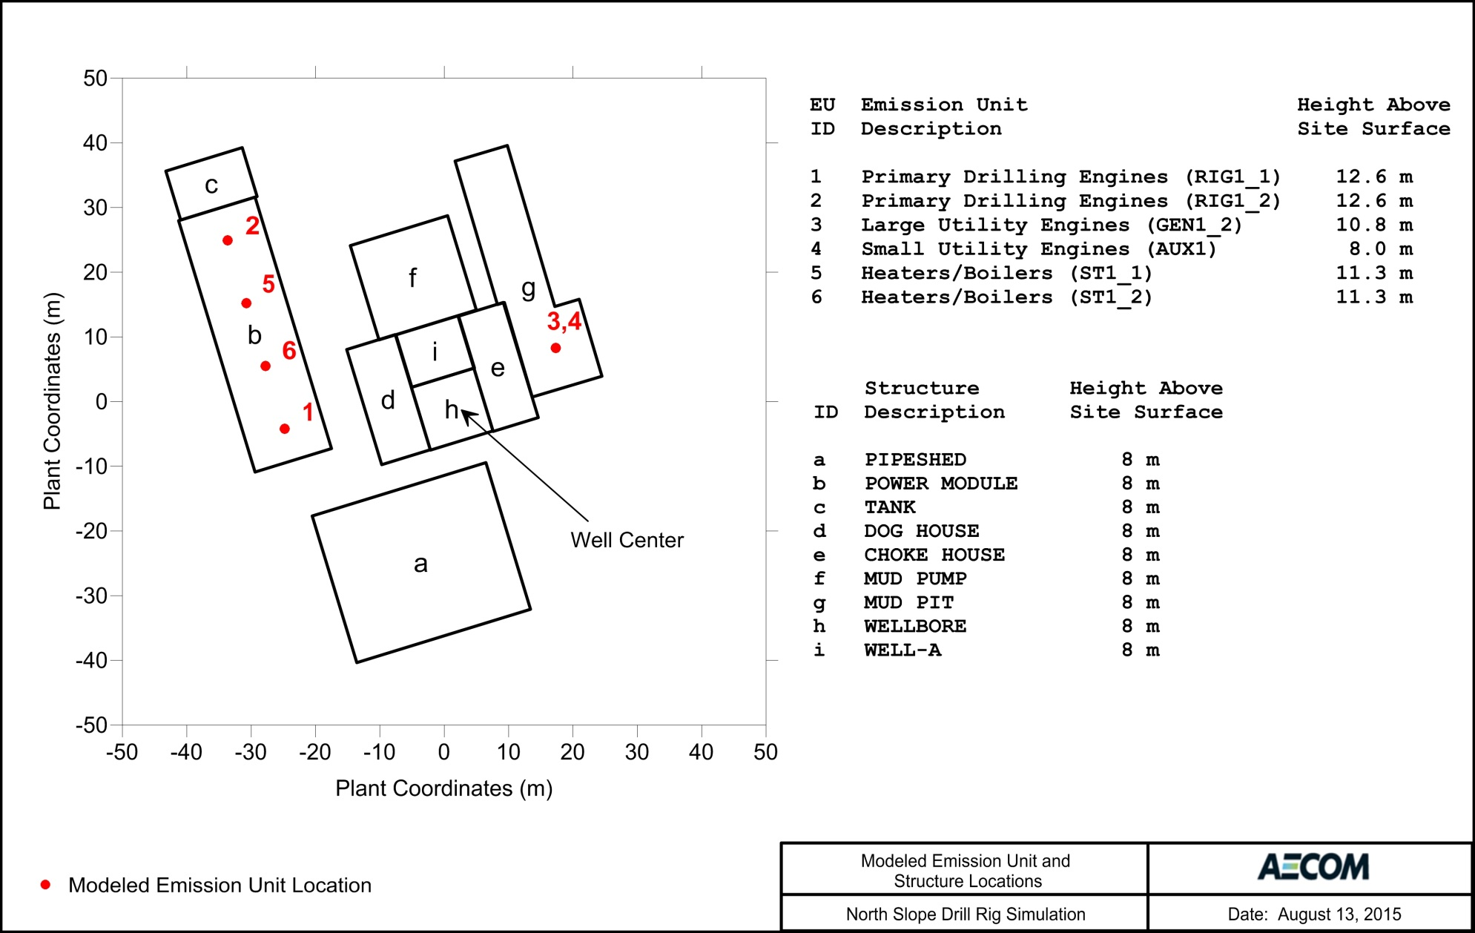
Figure 3 Placement of the Emissions Units on the Representative Modeled Drill Rig

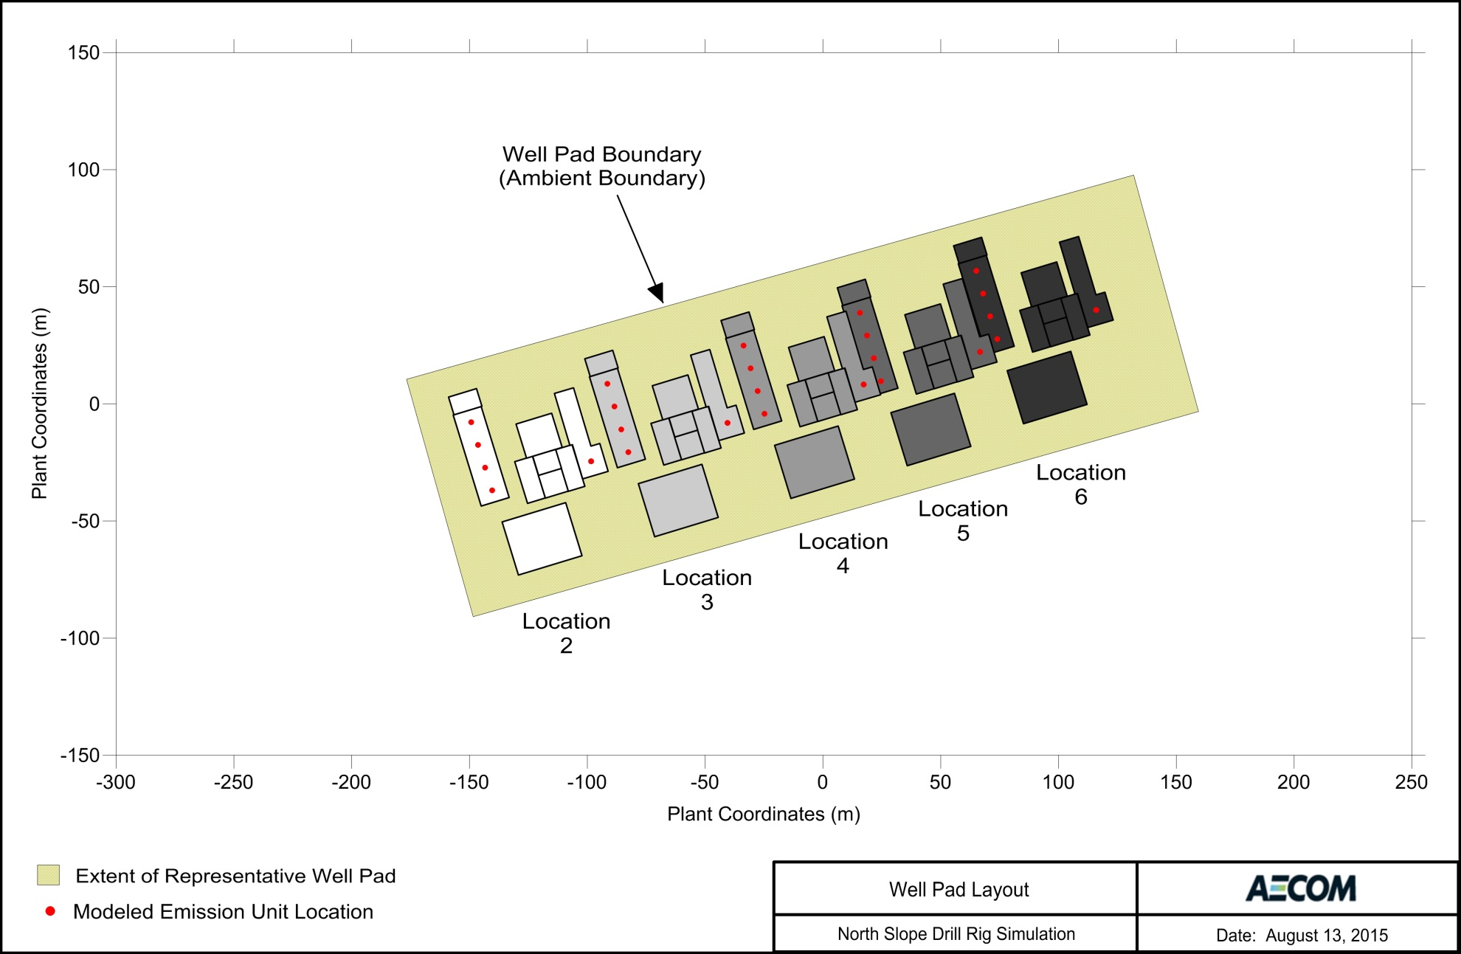
Figure 4 Configuration of the Representative Well Pad with Five Modeled Well (Drill Rig) Locations

Table 4 Example Non-Modeled EUs
Description |  | Description
Oilfield Construction Equipment
Worker housing/camp generators | Cranes
Passenger bus | Manlifts
Portable heaters | Snowblowers
Portable welders | Loaders
Portable light plant generators | Portable air compressors
Sewage Pump Trucks | Portable drills
Tractors | Other Mobile Sources
Other portable power generation
Well Drilling, Servicing, Maintenance, and Miscellaneous Oilfield Support Equipment
Worker housing/camp generators | Drill rig move engines
Portable light plant generators | Graders
Welding, cutting, and soldering equipment | Other portable power generation
Coil tubing units | N₂ pumping units
E-Line/Wireline units | Cementing units
Slickline units | Hydraulic fracturing units
Hydraulic lifts | Hot oil units
Portable Welders | Ball mills, grinding mills, and crushers
Bulldozers | Portable flares and waste gas incinerators
Cranes | Portable incinerators
Manlifts | Portable Heaters
Snow blowers, snow melters, and other general snow removal equipment | Other Mobile Sources
Permanent Well Pad Equipment
Production/line heater | Small stationary engines in power generation or mechanical service
Freeze protection pumps

EU Release Parameters
The characterization of emission rates and their release into the atmosphere can significantly influence model-predicted impacts. Therefore, the following sections provide discussion of the stack height, diameter, location, and base elevation, in addition to the pollutant emission rates, exhaust plume exit velocity, and exhaust temperature for each exhaust stack.

Emission Rates
Short-term and long-term emission rates were determined for all modeled EUs for the North Slope POGO Simulation for a base drill rig fuel consumption of 10,000 gallons per day. For the purposes of implementing the modeling approach described in Section 1, all emission rates for any modeled fuel consumption are scaled from these base emission rates, which are summarized in Table 5. Engine emission rates were derived from vendor data for non-tiered engines representative of large primary engines, large utility engines, and small utility engines supporting POGOs. Drill rig heater and boiler emission rates were calculated based on AP-42 emission factors. In addition to these considerations, emissions, which warrant additional discussion, were derived based on the information in the following sections.

Sulfur Compound Emissions
SO₂ emissions are directly related to the sulfur content of the fuel. Since 2006, all nonroad engines are required to burn ULSD with a maximum sulfur concentration of 15 parts per million or 0.0015 percent sulfur by weight. While ULSD is typical for most liquid-fired equipment supporting POGOs on the North Slope, heaters and boilers are allowed to burn a higher sulfur, Arctic grade fuel, known as LEPD. To accommodate this range of possible fuels, the North Slope POGO Simulation drill rig heaters and boilers were assumed to combust LEPD with a sulfur content of 0.15 percent sulfur by weight.

Operational Limits
There are no operational limits assumed in modeling the North Slope POGO Simulation outside those developed to demonstrate compliance. The Technical Subgroup assumed all of the modeled EUs are continuously and concurrently operating during the drilling operation. However, it should be noted that the purpose of this modeling analysis is to determine operational limits as discussed with the results in Section 5.

Short-Term Emission Rates
The modeled emission rate should generally reflect the maximum emissions allowed during a given averaging period. Modeled short-term emission rates for the North Slope POGO Simulation were developed to reflect maximum emissions by pollutant and averaging period. Short-term emission rates for 1-hour NO₂, 1-hour SO₂, and 1-hour CO were calculated by multiplying the average daily emission rates by a factor of 1.15 to account for short-term excursions from the daily average emission rate.

Application of Temporally-Varying Emissions
Temporally-varying emissions were applied to drill rig operation in two ways to simulate the following:
- Seasonally-varying drill rig equipment operation.
- Transient hourly excursions in fuel consumption above the daily modeled rate.

The use of heaters and boilers supporting a drill rig operation varies seasonally with higher usage during colder winter months and lower usage during warmer months. The North Slope POGO Simulation used a seasonal profile of drill rig heater and boiler usage to simulate this aspect of their operation. To vary the heater and boiler operation, a monthly nominal emissions scaling factor was applied to emission rates to simulate the seasonally-varying operation. These monthly scaling factors are summarized in Table 6.

In order to maintain a constant drill rig fuel consumption year-round, a complementary monthly factor was applied to drill rig engine operations, which is also shown in Table 6. This seasonally-varying operation is conservatively representative for drill rig engines, because it represents additional fuel consumption above expected drilling operation during warmer months of the year. The scaling factors in Table 6 were incorporated into the North Slope POGO Simulation for all pollutants and averaging periods.

Transient hourly excursions in fuel consumption above the nominal rate were incorporated into the North Slope POGO Simulation to demonstrate that conclusions are not sensitive to intermittent operation well above nominal daily fuel consumption. These excursions were applied by simulating drill rig operations with 25 percent higher fuel consumption during 20 percent of the modeled period. The duration of the excursions was randomly chosen according to a normal distribution with a mean of 48 hours (two days) and standard deviation of 24 hours (1 day). The length of time at normal operations, without excursions, was randomly chosen between 0 and 384 hours (16 days). In addition to emission rates, the modeled exit temperature and exit velocity were also scaled with the transient hourly excursions by a factor of 1.25 to account for stack conditions when equipment is running harder. The sensitivity of the North Slope POGO Simulation to the scaling of these parameters is discussed in Appendix A. Table 8 summarizes the stack parameters during excursions from nominal operation. The transient hourly excursions were applied to the 1-hour NO₂ modeling only because it was determined to be the limiting pollutant and averaging period for the North Slope POGO Simulation.

Figure 5 illustrates the emission rate scalars applied within AERMOD over a typical year to the modeled drill rig engines, heaters, and boilers. The depicted emission rate scalars include the seasonally-varying operations and transient hourly excursions applied to the modeling demonstration for 1-hour NO₂. However, the depicted scalars in Figure 5 do not include the constant scalar to adjust to a fuel consumption basis other than 10,000 gallons per day.

For 1-hour NO₂, emission rates for all EUs were applied in AERMOD using an hourly emissions input file with the “HOUREMIS” keyword to incorporate the following emission rate refinements: (1) constant scaling to simulate nominal fuel consumption other than 10,000 gallons per day, (2) seasonal equipment operations, and (3) transient hourly excursions in emission rates.

For all other pollutants and averaging periods, emission rates for all EUs were applied in AERMOD using variable emission rate factors with the “EMISFACT” keyword to incorporate the following emission rate refinements: (1) constant scaling to simulate nominal fuel consumption other than 10,000 gallons per day and (2) seasonal equipment operations.

Point Source Parameters
Stack height, stack diameter, location, orientation angle, base elevation, exhaust plume exit velocity, and exhaust temperature were determined for all modeled EUs. All EUs are modeled with vertical, uncapped stacks for the North Slope POGO Simulation. Stack parameters for the North Slope POGO Simulation are summarized in Table 7. The plant coordinates of EUs modeled at each well location are summarized in Table 9. The Technical Subgroup collocated stacks for the large and small utility engines, GEN1_2 and AUX1, respectively. Collocating stacks increases plume overlap and leads to more conservative modeled impacts.
Table 5 Base Emission Rates (Grams per Second) for a Drill Rig Operating at 10,000 Gallons per Day
Model ID | NO₂ |  | SO₂ |  | PM_{2.5} |  | PM₁₀ | CO
 | 1-hour | Annual | 1-hour | 3-hour  24-hour  Annual | 24-hour | Annual | 24-hour | 1-hour | 8-hour
RIG1_1 | 6.036 | 5.2491 | 0.0036 | 0.0032 | 0.0418 | 0.0418 | 0.0418 | 0.9863 | 0.8577
RIG1_2 | 6.036 | 5.2491 | 0.0036 | 0.0032 | 0.0418 | 0.0418 | 0.0418 | 0.9863 | 0.8577
GEN1_2 | 1.635 | 1.4215 | 0.0011 | 0.0005 | 0.0206 | 0.0206 | 0.0206 | 0.4893 | 0.4255
AUX1 | 0.150 | 0.1301 | 0.0001 | 0.0001 | 0.0009 | 0.0009 | 0.0009 | 0.0310 | 0.0269
ST1_1 | 0.183 | 0.1587 | 0.1862 | 0.1619 | 0.0169 | 0.0169 | 0.0189 | 0.0456 | 0.0397
ST1_2 | 0.183 | 0.1587 | 0.1862 | 0.1619 | 0.0169 | 0.0169 | 0.0189 | 0.0456 | 0.0397

Table 6 Nominal Emissions Scaling Factor Used as Input to AERMOD
Month | Jan | Feb | Mar | Apr | May | Jun | Jul | Aug | Sep | Oct | Nov | Dec
Heater/ Boiler Factor | 1.00 | 1.00 | 1.00 | 0.760 | 0.520 | 0.280 | 0.280 | 0.280 | 0.460 | 0.640 | 0.820 | 1.00
Engine Factor | 1.00 | 1.00 | 1.00 | 1.104 | 1.208 | 1.312 | 1.312 | 1.312 | 1.234 | 1.156 | 1.078 | 1.00

Jan Feb Mar Apr May Jun Jul Aug Sep Oct Nov Dec
(a)
(b)
Jan Feb Mar Apr May Jun Jul Aug Sep Oct Nov Dec
Figure 5 Normalized 1-hour NO₂ Seasonally-Varying Emission Rates with Transient Hourly Excursions for (a) Heaters and Boilers and (b) Engines for a Typical Year
Normalized Short-term Heater/Boiler Emission Rate
Normalized Short-term Engine Emission Rate
Table 7 Stack Parameters during Nominal Operation
Model ID | Base Elevation ª (m) | Release Height ^{b} |  | Exit Temperature |  | Exit Velocity |  | Exit Diameter |  | In-Stack NO₂-to-NO_{X} Ratio ^{g}
 |  | (ft) | (m) | (°F) | (°K) | (ft/s) | (m/s) | (in) | (m)
RIG1_1 ^{c, h} | 1.5 | 41.17 | 12.55 | 950.0 | 783.2 | 233.2 | 71.1 | 10.0 | 0.254 | 0.10
RIG1_2 ^{c, h} | 1.5 | 41.17 | 12.55 | 950.0 | 783.2 | 233.3 | 71.1 | 10.0 | 0.254 | 0.10
GEN1_2 ^{d, h} | 1.5 | 35.57 | 10.84 | 960.1 | 788.8 | 198.6 | 60.5 | 8.0 | 0.203 | 0.10
AUX1 ^{e, h} | 1.5 | 26.25 | 8.00 | 1,110 | 872.1 | 254.3 | 77.5 | 6.0 | 0.152 | 0.10
ST1_1 ^{f} | 1.5 | 37.13 | 11.32 | 449.8 | 505.3 | 29.8 | 9.1 | 12.0 | 0.305 | 0.05
ST1_2 ^{f} | 1.5 | 37.13 | 11.32 | 449.8 | 505.3 | 29.8 | 9.1 | 12.0 | 0.305 | 0.05
ª Base elevations are based on a 5-foot pad elevation typical of North Slope operations. North Slope pads are elevated by approximately 5 feet because of construction requirements on tundra.
^{b} Release heights developed using a statistical analysis of drill rig stack height to building height ratio from a survey of North Slope drill rigs.
^{c} Exit temperature and velocity derived from vendor data for representative drill rig engines (1,309 bhp Caterpillar D399 JWAC PCTA) at full load and 1,200 rpm.
^{d} Exit temperature and velocity derived from vendor data for representative large utility engines (629 bhp Caterpillar D379 JWAC) at full load and 1,200 rpm.
^{e} Exit temperature and velocity derived from vendor data for representative small utility engines (455 bhp Caterpillar 3406 PCTA) at full load and 1,800 rpm.
^{f} Exit temperature, velocity, and diameter for drill rig heaters and boilers based on those documented in the MG1 Modeling Protocol for a North Slope drill rig (April 21, 1999).
^{g} In-stack NO₂-to-NO_{X} ratios discussed in Section 3.8.1.3.
^{h} Engine stack diameters selected to achieve an exit velocity of approximately 70 m/s on the engines.

Table 8 Stack Parameters during Excursions from Nominal Operation
Model ID | Base Elevation ª (m) | Release Height ^{b} |  | Exit Temperature |  | Exit Velocity |  | Exit Diameter |  | In-Stack NO₂-to-NO_{X} Ratio ^{g}
 |  | (ft) | (m) | (°F) | (°K) | (ft/s) | (m/s) | (in) | (m)
RIG1_1 ^{c, h} | 1.5 | 41.17 | 12.55 | 1,303 | 979.0 | 291.6 | 88.9 | 10.0 | 0.254 | 0.10
RIG1_2 ^{c, h} | 1.5 | 41.17 | 12.55 | 1,303 | 979.0 | 291.6 | 88.9 | 10.0 | 0.254 | 0.10
GEN1_2 ^{d, h} | 1.5 | 35.57 | 10.84 | 1,315 | 986.0 | 248.1 | 75.6 | 8.0 | 0.203 | 0.10
AUX1 ^{e, h} | 1.5 | 26.25 | 8.00 | 1,503 | 1,090 | 317.8 | 96.9 | 6.0 | 0.152 | 0.10
ST1_1 ^{f, h} | 1.5 | 37.13 | 11.32 | 677.3 | 631.6 | 37.3 | 11.4 | 12.0 | 0.305 | 0.05
ST1_2 ^{f, h} | 1.5 | 37.13 | 11.32 | 677.3 | 631.6 | 37.3 | 11.4 | 12.0 | 0.305 | 0.05
ª Base elevations are based on a 5-foot pad elevation typical of North Slope operations. North Slope pads are elevated by approximately 5 feet because of construction requirements on tundra.
^{b} Release heights developed using a statistical analysis of drill rig stack height to building height ratio from a survey of North Slope drill rigs.
^{c} Exit temperature and velocity derived from vendor data for representative drill rig engines (1,309 bhp Caterpillar D399 JWAC PCTA) at full load and 1,200 rpm, scaled by a factor of 1.25 during excursions.
^{d} Exit temperature and velocity derived from vendor data for representative large utility engines (629 bhp Caterpillar D379 JWAC) at full load and 1,200 rpm, scaled by a factor of 1.25 during excursions.
^{e} Exit temperature and velocity derived from vendor data for representative small utility engines (455 bhp Caterpillar 3406 PCTA) at full load and 1,800 rpm, scaled by a factor of 1.25 during excursions.
^{f} Exit temperature, velocity, and diameter for drill rig heaters and boilers based on those documented in the MG1 Modeling Protocol for a North Slope drill rig (April 21, 1999). Exit temperature and velocity, but not diameter, are scaled by a factor of 1.25 during excursions. It is not appropriate to scale the diameter as physical changes do not occur to the rig during excursions.
^{g} In-stack NO₂-to-NO_{X} ratios discussed in Section 3.8.1.3.
^{h} Stack diameters equivalent to those set for Nominal Operation.

Table 9 Location of Emission Releases at Each Drilling Location (Plant Coordinates)
Model ID | Well Location 2 (m) |  | Well Location 3 |  | Well Location 4 |  | Well Location 5 |  | Well Location 6
 | X_{North} (m) | Y_{East} (m) | X_{North} (m) | Y_{East} (m) | X_{North} (m) | Y_{East} (m) | X_{North} (m) | Y_{East} (m) | X_{North} (m) | Y_{East} (m)
RIG1_1 | -140.4 | -36.9 | -82.6 | -20.6 | -24.8 | -4.2 | 24.6 | 9.7 | 74.0 | 27.7
RIG1_2 | -149.3 | -7.8 | -91.5 | 8.6 | -33.7 | 24.9 | 15.7 | 38.9 | 65.1 | 56.8
GEN1_2 | -98.4 | -24.5 | -40.5 | -8.1 | 17.3 | 8.3 | 66.7 | 22.2 | 116.0 | 40.1
AUX1 | -98.4 | -24.5 | -40.5 | -8.1 | 17.3 | 8.3 | 66.7 | 22.2 | 116.0 | 40.1
ST1_1 | -143.4 | -27.2 | -85.6 | -10.9 | -27.7 | 5.5 | 21.6 | 19.5 | 71.0 | 37.4
ST1_2 | -146.4 | -17.5 | -88.5 | -1.1 | -30.7 | 15.2 | 18.7 | 29.2 | 68.0 | 47.1

Pollutant-Specific Considerations
The NO₂ and secondarily-formed PM_{2.5} pollutants warrant additional discussion.

Ambient NO₂ Modeling
NO_{X} emissions from combustion sources are partly nitric oxide (NO) and partly NO₂. After the combustion gas exits the stack, additional NO₂ can be created due to atmospheric reactions. Section 5.2.4 of the Guideline (Section 4.2.3.4 of the 2017 Guideline) describes a tiered approach for estimating the annual average NO₂ impacts, ranging from the simplest but very conservative assumption that 100 percent of the NO is converted to NO₂, to other more complex methods.

The Technical Subgroup used the version of the Plume Volume Molar Ratio Method available as an alternative modeling technique prior to 2017 (pre-2017 PVMRM) to estimate ambient NO₂ concentrations to compare to the 1-hour and annual AAAQS. Throughout the development of the North Slope POGO Simulation, USEPA had been adjusting the pre-2017 PVMRM algorithm to better characterize the non-linear mixing of ozone through the modeled plume. After the modeling was complete, but before drafting this document, the pre-2017 PVMRM version had been replaced. Because of the work required in switching the analysis to the current version of PVMRM and pre-2017 PVMRM was current during the largest part of subgroup efforts, the analysis was not revised.

USEPA and ADEC Approval
The pre-2017 PVMRM approach is a non-Guideline method and required USEPA and ADEC approval in accordance with 18 AAC 50.215(c)(2). USEPA Region 10 granted the Workgroup permission to use pre-2017 PVMRM for the North Slope POGO Simulation on June 28, 2016. The Air Permits Program Manager gave his approval on November 5, 2015.

Public Comment
The use of a non-Guideline model in support of a minor permit decision is subject to public comment per 40 CFR 51.160(f)(2) and 18 AAC 50.542(d)(1)(F). Therefore, ADEC intends to solicit public comment regarding the use of pre-2017 PVMRM in the public notice for the preliminary permit decision.

In-Stack NO₂-to-NO_{X} Ratio
An in-stack NO₂-to-NO_{X} ratio (ISR) must be specified for each modeled EU when using pre-2017 PVMRM. The Technical Subgroup used an ISR of 0.10 for all drill rig engines, and an ISR of 0.05 for all drill rig heaters and boilers. The ISRs are summarized for each modeled EU in Table 7.

The Technical Subgroup used the following data sources to develop the ISRs:
- USEPA’s Technology Transfer Network (TTN) Support Center of Regulatory Atmospheric Modeling (SCRAM) database.
- ADEC’s Air Dispersion Modeling database.
- Measured ISRs compiled in Shell Offshore, Inc.’s (Shell’s) Conical Drilling Unit Kulluk OCS Permit Applications.

ISRs for Reciprocating Internal Combustion Engines
For the North Slope POGO Simulation, an ISR of 0.10 was selected for all sizes of RICE based on the data described in the following studies.

ISR data from USEPA’s SCRAM database for large (greater than 600 horsepower) diesel-fired RICE ranged from 0.06 and 0.10 over various load classes. ISR data from ADEC’s database are a subset of USEPA’s SCRAM database and confirmed ISRs less than 0.10 for large RICE. The average ISR from ADEC’s database was 0.04 across all load classes, with maximum and minimum ISRs for uncontrolled RICE of 0.05 and 0.03, respectively.

No ISR information exists for small (less than 600 horsepower) diesel-fired RICE in either the USEPA or ADEC databases. Therefore, ISRs compiled as supplemental information as part of Shell’s Conical Drilling Unit Kulluk OCS Permit Applications were examined to determine ISRs for small RICE without pollution controls. All ISRs for uncontrolled small RICE in Shell’s dataset are below 0.10, which indicates small RICE have similar ISRs to large RICE.

ISRs for Heaters and Boilers
For the North Slope POGO Simulation, an ISR of 0.05 was selected for all drill rig heaters and boilers based on the data described in the following studies.

ISR data from USEPA’s SCRAM database for diesel-fired “small” (less than 10 MMBtu/hr heat input) boilers confirm that an ISR as low as 0.05 is justifiable for the purposes of modeling small diesel fired boilers. An ISR of 0.05 is also more conservative than the 0.041 ISR used by Shell in their 2011 Conical Drilling Unit Kulluk OCS Permit Applications.

Ozone Data
Pre-2017 PVMRM requires ambient ozone data in order to determine how much of the NO is converted to NO₂. A conservatively representative hourly ozone dataset was compiled for input into AERMOD from five years of ozone data collected at BPXA’s A-Pad Monitoring Station between 2006 and 2010. These years of data were selected for consistency with the meteorological data used for modeling. This data and the approach to developing this dataset have been previously approved by ADEC and are routinely used for NO₂ modeling of North Slope sources. One example is the modeling conducted by BPXA in support of their “Liberty” PSD project (Construction Permit AQ0181CPT06).

Qualitative Assessment of Secondary PM_{2.5} Impacts
PM_{2.5} is either directly emitted from a source or formed secondarily through chemical reactions in the atmosphere (secondary formation) from other pollutants, such as NO_{X} and SO₂. AERMOD is an acceptable model for performing near-field analysis of the direct emissions, but USEPA has not developed a near-field model that includes the necessary chemistry algorithms for estimating the secondary impacts. The Technical Subgroup, therefore, used the USEPA guidance available at the time of the analysis to address how secondary formation could be accounted for in various PSD scenarios. While the guidance is not directed at minor permit modeling, it nevertheless provides useful information for minor permit assessments.

Following USEPA guidance on addressing secondary PM_{2.5} formation, secondary PM_{2.5} can be qualitatively assessed considering that:
- Secondary PM_{2.5} impacts are not correlated in time or space with direct PM_{2.5} impacts.
- Secondary PM_{2.5} impacts are captured in the ambient data used for background concentrations on the North Slope.
- Secondary PM_{2.5} impacts will be small because PM_{2.5} formation is limited by low NH₃ concentrations on the North Slope.

This USEPA guidance indicates that the maximum direct impacts and the maximum secondary impacts from a stationary source “…are not likely well-correlated in time or space.” Therefore, direct and secondary PM_{2.5} impacts will likely occur in different locations and at different times because secondary PM_{2.5} is formed through a complex photochemical reaction that requires time to occur. This time-frame is too long for substantial formation to occur in the near-field, which is where the maximum direct impacts occur. Since the maximum direct project impacts occur within the immediate near-field of the POGO, the formation of secondary particulates in the near-field of North Slope POGOs would likely be inconsequential and do not need to be accounted for in the cumulative impact analysis.

Similarly at larger distances from a source, where the maximum secondary impacts would occur, direct impacts would be negligible. However, even at these distances, the maximum secondary PM_{2.5} impacts expected from a North Slope POGO would also be very small. This is confirmed by a photochemical modeling study that explored the source-distance relationship of secondary PM_{2.5} formation from NO_{X} and SO₂ precursors. This study showed that maximum secondary PM_{2.5} impacts from these precursors occur approximately 5 to 10 kilometers from a source. For a single source with 1,000 to 3,000 tons per year (tpy) of NO_{X} emissions, 24-hour secondary PM_{2.5} nitrate impacts would be 0.1 to 1 µg/m³. For a single source with 500 to 1,000 tpy of SO₂ emissions, 24-hour secondary PM_{2.5} sulfate impacts would be 0.2 to 8 µg/m³. This study also showed that beyond a distance of 5 to 10 kilometers, secondary PM_{2.5} sulfate impacts were negligible. Secondary PM_{2.5} nitrate impacts were very small, potentially only as large as 0.2 µg/m³, at a distance of 100 kilometers from the source. Because direct impacts from a source at these distance would be negligible and the potential secondary PM_{2.5} impacts are well below the AAAQS, it is clear that secondary PM_{2.5} impacts are not a concern.

This study supports conclusions that the magnitude of secondary PM_{2.5} impacts from North Slope POGO emissions would be negligible in the immediate near-field of the POGO where maximum direct PM_{2.5} impacts occur and small at the location of peak secondary PM_{2.5} impacts which are likely to occur beyond five kilometers from the POGO. Drawing these conclusions for the North Slope POGO from this study is a conservative application of the study results considering that: (1) North Slope POGO NO_{X} and SO₂ emissions are only a small fraction of source emissions evaluated in this study and (2) this study was conducted for sources at mid-latitudes which have more favorable conditions, such as NH₃ concentrations, for particulate formation. Formation of secondary particulates on the North Slope is also limited by low NH₃ concentrations. Therefore, secondary PM_{2.5} formation in the near-field of the POGO from regional sources and regionally from the POGO will be small.

USEPA guidance also indicates that representative ambient monitoring data could be used to address the secondary formation that occurs from existing sources in the ambient modeling demonstration. The background data used in the PM_{2.5} AAAQS analysis in Section 4 adequately meets this objective. As described in Section 3.13, the ambient data collected is downwind of regional oil and gas operations at a distance that likely allows for secondary formation of particulates. Therefore, secondary PM_{2.5} impacts from upwind sources are accounted for in the North Slope POGO Simulation.

Downwash
Downwash refers to the situation where local structures influence the plume from an exhaust stack. Downwash can occur when a stack height is less than a height derived by a procedure called “Good Engineering Practice” (GEP), which is defined in 18 AAC 50.990(42). It is a consideration when there are receptors relatively near structures and exhaust stacks.

USEPA developed the “Building Profile Input Program – PRIME” (BPIPPRM) program to determine which stacks could be influenced by nearby structures and to generate the cross-sectional profiles needed by AERMOD to determine the resulting downwash. The North Slope POGO Simulation used the current version of BPIPPRM (version 04274) to determine the building profiles needed by AERMOD. All modeled point sources are included in the downwash analysis. BPIPPRM indicated that all modeled exhaust stacks are within the GEP stack height requirements.

Ambient Air Boundary
The AAAQS only apply in ambient air locations, which have been defined by USEPA as, “that portion of the atmosphere, external to buildings, to which the general public has access.” Therefore, areas that are owned or leased by the applicant can be excluded from the ambient demonstration if public access is “precluded by a fence or other physical barrier.” They conversely need to model that portion of their property/lease that has no such restriction, or where there is an easement or public right-of-way. Natural features, such as dense vegetation or topographical features, can provide adequate barriers to public access, although the adequacy of the given features must be evaluated on a case-specific basis.

The Technical Subgroup used the edge of the pad as the ambient air boundary, which is standard practice for North Slope permit applicants. The elevated nature of the gravel pad, or surrounding berms in the case of ice pads, provides a physical barrier to operations on the pad. The extent of the well pad and ambient boundary are illustrated in Figure 4 and
Figure 6.

Receptor Grid
The Technical Subgroup used a rectangular receptor grid of decreasing resolution with distance from the ambient boundary for modeling with AERMOD. The receptor resolutions are:
- 25-meter along the ambient boundary.
- 25-meter from the ambient boundary to a distance of 100-meter from the ambient boundary.
- 50-meter from a distance of 100-meter to 500-meter from the ambient boundary.

Since featureless terrain was simulated at tundra level, as discussed in Section 3.2, all receptors were modeled with at 0-meter elevation.

Model-predicted impacts were shown to have a steep concentration gradient in the near-field of the pad, and the maximum impact location was within 100-m of the ambient boundary. Therefore, this receptor grid is sufficient to define the maximum impacts.

For computational efficiency, the AERMOD receptor grid was further refined for TRANSVAP post-processing to only consider receptors with the highest AERMOD-predicted impacts. This process is described along with the development of other TRANSVAP inputs in Appendix C. Figure 6 illustrates the full AERMOD receptor grid used in the first steps of the modeling.

Off-Site Source Impacts and Characterization
The air quality impacts from natural and regional sources, along with long-range transport from far-field sources, must be accounted for in a cumulative AAAQS demonstration. Section 8.2 of the Guideline (Section 8.3 of the 2017 Guideline) discusses how the off-site impacts could be incorporated for purposes of demonstrating compliance with an air quality standard. Section 8.2.3 (Section 8.3.3 of the 2017 Guideline) recommends that all sources in the vicinity of the applicant’s source that are not adequately represented by ambient monitoring data should be explicitly modeled. In general, the Guideline suggests that sources that cause a significant concentration gradient near the applicant’s source are not likely to be adequately characterized by the monitored data due to the high degree of spatial variability of the source’s impact. The impacts from all other sources can be accounted for through ambient monitoring data. Table 8-1 of the Guideline also allows that, actual emissions, rather than allowable emissions, may be used to represent the impact from off-site sources.

The impacts from nearby and far-field off-site sources were accounted for through the selection of representative background concentrations. Therefore, explicitly modeling these sources was not required. The selection and representativeness of the monitored ambient data selected to develop background concentrations is discussed in Section 3.13.

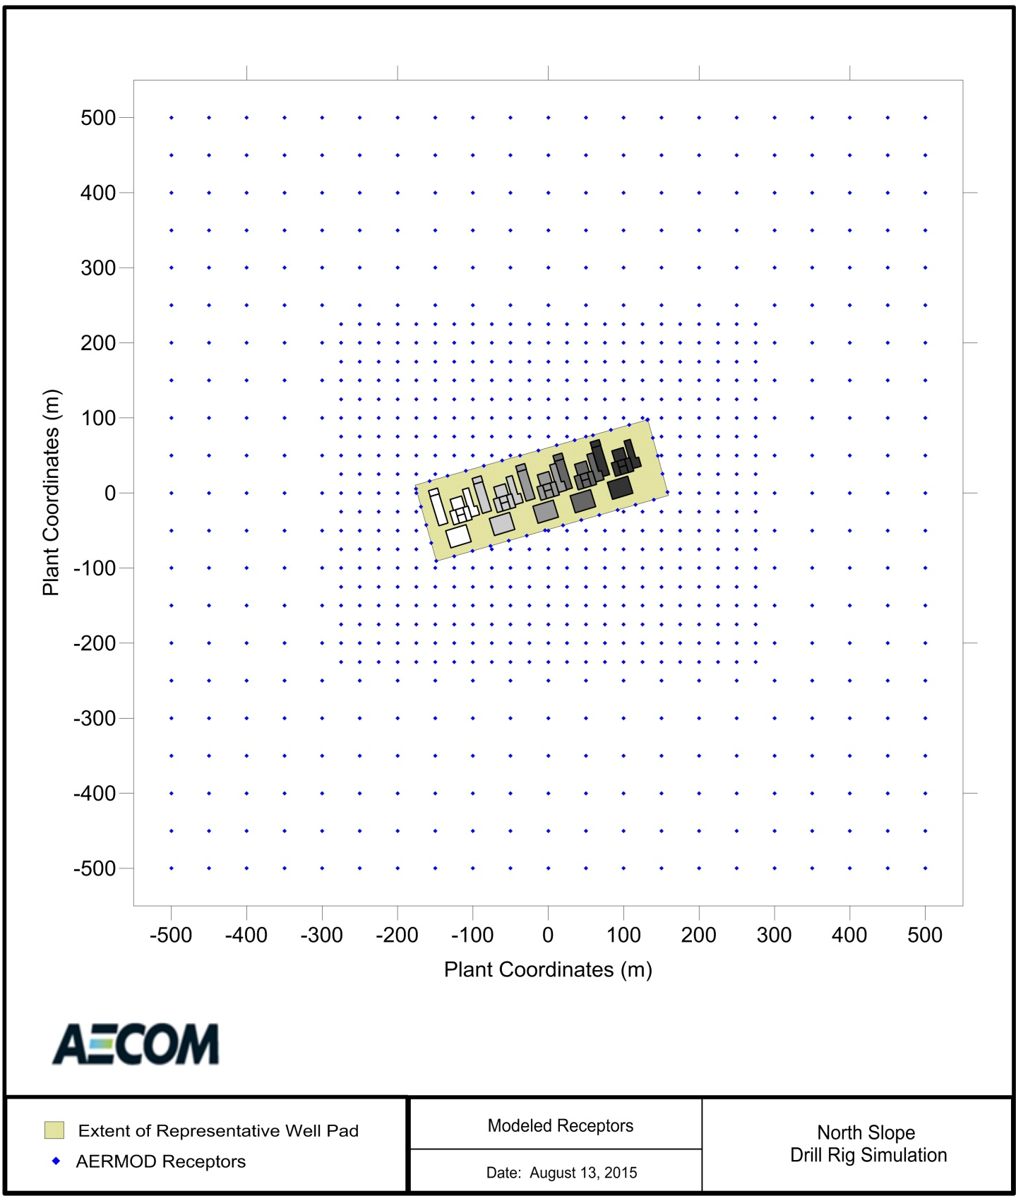
Figure 6 Full AERMOD Receptor Grid

Ambient Background Concentrations
For a cumulative impact analysis, representative ambient background concentrations must be developed to combine with model-predicted impacts to account for any non-modeled emission sources. According to Section 8.2.1 of the Guideline (Section 8.3.1 of the 2017 Guideline), background concentrations should be representative of the following in the vicinity of the source(s) under consideration:
- Natural sources.
- Nearby sources other than the one(s) currently under consideration.
- Unidentified sources.

For the North Slope POGO Simulation, these sources include those non-modeled mobile, portable, and intermittent or permanent EUs discussed in Section 3.6 and off-site sources discussed in Section 3.12. To account for these types of EUs in the North Slope POGO Simulation, the Technical Subgroup reviewed available North Slope datasets and developed representative background concentrations using ambient data collected at BPXA’s Well Pad A (A-Pad) Meteorological and Ambient Air Monitoring Station and at ConocoPhillips Alaska, Inc.’s (CPAI) Alpine CD1 Ambient Air Quality and Meteorological Monitoring Station. The A-Pad monitoring station is located on an isolated well pad and therefore, the ambient data generally represents activities at an isolated well pad (POGO categories RDi and DDi). The CD1 monitoring station is located on a collocated well pad and therefore, the data was determined to be representative of activities at a collocated well pad (POGO categories RDc and DDc) or an isolated well pad with concurrent hydraulic fracturing activities. The locations of the monitoring stations used to develop the background concentrations are depicted in Figure 7.

The Technical Subgroup developed separate background concentrations for both isolated pads and collocated pads for the 1-hour NO₂ cumulative impact analysis. For all other pollutants and averaging periods, the most conservative background concentration available from either monitor was selected as representative of both isolated and collocated pads. A summary of ambient background concentrations that are combined with model-predicted impacts is provided in Table 10 for each modeled pollutant and averaging period.

There are various ways to add a background concentration to the modeled concentration in an AERMOD analysis. Typical practice is to manually add a single background concentration to the model-predicted impact as a post-processing step. However, the most recent versions of AERMOD include options where the background concentration can be automatically added to the modeled concentration. This option also allows applicants to include temporarily-varying background concentrations in their ambient demonstrations.

The Technical Subgroup used the manual approach for all pollutants and averaging periods, except 1-hour NO₂, for the North Slope POGO Simulation. The 1-hour NO₂ ambient demonstration used AERMOD’s ability to incorporate temporally-varying background concentrations that were developed to vary by wind speed, as discussed in Appendix D.
Table 10 Summary of the Background Concentrations Used in the North Slope POGO Simulation
Pollutant | Averaging Period | Monitoring Station ª | Ambient Data Period | Applicable POGO Category | Form of the Background Concentration | Background Concentration ^{d}
 |  |  |  |  |  | (ppbv) | (µg/m³)
NO₂ | 1-hour | A-Pad | 1/1/2008 – 12/31/2012  (5 years) ^{b} | RDi, DDi | Multi-year average of the 98th percentile hourly concentration for each wind speed category | Varies dependent on  wind speed,  see Appendix D.
 |  | CD1 | 10/1/2012 – 9/30/2014  (2 years) | RDc, DDc, and RDi or DDi with Frac ^{c}
 | Annual | CD1 | 10/1/2012 – 9/30/2014  (2 years) | All | Maximum annual average concentration over the two-year period | 9.0 | 16.9
SO₂ | 1-hour | A-Pad | 1/1/2010 – 12/31/2012  (3 years) | All | Multi-year average of the 99th percentile of the annual distribution of daily maximum concentrations | 2.8 | 7.57
 | 3-hour | CD1 | 10/1/2012 – 9/30/2014  (2 years) | All | Maximum 3-hour block average concentration over the two-year period | 8 | 20.94
 | 24-hour | A-Pad | 1/1/2010 – 12/31/2012  (3 years) | All | Maximum 24-hour block average concentration over the three-year period | 3.0 | 7.90
 | Annual |  |  |  | Maximum annual average concentration over the three-year period | 1.0 | 2.6
PM_{2.5} | 24-hour | CD1 | 10/1/2012 – 9/30/2014  (2 years) | All | Multi-year average of the 98th percentile of the annual distribution of 24-hour average concentrations | N/A | 15
 | Annual |  |  |  | Maximum annual average concentration over the two-year period | N/A | 4.6
PM₁₀ | 24-hour |  |  |  | Maximum 24-hour average concentration over the two-year period | N/A | 124
CO | 1-hour | CD1 | 10/1/2012 – 9/30/2014  (2 years) | All | Maximum hourly average concentration over the two-year period | 2,000 | 2,290
 | 8-hour |  |  |  | Maximum 8-hour average concentration over the two-year period | 2,000 | 2,290
ª The Technical Subgroup selected the most conservative and available background concentration calculated between the A-Pad and CD1 datasets as representative of isolated and collocated well pads for all pollutants and averaging periods, except 1-hour NO₂. For 1-hour NO₂, a unique background concentration was refined for each isolated and collocated well pads.
^{b} All A-Pad ambient air quality data meets PSD-quality data capture requirements, except for hourly NO₂ data during the third quarter of 2008, as discussed in Appendix D.
^{c} “Frac” means hydraulic fracturing equipment.
^{d} Background concentrations from ADEC’s Industrial Data Summary (August 7, 2017) available at: http://dec.alaska.gov/air/ap/modeling.htm.

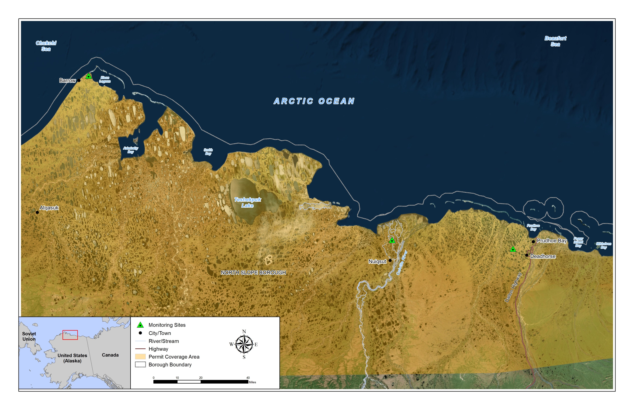
CD1 MONITORING
STATION
APAD MONITORING
STATION
BARROW
OBSERVATORY
Figure 7 Meteorological and Ambient Air Monitoring Stations Used for the North Slope POGO Simulation

Section 8.2.1.b of the Guideline (Section 8.3.1.b of the 2017 Guideline) indicates that the ambient data used to develop background concentrations should conform to the requirements for PSD-quality data. The Technical Subgroup met this requirement with the A-Pad and CD1 datasets, with one minor exception. One calendar quarter of the five-year A-Pad NO₂ dataset did not meet the 80 percent data capture requirement. The Technical Subgroup decided to include this quarter of data for the following reasons:
- The data capture requirement was already fulfilled through the other four years of data.
- The NO₂ data measured in the third quarter of 2008 met all other quality assurance requirements, except data capture.
- Including this additional year of data made the overall dataset more robust.

Sections 3.9 and 3.13.2 further describe relevant aspects of the monitoring sites and the representativeness of the ambient data selected to develop background concentrations to support the North Slope POGO Simulation.

A-Pad Ambient Air and Meteorological Monitoring Station
BPXA owns and operates a monitoring station located at A-Pad as part of its PBU Ambient Air and Meteorological Monitoring Program. The A-Pad Monitoring Station is located approximately 13.5 kilometers northwest of Deadhorse, Alaska, as depicted in Figure 7. A detailed layout of A-Pad, showing the monitoring station and its location on the well pad, is included in Appendix D. Because of the location of the monitor and long history of the monitoring program, BPXA’s A-Pad ambient air quality data is considered representative of local and regional oil and gas, biogenic, and globally transported emissions throughout the North Slope and is frequently accepted for use supporting modeling for North Slope permit applications.

BPXA’s A-Pad is an active well pad with approximately 45 wells that is located at the edge of the PBU, downwind of several major PBU stationary sources. The location of the A-Pad Monitoring Station ensures that the station captures regional impacts from minor stationary, major stationary, and mobile transportation sources associated with regional oil and gas development. For this reason, A-Pad measurements represent regional scale impacts from oil and gas development, including impacts from processing facilities, power stations, drill rigs, well servicing activities, and other temporary and mobile sources supporting well pad development and maintenance.

The A-Pad Monitoring Station, at its nearest point, is located within 300 feet of the well line. Therefore, the A-Pad ambient air quality data includes impacts from near-field emission sources operating at the well pad including drill rigs, well servicing equipment, camps, mobiles sources, and other portable and temporary equipment, as summarized in Table 11. The level of activity captured in the measurements is analogous with current routine infill drilling and well servicing activities on the North Slope. Although the fuel consumption values listed in Table 11 may appear small compared to the allowable daily fuel consumption modeled with the North Slope POGO Simulation, the modeled fuel consumption greatly overstates typical actual operations.

Based on known activities at A-Pad, the Technical Subgroup determined that the A-Pad data is directly representative of activities local to an active and isolated well pad (POGO categories RDi and DDi). However, in many cases, impacts from activities captured in the A-Pad ambient measurements also result from unidentifiable local sources of emissions. Figure 8 illustrates the A-Pad hourly NO₂ ambient data in relation to time periods when a drill rig was onsite, the most frequently occurring and highest measurements occur without a drill rig onsite which clearly indicates that the data is representative of significant intermittently used oilfield support equipment and temporary construction activities. While the exact type and length of these activities varied over time, the Technical Subgroup concluded that the overall level of activity was adequate for representing most of the non-modeled activities listed in Table 4. The exception was hydraulic fracturing. Because it is known that limited hydraulic fracturing occurred at A-Pad during the ambient data period, the Technical Subgroup decided it was too difficult to justify representing the impacts from this activity with the A-Pad data and instead represent them using the CD1 ambient data, which is discussed in Section 3.13.2.

After these considerations, the Technical Subgroup used the A-Pad ambient data to develop background concentrations for the RDi and DDi POGO categories for the 1-hour NO₂ cumulative impact analysis when there are no concurrent hydraulic fracturing activities. For all other pollutants and averaging periods, the Technical Subgroup used the A-Pad ambient data as representative of isolated and collocated well pads (POGO categories RDi, DDi, RDc, and DDc) when it produced a more conservative background concentration than the CD1 ambient data. This was the case for 1-hour, 24-hour, and annual SO₂.

The Technical Subgroup also determined that because the A-Pad ambient data includes impacts from periodic drill rig activity, using the A-Pad ambient data to develop background concentrations double-counts some of the impacts from drill rigs when included in the North Slope POGO Simulation.

Table 11 Summary of Direct Representativeness of Four North Slope Datasets
Pollutant-Emitting Source of Emissions | A-Pad | CD1
Relevant Ambient Data Periods | 1/1/2008 to 12/31/2012 (1-hour NO₂)  1/1/2010 to 12/31/2012 (All Other) | 10/1/2012 to 9/30/2014
Regional Oil & Gas Activities | A-Pad is downwind of several major Prudhoe Bay Unit stationary sources, including the Gathering Center # 3, Pump Station #1, Central Power Station, Flow Stations #1 and #3, Central Compressor Plant, and Central Gas Facility, as well as numerous Prudhoe Bay Unit oil and gas well pads. | The CD1 well pad is downwind of regional oil and gas activities in the Kuparuk, Prudhoe Bay, and other North Slope operating units.
Nearby Stationary Sources | None. The A-Pad ambient data are representative of an isolated well pad on the North Slope. | The CD1 well pad is collocated with the Alpine Central Processing Facility (Title V Permit No. AQ0489TVP02). The CD1 ambient data are representative of a collocated well pad.
Permanent Well Pad Equipment or Activities | Any permanent EUs at the well pad are below permitting thresholds. | Permanent equipment include EUs associated with the Alpine Central Processing Facility (Title V Operating Permit No. AQ0489TVP02).
Camp Generators for Worker Housing | A camp, generating its own power, located to A-Pad during the following periods:  - 1/4/2008 to 1/19/2008  - 1/25/2011 to 2/5/2011  Generators associated with the camp burned approximately 300 to 400 gallons of liquid fuel per day during these periods. | Portable camps do not locate to the CD1 pad because permanent worker housing exists at the facility.
Drill Rig Activities | Coiled tubing rigs operated at various wells during the following periods:  - 1/4/2008 to 1/21/2008 (Nordic 1)  - 1/11/2011 to 2/6/2011 (Nordic 2)  These rigs burned anywhere from 1,200 to 2,800 gallons of liquid fuel per day during these periods.  Other drill rigs operated at various wells on A-Pad during the following periods:  - 5/23/2008 to 6/13/2008 (Nabors 4ES)  - 4/10/2009 to 4/29/2009 (Nabors 7ES)  - 5/15/2009 to 6/9/2009 (Doyon 16)  - 7/15/2011 to 8/11/2011 (Doyon 25)  These rigs burned anywhere from 300 to 3,800 gallons of liquid fuel per day during these periods. | The Doyon19 drill rig operated at various wells during the following periods:  - 9/24/2012 to 1/25/2013  - 5/3/2013 to 7/14/2013  - 4/24/2014 to 5/29/2014  The drill rig engines operated largely on highline power during these periods with 1,000 to 4,000 gallons per day of liquid fuel burned by the drill rig heaters and boilers and other auxiliary or support equipment.
Hydraulic Fracturing and Well Servicing Activities | The A-26 well was hydraulic fractured on 12/16/2011. Meteorological conditions indicate that the monitor may not have captured impacts from the activity.  E-line units, slick-line units, pumping units, coiled tubing units, and/or other well testing equipment operated sporadically on 473 days between 2008 and 2012. The location and duration of these activities varied, depending on the type and level of operation. This equipment burned liquid fuel. | The CD1-22B, 34, 40, 43, 44, and 47 wells were hydraulically fractured over 7 days in March 2013 and April 2014. Hydraulic fracturing activities lasted from 12 to 18 hours per day and consumed anywhere from 350 and 1,380 gallons of liquid fuel per day. Meteorological conditions indicate that the monitor captured impacts from some of these hydraulic fracturing events.  E-line units, slick-line units, hot oil units, and/or coiled tubing units operated sporadically on 551 days of the ambient data period. The location and duration of these activities varied, depending on the type and level of operation. Liquid fuel consumed by equipment associated with each of these operations ranged from approximately 5 to 300 gallons of fuel per day.
Other Well Pad Equipment and Activities | Temporary, mobile, and portable equipment. | Temporary, mobile, and portable equipment.

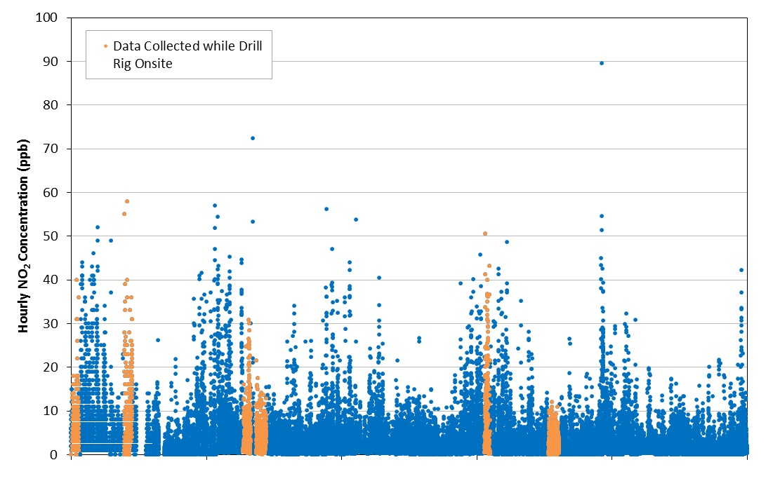
1/1/08 1/1/09 1/1/10 1/1/11 1/1/12
Figure 8 Comparison of A-Pad Ambient Data and Drill Rig Activity Onsite

CD1 Ambient Air and Meteorological Monitoring Station
CPAI owns and operates a monitoring station located at its Alpine CD1 Pad. The CD1 Pad is located in the Colville River Unit approximately 13 kilometers north of Nuiqsut, Alaska, as depicted in Figure 7. A detailed layout of the CD1 Monitoring Station and its location relative to the well pad is included in Appendix D. CPAI’s CD1 ambient air quality data are considered representative of local and regional oil and gas, biogenic, and globally transported emissions throughout the North Slope.

The CD1 ambient data includes impacts from the Alpine Central Processing Facility (CPF), located on the CD1 Pad, which includes operation of natural gas-fired turbines, natural gas-fired heaters, emergency generators, incinerators, and flares. The facility has the capability to process three phase liquids (oil, gas, and water) into as much as 139,000 barrels per day of oil for input to the TransAlaska Pipeline system and has an active airstrip and associated housing for workers. The Alpine CPF is classified as a PSD-major stationary source for NOx, CO, SO₂, PM₁₀, and PM_{2.5}. Actual emissions from the stationary sources at the Alpine CPF were over 137 tpy CO and 956 tpy NO_{X} in 2015.

The CD1 Pad also includes an active well line consisting of 48 wells. At its nearest point, the monitoring station is located within 200 feet of the well line. Therefore, the CD1 ambient air quality data captures impacts from a variety of equipment involved in drilling, well development, hydraulic fracturing and well maintenance, including drill rig engines, drill rig heaters and boilers, well servicing equipment, and other mobile and portable sources, as summarized in Table 11. The CD1 ambient data does not directly include impacts from camp generators because most well pads that are collocated with major stationary sources already include permanent worker housing facilities. The level of operation described at CD1 is analogous with current drilling and well servicing activities on the North Slope. Figure 9 presents a visualization of the timeline of hydraulic fracturing activities at CD1 over the last several years.

Figure 9 Visualization of the Frequency of an Actual Hydraulic Fracturing Operation at the CD1 Pad
Based on the size of the collocated facility, the number of EUs, the presence of an active well line, and documented portable and mobile source activity, the Technical Subgroup found the CD1 ambient data to be directly representative of most non-modeled activities in Table 4 and representative of a collocated well pad. Because of the increased level of activity and associated impacts, the CD1 ambient data was also considered representative of isolated well pad POGO categories (RDi and RDc) when drilling is occurring concurrent with hydraulic fracturing.

After these considerations, the Technical Subgroup used the CD1 ambient data to develop background concentrations for the RDc and DDc POGO categories and for the RDi and RDc POGO categories when there is concurrent hydraulic fracturing for the 1-hour NO₂ cumulative impact analysis. For all other pollutants and averaging periods, the Technical Subgroup used the CD1 ambient data as representative of isolated and collocated well pads (POGO categories RDi, DDi, RDc, and DDc) when it produced a more conservative background concentration than the A-Pad ambient data. This was the case for annual NO₂, 3-hour SO₂, 24-hour PM_{2.5}, annual PM_{2.5}, 24-hour PM₁₀, 1-hour CO, and 8-hour CO.

The Technical Subgroup also determined that because the CD1 ambient data includes impacts from periodic drill rig activity, using the CD1 ambient data to develop background concentrations double-counts some of the impacts from drill rigs when included in the North Slope POGO Simulation.

Design Concentrations
USEPA allows the use of modeled concentrations that are consistent with the form of the standard for design concentrations. The allowed design concentrations when using five years of meteorological data are summarized in Table 12, along with applicable AAAQS and NAAQS evaluated for the North Slope POGO Simulation. The Technical Subgroup evaluated model-predicted impacts against the AAAQS with design concentrations at least as conservative as the values described in Table 12.

Post-Processing
AERMOD output for 1-hour NO₂ and 1-hour SO₂ modeling demonstrations for the North Slope POGO Simulation was post-processed with TRANSVAP to better simulate the transitory nature of the portable sources. AERMOD-predicted impacts for all other pollutants and averaging periods were analyzed for the North Slope POGO Simulation without further processing. Additional information about the TRANSVAP post-processor and input development for TRANSVAP is discussed in Appendix C.

Table 12 Allowed Design Concentrations and Applicable AAAQS and NAAQS
Pollutant | Averaging Period | Modeled Design Value to Compare to AAAQS and NAAAQS | AAAQS | NAAQS
NO₂ | 1-hour | 5-year average of the high-eighth-high daily maximum 1-hour average concentration | 188 µg/m³ | 100 ppbv  (188 µg/m³)
 | Annual | Maximum annual average concentration from any modeled year | 100 µg/m³ | 53 ppbv  (100 µg/m³)
SO₂ | 1-hour | 5-year average of the high-fourth-high daily maximum 1-hour average concentration | 196 µg/m³ | 75 ppbv  (196 µg/m³)
 | 3-hour ª | Maximum high-second-high 3-hour average concentration from any year | 1,300 µg/m³ | 0.5 ppmv  (1,300 µg/m³)
 | 24-hour ª | Maximum high-second-high 24-hour average concentration from any year | 365 µg/m³ | N/A
 | Annual | Maximum annual average concentration from any modeled year | 80 µg/m³ | N/A
PM_{2.5} | 24-hour | 5-year average of the high-eighth-high 24-hour average concentration | 35 µg/m³ | 35 µg/m³
 | Annual | 5-year average of the annual average concentrations | 12 µg/m³ | 12 µg/m³
PM₁₀ | 24-hour ª | High-sixth-high 24-hour average concentration over 5 years | 150 µg/m³ | 150 µg/m³
CO | 1-hour ª | Maximum high-second-high 1-hour average concentration from any year | 40 mg/m³ | 35 ppm  (40 mg/m³)
 | 8-hour ª | Maximum high-second-high 8-hour average concentration from any year | 10 mg/m³ | 9 ppm  (10 mg/m³)
ª For the North Slope POGO Simulation, the design concentration for this pollutant and averaging period was simulated as the highest-second-high concentration over the entire five-year model simulation, which is more conservative than the allowable design concentration.

RESULTS AND DISCUSSION
The maximum modeled-predicted impacts from the North Slope POGO Simulation are presented in Figure 10 and Table 13. The background concentration, maximum model-predicted impact for each fuel consumption simulated, and respective ambient standard are also presented for comparison. The model-predicted impacts are used to find the maximum allowable drill rig operation that does not cause or contribute to a violation of the AAAQS using the modeling approach discussed in Section 1.

Conservatism in the Modeling Demonstration
The North Slope POGO Simulation was developed to be conservatively representative of a POGO operating on the North Slope. However, the following aspects of the simulation should also provide reasonable assurance that the AAAQS will not be violated and are worth noting when interpreting results:

- The simulation included a drill rig operating at five potential well locations at a well pad. Many North Slope well pads have 15 or more wells. Modeling fewer wells than exist in reality will lead to overstating actual impacts because each well location represents three or more wells, which increases the probability of drill rig impacts occurring in the same location. The simulation will also overstate the impacts for activities involving less than five wells, such as exploratory programs, because more activity is simulated at a well pad than what would be expected if drilling only a few wells.

- The drill rig is modeled operating on a 320-meter by 105-meter (11.9 acre) well pad, within 25 meters of the well pad ambient boundary. This is representative of distances to pad edge on the smallest pads on the North Slope. A small pad means that stacks are simulated closer to ambient air. Well pads on the North Slope range from as small as six acres (with fewer than 20 wells) in newer developments to larger than 80 acres in older developments, such as Prudhoe Bay.

- Well Location 6 is located closer to the side of the well pad ambient boundary where the maximum impacts are predicted, which adds additional conservativism to model-predicted impacts.

- The drill rig heaters and boilers burn LEPD, which has a higher sulfur content than ULSD. On the North Slope, many POGOs do not have access to LEPD because its use is restricted by access to a North Slope topping plant. Therefore, predicted SO₂ impacts dominated by North Slope POGO heaters and boilers are potentially 100 times higher than what occurs at many North Slope locations. For locations accessible from a North Slope topping plant, the sulfur content of LEPD is prescribed by permit restrictions for sulfur content at other stationary sources that receive and burn LEPD. Based on current conditions, North Slope topping plants are producing LEPD fuels with a sulfur content of 0.11 percent by weight or less. LEPD for the North Slope POGO Simulation was characterized with a sulfur content of 0.15 percent by weight.

- The drill rig heaters and boilers were modeled with a seasonal operational profile using monthly scaling factors. In order to maintain a constant drill rig fuel consumption year-round, a complementary monthly factor was applied to the drill rig engines. While assuming a seasonal variation in drill rig heater and boiler operation is less conservative than assuming a constant value, the complementary seasonal variation in drill rig engine operations is not. It is not expected that drill rig engines will operate more when heaters and boilers operate less. This will over predict impacts from drill rig engines during warmer months of the year than would reasonably be anticipated with less heater and boiler operation.

- All EUs are modeled operating concurrently.

- TRANSVAP post-processing requires the use of activity input files to simulate a drill rig operating at different locations and the duration of active drilling and inactivity at a well pad. For the routine infill drilling activity profile, these activity inputs are based on actual North Slope drill rig activity data. Additional conservatism is built into the analysis of this data by including drill rig activities that are not necessarily representative of routine infill drilling. The dataset developed includes activities performed by drill rigs supporting developmental drilling events. Including these activities in the data has the effect of increasing the duration of time a well pad is active.

- Although the 1-hour NO₂ and 1-hour SO₂ modeling demonstrations incorporated several refinements, demonstrations for all other pollutants and averaging periods were conducted with the standard, simplified modeling approach. For modeling a drill rig, this includes modeling year-round operations (8,760 hours per year) at a single location and combining model-predicted impacts with a constant background value determined from ambient data.

- Background concentrations developed from A-Pad and CD1 ambient datasets include impacts from drill rigs, which were also explicitly modeled in the ambient demonstration for the North Slope POGO Simulation. Therefore, there is some amount of double-counting drill rig impacts. Based on drill rig fuel use data collected between 2006 and 2011 during operations at A-Pad, typical drill rig fuel use was 1,760 gallons per day on average and as high as 3,840 gallons per day.

- PVMRM requires ambient ozone data in order to determine how much of the NO is converted to NO₂. A conservatively representative hourly ozone dataset was compiled for input into AERMOD from five years of ozone data collected at BPXA’s A-Pad Monitoring Station between 2006 and 2010. This increases conversion to NO₂.

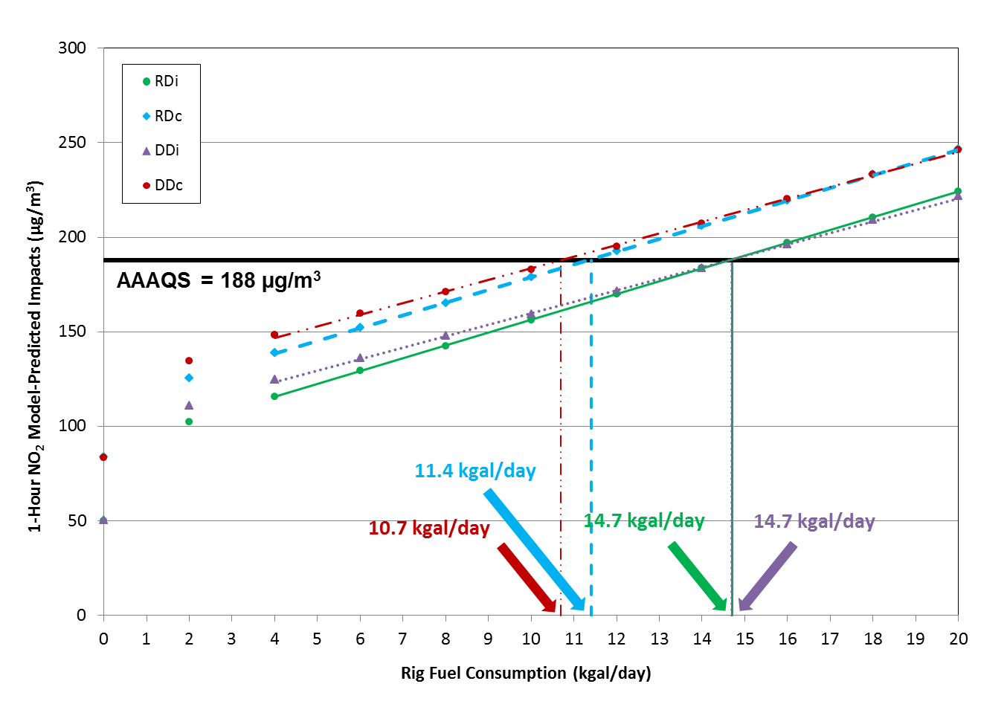
(a)
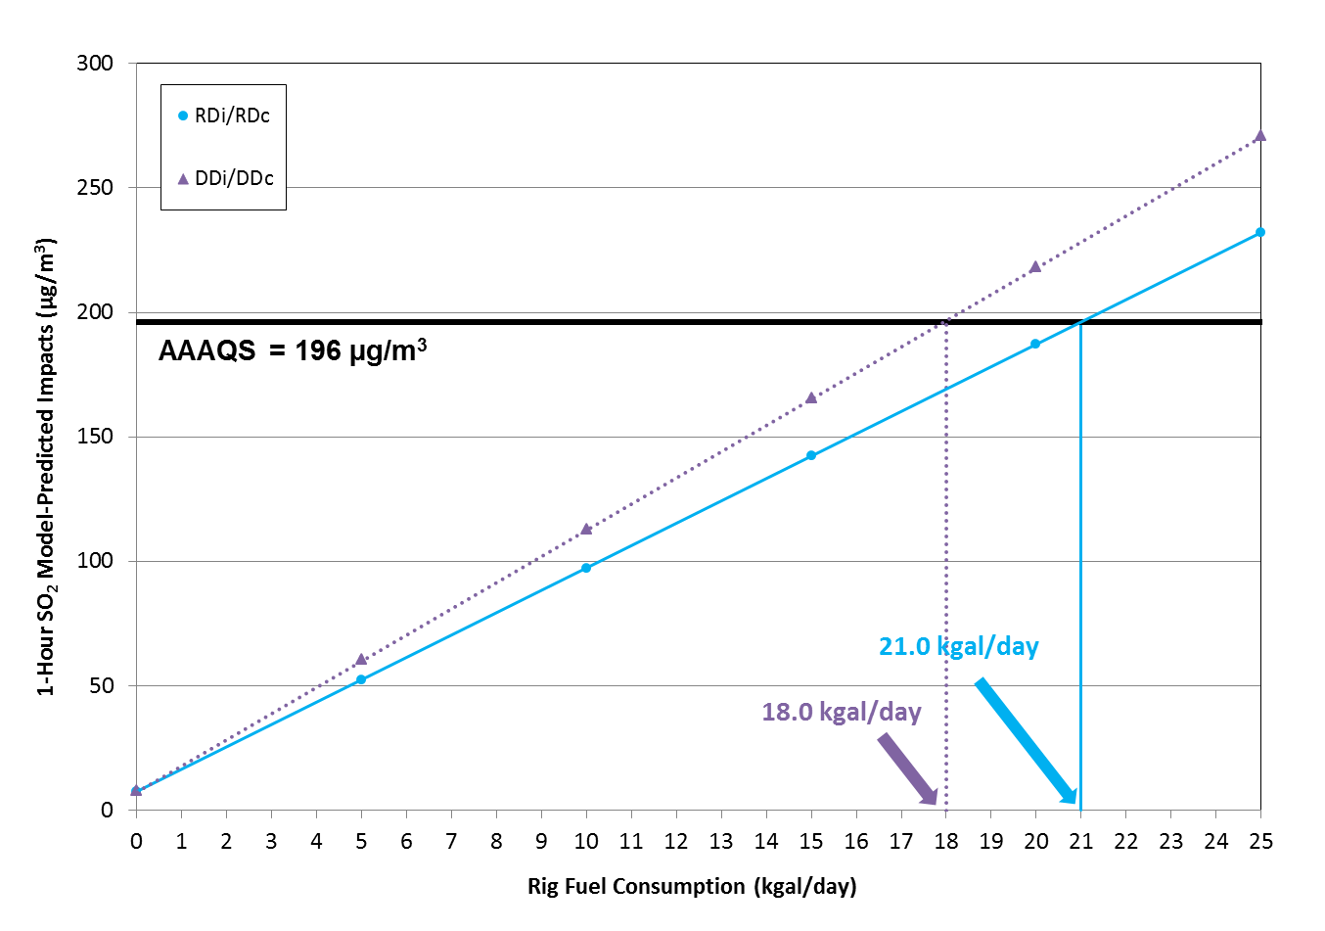
(b)
Figure 10 (a) 1-hour NO₂ and (b) 1-hour SO₂ Model-Predicted Impacts after TRANSVAP Post-Processing

Table 13 Summary of Results
Pollutant | Averaging Period | Model and  Post-Processor (if applicable) | AERMOD Results (µg/m³)  for Each Fuel Consumption (kgal/day) |  |  |  |  |  | Background Concentration  (µg/m³) | AAAQS/ NAAQS  (µg/m³) | Nominal Fuel Consumption to Predict Impacts as  High as the AAAQS  (kgal/day)
 |  |  | 0 | 5 | 10 | 15 | 20 | 25 |  |  | RDi | RDc | DDi | DDc
NO₂ | 1-hour | AERMOD (version 15181)  TRANSVAP | See Figure 10(a). |  |  |  |  |  | Varies with wind speed, see Appendix D. | 188 | 14.7 | 11.4 | 14.7 | 10.7
 | Annual | AERMOD (version 15181) | 0.0 | 8.5 | 11.8 | 15.3 | 18.7 | 21.9 | 16.9 | 100 | 116.2
SO₂ | 1-hour | AERMOD (version 14134) TRANSVAP | See Figure 10(b). |  |  |  |  |  | 7.57 | 196 | 21.0 |  | 18.0
 | 3-hour | AERMOD (version 14134) | 0.0 | 62.1 | 124.2 | 186.3 | 248.4 | 310.6 | 20.94 | 1,300 | 103.0
 | 24-hour |  | 0.0 | 44.6 | 89.2 | 133.8 | 178.5 | 223.1 | 7.90 | 365 | 40.0
 | Annual |  | 0.0 | 3.0 | 6.0 | 9.0 | 12.0 | 14.9 | 2.6 | 80 | 129.4
PM_{2.5} | 24-hour | AERMOD (version 15181) | 0.0 | 2.7 | 5.5 | 8.2 | 10.9 | 13.6 | 15 | 35 | 36.7
 | Annual | AERMOD (version 14134) | 0.0 | 0.4 | 0.8 | 1.2 | 1.6 | 2.0 | 4.6 | 12 | 90.5
PM₁₀ | 24-hour |  | 0.0 | 5.2 | 10.4 | 15.6 | 20.8 | 26.0 | 124 | 150 | 25.0
CO | 1-hour |  | 0.0 | 129.1 | 258.2 | 387.2 | 516.3 | 645.4 | 2,290 | 40,000 | 1,461
 | 8-hour |  | 0.0 | 69.3 | 138.7 | 208.0 | 277.4 | 346.7 | 2,290 | 10,000 | 555.9
Allowable Nominal Fuel Consumption |  |  |  |  |  |  |  |  |  |  | 14.7 | 11.4 | 14.7 | 10.7

CONCLUSIONS
The North Slope POGO Simulation was developed to be representative of any POGO on the North Slope. The modeling analysis was conducted in a manner consistent with the Guideline, as required under 18AAC 50.215(b)(1). The following sections summarize the key parameters and assumptions used in the North Slope POGO Simulation and the results of the modeling analysis.

Summary of Key Parameters and Assumptions
The following list summarizes key parameters and assumptions used in the North Slope POGO Simulation. For this analysis, the Technical Subgroup:

- Simulated onshore POGOs at well pads on the North Slope coastal plain, where POGO activities occur on a “small” pad, and the ambient boundary is at pad edge.

- Addressed four POGO categories including routine infill drilling at an isolated well pad (RDi) or a collocated well pad (RDc) and developmental drilling at an isolated well pad (DDi) or collocated well pad (DDc).

- Included nonroad drill rig engines that meet past or present federal emission requirements (Tier 0 to Tier 4).

- Modeled fuel consumption only applies to primary units permanently attached to or integral to the drill rig, and all other ancillary equipment are adequately represented through the background data and did not need to be explicitly modeled.

- Assumed all modeled and non-modeled POGO EUs are liquid-fired and that all of the internal combustion units are reciprocating engines.

- Assumed the total volume of fuel consumed by the modeled drill rig RICE and heater/boiler EUs does not exceed the levels shown in Table 14.

- Simulated the sulfur content of the liquid fuel as:
  - ≤ 0.0015 percent by weight (ULSD) for the fuel consumed by the RICE EUs.
  - ≤ 0.15 percent by weight (LEPD) for the fuel consumed by the heaters/boilers.

- Assumed rig emissions are linearly-correlated to fuel consumption.

- Assumed that the operation of the drill rig heaters and boilers vary seasonally but do not exceed 30 percent of the levels shown in Table 14.

- Characterized the modeled exhaust stacks of the drill rig RICE and heater/boiler EUs as vertical and uncapped, with stack heights that represent the current existing stack heights of North Slope drill rigs.

- Did not conduct modeling to demonstrate compliance with the maximum allowable increases listed in 18 AAC 50.020.

- Assumed that air quality impacts from equipment outlined in Table 4 are adequately represented through background ambient data, or the sensitivity analysis provided in Appendix A, and did not need to be explicitly modeled. These equipment include:
  - oilfield construction equipment.
  - well drilling, hydraulic fracturing, well servicing, maintenance, and miscellaneous oilfield support equipment.
  - stationary well pad equipment, including a production or line heater, freeze protection pump, or other small stationary engines used to power generation or mechanical service to support well pad activities.

- Assumed the hydraulic fracturing impacts captured in the background data are only representative of those from activities used in the development of conventional resources.

Summary of Conclusions
Based on the results of the modeling analysis developed for the North Slope POGO Simulation, the level of drill rig operations described in Table 14 will not cause or contribute to a violation of the AAAQS listed in Section 1 of this report.

Table 14 Maximum^{b} Modeled Quantity of Fuel That a North Slope POGO ª Could Consume Without Violating an AAAQS (Gallons per Day)
Allowable Onshore Drill Rig Operation | RDi ^{b} | RDc ^{b} | DDi ^{b} | DDc ^{b}
POGO Without Concurrent Hydraulic Fracturing Activities ^{c} | 14,700 | 11,400 | 14,700 | 10,700
POGO With Concurrent Hydraulic Fracturing Activities ^{c} | 11,400 | 11,400 | 10,700 | 10,700
ª Daily fuel consumption thresholds apply to the drill rig only and do not apply to other emission units that may be a part of the POGO or operating on the well pad, such as stationary well pad equipment, portable power generators, or well servicing equipment (as defined in 18 AAC 50.990(125)) – these activities are represented by the background values added to the modeled impacts. An example list of this equipment is outlined in Table 4.
^{b} Daily fuel consumption thresholds can be exceeded by 25 percent, 20 percent of the days in a year (73 days per year), which is equivalent to the following daily volumes:
14,700 x 1.25 = 18,375 gallons per day.
11,400 x 1.25 = 14,250 gallons per day.
10,700 x 1.25 = 13,375 gallons per day.
^{c} Hydraulic fracturing in Alaska is discussed in Appendix E.

Appendix A

AERMOD Sensitivity Analyses

A1. SENSITIVITY OF MODEL-PREDICTED IMPACTS TO AERMOD UPDATES BETWEEN versions 14134, 15181, AND 16216R
As the Technical Subgroup was finalizing the North Slope POGO Simulation, USEPA promulgated new versions of AERMET (versions 15181 and 16216) and AERMOD (version 15181 and 16216r). This analysis describes a limited study conducted to demonstrate that assessments conducted with the superseded versions of AERMOD and AERMET yield the same results as those conducted with the current versions (16216r and 16216, respectively), obviating the need to revise all analyses conducted with the previous versions of AERMOD and AERMET. To conduct this study, a sensitivity analysis was conducted for 1-hour NO_{X}, 1-hour SO₂, and 24-hour PM_{2.5} to compare the potential influence of any updates to algorithms between AERMOD and AERMET versions 14134, 15181, and 16216r (16216). The sensitivity analysis was conducted for NO_{X} rather than NO₂ because the PVMRM chemical algorithms in AERMOD version 15181, are no longer available with version 16216r. Therefore, a direct comparison is not possible. Table A1 compares AERMOD-predicted impacts for the North Slope POGO Simulation. These results indicate there are no discernible differences to the AERMOD-predicted 1-hour NO_{X}, 1-hour SO₂, and 24-hour PM_{2.5} impacts between processing with AERMOD versions 14134, 15181, and 16216r.

Table A1 Comparison of 1-hour NO_{X}, 1-hour SO₂, and 24-hour PM_{2.5} Impacts Modeled with AERMOD Versions 14134, 15181, and 16216r
Nominal Fuel  Consumption Modeled  (kgal/day) | AERMOD-Predicted Design Values (µg/m³)
 | Version 14134 | Version 15181 | Version 16216r
1-hour NO_{X}
5 | 493.88051 | 493.88051 | 493.88051
10 | 987.76102 | 987.76102 | 987.76102
15 | 1481.64152 | 1481.64152 | 1481.64152
20 | 1975.52203 | 1975.52203 | 1975.52203
25 | 2469.40254 | 2469.40254 | 2469.40254
1-hour SO₂
5 | 69.86519 | 69.86519 | 69.86519
10 | 139.73038 | 139.73038 | 139.73038
15 | 209.59556 | 209.59556 | 209.59556
20 | 279.46075 | 279.46075 | 279.46075
25 | 349.32594 | 349.32594 | 349.32594
24-hour PM_{2.5}
5 | 2.72593 | 2.72593 | 2.72593
10 | 5.45187 | 5.45187 | 5.45187
15 | 8.1778 | 8.1778 | 8.1778
20 | 10.90374 | 10.90374 | 10.90374
25 | 13.62967 | 13.62967 | 13.62967

A2. SENSITIVITY OF Model-predicted impacts TO NON-TIERED VERSUS TIER 4 DRILL RIG ENGINES
The North Slope POGO Simulation was developed with drill rig equipment and emissions representative of current drill rigs operating on the North Slope. However, future POGOs will include equipment subject to continually more stringent emission standards and equipment regulations leading to lower polluting operations. However, for nonroad engines, designing cleaner burning equipment with respect to NO_{X} and PM emissions can lead to an increase in the portion of NO_{X} that is NO₂. For future operations, this warrants further investigation because the National Ambient Air Quality Standard (NAAQS) regulates NO₂. Therefore, in an effort to confirm the North Slope POGO Simulation modeling results are applicable for future operations, a 1-hour NO₂ analysis was conducted comparing impacts from drill rig engines representative of current operations to impacts from Tier 4 drill rig engines. This type of analysis was not carried out for the other major class of equipment in the North Slope POGO Simulation, heaters and boilers, because there are not similar concerns.

A2.1 Background
Representative drill rig emissions were developed for the North Slope POGO Simulation with non-tiered engines from Caterpillar vendor data. For this demonstration, impacts from the non-tiered, vendor-supplied drill rig engine emissions are compared to impacts from Tier 4 drill rig engine emissions, which must comply with a more stringent NO_{X} emission standard. While the NO_{X} emissions from these engines are lower, they are expected to have higher in-stack NO₂-to-NO_{X} ratios (ISRs) than non-tiered engines because of catalyzed diesel particulate filters.

Tier 4 engine emissions were derived using the emission standards in 40 CFR 1039.101 and adding an additional 25 percent, or factor of 1.25, to represent not-to-exceed (NTE) emission rates consistent with the NTE basis for the vendor-supplied non-tiered engines. The primary drill rig engines are assumed to be in generator service while the large and small utility engines are assumed to be in mechanical service. For Tier 4 engines, an ISR of 0.30 is conservatively assumed for this demonstration. For modeling purposes, the only model parameters that change are estimated emissions and ISR between simulations with the non-tiered and Tier 4 engines. Table A2 compares estimated emissions and ISRs for the non-tiered and Tier 4 drill rig engines. The NO_{X} emission rates in Table A2 are calculated based on a nominal fuel consumption of 10,000 gallons per day.

Table A2 Comparison of Non-Tiered and Tier 4 Engine Emission Rates and Model Parameters for Sensitivity Analysis
Source ID | Source Description | North Slope Non-Tiered  Drill Rig Engines |  | Tier 4 Drill Rig Engines
 |  | NO_{X} Emission Rate  (g NO_{X}/s) | In-Stack  NO₂-to-NOx Ratio | NO_{X} Emission Rate  (g NO_{X}/s) | In-Stack  NO₂-to-NOx Ratio
RIG1_1 | Primary Drilling Engines | 6.036 | 0.07 | 0.466 | 0.30
RIG1_2 | Primary Drilling Engines | 6.036 | 0.07 | 0.466 | 0.30
GEN1_2 | Large Utility Engines | 1.635 | 0.07 | 0.727 | 0.30
AUX1 | Small Utility Engines | 0.150 | 0.07 | 0.011 | 0.30

This modeling demonstration is conducted using the PVMRM option with AERMOD and all other model parameters developed for the North Slope POGO Simulation as discussed in the modeling report. For simplicity in this demonstration, impacts are compared using AERMOD results only; results were not post-processed with TRANSVAP. In addition, to evaluate the differences specific to the drill rig engines:
- All other non-engine sources, such as boilers and heaters, have zero emissions.
- No ambient background concentrations were incorporated into the AERMOD results.
By removing the emissions from all other sources, except for the engines, this analysis is focused on the engines.

A2.2 Results
Table A3 compares the modeled impacts from the non-tiered and Tier 4 drill rig engines given the assumptions outlined in Section A3.1 for the five well (drill rig) locations modeled for the North Slope POGO Simulation. The ratio of Tier 4 to non-tiered engine impacts in Table A3 is calculated as follows:

Ratio of Tier 4 to Non-Tiered Engine Impacts = | Tier 4 Engine Impacts at Max Receptor
 | Non-Tiered Engine Impacts at Max Receptor

Note that the modeled receptor with the maximum impact may be different between simulations. In all cases in Table A3, impacts from Tier 4 drill rig engines are only a fraction of impacts from the non-tiered drill rig engines. The ratio of Tier 4 to non-tiered engine impacts varies with emissions based nominal daily fuel consumption. Therefore, impacts were predicted using several daily fuels consumption values spanning the range of those potentially proposed as limits. At the extreme upper limit of potential daily fuel consumption modeled, the Tier 4 engine model-predicted impacts are most similar to non-tiered impacts. Yet, the high-eighth-high (H8H) Tier 4 engine impacts are less than 76 percent of non-tiered engine impacts across all modeled drill rig locations. Therefore, for any reasonably expected amount of drill rig operation, the modeling developed with non-tiered engine emissions conservatively represents potential future operations with Tier 4 or better drill rig engines. This demonstration shows the North Slope POGO Simulation is applicable to future operations.

Table A3 Ratio of Tier 4 to Non-Tiered Drill Rig Engine 1-Hour NO₂ Impacts
Modeled  Well Pad  Location | Ratio of Tier 4 to Non-Tiered Engine Impacts
 | 5 kgal/day  Nominal Fuel Consumption |  | 15 kgal/day  Nominal Fuel Consumption |  | 25 kgal/day  Nominal Fuel Consumption
 | H1H ¹ | H8H ² | H1H ¹ | H8H ² | H1H ¹ | H8H ²
2 | 0.53 | 0.49 | 0.70 | 0.73 | 0.66 | 0.76
3 | 0.48 | 0.45 | 0.79 | 0.71 | 0.90 | 0.73
4 | 0.45 | 0.46 | 0.76 | 0.72 | 0.91 | 0.74
5 | 0.45 | 0.47 | 0.76 | 0.72 | 0.91 | 0.74
6 | 0.45 | 0.43 | 0.76 | 0.66 | 0.89 | 0.68
¹ High-First-High (H1H) 1-hour NO₂ results are based on the ratio of first-highest maximum daily 1-hour NO₂ results averaged over five years.
² High-Eighth-High (H8H) 1-hour NO₂ results are based on the ratio of eighth-highest maximum daily 1-hour NO₂ results averaged over five years (design value).

A3. SENSTIVITY OF MODEL-PREDICTED IMPACTS TO STACK PARAMETERS DURING EXCURSIONS
For the cumulative impact analysis for the North Slope POGO Simulation, temporally-varying emissions were applied to drill rig operation to simulate transient hourly excursions in fuel consumption above the nominal modeled daily rate. In the North Slope POGO Simulation modeling report, these are referred to as “excursions.” For modeling purposes, an excursion is equivalent to a 25 percent increase in drill rig fuel consumption (emissions), which occurs sporadically 20 percent of the time during the five-year simulation. Concurrent with the excursions in drill rig fuel consumption, a 25 percent increase in the exit temperature and exit velocity stack parameters was also applied in the modeling. This memorandum addresses concerns that these stack parameter assumptions may understate model-predicted impacts and discusses the sensitivity of the modeling demonstration to those assumptions.

A3.1 Stack Parameters for Modeling
For the North Slope POGO Simulation, two stack parameters, exit temperature and exit velocity, were scaled by a factor of 1.25, concurrent with the scaling of modeled emission rates for excursions. Table A4 compares the difference in exit temperature and exit velocity between periods of nominal operations and periods of excursions from nominal operations. All other stack parameters, including release height, exit diameter, and in-stack NO₂-to-NO_{X} ratio, remain the same under both operational conditions.
Table A4 Comparison of Stack Parameters during Nominal Operations and Excursions from Nominal Operations
Model ID | Exit Temperature |  |  |  | Exit Velocity
 | Nominal Operations  (No Scaling) |  | Excursions  (1.25 Factor) |  | Nominal Operations  (No Scaling) |  | Excursions  (1.25 Factor)
 | (°F) | (°K) | (°F) | (°K) | (ft/s) | (m/s) | (ft/s) | (m/s)
RIG1_1 | 950.0 | 783.2 | 1,303 | 979.0 | 233.2 | 71.1 | 291.6 | 88.9
RIG1_2 | 950.0 | 783.2 | 1,303 | 979.0 | 233.2 | 71.1 | 291.6 | 88.9
GEN1_2 | 960.2 | 788.8 | 1,315 | 986.0 | 198.6 | 60.5 | 248.1 | 75.6
AUX1 | 1,110 | 872.1 | 1,503 | 1,090 | 254.3 | 77.5 | 317.8 | 96.9
ST1_1 | 449.8 | 505.3 | 677.3 | 631.6 | 29.8 | 9.1 | 37.3 | 11.4
ST1_2 | 449.8 | 505.3 | 677.3 | 631.6 | 29.8 | 9.1 | 37.3 | 11.4

A3.2 Results and Discussion
A sensitivity analysis was conducted to explore how the model-predicted impacts are influenced by the difference in exit temperature and exit velocity between nominal operations and excursions from nominal operations. The sensitivity analysis was conducted with the 1-hour NO₂ modeling demonstration because it is the limiting pollutant and averaging period identified for the North Slope POGO Simulation, and consequently, it is also the only ambient demonstration that included excursions. Table A5 summarizes cumulative model-predicted impacts for the North Slope POGO Simulation, modeled with two different stack parameter scenarios during excursions: (1) scaling both exit temperature and exit velocity and (2) scaling exit velocity only. These stack parameter scenarios are only applicable to the 20 percent of the time that is simulated as excursions. No scaling is applied to stack parameters during the other 80 percent of the time which was modeled as nominal operations.

ADEC has noted that simulating an increase in flow rate (exit velocity) during excursions is a reasonable assumption for reciprocating internal combustion engines (RICE) and external combustion units. ADEC also noted that while temperature may also increase with load, the magnitude or character of that increase is unclear. However, the results in Table A5 show that the cumulative impact analysis for the North Slope POGO Simulation is not sensitive to the scaling of exit temperature. Whether exit temperature and exit velocity or exit velocity only is scaled during excursions, there is little difference in the model-predicted impacts.

Table A5 Comparison of Model-Predicted Impacts for the RDi POGO Category
Description of Processing | Form of the Model Predicted Impact | Cumulative Model-Predicted Impact ª (µg/m3)
 |  | Exit Temperature and Exit Velocity Scaled | Exit Velocity
AERMOD^{b} Only | Highest-eighth-high from all rig locations | 214.00 | 211.35
AERMOD^{b} + TRANSVAP Post-Processing | 99th Percentile | 169.87 | 170.01
ª Cumulative model-predicted impacts are based 12,000 gallons per day of drill rig operation and includes the background concentration for the RDi POGO Category.
^{b} Version 15181 was used for consistency with the North Slope POGO Simulation.

Also of note are the AERMOD-predicted impacts with exit temperature and exit velocity scaled compared to the impacts with exit velocity only scaled. Cumulative AERMOD-predicted impacts appear to improve when scaling of the exit temperature during excursions is removed from the analysis. Because higher exit temperatures are expected to improve dispersion characteristics of the plume due to buoyancy, there may be other explanations for the results:
- Changing the exit temperature may alter the dispersion of the plume to the extent that it shifts maximum impacts in relation to the receptors, or
- Changing the exit temperature may alter, temporally, which days contribute to the daily maximum 1-hour NO₂ concentrations in the annual distribution of daily maximums for each year of the simulation. This is worth noting considering that background concentrations are dependent on wind speed, and therefore, also vary temporally.

A3.3 Stack Parameters for Modeling
The sensitivity analysis indicates that the North Slope POGO Simulation model-predicted impacts are not sensitive to whether either (1) exit temperature and exit velocity or (2) exit velocity only are scaled during excursions from nominal operations. The differences in the model-predicted impacts between these scenarios are within the variability of other aspects of the model and assumptions.

ADEC noted that increasing the flow rate (exit velocity) during excursions is a reasonable assumption although it is unclear how much temperature would increase with load. Even though this is unknown, this sensitivity analysis shows that the exit velocity assumption is the main driver in determining model-predicted impacts, and exit temperature is not a critical assumption. Therefore, this analysis suggests that the results of the North Slope POGO Simulation excursion analysis would not materially change if the assumption about stack exit temperature variation with fuel consumption was incorrect.
A4. culpability of a production heater and portable flare to the north slope pogo simulation

There is a small category of equipment supporting oil and gas development that were not explicitly modeled as part of the North Slope POGO Simulation but could operate concurrently with drilling operations. This category includes flares and production heaters. These emissions units were not explicitly modeled because they are not the focus of the permitting program, nor do they influence impacts or conclusions. Because they have considerably different stack parameters, such as higher stack heights, than the non-modeled temporary and portable equipment, it was decided that they deserve more attention than simply saying they are included in the background concentrations.

The nature of operations of production heaters and flares makes their impacts unimportant in terms of modeling for the North Slope POGO Simulation. Because of the nature of their operations, production heaters and flares rarely produce plumes of emissions that overlap with the dominant source of emissions, the drill rig, in the North Slope POGO Simulation. The chances of plume overlap are low, because (1) there is a large separation distance between production heaters or flares and the well line along which a drill rig would operate, and (2) emissions release characteristics are considerably different between a production heater or flare and a drill rig. There is a large separation distance because production heaters are located downstream of where produced liquids are gathered for logistical reasons, and flares are never located near other equipment or personnel on a well pad for safety. Therefore, comingling of the plumes is unlikely.

To demonstrate this concept, a sensitivity analysis was conducted to estimate model-predicted impacts from a production heater and flare and the culpability of these impacts to the North Slope POGO Simulation.

A4.1 Characterization of Simulation Used for the Sensitivity Analysis

The sensitivity analysis was developed based on the following characterization:
- A 30 MMBtu/hr (lower heating value [LHV]) natural gas-fired production heater was simulated with its potential-to-emit and toward the end of the generic well pad around Well Location 6.
- The drill rig emission units were simulated in the same way they are characterized in Section 3 of the North Slope POGO Simulation report. For this analysis, the drill rig is specifically modeled at Well Location 5 since it needed to be close to the heater which occupies Well Location 6.
- A flare burning 10 million standard cubic feet (MMscf) per day and 130 MMscf per year of gaseous fuel was simulated toward the end of the generic well pad around Well Location 6.
- The production heater and flare were simulated without downwash since neither requires an associated building.

Table A6 summarizes the emission rates, stack parameters, and location of modeled emission releases used to characterize the production heater and flare for the sensitivity analysis.

Using this characterization of a production heater and flare, several different model runs were conducted to assess the sensitivity of the North Slope POGO Simulation to impacts from these types of equipment. It is not only important to understand how much these types of units would contribute to the overall cumulative model-predicted impacts but also to understand the magnitude of maximum impacts possible from a production heater and flare. Therefore, cumulative model runs (simulating the drill rig, production heater, and flare) and analysis of results were conducted at three different locations for each pollutant and averaging period:
- At the overall cumulative maximum model-predicted design value impact location.
- At the location of the production heater’s maximum impact (worst-case) location.
- At the location of the flare’s maximum impact (worst-case) location.

These runs were used to assess the culpability of the production heater and flare impacts to the overall model-predicted design values, as well as at their maximum impact locations where they are expected to produce the highest impacts.

A4.2 Results and Discussion
Table A7 summarizes the culpability of the production heater and flare model-predicted impacts at the location of the overall model-predicted design values and at each maximum impact location for all modeled pollutants and averaging periods. Based on these results, the sensitivity analysis supports the following conclusions:
- Model-predicted impacts from a large production heater and portable flare do not have significant overlap with model-predicted drill rig impacts, nor are they likely to have significant overlap with each other due to the nature of their operations and configurations.
- Because the drill rig is the dominate source of emissions and plumes are unlikely to overlap, impacts from the production heater and flare do not contribute to maximum model-predicted design values. The only exception is 1-hour and 8-hour CO. However, considering the large modeled compliance margin, it is unlikely that the impacts from these sources will change critical results of the North Slope POGO Simulation.
- Even at the maximum model-predicted impact location for the production heater and flare, the drill rig is the dominate contributor to model-predicted impacts.

Table A6 Emission Rates, Stack Parameters, and Emission Release Locations for the Production Heater and Flare
Characterization | Permanent Production or Line Heater (HTR) | Portable Flare  (FLARE)
Base Emission Rates (grams per second)
1-hour NO₂ | 0.407 ª | 4.941 ^{b}
Annual NO₂ | 0.407 ª | 0.176 ^{b}
1-hour, 3-hour, and 24-hour SO₂ | 0.101 ^{c} | 1.772 ^{c}
Annual SO₂ | 0.101 ^{c} | 0.063 ^{c}
24-hour PM_{2.5} | 0.031 ª | 1.389 ^{b}
Annual PM_{2.5} | 0.031 ª | 0.049 ^{b}
24-hour PM₁₀ | 0.031 ª | 1.389 ^{b}
1-hour CO | 0.342 ª | 20.49 ^{b}
8-hour CO | 0.342 ª | 20.49 ^{b}
Stack Parameters (units as indicated)
Base Elevation (meters) | 1.5 ^{g} | 1.5 ^{g}
Release Height (meters) | 10.0 ^{d} | 38.0 e
Exit Temperature (Kelvin) | 450.0 ^{d} | 1,273 e
Exit Velocity (meters per second) | 8.9 ^{d} | 20.0 e
Exit Diameter (meters) | 0.847 ^{d} | 4.214 e
In-Stack NO₂-to-NO_{X} Ratio | 0.05 ^{g} | 0.50 ^{f}
Plant Coordinates of Emission Releases (meters)
X_{North} | 112.3 | 120.0
Y_{East} | 53.8 | 26.6
ª Production heater emission rates based on emission factors from U.S. Environmental Protection Agency (USEPA) AP-42, Section 1.4, Table 1.4-2 (July 1998).
^{b} Flare emission rates based on emission factors from USEPA AP-42, Section 13.5, Tables 13.5-1 and 13.5-2 (April 2015).
^{c} SO₂ emission rates based on a mass balance assuming a sulfur content of 200 parts per million by volume H₂S in the gaseous fuel.
^{d} Stack parameters for the production heater are based on a survey of all similar heaters in ConocoPhillips Alaska, Inc.’s Kuparuk River Unit and Colville River Delta Unit.
^{e} The flare stack parameters were developed using procedures and assumptions in the Alaska Department of Environmental Conservation (ADEC) Modeling Review Procedure Manual (May 2016).
^{f} USEPA default in-stack NO₂-to-NO_{X} ratio.
^{g} Parameter is consistent with information presented for the drill rig modeled inventory in this report.

Table A7 Culpability of Production Heater and Portable Flare at Specific Locations within the Model Domain ª
Pollutant and Averaging Period | At the Location of the Overall Design Value (percent) |  | At the Location of the Production Heater’s Maximum Impact (percent) | At the Location of the Portable Flare’s Maximum Impact (percent) ^{b}
 | Production  Heater | Portable  Flare | Production  Heater | Portable  Flare
1-hour NO₂ | 0.00 | 0.00 | 0.00 | 0.03
Annual NO₂ | 0.00 | 0.00 | 13.78 | 0.00
1-hour SO₂ | 0.00 | 0.00 | 0.00 | 0.02
3-hour SO₂ | 0.00 | 0.00 | 26.32 | 16.48
24-hour SO₂ | 0.00 | 0.00 | 21.17 | 12.73
Annual SO₂ | 0.02 | 0.00 | 9.40 | 0.03
24-hour PM_{2.5} | 0.00 | 0.00 | 6.06 | 1.11
Annual PM_{2.5} | 0.02 | 0.00 | 11.22 | 0.03
24-hour PM₁₀ | 0.00 | 0.00 | 19.26 | 11.59
1-hour CO | 11.33 | 0.00 | 16.39 | 53.15
8-hour CO | 0.90 | 0.00 | 18.29 | 17.43
ª Background not included. No TRANSVAP post-processing was conducted.
^{b} The portable flare’s maximum impact location may be outside the model domain, indicating that flare impacts are highly unlikely to overlap with POGO impacts.

The Technical Subgroup also considered the magnitude of the maximum model-predicted impacts of each the production heater and the flare in the context of the culpability presented in Table A7. The production heater 1-hour NO₂ maximum AERMOD-predicted impact is 19.7 µg/m³ and occurs on the northwest boundary of the modeled well pad. The cumulative model-predicted design value (highest-eighth-high) at this location is 79.2 µg/m³, to which the production heater contributes zero percent of the impact. This occurs because the production heater impacts are generally low, and the meteorological conditions causing the maximum production heater impacts are different than those conditions causing the maximum impacts at this location which are caused by the drill rig. Stated another way, the production heater can produce elevated impacts; however, they are not frequent enough, high enough or overlapping with drill rig impacts in a way that would influence the design value impact even where the heater produces the highest hourly impacts.

This result should be expected because of the large separation distance previously discussed and the considerably different stack parameters between equipment on the drill rig and production heaters or flares. Production heaters typically have a similar stack height, lower exit temperature and velocity, and larger stack diameter than most equipment on a drill rig. Portable flares typically have higher effective stack heights, exit temperature, and larger effective exit diameter than most equipment on a drill rig. In addition, this equipment is typically not near other structures, and therefore, was not simulated with downwash. These aspects of the operation of production heaters and flares, as well as separation from other sources of emissions, keep (1) plumes from overlapping in space and (2) plumes from overlapping under the same meteorological conditions (in time). With these considerations, the Technical Subgroup determined that it was not necessary to explicitly include equipment like production heaters and portable flares in the North Slope POGO Simulation.

Appendix B

Drill Rig Equipment Inventory Survey

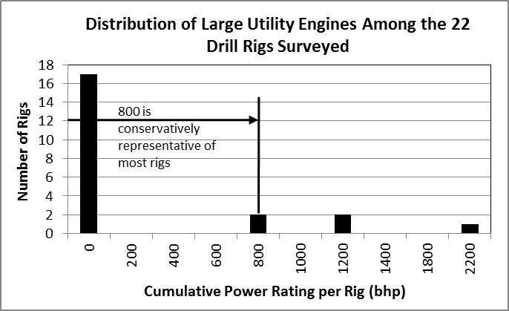
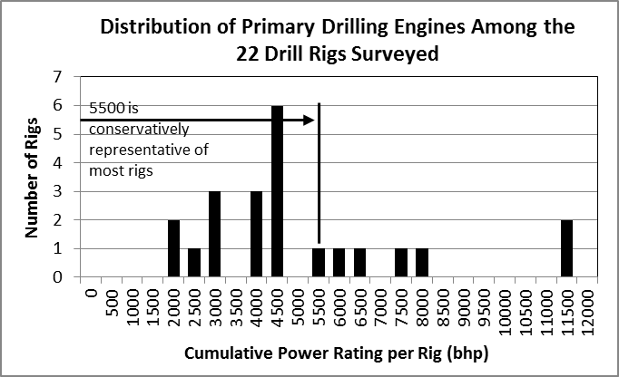
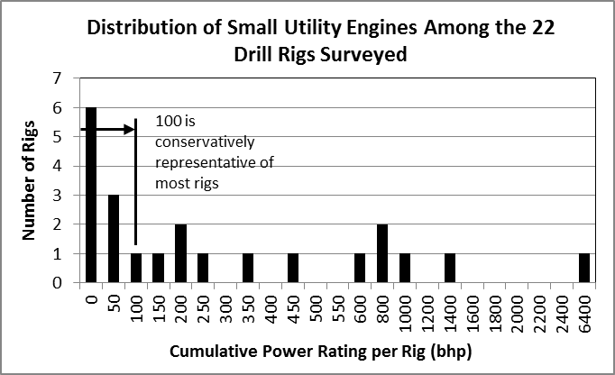
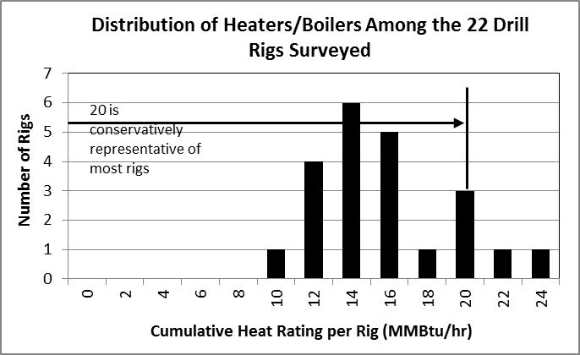

Figure B1 Results of Drill Rig Inventory Survey

Appendix C

Transportable Source Variability Processor

(TRANSVAP)

C1. INTRODUCTION
Given the stringency of the short-term probabilistic National Ambient Air Quality Standards (NAAQS) and the need to include non-stationary emissions units (EUs) in NAAQS compliance demonstrations using steady state dispersion modeling in Alaska, a robust technique was developed to predict air quality impacts from EUs that are characterized by portable, temporary, and intermittent operations. Examples of such equipment and operations could include drill rigs, hydraulic fracturing units and other well servicing activities, rock crushers, asphalt batch plants, construction equipment, and shipping vessels and other port operations. This technique was implemented as a post-processor, called the Transportable Source Variability Processor (TRANSVAP), for U.S. Environmental Protection Agency (USEPA) Modeling Guideline dispersion models. Because this technique better simulates the transitory nature of portable sources, it fills a gap in USEPA’s Modeling Guideline and predicts more realistic concentrations for assessing compliance with the probabilistic and multi-year form of the 1-hour NO₂, 1-hour SO₂, and 24-hour PM_{2.5} NAAQS.

For the North Slope POGO Simulation, the TRANSVAP post-processor was used to more realistically simulate the transitory nature of a drill rig operating for varying lengths of time at multiple well locations across a well pad. The following discussion outlines background on the TRANSVAP post-processor, how inputs are developed for TRANSVAP, and how TRANSVAP was implemented for the North Slope POGO Simulation.

C2. TRANSVAP BACKGROUND
TRANSVAP was designed to predict a representative distribution of impacts from portable sources by taking advantage of the fact that these sources: (1) only remain at a location for a limited period of time, (2) can have a random spatial distribution, and (3) can have various physical configurations. This technique was implemented as a post-processor that utilizes output from USEPA Modeling Guideline dispersion models, such as AERMOD and OCD. The models themselves do not need to be modified for use with TRANSVAP and, therefore, do not constitute an alternative modeling technique under Section 3.2 of the Guideline. Because TRANSVAP is model-independent, the technique is flexible enough to be used in short-range and long-range, as well as over land and over water, applications. TRANSVAP is designed to provide a conservatively representative distribution of model-predicted impacts from one or more portable sources operating at locations according to a random or predictable pattern. The resulting distribution of design values (a distribution describing the probability that a particular impact will occur in time) is more consistent with describing impacts from portable sources than the results from single model runs because of the unpredictable spatial and temporal nature of portable sources.

Figure C1 illustrates how the TRANSVAP post-processing technique compares to more conservative and unrealistic standard modeling approaches for a potential drill rig operation. Figure C1(a) illustrates the standard conservative modeling approach, assuming a constant drill rig operation at a single location and at its potential-to-emit or a permitted limit over the entire modeled period. For this type of operation, this scenario is unrealistic and does not occur. An alternative to the conservative modeling approach in Figure C1(a) would be modeling the drill rig operating only during specific periods according to a fixed schedule as depicted in Figure C1(b). While this scenario is more realistic, this type of modeling demonstration could lead to impractical permit conditions that hold the drill rig operation to a fixed schedule. While these activities can be planned in advance, operators almost always need to deviate from their original drilling plan due to unforeseen circumstances. TRANSVAP provides a solution to this by processing up to 10,000 different randomly-generated scenarios of possible drill rig activity, as shown in Figure C1(c). This approach accounts for any number of different operational scenarios in order to determine a worst-case reality.

C3. OVERVIEW: HOW TRANSVAP WORKS
TRANSVAP was developed as a post-processor that utilizes binary output from AERMOD for each distinctly identified short-term operational scenario. TRANSVAP uses a series of realizations designed to represent possible sequences of activity amongst those operational scenarios to generate modeled design concentrations from thousands of those realizations. The results are then presented in a statistical manner that can be used to characterize the distribution of possible air quality impacts from a portable source for use in assessing compliance with the NAAQS.

C3.1 TRANSVAP Control File
In order to run TRANSVAP, the user must create a TRANSVAP Control File which provides the program with the following information:

- Number of modeled meteorological years and dates within those years to be analyzed in the study; up to five meteorological years can be specified.

- Total number of receptors used in the AERMOD simulation and the filename containing those receptors.

- NAAQS being evaluated; TRANSVAP currently supports 1-hour NO₂, 1-hour SO₂, and 24-hour PM_{2.5} probabilistic NAAQS.

- Percentile ranking of design values output from TRANSVAP. Default rankings are 50th, 60th, 70th, 75th, 80th, 85th, 90th, and 95th percentiles. Percentile rankings can also be user-defined.

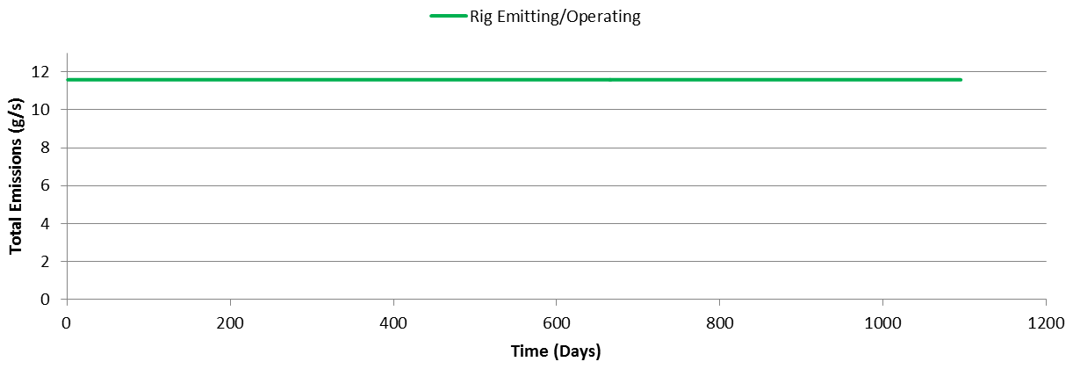

(a) Continuous Operation - Highly Conservative for Modeling a Portable Source
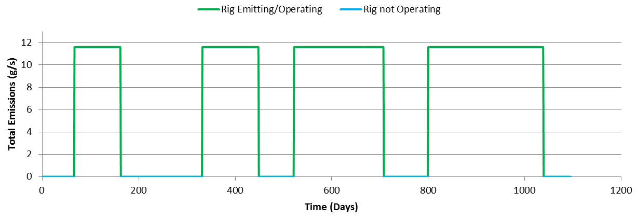
(b) Intermittent Operation - More Realistic for a Portable Source, but only One of Many Possibilities
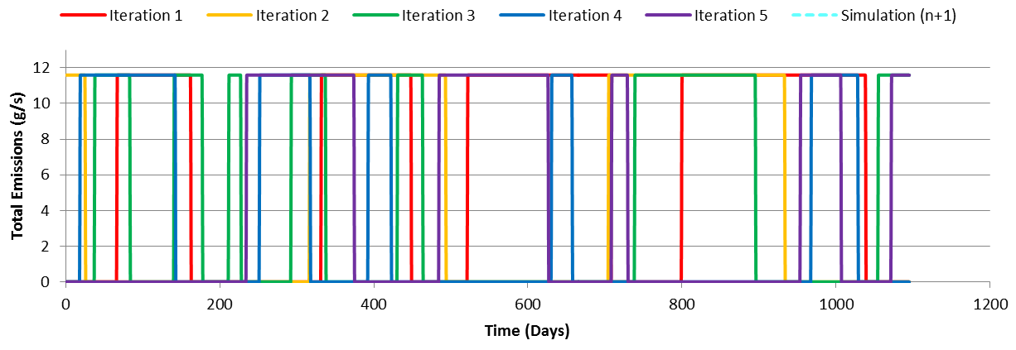
(c) Intermediate Operation - Several Realizations of Operational Profiles using the TRANSVAP Approach
Figure C1 Potential Modeling Approaches for a Portable and Transitory Operation
- Filenames of all of the AERMOD binary files representing impacts generated for each operational scenario processed with TRANSVAP.

- Filenames of all TRANSVAP simulation files for use with TRANSVAP. These files contain instructions for how to string together series of identified short-term portable source operational modes into each of the thousands of realizations of activity.

C3.2 TRANSVAP Input Files
Before using TRANSVAP, the user must perform two steps in order to prepare key files necessary for input into the program. The development of these inputs is discussed in the following sections.

C3.2.1 AERMOD Binary Files
The user must define a number of operational scenarios that represent distinct short-term activities of one or more portable sources operating at a given location or multiple locations either individually or simultaneously. For example, the sources representing a drilling operation at a location might be considered one operational scenario, while another operational scenario might represent hydraulic fracturing operations at that same location, while yet another might be the same drilling equipment as used in the first scenario but operating at a different load or entirely different location. For each operational scenario identified by the user, one AERMOD run must be executed and a binary file of the modeled concentrations in AERMOD’s POSTFILE format (either in 1-hour or 24-hour periods depending on the standard under consideration) generated containing the results from the entire period of meteorological data being modeled. One binary file representing each operational scenario will be input into TRANSVAP. Because this AERMOD run can contain any of the combinations of source types, emission rates, and source locations that an AERMOD run can contain, there is great flexibility in the kinds of operational scenarios that TRANSVAP can simulate.

C3.2.2 TRANSVAP Simulation Files
The user must also generate a number of operating schedules, or realizations, which represent a possible sequence of user developed operational modes over the meteorological period being modeled. To define each simulation, it is necessary to first determine the probability distribution for each operational scenario under consideration. For example, suppose Scenario 1 represents well drilling, while Scenario 2 represents hydraulic fracturing. Probability distributions for each scenario are developed using knowledge of how these activities typically occur. For example, using the typical mean number of days that well drilling occurs, and a typical standard deviation from the mean, spreadsheet tools can be used to generate a series of random numbers representing the probable number of hours that well drilling occurs. Similar sets of random numbers can be generated for hydraulic fracturing and for periods of inactivity when neither well drilling nor hydraulic fracturing occurs. These numbers are then combined to define as many realizations as are desired, and are used to produce the TRANSVAP Simulation File.

The format of the TRANSVAP Simulation File is a list of hours for each simulation at which the activity of one or more of the operational scenarios starts. During the period starting with the hour identified, an operational mode that is active is signified by a “1” for on, or “0” for off. For example, a single simulation representing two operational scenarios modeled over a five-year period might look like the example below. In this example shown in Figure C2, for hours 1 through 7,870 both scenarios are set to 0 and therefore are inactive. At hour 7,871, Scenario 1 becomes active and remains active through hour 8,230, at which point both scenarios are inactive until hour 13,775 when Scenario 2 becomes active through hour 14,110 of the five-year period, etc. This simulation is also shown graphically as a time series of activity in Figure C2(b). There are no restrictions regarding the number of scenarios that can be active or inactive simultaneously, or the number of realizations that can be included one after the next in a single TRANSVAP analysis (depending on computer resources available).

C3.3 Executing TRANSVAP
Once the user creates the necessary files, the TRANSVAP executable must be run based on the inputs provided by the user in a control file. All of the necessary files are imported into the program and each simulation outlined in the TRANSVAP Simulation File is run by the following process:
- For each averaging period, dependent on the NAAQS being evaluated, the program determines if any of the user-defined operational scenarios are active. If they are not, the modeled concentrations for the period are set to zero.

- For any operational scenario that is active during the period (1-hour or 24-hours depending on the NAAQS evaluated), the modeled concentration for that operational scenario is summed with the modeled concentrations from any other active operational scenarios to produce an overall modeled concentration for that period at each receptor.

- Once all hours are processed for a particular simulation period, appropriate design concentrations are calculated according to the NAAQS being evaluated and then written to a file.

- Once all realizations have been completed, design values for each user specified percentile rank are calculated and presented to the user.

TRANSVAP produces the following output:

- A file containing the design concentrations for each simulation defined in the TRANSVAP Simulation File, identifying the design concentration and the receptor at which the design concentration for that simulation occurred.

- A violation report file containing a list of every receptor at which the design concentration exceeded the NAAQS for each simulation defined in the TRANSVAP Simulation File.
- A file containing the modeled concentration, in the form of the standard, at every receptor for each simulation defined in the TRANSVAP Simulation File.

- For every simulation, a file reflecting the activity switches used for that simulation, taken from the TRANSVAP Simulation File, and the yearly modeled concentrations for each receptor. These files are primarily for quality assurance and debugging.

(a) | Example Format of Simulation:  START SIMULATION 1  **Hour SCENARIO 1 SCENARIO 2  1 0 0  7871 1 0  8231 0 0  13775 0 1  14111 0 0  15623 0 1  16007 0 0  20207 0 1  20495 0 0  23855 0 1  24191 0 0  29567 0 1  29807 0 0  36023 0 1  36431 0 0  41975 0 1  42311 0 0  END SIMULATION 1
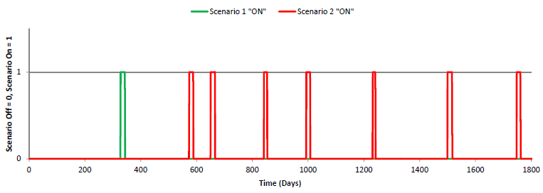
(b)
Figure C2 Example (a) TRANSVAP Simulation File and (b) Graphical Depiction for a Single Simulation
- The TRANSVAP.OUT file provides a statistical analysis based on the results from each of the realizations defined in the TRANSVAP Simulation File. This file presents the following information:
  - For every receptor, the overall maximum design concentration calculated over all realizations, the average design concentration calculated over all realizations, and eight different percentile results of the design values calculated over all realizations. By default, the program presents, for each receptor, the 50th, 60th, 70th, 75th, 80th, 85th, 90th, and 95th percentiles design concentrations over all realizations. These percentile values are customizable by the user.
  - The highest design concentration, highest average value, and highest design concentration at each of the percentile levels described above is reported separately.
  - For the overall highest design concentration, the receptor at which it occurred and the simulation it occurred in is identified.
  - For the highest overall average design concentration, the receptor at which it occurred is identified.
  - If the NAAQS is violated at any receptor, the percentile result at which the violation occurred.

C4. APPLICATION OF TRANSVAP FOR THE NORTH SLOPE POGO SIMULATION
TRANSVAP was used to post-process AERMOD-predicted impacts for 1-hour NO₂ and 1-hour SO₂ averaging periods for the North Slope POGO Simulation. Sections C4.1 through
C4.4 summarize input development for post-processing the North Slope POGO Simulation with TRANSVAP. Figure C2 illustrates the AERMOD and TRANSVAP processing steps specific to the North Slope POGO Simulation. The process outlined would be used for each fuel consumption modeled.

C4.1 TRANSVAP Control File
As described in Section C3, there are several key inputs required to use the TRANSVAP post-processor. For the North Slope POGO Simulation, required inputs specified in the control file are summarized in Table C1 for both the 1-hour NO₂ and 1-hour SO₂ modeling demonstrations.

C4.2 Receptor Grid
For computational efficiency, the full AERMOD receptor grid described in the North Slope POGO Simulation modeling report is refined to only consider receptors with AERMOD-predicted impacts for a representative fuel consumption that show a violation of the NAAQS. This processing step was performed for all AERMOD simulations that are post-processed with TRANSVAP.

Table C1 North Slope POGO Simulation Control File
 | Pollutant | Isolated Pad |  | Collocated Pad
 |  | RDi | DDi | RDc | DDc
Meteorological Years Processed | 1-hour NO₂ | 5 years – 2006, 2007, 2008, 2009, 2010
 | 1-hour SO₂
Number of Receptors and Filename with Receptors | 1-hour NO₂ | 100  (ReGrid_NO2_isolated.dat) |  | 152  (ReGrid_NO2_collocated.dat)
 | 1-hour SO₂ | 100 (ReGrid_SO2.dat)
NAAQS Evaluated | 1-hour NO₂ | Option 2
 | 1-hour SO₂ | Option 1
Percentile Ranking of Design Values | 1-hour NO₂ | Default (50th, 60th, 70th, 75th, 80th, 85th, 90th, and 95th)
 | 1-hour SO₂
AERMOD Output Files for Each Operational Scenario | 1-hour NO₂ | Drill Rig Not Operating at Well Pad: DRILLING_SC1_SO2.POS  Drill Rig Operating at Well Location 2: DRILLING_SC2_SO2.POS  Drill Rig Operating at Well Location 3: DRILLING_SC3_SO2.POS  Drill Rig Operating at Well Location 4: DRILLING_SC4_SO2.POS  Drill Rig Operating at Well Location 5: DRILLING_SC5_SO2.POS  Drill Rig Operating at Well Location 6: DRILLING_SC6_SO2.POS
 | 1-hour SO₂
TRANSVAP Activity Profiles | 1-hour NO₂ | WOA_INFILL_ 23-OCT-2014.inp | Rig_Movement_ 22-APR-2014.inp | WOA_INFILL_ 23-OCT-2014.inp | Rig_Movement_ 22-APR-2014.inp
 | 1-hour SO₂

C4.3 AERMOD Output
All required AERMOD binary output files were generated in POSTFILE (*.pos) format. A POSTFILE was generated for each of the six operational scenarios which consist of a drill rig operating at five different well locations across a representative well pad and one scenario with no drill rig operation. Modeled drill rig locations across the well pad are illustrated in Figure C3.

C4.4 TRANSVAP Simulation Files
As previously described, TRANSVAP recombines AERMOD-predicted impacts according to randomly-generated drill rig realizations. To develop and generate the different realizations of drill rig activity, a TRANSVAP Simulation File for the North Slope POGO Simulation, there were three degrees of freedom considered:
- Location of the drill rig (See Figure C3).
- Duration of active drilling.
- Duration without drill rig activity.

Based on these degrees of freedom and actual operational data collected on the North Slope, 10,000 realizations of drill rig activity were developed.

Model-predicted impacts are predicted with AERMOD for each operational scenario, which, in this case, consists of a drill rig operating at each location at the well pad continuously and one where the drill rig is not operating at any of the well pad locations. The individual well site locations are depicted in Figure C3. Model-predicted impacts at each of these locations are then recombined according to 10,000 different realizations of drill rig activity. Sections C4.4.1 and C4.4.2 describe the development of the unique activity profiles for routine infill drilling and developmental drilling activities.

C4.4.1 Routine Infill Drilling Activity
Routine infill drilling is characterized by intermittent drilling at a well pad where the drill rig operates at a well pad, leaves, and then returns to the well pad to operate after a period of inactivity. To characterize the activity on the North Slope, an analysis was conducted on 6.5 years of daily drill rig activity data. This data was collected for drill rig activities occurring across 26 separate well pads in the Western Operating Area of the Prudhoe Bay Unit (PBU). The data was analyzed to characterize the duration of time when a drill rig was operating at a well pad and duration of time when a drill rig was not operating at a well pad. The information derived from the PBU data are summarized in the form of probability frequency distributions in Figure C4. For processing with TRANSVAP, a probability density function is fitted to each of these datasets. Active drilling activity is characterized by a lognormal probability density function with a mean of 29.5 days and standard deviation of 34.9 days. Inactivity is characterized by a gamma probability density function with a mean of 160.1 days and standard deviation of 200.6 days.

Using these activity and inactivity probability density functions, a TRANSVAP Simulation File is developed for input into TRANSVAP. To create five years of intermittent drill rig activity at a well pad for modeling, activity proceeds as follows:
- Well pad is vacant between 0 and 365 days.
- Drill rig operates at one of the five well locations for a random duration of time determined according to the lognormal drill rig activity profile.
- Drill rig is inactive at the well pad for a random duration of time determined according to the gamma drill rig inactivity profile.
- Alternating drill rig activity and inactivity continue through the remainder of the five-year modeled period according to the activity and inactivity profiles.

For routine infill drilling, the lognormal probability density function was selected to better represent the tail of the active drilling dataset that is less representative of routine infill drilling activities. This type of distribution does not represent typical routine infill drilling activities, which last between 30 to 60 days, as well as other probability density functions considered. This has the effect of increasing the likelihood of non-routine infill drilling activities, such as multi-year drilling events at a single well, occurring amongst the 10,000 realizations and adding additional conservativism into the analysis.

C4.4.2 Developmental Drilling Activity
Developmental drilling is characterized by continuous drilling at a well pad where a drill rig moves from one well to another with little to no inactivity between drilling new wells. To represent developmental drilling activity for the North Slope, a drill rig is assumed to be operating at one of five well locations for an average of three weeks to drill a new well before drilling another new well at the well pad. Active drilling activity is characterized by a normal probability density function with a mean of 21 days and standard deviation of 3.5 days. This characterization is based on a typical drilling cycle rather than the PBU data discussed for infill drilling activity. However, because continuous drilling is assumed, the analysis is not very sensitive to the duration of activity at any particular well location.

The probability density functions used to represent developmental drilling activity and inactivity are depicted in Figure C5.

To create five years of developmental drill rig activity at a well pad for modeling, activity proceeds as the following:
- Well pad is vacant between 0 and 730 days (2 years).
- Drill rig operates at one of the five well locations for a random duration of time determined according to the normal drill rig activity profile.
- Continuous drill rig activity through the remainder of the five-year modeled period among the five well locations at the well pad according to the normal drill rig the activity profile.

Using this characterization, developmental drilling activities are simulated for three to five years of continuous drilling. The maximum model-predicted impacts are most likely to occur with realizations of drill rig activity that have the longest period of continuous drilling activity because of the multi-year average form of the 1-hour standards. Therefore, this is a very conservative characterization of developmental drilling because continuous drilling for that length of time on the North Slope is unrealistic.

C4.5 Using TRANSVAP Results for the North Slope POGO Simulation
For the North Slope POGO Simulation, the 99th percentile of the distribution of impacts predicted for the 10,000 realizations of drill rig activity is used to represent design value air quality impacts for comparison to the NAAQS.

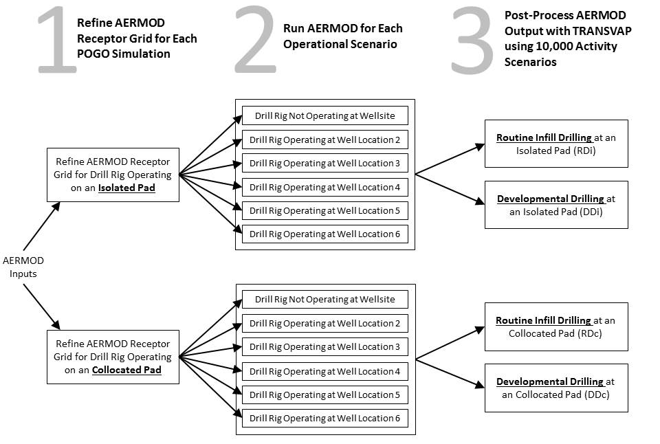

Figure C2 Flowchart of Processing for North Slope POGO Simulation
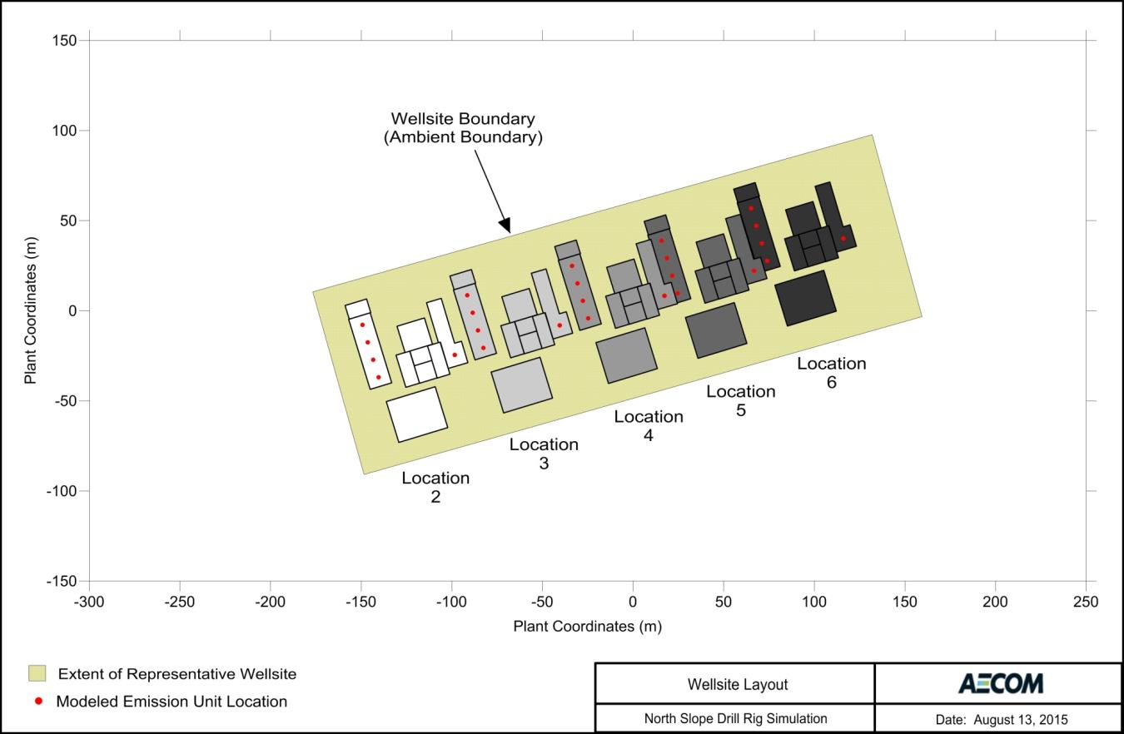
Figure C3 Configuration of Representative Well pad with Five Modeled Well (Drill Rig) Locations
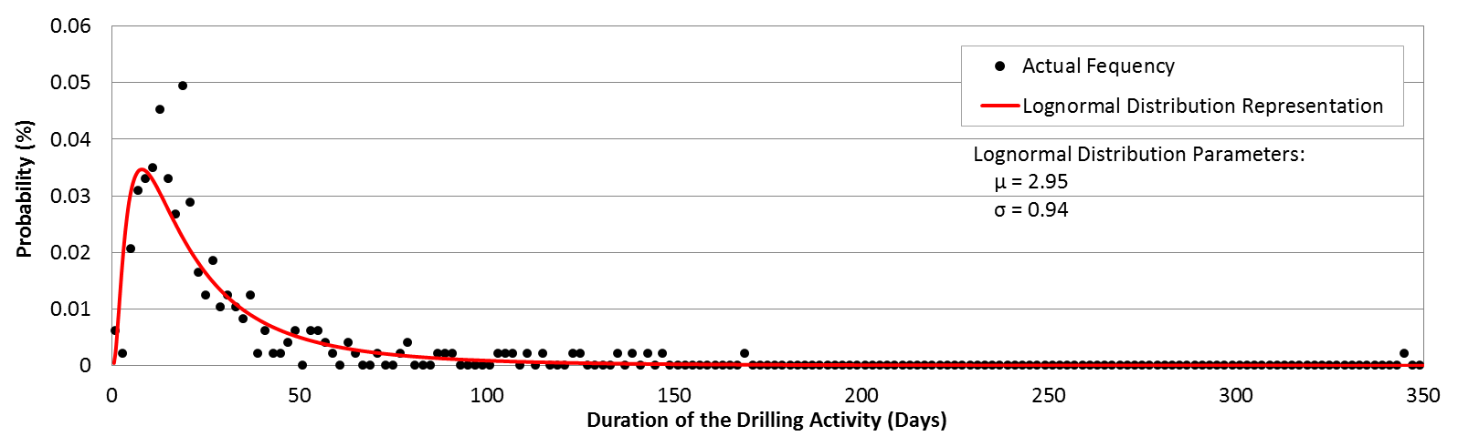
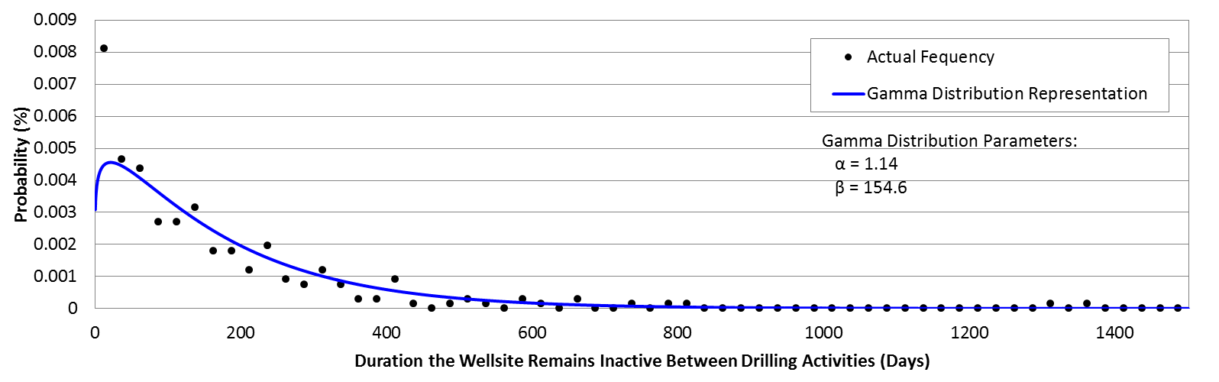
Figure C4 Representative Routine Infill Drilling Activity Profiles
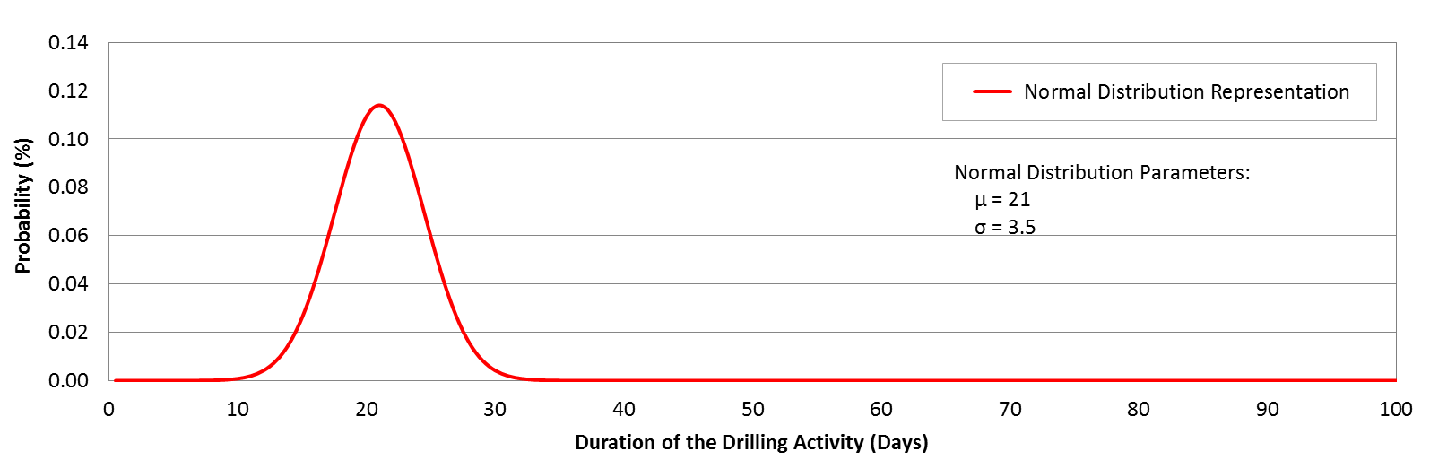
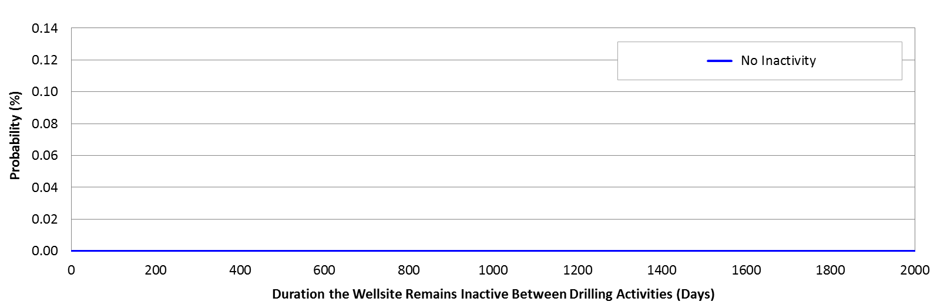
Figure C5 Representative Developmental Drilling Activity Profiles

C5. SENSITIVITY ANALYSIS: STATISTICAL CONVERGENCE OF THE MODELING
Sensitivity analyses were conducted to show that the results are stable regardless of which set of 10,000 realizations of drill rig activity are selected, and to show that 10,000 realizations is sufficient to generate a stable result. Two separate analyses were conducted to test the statistical convergence of TRANSVAP post-processed 1-hour NO₂ AERMOD-predicted results by (1) varying the number of realizations of drill rig activity processed with TRANSVAP and (2) creating multiple randomly-generated activity input files.

Sensitivity analyses were conducted for 1-hour NO₂ modeling for the RDi POGO category with drill rig operation at 12,000 gallons per day and AERMOD version 14134. While the representative fuel consumption selected is not important to these analyses, the conclusions of these analyses are sensitive on the number of and nature of the degrees of freedom incorporated into the model simulation. Degrees of freedom include well location, duration of drill rig activity, and duration of drill rig inactivity. These AERMOD runs do not include transient hourly excursions and do not represent a compliance demonstration for the North Slope POGO Simulation. Therefore, the model-predicted impacts presented do not have meaning in the context of the allowable fuel consumption determined for North Slope POGOs.

C5.1 Convergence of Results and the Number of Realizations
Table C2 summarizes 1-hour NO₂ results after TRANSVAP post-processing while varying the number of realizations of drill rig activity processed. Model-predicted impacts indicate results generally converge with less than 1,000 realizations. The maximum AERMOD-predicted impacts will continue to vary as additional realizations are processed. However, the average and other statistical percentile results show little variability beyond 1,000 realizations.

Table C2 1-Hour NO₂ Results Varying the Number of Realizations of Drill Rig Activity
Number of Realizations of Drill Rig Activity | Design Concentrations (µg/m³)
 | Maximum | 99th Percentile | 95th Percentile | 90th Percentile | 75th Percentile | 50th Percentile | Average
100 | 153.26 | 146.36 | 135.86 | 129.45 | 119.41 | 108.53 | 111.03
500 | 162.10 | 148.81 | 135.77 | 130.38 | 121.57 | 112.04 | 113.13
1,000 | 162.10 | 147.03 | 137.06 | 131.26 | 121.93 | 112.33 | 113.38
2,500 | 162.10 | 147.03 | 137.39 | 131.70 | 122.07 | 112.89 | 113.43
5,000 | 164.97 | 147.17 | 137.17 | 131.47 | 122.04 | 112.79 | 113.40
7,500 | 164.97 | 147.69 | 137.64 | 131.74 | 122.23 | 112.74 | 113.50
10,000 | 164.97 | 147.74 | 137.45 | 131.84 | 122.39 | 112.79 | 113.60

C5.2 Convergence of Results and Randomly-Generated Activity Input Files
Table C3 summarizes 1-hour NO₂ results after TRANSVAP post-processing with ten different randomly-generated TRANSVAP activity input files. Each activity input file was created with 10,000 realizations of drill rig activity. Model-predicted impacts indicate that the specific realizations comprising the activity input file made little difference to the model-predicted impacts. Similar to varying the number of realizations, the most variability is seen in the maximum results, while the average and other statistical percentile results show less variability in results.

Table C3 1-Hour NO₂ Results Predicted with Different Activity Input Files
File # | Design Concentrations (µg/m³)
 | Maximum | 99th Percentile | 95th Percentile | 90th Percentile | 75th Percentile | 50th Percentile | Average
1 | 164.97 | 147.74 | 137.45 | 131.84 | 122.39 | 112.79 | 113.60
2 | 165.09 | 147.77 | 137.25 | 131.59 | 122.63 | 112.43 | 113.47
3 | 164.33 | 147.17 | 137.23 | 131.54 | 122.54 | 112.60 | 113.49
4 | 161.84 | 147.68 | 137.15 | 131.42 | 122.17 | 112.45 | 113.17
5 | 166.85 | 147.88 | 137.43 | 131.91 | 122.65 | 112.64 | 113.50
6 | 171.37 | 147.64 | 137.28 | 131.96 | 122.94 | 112.96 | 113.68
7 | 169.80 | 147.16 | 137.27 | 131.63 | 122.55 | 112.89 | 113.53
8 | 166.50 | 146.39 | 136.89 | 131.57 | 122.48 | 112.72 | 113.43
9 | 165.93 | 147.64 | 137.72 | 132.14 | 122.74 | 112.90 | 113.69
10 | 162.53 | 147.70 | 137.35 | 131.76 | 122.69 | 112.82 | 113.55
Summary
Minimum | 161.84 | 146.39 | 136.89 | 131.42 | 122.17 | 112.43 | 113.17
Maximum | 171.37 | 147.88 | 137.72 | 132.14 | 122.94 | 112.96 | 113.69
Range | 9.53 | 1.49 | 0.83 | 0.72 | 0.77 | 0.53 | 0.52
Average | 165.92 | 147.48 | 137.30 | 131.74 | 122.58 | 112.72 | 113.51
Std. Dev. | 2.95 | 0.45 | 0.22 | 0.22 | 0.21 | 0.19 | 0.15

C5.3 Conclusions
The following conclusions can be drawn from the two sensitivity analyses conducted with the TRANSVAP post-processor. TRANSVAP post-processing with 10,000 realizations of drill rig activity is sufficient:
            - to allow for the convergence of results.
            - to account for the expected variability in randomly-generated drill rig activity.
            - to capture a diverse range of realizations of drill rig activity, such that one set of 10,000 realizations produces identical results to an independently produced set or realizations.

For the North Slope POGO Simulation, these sensitivity analyses demonstrate the approach is robust. This analysis also supports using the 99th percentile TRANSVAP-processed results to evaluate impacts from North Slope POGOs. Based on the sensitivity analyses conducted, the 99th percentile results show better general convergence and less variability in results than that maximum.

Sensitivity analyses were not conducted for a developmental drilling, DDi or DDc, POGO categories because the developmental drilling activity input files have fewer degrees of freedom and will have less variability than routine infill drilling results.

Appendix D

Second Tier Approach to Combining Model-Predicted Impacts with a Monitored NO₂ Background

D1. INTRODUCTION
Guidance published by the U.S. Environmental Protection Agency (USEPA) offers multiple approaches for developing monitored 1-hour NO₂ background concentrations to combine with model-predicted impacts. Given the stringency of the 1-hour NO₂ National Ambient Air Quality Standard (NAAQS), a second tier approach was used to combine background concentrations with model-predicted impacts from the North Slope POGO Simulation. This appendix reviews the development and implementation of a second tier 1-hour NO₂ background approach using data collected at representative North Slope monitoring stations. The representativeness of the monitored data collected at these stations is discussed in the modeling report for the North Slope POGO Simulation.

D2. BACKGROUND
A guidance memo published by the USEPA outlines a tiered approach to develop monitored NO₂ background values to assess compliance with the 1-hour NO₂ National Ambient Air Quality Standard (NAAQS). The first tier approach assumes “a uniform monitored background contribution” by “[adding] the overall highest hourly background NO₂ concentration (across the most recent three years) from a representative monitor to the modeled design value.” A less conservative first tier approach assumes “a uniform monitored background contribution based on the monitored design value” (98th percentile of the annual distribution of daily maximum 1-hour values). Though these approaches are generally acceptable, the first tier approach may “be overly conservative in many cases and may also be prone to reflecting source-oriented impacts from nearby sources.”³¹

USEPA also provides guidance on a second tier approach that can be used if a first tier approach is overly conservative and compliance cannot be demonstrated with that approach. The second tier approach is a collection of approaches that involves developing background concentrations based on identifying “the meteorological conditions accompanying the concentrations of concern” (meteorological conditions of concern). For sources with diurnal patterns of ambient impacts, USEPA suggests a temporally varying background based on “multiyear averages of the 98th-percentile of the available background concentrations by season and hour-of-day, excluding periods when the source in question is expected to impact the monitored concentration.”³¹ When identifying meteorological conditions of concern, the second tier approach can also be interpreted to include methods in which the monitored NO₂ background levels can be shown to vary by wind direction, wind speed, hour of day, day of week, or month of year, as appropriate. Second tier approaches are representative because “the monitored values will be temporally paired with modeled concentrations based on temporal factors that are associated with the meteorological variability, but will also reflect worst-case meteorological conditions in a manner that is consistent with the probabilistic form of the 1-hour NO₂ standard.”³¹
An analysis of NO₂ data from the A-Pad and CD1 monitoring stations demonstrated that the measured 1-hour NO₂ concentrations have a strong dependence on wind speed on the North Slope. This relationship exists because higher wind speeds promote increased dispersion and dilution of plumes, making NO₂ concentrations generally decrease with increasing wind speeds.

Figure D1 illustrates the relationship between hourly average NO₂ concentration and hourly average wind speed measurements at the (a) A-Pad Monitoring Station and (b) CD1 Monitoring Station. Note that the NO₂ concentrations collected at the CD1 Monitoring Station are paired with wind speed measurements collected at the Nuiqsut Monitoring Station also operated by ConocoPhillips Alaska, Inc. (CPAI). The Nuiqsut Monitoring Station is located approximately 13 kilometers south of the CD1 Monitoring Station.

Figure D1 clearly shows that the monitored NO₂ concentrations at these locations decrease with increasing wind speed. Therefore, in this case, low wind speeds are associated with the highest concentrations and are the “meteorological conditions accompanying the concentrations of concern” referenced in the USEPA guidance. The existence of the relationship shown in Figure D1 makes a second tier approach appropriate for development of background concentrations varying by wind speed.

D3. IMPLEMENTATION OF A SECOND TIER APPROACH
The second tier approach for 1-hour NO₂ background development is applied using the following ambient NO₂ and wind speed measurements:
- A-Pad Monitoring Station data collected between January 1, 2008 and December 31, 2012(5 years).
- CD1 Monitoring Station data collected between October 1, 2012 and September 30, 2014 (2 years).

Background concentrations are determined by first sorting all hourly average NO₂ measurements according to the accompanying wind speed using the categories listed in Table D1. These wind speed categories are defined in the AERMOD User’s Guide. Once the data have been sorted, the 98th percentile hourly average NO₂ concentration is calculated from the data in each wind speed category for each year of data. All annual 98th percentile values are then averaged together for each wind speed categories. The use of multi-year average monitored background concentrations accounting for the meteorological conditions of concern is consistent with the language in USEPA’s Guideline³² and other guidance on modeling for the 1-hour NO₂ NAAQS.³¹

Table D1 summarizes the resulting NO₂ background concentrations that were calculated using data collected at the A-Pad and CD1 monitoring stations. The background NO₂ values corresponding to specific wind speed categories vary from 16.7 to 50.3 µg/m³ using the A-Pad dataset and from 41.8 to 83.7 µg/m³ using the CD1 dataset.

Once the second tier approach background concentrations are determined, these values are incorporated into the AERMOD modeling using the “BACKGRND” keyword on the “SO” pathway and the secondary keyword “WSPEED.” The wind speed categories can be user-defined by using the “WINDCATS” keyword on the “ME” pathway, though this is unnecessary as AERMOD default wind speed categories have been used in this analysis. Using this approach, within the AERMOD run an NO₂ background concentration is assigned to all receptors for each hour of the meteorological input, with the selected background value being determined by the wind speed for that hour in accordance with Table D1.

D3.1 Data Completeness
Table D2 summarizes the annual and quarterly data completeness for applicable data collected at the A-Pad Monitoring Station between January 1, 2008 and December 31, 2012. Table D3 summarizes the annual and quarterly data completeness for applicable data collected at the CD1 and Nuiqsut monitoring stations between October 1, 2012 and September 30, 2014. Hourly wind speed data from the A-Pad and Nuiqsut monitoring stations used in the implementation of the second tier approach meet minimum data completeness requirements for PSD-quality ambient air quality data. Hourly NO₂ data used to develop background concentrations from the A-Pad and CD1 monitoring stations also meet minimum PSD data completeness requirements, except for the third quarter of 2008 A-Pad NO₂ data. Although this is the case, little bias is expected in the development of background concentrations because ambient NO₂ on the North Slope has no discernible seasonal variability. Any effect is also minimized by the use of five years rather than three years of ambient data.

For implementation of the second tier approach, hourly NO₂ measurements in the dataset without a corresponding wind speed measurement were disregarded in the development of background concentrations. However, given that both parameters generally meet PSD data completeness requirements and wind speed data completeness is generally very high, near 100 percent, the joint data completeness of these parameters would be similar to the NO₂ data completeness, and the joint data completeness was not further analyzed. Any effect on the calculated background values is also minimized by the use of five years rather than three years of ambient data.
(a)
A-Pad (Isolated Pad) Monitoring Station
January 1, 2008 – December 31, 2012
(b)
CD1 (Collocated Pad) Monitoring Station
October 1, 2012 – September 30, 2014
Figure D1 Relationship Between Hourly NO₂ Concentrations and Wind Speed Measured at the (a) A-Pad and (b) CD1 Monitoring Stations
Table D1 1-Hour NO₂ Background Varying by Wind Speed
Wind Speed (W_{S})  Category ª  (m/s) | NO₂ Concentration
 | A-Pad (Isolated Pad) |  | CD1 (Collocated)
 | (ppbv) | (µg/m³) | (ppbv) | (µg/m³)
W_{S} < 1.54 | 26.7 | 50.3 | 44.5 | 83.7
1.54 ≤ W_{S} < 3.09 | 24.6 | 46.2 | 37.0 | 69.5
3.09 ≤ W_{S} < 5.14 | 17.0 | 31.9 | 30.4 | 57.2
5.14 ≤ W_{S} < 8.23 | 12.3 | 23.2 | 23.0 | 43.2
8.23 ≤ W_{S} < 10.8 | 8.9 | 16.7 | 22.2 | 41.8
W_{S} ≥ 10.8 | 13.6 | 25.5 | 22.6 | 42.5
ª AERMOD-default wind speed categories.

Table D2 Summary of Quarterly and Annual Data Completeness for Hourly NO₂ and Wind Speed Measurements at A-Pad (percent)
Data Period | 2008 |  | 2009 |  | 2010 |  | 2011 |  | 2012
 | NO₂ ª | Wind Speed ^{b} | NO₂ ª | Wind Speed ^{b} | NO₂ ª | Wind Speed ^{b} | NO₂ ª | Wind Speed ^{b} | NO₂ ª | Wind Speed ^{b}
First Quarter (Q1) | 91 | 99 | 98 | 100 | 91 | 100 | 96 | 100 | 98 | 96
Second Quarter (Q2) | 84 | 98 | 97 | 98 | 98 | 97 | 93 | 97 | 92 | 99
Third Quarter (Q3) | 55 | 99 | 97 | 99 | 98 | 100 | 96 | 99 | 97 | 100
Fourth Quarter (Q4) | 97 | 91 | 98 | 91 | 93 | 100 | 98 | 100 | 98 | 99
Annual | 82 | 97 | 97 | 97 | 95 | 99 | 98 | 99 | 96 | 98
ª Hourly NO₂ data for all quarters, except third quarter 2008, meet the 80 percent completeness requirement for PSD-quality ambient air quality data.
^{b} Hourly wind speed data for all quarters meet the 90 percent completeness requirement for PSD-quality meteorological data.

Table D3 Summary of Quarterly and Annual Data Completeness for Hourly NO₂ Measurements at CD1 Paired with Wind Speed Measurements at Nuiqsut (percent)
Data Period | October 1, 2012 – September 30, 2013 |  | October 1, 2013 – September 30, 2014
 | NO₂ ª | Wind Speed ^{b} | NO₂ ª | Wind Speed ^{b}
First Quarter (Q1) | 93 | 90 | 97 | 90
Second Quarter (Q2) | 96 | 95 | 98 | 99
Third Quarter (Q3) | 96 | 100 | 87 | 97
Fourth Quarter (Q4) | 96 | 100 | 98 | 100
Annual | 95 | 96 | 95 | 97
ª Hourly NO₂ data for all quarters meet the 80 percent completeness requirement for PSD-quality ambient air quality data.
^{b} Hourly wind speed data for all quarters meet the 90 percent completeness requirement for PSD-quality meteorological data.

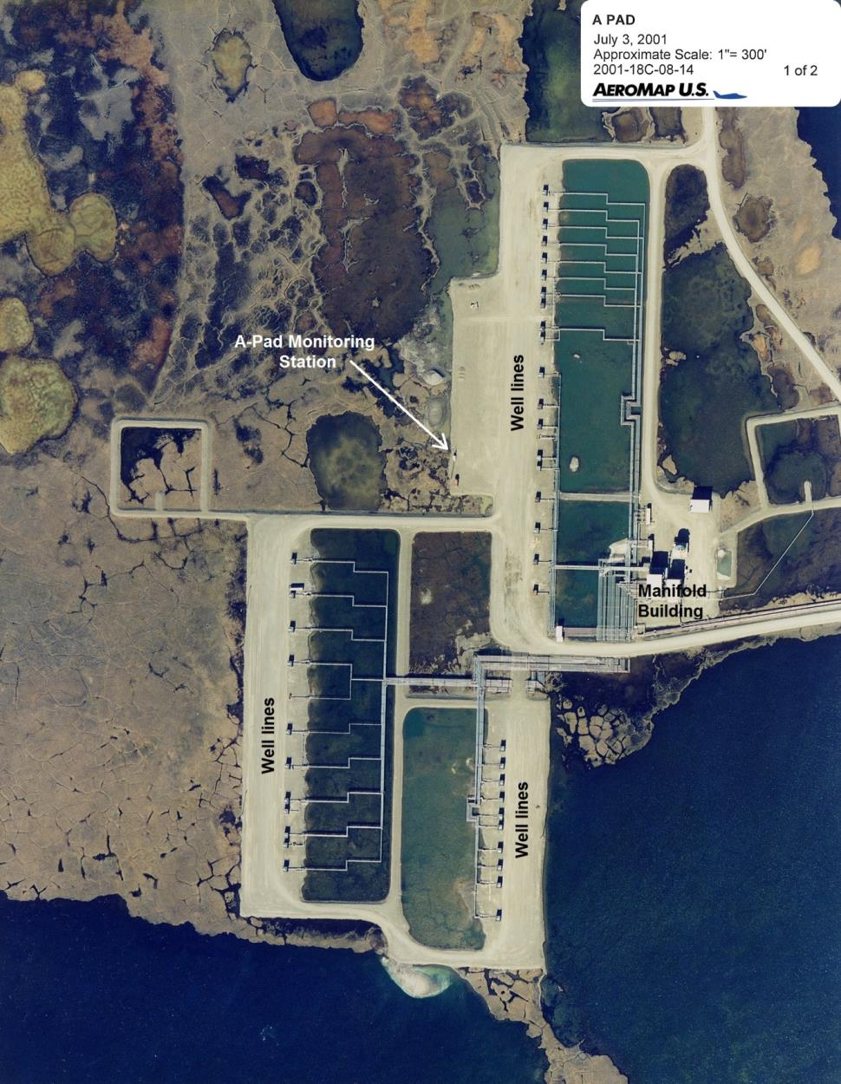
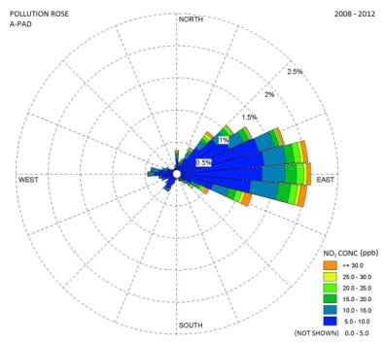
Figure D2 Aerial Image of A-Pad Monitoring Station

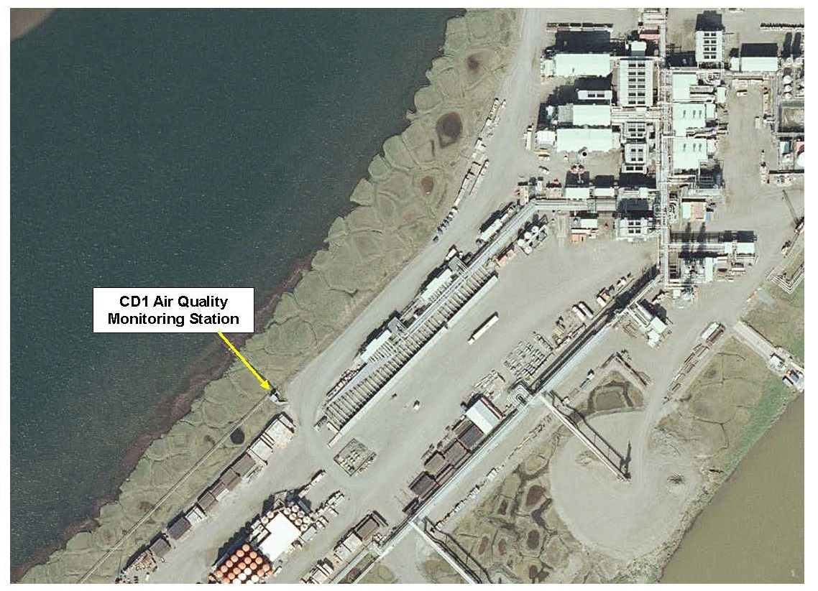
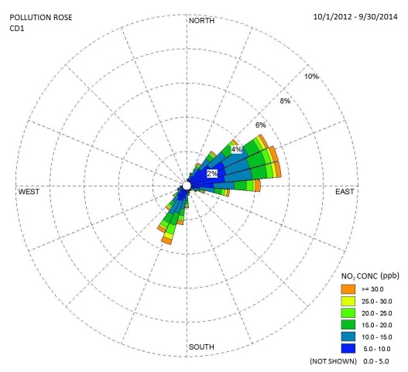
Well Lines
Figure D3 Aerial Image of CD1 Monitoring Station

Appendix E

Hydraulic Fracturing in Alaska

EXECUTIVE SUMMARY
The purpose of this document is to describe hydraulic fracturing in Alaska for the purpose of applying ambient air quality background measurements with air quality dispersion modeling. Hydraulic fracturing, as it’s been conducted in Alaska to date, is captured by the ambient air quality measurements at several North Slope drill sites. The hydraulic fracturing conducted to date in Alaska is fracturing of wells drilled for conventional resources, rather than unconventional. Conventional oil and gas resources are found in more permeable formations (sandstone) and are easier to produce as oil and gas flow readily to wellbores. Unconventional resources are found in less permeable formations (shale) and require more energy to produce. Impacts from hydraulic fracturing of unconventional resources are not captured in existing ambient air quality measurements because unconventional resources have not yet been brought into production in Alaska.

E1. INTRODUCTION
The following is a brief discussion characterizing hydraulic fracturing currently occurring in Alaska and contrasting that with hydraulic fracturing associated with unconventional oil and gas development which has recently gained significant attention in the lower 48 states. This discussion is supplemented by a description of current trends and what might be expected in the future regarding the use of hydraulic fracturing in the development of oil and gas in resources in Alaska. This discussion relies heavily on North Slope data but is applicable to other parts of Alaska, as well.

E2. HISTORIAL PERSPECTIVE ON THE PURPOSE OF HYDRUALIC FRACTURING
Hydraulic fracturing was first conducted in the 1940’s to enhance oil and gas well productivity. The method was based on the idea that creating fractures or conduits enables fluids to flow more easily to the wellbore. Since its development, hydraulic fracturing has been used to enhance the productivity of low permeability formations, remove near-wellbore formation damage caused by drilling or completion, increase secondary recovery productivity, and increase the capacity of disposal injection wells (Howard and Fast 1970). In addition to these uses of fracturing, the method evolved in the 1970s to enable the commerciality of very low permeability “tight” gas sands. From the 1980s to present, multi stage hydraulic fracturing was combined with horizontal drilling technology to produce oil and gas from extremely low permeability rocks, such as shales. This unconventional oil and gas development has led to increased visibility on the role of hydraulic fracturing.

E3. HISTORIAL PERSPECTIVE ON THE PURPOSE OF HYDRUALIC FRACTURING
In order to understand how hydraulic fracturing has become a highly visible activity in the past decade, it is important to understand the difference between conventional and unconventional oil and gas resources. According to the U.S. Department of Energy (USDOE n.d.):

“Unconventional oil and gas is differentiated from conventional hydrocarbon resources based on the state of the hydrocarbon, nature of the geologic reservoirs and the types of technologies required to extract the hydrocarbon. Conventional oil and gas deposits have a well-defined areal extent, the reservoirs are porous and permeable, the hydrocarbon is produced easily through a wellbore, and reservoirs generally do not require extensive well stimulation to produce. Unconventional hydrocarbon deposits … in general are often lower in resource concentration, dispersed over large areas, and require well stimulation or additional extraction or conversion technology. They also are often more expensive to develop per unit of energy and require a higher price to be economic.”

Oil and gas produced from shale are considered unconventional resources where hydraulic fracturing is integral to their recovery.

While there are many factors that influence the purpose and design of hydraulic fracturing, there are a couple of major differences between fracturing conventional and unconventional reservoirs due to the following factors:
- Fracture Gradient: The fracture gradient is “the pressure required to induce fractures in rock at a given depth.” (Schlumberger 2017). The fracture gradient is stated in pounds per square inch per foot (psi/ft) or kilo Pascals per meter (kPa/m).
- Fracture Half-Length: Fracture half-length is the radial distance from the wellbore to the limit of fractures created by hydraulic fracturing.

In general, shales have higher fracture gradients than sandstone (Leach 1994) formations. The significantly higher fracture gradients and fracture half-lengths required for unconventional shale development leads to very different scales of activities between Alaska and the lower 48 states, as shown in Table E1. In general, hydraulic fracturing of shale requires more fluid, proppant, pumping equipment, pumping pressure, and time. Figure E1depicts two hydraulic fracturing operations at conventional developments on the North Slope. Figure E2 depicts a hydraulic fracturing operation at an unconventional Woodford Shale development in the lower 48 states.

E4. HYDRAULIC FRACTURING IN ALASKA
The oil and gas resources that are currently being extracted in Alaska are considered conventional. However, hydraulic fracturing has been an integral part of Alaskan oil production by increasing the recovery of oil and gas resources. Due to the scale and historical timeline of the development, the largest body of research comes from North Slope experience. In the mid-1980s, the operators of Prudhoe Bay noticed a sharp production decline in many wells that was due to extensive formation damage in the Ivishak formation (Reimers, et al. 1991). Formation damage typically results from exposing a virgin formation to water, drilling fluids, solids, cement, as well as damage caused by perforations, which decreases porosity and effective permeability in the near-wellbore region. Ivishak formation wells that were fractured had production gains averaging 1,600 stock tank barrels per day (STB/D) with gains as high as 5,000 STB/D recorded. In the stimulation program described by Reimers, et al. (1991), over 100 wells were stimulated resulting in a production increase of 100,000 STB/D. Hydraulic fracturing also was used to great
Table E1 Comparison of Hydraulic Fracturing Activities for Conventional and Unconventional Development
Characteristic | Alaskan North Slope Conventional Development ª | Unconventional Shale (Tight Oil or Gas) Development ^{b}
Formation | Sandstone | Shale
Fracture Gradient | Low | High
Fracture Half Length | Short | Long
Generally Required for  Resource Recovery | No  (increases flow rate) | Yes
Type of Chemicals | Will vary depending on reservoir properties and well conditions
Fluid Used (bbls) | Less than 30,000 | Approximately 300,000+
Proppant (ton) – untreated sands, ceramics, resin coated sands, etc. | Less than 2,000 | Approximately 2,000-8,000+
Percent of Wells Fractured | Approximately 25 | 100
Horizontal Well Spacing (ft) | 1,200 – 1,500 | Approximately 600
Duration of a Fracturing Event  (Engine Operation) | Approximately 1 day  (only 2-3 hours at high load) | Approximately 2-7 days  (varying hours at high load)
Treating Pressure (psi) | 5,000 – 8,000 | 8,500+
Pumping Horsepower (hp) | 3,000 | 16,700
ª Review of records from the Kuparuk River Unit and Colville River Unit.
^{b} Review of records from the Denver-Julesburg Basin.

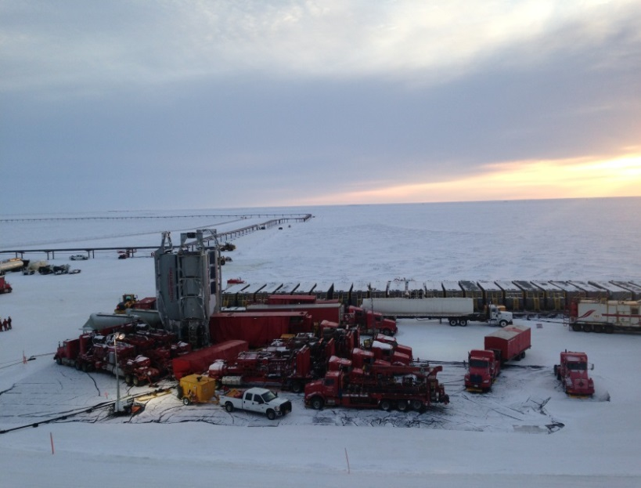
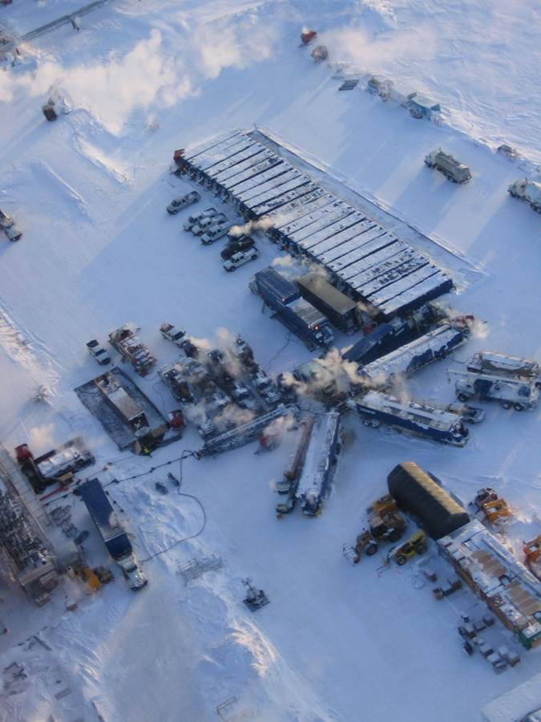
Colville River Unit, CD5
Colville River Unit, CD3
Provided by ConocoPhillips Alaska, Inc.
Figure E1 Alaskan North Slope Hydraulic Fracturing with Conventional Developments

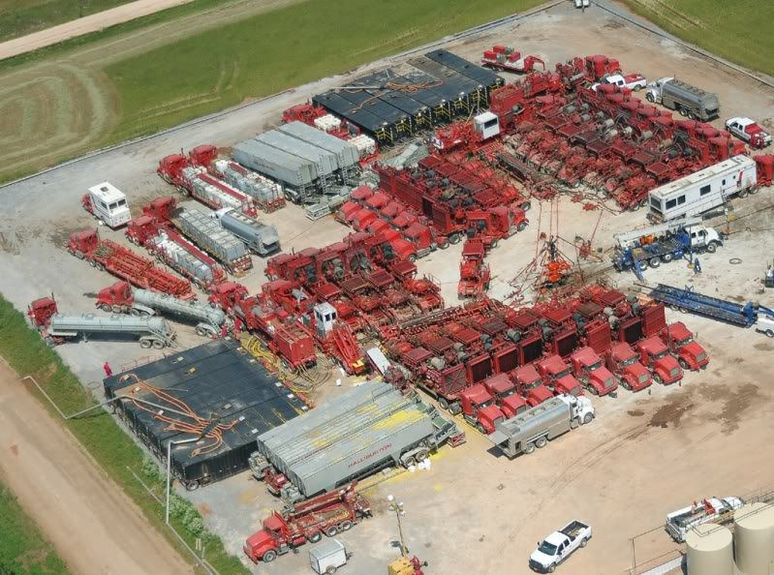
A Woodford Shale Development
https://wellworc.com/wp-content/uploads/2016/03/1_Frac.jpg
Figure E2 Hydraulic Fracturing with Unconventional Shale Development
extent at the Kuparuk field because the “A” sand reservoir was extremely susceptible to damage from drilling and completion (Niemeyer and Reinart 1986). In the 1980s, an aggressive fracturing program was implemented using a variety materials and methods in order to determine optimum stimulation. The fracturing program yielded production gains averaging 300 percent. Hydraulic fracturing of conventional resources intended to counter formation damage has been a successful well stimulation technology at North Slope oil and gas fields, and an important factor in maximizing recovery. It is reported that 25 percent of the oil and gas wells in Alaska have been stimulated by hydraulic fracturing (Bond 2016).

In recent years, there has been interest in the unconventional resources in source rock shales of the North Slope. The shale formations include the Triassic Shublik Formation, Jurassic–Lower Cretaceous Kingak Shale, and Cretaceous pebble shale unit and Hue Shale, referred to as the Brookian Shale. The U.S. Geological Survey conducted a probabilistic oil and gas resource assessment that indicated a mean total resource for all the shales as 940 million barrels of oil, 42 trillion cubic feet of gas, and 262 million barrels of natural gas liquids are technically recoverable from the shales (Houseknecht, et al. 2012). One oil company, Great Bear Petroleum Operating, LLC (Great Bear), undertook exploration for shale resources on the North Slope in 2010 (Bailey 2016a). Great Bear drilled a couple of wells and conducted extensive testing but has since decided to explore conventional targets.

E5. CURRENT TRENDS
While the possibility of unconventional resources exists in the Cook Inlet (Schenk, et al. 2015), discussions have been, and will continue to focus on Alaskan North Slope resources due the known availability and location of source rock. Shale production on the North Slope is not limited by whether these shales could yield oil, but rather, if the need for fracturing is cost prohibitive for commercial production. Successful unconventional shale production is not only very price sensitive, but also requires a logistical train that will assure adequate supplies of proppant (silica sand), drilling equipment, fuel, cement, and other necessary commodities (Metz 2013). As alluded to in Table E1, the major difference in the hydraulic fracturing described for conventional North Slope resources and shale development is the amount of material that would be needed to stimulate shale wells and the increased number wells to develop a similar area. In the well stimulation program described by Reimers and Clausen (1991) for Prudhoe Bay, a typical frac job consumed less than 20 tons of proppant (one bulk truck load) and 900 barrels of fluid. By contrast, based on Eagle Ford Formation (South Texas) development, a typical well in the Shublik Formation shale may require up to 6,000 tons (240 bulk truck loads) of proppant and 200,000 to 300,000 barrels of fluid (Metz 2013; LaFollette, et al. 2014). Assuming 200 potential horizontal shale wells per year (as envisioned by Great Bear), the water and proppant needed presents an substantial supply chain task. This, in addition to the supply chain issues for drilling unconventional resources, may explain why Alaska shale resources have been slow to develop (Hobson 2013).

The issues challenging unconventional shale production in Alaska do not apply to the use of hydraulic fracturing combined with horizontal wells to develop conventional resources in Alaska into the future. At Cook Inlet, BlueCrest Alaska Operating, LLC has commenced a program to drill horizontal wells and conduct staged hydraulic fracturing to enhance recovery from conventional reservoirs as opposed to unconventional shale (Bailey 2016b). The total amount of frac fluid that would be used by BlueCrest probably would not exceed 36,000 barrels per well, a much smaller hydraulic fracturing effort as compared to a “typical” shale well. Recent large discoveries (Pikka Unit and Smith Bay) in lower permeability Cretaceous rocks on the North Slope indicate that hydraulic fracturing may be a well stimulation method that will continue to be used for many years into the future to develop Alaskan conventional oil and gas resources.

E6. REFERENCES
American Oil and Gas Historical Society [AOGHS]. 2017. Shooters – A “Fracking” History. http://aoghs.org/technology/shooters-well-fracking-history/.

Bailey, A. 2016a. Great Bear Evaluating Eight Prospects: Petroleum News, Volume 21, No. 41, October 9, 2016. http://petroleumnews.com. Accessed March 12, 2017.

Bailey, A. 2016b. BlueCrest Drilling Ahead: Petroleum News, Volume 21, No. 50, December 11, 2016. . http://petroleumnews.com. Accessed March 12, 2017.

Bond, A. 2016. Fracturing Overview: Fact vs. Fiction. Caelus Energy Alaska, December 8, 2016.

Brehmer, Elwood. 2016. Partners will drill at Icewine in 2017: Alaska Journal of Commerce, October Issue 1-2016. Wed, 09/28/2016 - 2:09pm.

Hobson, M.K. 2013. Geologist’s Alaska gamble could turn into America’s next big shale play: E&E News, Energywire, April 3, 2013. https://www.eenews.net/stories/1059978794. Accessed June 6, 2017.

Houseknecht, D.W., W.A. Rouse, C.P. Garrity, K.J. Whidden, J.A. Dumoulin, C.J. Schenk, R. Charpentier, T.A. Cook, S.B. Gaswirth, M.A. Kirschbaum, and R.M. Pollastro. 2012. Assessment of Potential Oil and Gas Resources in Source Rocks of the Alaska North Slope, 2012. U.S. Geological Survey Fact Sheet 2012–3013, February 2012.

Howard, G.C. and C.R. Fast. 1970. Hydraulic Fracturing: Society of Petroleum Engineers of AIME, Monograph Volume 2 of the Henry A. Doherty Series, 203 p.

LaFollette, R.F., G. Izadi, and M. Zhong. 2014. Application of Multivariate Statistical Modeling and Geographic Information Systems Pattern-Recognition Analysis to Production Results in the Eagle Ford Formation of South Texas. Society of Petroleum Engineers paper SPE 168628. The paper was prepared for presentation at the SPE Hydraulic Fracturing Technology Conference, The Woodlands, Texas, February 4-6, 2014.

Leach, W.G. 1994. Distributions of Hydrocarbons in Abnormal Pressure in South Louisiana, U.S.A., in Fertl, W.H., R.E. Chapman, and R.F. Hotz, editors, Studies in Abnormal Pressures. Developments in Petroleum Science 38. Elsivier Science, B.V., Amsterdam, Netherlands, p. 391 to 428.
Lidji, A. 2017. Icewine Exploration Plan Approved: Petroleum News, Volume 22, No. 1. http://petroleumnews.com. Accessed March 17, 2017.

Metz, P. 2013. Economic Impact of a North Slope Rail Extension on Future Northern Energy and Mineral Development.

Niemeyer, B.L. and M.R. Reinart. 1986. Hydraulic Fracturing of a Moderate Permeability Reservoir, Kuparuk River Unit: Society of Petroleum Engineers paper SPE15507. The paper was prepared for the 61st Annual Technical Conference and Exhibition, New Orleans, Louisiana, October 5-8, 1986.

Reimers, D.R., and R.A. Clausen. 1991. High-Permeability Fracturing at Prudhoe Bay, Alaska: Society of Petroleum Engineers paper SPE 22835. Paper was prepared for the 66th Annual Technical Conference and Exhibition, Dallas, Texas, October 6-9, 1991, p. 181-194.

Schenk, C.J., and Nelson, P.H., 2015, Geologic model and assessment of potential unconventional (tight) gas resources in Upper Cook Inlet Basin, South-central Alaska, chap. 1 of Assessment of unconventional (tight) gas resources in Upper Cook Inlet Basin, South-central Alaska: U.S Geological Survey Digital Data Series 69–AA, 31 p., http://dx.doi.org/10.3133/ds69AA.

Schlumberger. 2017. Oil Field Glossary. Internet website: http://www.glossary.oilfield.slb.com/Terms/f/fracture_gradient.aspx. Site accessed April 5, 2017.

U.S. Department of Energy (USDOE). Unconventional Energy Resources. http://www.unconventionalenergyresources.com/#about. Accessed March 16, 2017.

A “Portable Oil and Gas Operation” (POGO) under 18 Alaska Administrative Code (AAC) 50.990(124) means “an operation that moves from site to site to drill or test one or more oil or gas wells, and that uses drill rigs, equipment associated with drill rigs and drill operations, well test flares, equipment associated with well test flares, camps or equipment associated with camps; ‘portable oil and gas operation’ does not includes well servicing activities; for the purposes of this paragraph, ‘test’ means a test that involves the use of a flare.”
The listed AAAQS are identical to the National Ambient Air Quality Standards (NAAQS) set forth in Title 40 of the Code of Federal Regulations, Part 50 (40 CFR 50).
Additional information on the Workgroup for Global Air Permit Policy Development for Temporary Oil and Gas Drill Rigs and associated subgroups can be found on the Workgroup website (http://dec.alaska.gov/air/ap/OilGasDrillWorkgroup.html).
The Technical Subgroup did not evaluate drilling operations powered by gas-fired or dual fuel-fired RICE EUs or gas/liquid-fired combustion turbines.
Average activity and inactivity at typical North Slope well pads is discussed in Appendix C.
The PSD Increment was also discussed at the Tenth Meeting of the Workgroup on February 4, 2016. Meeting minutes and transcript are available on the Workgroup website (http://dec.alaska.gov/air/ap/OilGasWorkgroup.html).
The Minor General Permit 1 (MG1) was issued by ADEC on December 15, 2005. Modeling to support this general permit is documented in the Modeling Protocol [for] Oil Exploration Permit by Rule (April 21, 1999) and Report on Ambient Air Quality Analysis for Oil Drilling Permit by Rule (June 23, 1999), prepared by Bill Walker (ADEC).
Varying the amount of drill rig fuel consumption is equivalent to varying the size (in brake horsepower (bhp), million British thermal units per hour (MMBtu/hr), etc.) of equipment on the drill rig or varying the number of rigs that could be concurrently operated on the pad.
Linear extrapolation is used for all pollutants and averaging periods, except 1-hour NO₂ and 1-hour SO₂, because of the high rate of fuel consumption needed to cause a violation of the AAAQS.
USEPA Guideline on Air Quality Models, 40 CFR 51, Appendix W promulgated November 9, 2005. Draft revisions to the Guideline proposed by USEPA were published in the Federal Register on July 14, 2015, and the revised Guideline became effective on May 22, 2017. All references to the Guideline in this document refer to the version in place when the modeling was conducted (November 9, 2005 version). Differences in the references between the 2005 and 2017 Guidelines are indicated.
Concurrent upper air data were obtained from the National Oceanic and Atmospheric Administration Earth System Research Laboratory (NOAA/ESRL) Radiosonde Database (http://www.esrl.noaa.gov/raobs/).
The Technical Subgroup did not utilize the newly developed AERMET algorithm for adjusting the surface friction velocity (ADJ_U*) since it was not a regulatory option when the analysis began.
AP-42, Chapter 1.3 Fuel Oil Combustion; May 2010.
The drill rig heater and boiler operational profile follows an approach previously approved by ADEC through an amendment application submitted for BPXA’s Transportable Drill Rigs Title V Operating Permit AQ0455TVP01. This information is documented in Figure A-1 of May 11, 2004 letter from Tom Damiana (SECOR International) to Alan Schuler (ADEC), Re: Response to ADEC Comments Regarding the BP Exploration (Alaska) Inc. Multiple-Rig Drilling Operations Permit Amendment Application.
Letter from David C. Bray (USEPA Region 10) to Alan Schuler (ADEC), dated June 28, 2016.
The Commissioner delegated his authority regarding the use of non-guideline models to the Air Permits Program Manager on June 3, 2008.
The ISR database on SCRAM may be found at: http://www.epa.gov/ttn/scram/no2_isr_database.htm.
ADEC’s ISR database may be found at: http://dec.alaska.gov/air/ap/modeling.htm.
Attachment D: Measured NO₂/NOx Ratios for Discoverer Source to OCS Permit Applications, Conical Drilling Unit Kulluk, Beaufort Sea – Supplemental Information, Shell Offshore, Inc. (June 29, 2011).
Additional details regarding the dataset are available in ADEC’s November 22, 2008 modeling review of BPXA’s ambient demonstration for Liberty.
The NO_{X} and SO₂ emissions are also referred as “precursor emissions” in a PM_{2.5} assessment.
Guidance for PM_{2.5} Permit Modeling (EPA-454/B-14-001); May 2014.
Baker, K.R., Robert A. Kotchenruther, Rynda C. Hudman. “Estimating ozone and secondary PM_{2.5} impacts from hypothetical single source emissions in the central and eastern United States”. Atmospheric Pollution Research, 2016. 7(1), pp 122-133.
The term “ambient air” is defined in 40 CFR 50.1 and adopted by reference in AS 46.14.90(2).
USEPA has written a number of guidance documents regarding ambient air issues which may be found in their Modeling Clearinghouse Information Storage and Retrieval System (MCHISRS) or USEPA Region 7’s “Title V, NSR/PSD Policy and Guidance Database” (http://cfpub.epa.gov/oarweb/MCHISRS/ and http://www.epa.gov/region07/air/search.htm). The documents routinely use the phrase “fence or other physical barrier” when discussing an acceptable means for precluding public access at onshore locations. The phrase originated in a December 19, 1980 letter from USEPA Administrator Douglas Costle to Senator Jennings Randolph.
This monitoring program was established in 1986 by BPXA to collect meteorological and ambient air quality data representative of background concentrations in the PBU. The A-Pad Monitoring Station collects PSD-quality meteorological data and ambient concentration measurements of oxides of nitrogen (NO_{X}, NO₂, and NO), O₃, and SO₂ in accordance with its approved Quality Assurance Plan (QAPP). The current QAPP for the PBU Monitoring Program was approved by ADEC on April 19, 2011.
Data collection began on October 1, 2012. The CD1 Monitoring Station collects PSD-quality meteorological data and ambient concentration measurements of CO, NO_{X}, NO₂, NO, O₃, SO₂, PM_{2.5}, and PM₁₀ in accordance with its approved QAPP. The current QAPP for the CD1 Monitoring Program was approved by ADEC on September 28, 2012.
Tier 4 emissions standards in 40 CFR 1039.101, Table 1, Tier 4 Exhaust Emission Standards After the 2014 Model Year, g/kW-hr.
Additional information available in TRANSVAP: A new technique for predicting impacts from portable or transitory sources (Damiana, T.A. and Hamel, R.P., 2013), presented and published through the Air and Waste Management Association (AWMA) – Guideline on Air Quality Models 2013: The Path Forward Conference in Raleigh, North Carolina, March 19-21, 2013.
USEPA Guideline on Air Quality Models, 40 CFR 51, Appendix W promulgated November 9, 2005. Draft revisions to the Guideline proposed by USEPA were published in the Federal Register on July 14, 2015, and the revised Guideline became effective on May 22, 2017. All references to the Guideline in this document refer to the version in place when the modeling was conducted (November 9, 2005 version). Differences in the references between the 2005 and 2017 Guidelines are indicated.
USEPA Memorandum from Tyler Fox to Regional Air Division Directors, Additional Clarification Regarding Application of Appendix W Modeling Guidance for the 1-hour NO₂ National Ambient Air Quality Standard, dated March 1, 2011.
USEPA Guideline on Air Quality Models, 40 CFR 51, Appendix W promulgated November 9, 2005. Draft revisions to the Guideline proposed by USEPA were published in the Federal Register on July 14, 2015, and the revised Guideline became effective on May 22, 2017. All references to the Guideline in this document refer to the version in place when the modeling was conducted (November 9, 2005 version). Differences in the references between the 2005 and 2017 Guidelines are indicated.
User’s Guide for the AMS/EPA Regulatory Model – AERMOD (EPA-454/B-03-001), Office of Air Quality Planning and Standards; September 2004.

