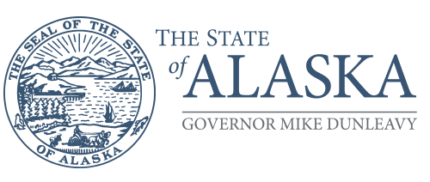**Department of Environmental Conservation**

DIVISION OF ENVIRONMENTAL HEALTH

Environmental Health Laboratory

5251 Dr. Martin Luther King Jr. Ave.

Anchorage, AK 99507-1293

Main: 907.375.8200

Fax: 907.929.7335

www.dec.alaska.gov

March 6, 2025

**RE: Environmental Health Laboratory schedule week of March 31-April 4, 2025**

To our valued clients:

Alaska state offices will be **closed** on Monday, March 31st in observance of Seward’s Day.

As a result, the sample acceptance schedule for **March 31- April 4** must be modified, as follows:

* Shellfish Growing Water (SGW) samples will be accepted on Tuesday Apr. 1, Wednesday Apr. 2, and by noon on Thursday Apr. 3.
* Paralytic Shellfish Toxin (PST) commercial samples will be accepted Tuesday Apr. 1, Wednesday Apr. 2, Thursday Apr. 3, and by noon on Friday Apr. 4.
* Wet Storage samples will be accepted by noon Tuesday Apr. 1.
* Raw meat samples will be accepted Tuesday Apr. 1, Wednesday Apr. 2, and by noon on Thursday Apr. 3, however meat samples are pooled for efficiency, generally once a week**.**
* Slaughter sponge samples are good for 24 hours per USDA. Sponges will be accepted Tuesday Apr. 1, Wednesday Apr. 2, and by noon on Thursday Apr. 3, unless written extension provided to hold longer than 24 hours for testing**.**
* Manufactured and Cottage food samples and swabs will be accepted Tuesday Apr. 1– Friday Apr. 4, however the testing will be conducted when samples are pooled for efficiency.
* Dairy testing is scheduled once a month and is next scheduled for the week of April 14th.
* Paralytic Shellfish Toxin (PST) recreational/research (PCOX) sample will be accepted any workday; however, the testing will be as soon as possible given current backlog.

Normal sample acceptance schedules resume on Monday, April 7, 2025.

Assistance is available with timing of sample collections, completion of submission forms, packaging, temperature requirements, shipping, and sample tracking. Sampling questions, planned sampling activities, and shipping notifications, can be made to [DEC.EH-Lab-ShippingReceiving@alaska.gov](mailto:DEC.EH-Lab-ShippingReceiving@alaska.gov) or 907-375-8231.

Regards,

Patryce D. McKinney, MBA

Chief, Environmental Health Laboratory