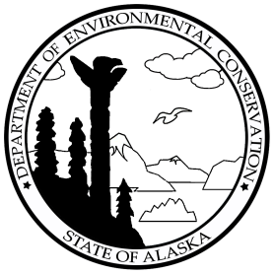ALASKA DEPARTMENT OF ENVIRONMENTAL CONSERVATION

**Milne Point**

Division of Spill Prevention and Response

Prevention and Emergency Response Program

**SITUATION REPORT**

**CHANGES FROM THE PREVIOUS SITREP ARE DENOTED IN RED**

# Milne Point Tract 14 Production Line Release

## SITREP #: 5 and final

## SPILL #: 15399905901

## TIME/DATE OF DISTRIBUTION: 2:30 p.m. January 26, 2023

## Potential Responsible Party (PRP): Hilcorp Alaska, LLC (HAK)

## INCIDENT LOCATION: Milne Point Tract 14 Production Line (approximately 25 miles northwest of Deadhorse and 40 miles northeast of Nuiqsut).

**TIME/DATE OF SPILL:** 7:50 a.m. on February 28, 2015

**HOW/WHEN SPILL WAS DISCOVERED AND REPORTED:** A release from a 10-inch production line was observed at 7:50 a.m. on February 28, 2015. Alaska Department of Environmental Conservation’s (ADEC’s) After Hours Call service was notified at approximately 9:00 a.m. on the same day. ADEC responders were then contacted within 15 minutes.

## TYPE/AMOUNT OF PRODUCT SPILLED: Engineering calculations have resulted in an estimated 339 barrels (14,238 gallons) of produced fluids including crude oil and produced water were released to the pad and tundra.

## Cause of Spill: Produced fluids escaped from an estimated 1/4-inch diameter hole discovered in the six o’clock position of the 10-inch pipeline.

## Source Control: Tract 14 wells were shut in; production was stopped, and the 15-foot segment of pipe in which the hole is located was isolated by shutting valves on either side of the hole. Pressure inside the pipe segment was relieved to zero pressure. A wooden plug was inserted in the hole and that portion of the production line was wrapped to prevent further release. Containment supplies were placed under the release point to reduce further environmental impact, and the remaining product in the affected pipe segment was removed. Production wells were reestablished within 24 hours after operations installed a temporary bypass line restoring flow to production.

## Response Action: On March 17, responders began the water flood/flush tactic to remove released product from the gravel pad and tundra in accordance with ADEC’s Tundra Treatment Guidelines. Other site work accomplished during the cleanup phase included establishing a surveyed grid throughout the spill site to reference the cleanup tactics, environmental field screening, and the analytical confirmations sample locations. Ground disturbance utility locates were identified prior to the mechanical recovery of the embedded oil in the gravel pad. The pipeline spool that contained the section of pipeline that leaked was removed.

Cleanup workers recovered approximately 2,000 cubic yards of snow impacted by the produced fluids. Approximately 8 cubic yards of contaminated gravel was removed from the edge of the gravel pad before constructing the ice berm treatment cell on the tundra adjacent to the gravel pad.

Subsequent contaminant recovery tactics were selected after visual assessments indicated that the tundra

surface had remained frozen during both the spill and cleanup operations, which prevented released fluids

from infiltrating the plant rooting zone. Thus, it was not necessary to excavate soil to recover contaminants,

and the destruction of live vegetation was avoided across most of the site. Above-ground vegetation was

mostly absent across the site the following summer, but close inspections during the summers of 2015 and

2017 confirmed that live rooting systems were present throughout, including locations where all of the

above-ground vegetation had been removed during the cleanup. A fence (~4 ft high) was installed around the affected area in June 2017 to exclude grazing wildlife, which can delay revegetation by removing much of the new growth. Monitoring in 2020 included a qualititative assessment of vegetation response; it was determined that the fence will remain in place for an additional 5 years to ensure that the vegetation has sufficiently recovered enough to be able to withstand the impacts associated with grazing wildlife.

## recourses at risk or Affected: Preliminary delineation activities have reported that approximately 38,800 square feet of gravel pad and tundra have been heavily to lightly misted by fluids. There have been no reports of impacted wildlife. As a precaution, wildlife fencing has been erected to prevent wildlife from entering the impacted area. Wildlife hazing permits and hazing personnel were activated to further deter and protect wildlife. A survey was conducted to determine any impacts to historic or cultural sites. The survey concluded that there were no sites present.

**FUTURE PLANS AND RECOMMENDATIONS:** Continued monitoring of vegetation growth and rehabilitation efforts. If the results of annual monitoring indicate that the rehabilitation goal has been met, the wildlife exclusion fence will be removed in summer 2024.

## Weather: Today: Clear -5° F, SE wind about 5 mph.

## Unified Command and Personnel:

Incident Commander: Rob Handy/Mark O’Malley, HAK

State On-Scene Coordinator: Kimberley Maher, ADEC

Federal On-Scene Coordinator: Torri Hoesketer, Environmental Protection Agency

Local On-Scene Coordinator: Waska Williams, North Slope Borough

## Time/Date of the Next Report Distribution: This is the final report.

**FOR ADDITIONAL INFORMATION CONTACT**: Kimberley Maher, SOSC, ADEC (907) 451-2124

<https://dec.alaska.gov/spar/ppr/spill-information/response/2015/05-milne/>

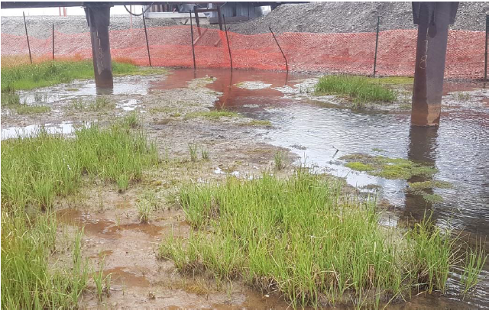

**Photo 1:** View of recovering vegetation within the spill site affected area (ABR, August 2019).

**Agency/Stakeholder Notification List:** Please refer to the first SITREP, distributed February 28, 2015, for the agency/stakeholder notification list. The first SITREP can be found by following the link in the Additional Information box above.