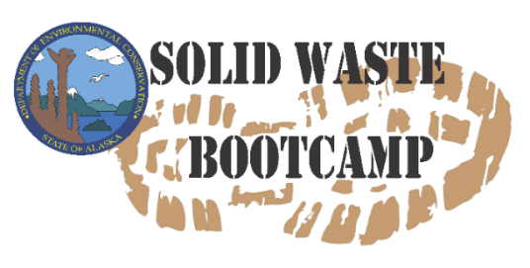

Agenda for May 5, 2026
10:00 – 10:20 | Laona DeWilde | Solid Waste Bootcamp Course Introduction
10:20– 11:05 | Trisha Bower | Zender Environmental and Funding Sources for Landfills
11:05 – 11:10 |  | 5 Minute BREAK
11:10 – 11:30 | Rachel Mills | Landfill Designs
11:30 – 12:00 | Zach Gianotti | Site Maps and Operations Plans
12:00 – 1:00 |  | LUNCH
1:00 – 1:30 | Michelle Beadle/Erin Anderson | Honey Buckets and Sewage -Alaska Department of Environmental Conservation- Village Safe Water (ADEC-VSW)
1:30– 1:40 |  | 10 Minute BREAK
1:40 – 2:00 | Stephen Price | Administrators and Operators
2:00 – 3:00 | Luci Farrell (ADEC) | The Four C’s of Rural Landfill Operation

Agenda for May 6, 2026
10:00 – 10:30 | Rachel Mills |  | Solid Waste Management Outreach and Education
10:30 – 11:00 | Rachel Mills |  | Renewing a Rural Landfill Permit
11:00 – 11:10 |  |  | 10 Minute Break
11:10-12:00 | Laona DeWilde |  | Waste Burning Basics & Forest Fire Prevention
12:00 – 1:00 |  |  | LUNCH
1:00 – 1:50 | Reilly Kosinski |  | Backhaul 101 – Zender Environmental
1:50 – 2:00 |  |  | 10 Minute BREAK
2:00 – 2:30 | Stephen Price |  | Construction and Demolition (C&D) Debris
2:30 – 3:00 | Zach Gianotti |  | What to Expect when Inspecting
Agenda for May 7, 2026
10:00 – 11:00 |  | Stephen Price | Visual Waste Index: ADEC SW’s Inspection Form
11:00 – 11:10 |  |  | 10 Minute BREAK
11:10 – 12:00 |  | Neil Lehner | Accidents Happen! Cleaning Up Polluted Soil and Burning Buildings
12:00 – 1:00 |  |  | LUNCH
1:00 – 1:30 |  | Zach Gianotti | Technical Assistance Resources
1:30 – 2:10 |  | Stephen Price | Personal Protective Equipment (PPE) & Landfill Supplies
2:10 – 2:20 |  |  | 10 Minute BREAK
2:20 – 2:50 |  | Paul Berry | Heavy Equipment Operations and the Landfill
2:50 – 3:00 |  | Laona DeWilde | Question and Answers – Bootcamp Survey and Certificates

* ADEC SW Program reserves the right to update this schedule if speaker availability changes or last-minute conflicts arise. All attendees will be notified of changes as soon as possible.

