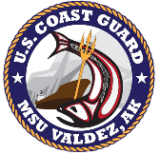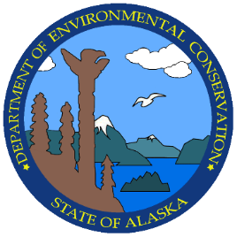

|  |
| --- |
| Prince William Sound Area Committee Meeting  Thursday, April 10th, 2025  and Virtual |

# INTRODUCTIONS

|  |  |
| --- | --- |
| **0845**  Arrival and Sign-in Introductions and opening remarks  **0900**  Participant Introductions. Opening remarks from Federal On-Scene Coordinator (FOSC) CDR Sarah Rousseau and State On-Scene Coordinator (SOSC) Anna Carey |  |

# guest Presentations

|  |
| --- |
| **0915**  Jerry Warrick (Andeavor), Melissa Woodgate (DEC), Thomas Tapp (AK Drone), Derek Samora (CISPRI), Levi Rowland (AK Drone)  PWS Shippers Exercise, October 15-17, 2024  **1000 - 1015**  Break  **1015**  USCG LT. Frasca & DEC Julie Parker – PWS Area Plan changes and updates   1. Admin Sub-committee 2. GRS Sub-Committee   **1025**  PWS RCAC, Jeremy Robida – Copper River Delta Flats GRS update  **1035**  Aaron Timian and Krystyn Kelly  Abandoned and Derelict Vessel Program, Department of Natural Resources  **1100 - 1115**  Break  **1115**  USCG LCDR Mcintyre-Coble – Spill Response Containers in Prince William Sound  **1130**  City of Valdez, Andrew Doherty – Valdez Port Operations  **1145 - 1200**  Public comment and closing remarks |
|  |