**State of Alaska**

**DEPARTMENT OF**

**ENVIRONMENTAL CONSERVATION**

**DIVISION OF WATER**

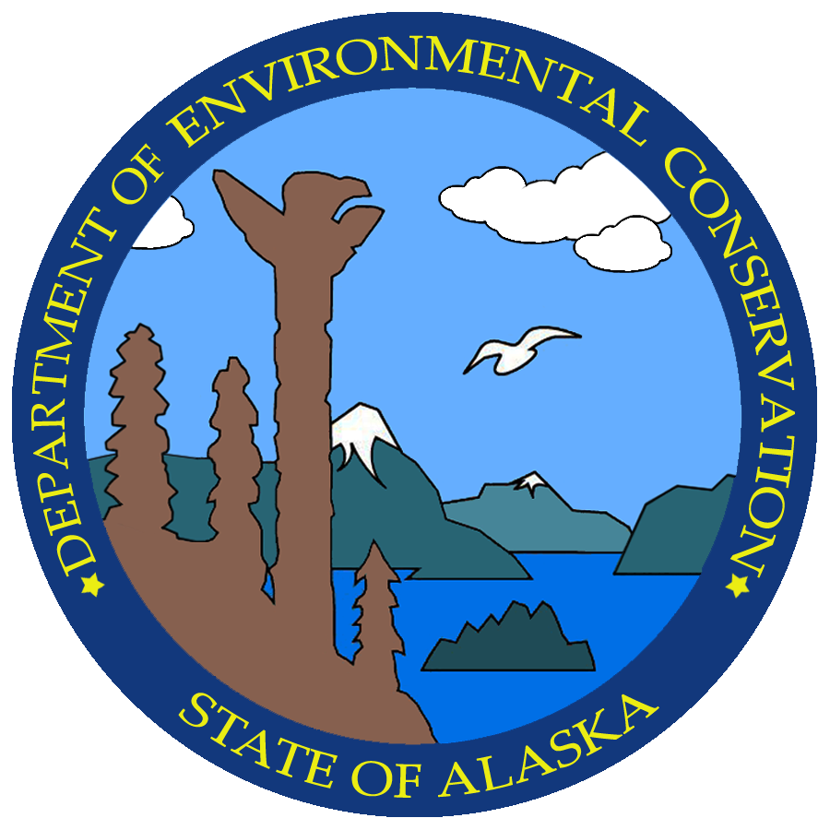

**18 AAC 70**

**Water Quality Standards**

*Draft Amendments*

***May 7, 2024***

18 AAC 70.230(e) is amended by adding new paragraphs to read:

|  |  |  |  |  |  |
| --- | --- | --- | --- | --- | --- |
| **18 AAC 70.230(e)**  **WATERSHED** | | **LATITUDE**  **LONGITUDE\*\*** | **LOCATION** | **DESIGNATED USE**  **CLASS** | **REACH OF WATER**  **AFFECTED** |
| TYPE/NAME | NUMBER* |
| (26) Copper Creek | 19020202 | 60°3'3"N  147°54'14"W | LaTouche Island, Prince William Sound | (1)(A)(i), except for 18 AAC 70.020(b)(6) with respect to pH and 18 AAC 70.020(b)(11) with respect to cadmium and copper;  (1)(A)(ii), except for 18 AAC 70.020(b)(6) with respect to pH and 18 AAC 70.020(b)(11) with respect to cadmium and copper;  (1)(A)(iii), except for 18 AAC 70.020(b)(6) with respect to pH and 18 AAC 70.020(b)(11) with respect to cadmium, copper, lead, and zinc; (1)(A)(iv), except for 18 AAC 70.020(b)(6) with respect to pH;  (1)(B)(i), except for 18 AAC 70.020(b)(6) with respect to pH and 18 AAC 70.020(b)(11) with respect to cadmium;  (1)(B)(ii), except 18 AAC 70.020(b)(6) with respect to pH and 18 AAC 70.020(b)(11) with respect to cadmium;  (1)(C), except for 18 AAC 70.020(b)(6) with respect to pH and 18 AAC 70.020(b)(11) with respect to cadmium, copper, lead, and zinc. | Confluence with Prince  William Sound to  designated reach break  above mining activities;  includes all minor  tributaries to Copper  Creek and impoundments  (including Mine Lake and  Historical Copper Creek)  within the affected reach |
| (27) South Blackbird Creek | 19020202 | 60°3'23"N  147°53'53"W | LaTouche Island, Prince William Sound | (1)(A)(i), except for 18  AAC 70.020(b)(6) with respect to pH and 18 AAC 70.020(b)(11) with respect to cadmium, and copper;  (1)(A)(ii), except for 18 AAC 70.020(b)(6) with respect to pH and 18 AAC 70.020(b)(11) with respect to cadmium and copper;  (1)(A)(iii), except for 18  AAC 70.020(b)(6) with respect to pH and 18 AAC 70.020(b)(11) with respect to cadmium, copper, lead, and zinc;  (1)(A)(iv), except for 18  AAC 70.020(b)(6) with respect to pH;  (1)(B)(i), except for 18  AAC 70.020(b)(6) with respect to pH and 18 AAC 70.020(b)(11) with respect to cadmium;  (1)(B)(ii), except for 18  AAC 70.020(b)(6) with respect to pH and 18 AAC 70.020(b)(11) with respect to cadmium  (1)(C), except for 18  AAC 70.020(b)(6) with respect to pH and 18 AAC 70.020(b)(11) with respect to cadmium, copper, lead, and zinc. | Confluence with Prince  William Sound to  Headwaters; includes minor tributaries |
| (28) Northern Blackbird Creek | 19020202 | 60°3'24"N  147°53'49"W | LaTouche Island, Prince William Sound | (1)(A)(i), except for 18 AAC 70.020(b)(6) with respect to pH and 18 AAC 70.020(b)(11) with respect to copper;  (1)(A)(ii), except for 18 AAC 70.020(b)(6) with respect to pH and 18 AAC 70.020(b)(11) with respect to copper;  (1)(A)(iii), except for 18 AAC 70.020(b)(6) with respect to pH and 18 AAC 70.020(b)(11) with respect to cadmium, copper, lead, and zinc;  (1)(A)(iv), except for 18 AAC 70.020(b)(6) with respect to pH;  (1)(B)(i), except for 18 AAC 70.020(b)(6) with respect to pH;  (1)(B)(ii), except for 18 AAC 70.020(b)(6) with respect to pH;  (1)(C), except for 18 AAC 70.020(b)(6) with respect to pH and 18 AAC 70.020(b)(11) with respect to cadmium, copper, lead, and zinc. | Confluence with Prince  William Sound to  designated reach break  above mining activities; includes all minor tributaries |
| (29) Beach Level Portal | 19020202 | 60°3'24"N  147°53'49"W | LaTouche Island, Prince William Sound | (1)(A)(i), except for 18 AAC 70.020(b)(11) with respect to copper;  (1)(A)(ii), except for 18 AAC 70.020(b)(11) with respect to copper;  (1)(A)(iii), except for 18 AAC 70.020(b)(11) with respect to cadmium, copper, lead, and zinc.  (1)(C), except for 18 AAC 70.020(b)(11) with respect to cadmium, copper, lead, and zinc. | Confluence with Prince  William Sound to portal |

(Eff. 11/1/97, Register 143; am 3/5/2020, Register 233, am ____/____/______, Register _____)

**Authority:** AS 46.03.020 AS 46.03.070 AS 46.03.080

AS 46.03.050