Title VI
Limited English Proficiency Plan

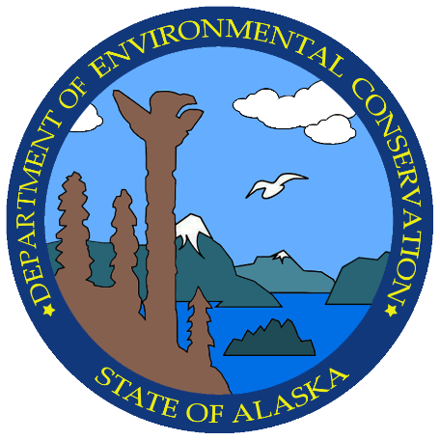
Alaska
Department of
Environmental Conservation

February 2025

I. Introduction
The Alaska Department of Environmental Conservation (DEC) recognizes the importance of meaningful access for Alaska’s citizens. Language barriers can impede accurate communication and inhibit individuals with limited English proficiency (LEP) from accessing programs or services.

This plan establishes guidelines to ensure essential communication with Alaska citizens and comply with Title VI of the Civil Rights Act of 1964 (Executive Order 13166 and 40 CFR 7).

II. LEP Plan
DEC will provide timely and meaningful access to DEC’s programs and activities for individuals with limited English proficiency in the language they are most comfortable communicating.

DEC’s nondiscrimination coordinator will oversee implementation of the LEP plan and grievance procedures, provide training, and monitor its effectiveness (section 4).

III. Four-Factor Analysis
DEC will consider four factors when assessing language needs and determining steps to ensure access for LEP individuals.

1. The number, or proportion, of LEP individuals likely to encounter a DEC program or service—This factor measures the number or percentage of LEP individuals that might encounter a DEC program or service. Appendix A provides demographic data.

If at least 5% of a community speaks a language other than English, staff must continue working through the four factors to determine what, if any, language assistance services are needed.

2. The frequency with which LEP individuals encounter a DEC program—This factor measures the frequency at which DEC staff has, or could possibly have, contact with LEP individuals. Encounters include office visits, telephone conversations, attendance at outreach events, website, social media, and public meetings. The factor also measures the frequency at which DEC might need to proactively share information with LEP individuals (without a direct request).

3. The nature, importance, or impact of the program, activity, or service on peoples’ lives—This factor measures the impact DEC’s documents or services have on peoples’ lives. When determining language assistance needs, DEC should consider how important certain information is on the health and well-being of an individual.

For example, this information includes air quality advisories, water quality advisories, boil advisories, and public notices that will likely have a greater impact on an individual’s well-being than marketing collateral or promotional material.

4. The resources available to DEC for outreach and costs associated with that outreach— This factor compares the reasonable steps DEC must take under federal law to ensure meaningful access to programs, services, and activities by LEP individuals against the costs associated with doing that outreach.

On a case-by-case basis, DEC staff will work with the nondiscrimination coordinator to identify the most cost-effective means of delivering timely, accurate, and effective language services to LEP individuals.

IV. LEP Plan Implementation
Staff can take these steps to identify an LEP need, provide language assistance, and notify the public of LEP services.
- Identify LEP individuals who need language assistance—DEC will use any of the following measures to identify individuals who may need language assistance.
- Tracking LEP contact—DEC staff who regularly communicate with the public (e.g., front desk staff, public records request custodians, complaint response staff, social media manager, and webmaster) will document and track requests for language assistance received via meetings, telephone calls, and events. This information will be reported monthly to DEC’s nondiscrimination coordinator.
- Language identification—DEC will offer US Census Bureau’s “I Speak” cards at public counters, document the language assistance request in the tracking form, and refer the request to the nondiscrimination coordinator.
- Identifying vital documents—Staff will use the vital document translation guidance to identify vital documents for translation in the languages “regularly encountered” in a specific community. The term “languages regularly encountered” means any language spoken by at least 5% of the population served by a particular agency program, service, or activity.
- Universal access goal—Each division is encouraged but not required to provide universal access to interpretation services even if the community served does not meet the 5% threshold.

- Language assistance measures—The language assistance options listed here include the most common and cost-effective methods. In cases where the information is important and technical, staff should use a professional translation service.
- Accommodation notices—DEC will ensure that print and electronic public meeting notices include instructions for requesting an accommodation and direct the public to DEC’s language assistance web page.
- Opportunity to request a language assistance accommodation—DEC will include in the footer of all vital documents a notice informing the public of the opportunity to request an accommodation or translation service.
- Enlist bilingual volunteers—DEC will survey employees in each division and create a list of staff who are able and willing to translate documents. DEC’s nondiscrimination coordinator will also educate employees about the existence of the multilingual employees in the agency. Senior managers can update individual position description forms to reflect this increased workload.
- Enlist community groups—The nondiscrimination coordinator will reach out to tribes and community groups who might provide translation assistance.
- Language identification—DEC will provide US Census Bureau’s “I Speak” cards at each reception desk.
- Language assistance technology—DEC will train staff to use translation apps during field work.

When an interpreter is needed, in-person or on the telephone, and DEC staff has exhausted the above options, contact DEC’s nondiscrimination coordinator.

- Providing notice to LEP persons—DEC can notify LEP individuals of language and document assistance services in the following ways:
- Provide Language Identification Flashcards (“I Speak” cards), which allow an LEP individual to point to the language that the individual speaks.
- Include a statement on the agency’s website indicating that language assistance is available.
- Include a statement on vital documents indicating that language assistance is available.

Vital documents—Documents are considered vital if they convey information critically affecting the ability of an individual to make decisions about their health or participation in a program. All vital documents will be translated or be made available for translation into “prominent language(s)” other than English, even if the non-English language spoken does not exceed 5% in community.

The term “prominent language(s)” means the non-English language most regularly encountered in a community. Staff, in coordination with the nondiscrimination coordinator, will determine the appropriate language(s) by reviewing demographic and census data and identifying the most appropriate language(s).

Informal documents—For less formal documents such as marketing collateral, staff are encouraged to use cost-effective methods such as coordinating with bilingual staff or using community resources such as colleges and universities or local community groups.

- Training staff—DEC’s nondiscrimination coordinator will host an annual training for staff to clarify obligations to provide meaningful access to information and services for LEP persons. Training topics can include:
- Understanding the Title VI LEP responsibilities
- What language assistance services DEC offers
- Specific procedures to follow when encountering an LEP person
- How to use the “I Speak…” multilanguage identification flashcards
- How to contact translation services
- How to access Google Translate on public access computers

- Monitoring and updating the LEP plan—DEC’s nondiscrimination coordinator will review this plan annually and report to senior management at the end of each calendar year.

V. LEP Plan Dissemination
Hard copies of the plan will be provided to any individual or agency requesting a copy. LEP persons may obtain copies/translations of the plan upon request.

VI. LEP Contact Information
DEC Nondiscrimination Coordinator
555 Cordova Street
Anchorage, AK 99501
dec.nd@alaska.gov
(907) 334-0884

Appendix A: Demographic Data

The 2023 estimate from the American Community Survey estimated the population of Alaska to be 702,315. The first table is Alaska demographics by age and disability.

Total: | 702,315 | ±2,648
Male: | 359,739 | ±3,192
Under 5 years: | 24,360 | ±1,373
With a disability | 127 | ±118
No disability | 24,233 | ±1,369
5 to 17 years: | 67,146 | ±1,653
With a disability | 7,518 | ±1,677
No disability | 59,628 | ±2,303
18 to 34 years: | 79,435 | ±3,070
With a disability | 9,317 | ±1,610
No disability | 70,118 | ±3,172
35 to 64 years: | 139,024 | ±2,422
With a disability | 21,911 | ±2,231
No disability | 117,113 | ±2,873
65 to 74 years: | 33,512 | ±792
With a disability | 10,240 | ±1,108
No disability | 23,272 | ±1,178
75 years and over: | 16,262 | ±793
With a disability | 8,332 | ±1,005
No disability | 7,930 | ±923
Female: | 342,576 | ±2,616
Under 5 years: | 20,851 | ±1,221
With a disability | 359 | ±377
No disability | 20,492 | ±1,146
5 to 17 years: | 61,697 | ±1,807
With a disability | 3,549 | ±1,025
No disability | 58,148 | ±2,162
18 to 34 years: | 78,187 | ±1,759
With a disability | 8,429 | ±1,954
No disability | 69,758 | ±2,267
35 to 64 years: | 130,462 | ±1,766
With a disability | 18,204 | ±1,997
No disability | 112,258 | ±2,345
65 to 74 years: | 32,603 | ±859
With a disability | 8,558 | ±1,209
No disability | 24,045 | ±1,395
75 years and over: | 18,776 | ±833
With a disability | 9,582 | ±1,165
No disability | 9,194 | ±1,220
U.S. Census Bureau, U.S. Department of Commerce. "Sex by Age by Disability Status." American Community Survey, ACS 1-Year Estimates Detailed Tables, Table B18101, 2023. Accessed on January 22, 2025.
The American Community Survey (ACS) 2017-2021 5-Year Estimate Data Profile estimates the population in Alaska to be 733,391 people comprised of Black/African American, White, American Indian/Alaska Native, Hispanic/Latino, Native Hawaiian or other Pacific Islander, Asian, and other. Of the demographic data gathered on The ACS estimates that 27.0% of people speak a language other than English at home or speak English less than “very well”. LEP persons within the state of Alaska under ACS (American Community Survey-Office of the U.S. Census Bureau) through a 5-year estimate during 2017- 2021, the percentage of individuals where the “Language Other Than English Spoken at Home in Alaska” is 27.7% MoE +/1.4. The ACS estimates that the following languages are spoken at home in Alaska: English only 84.4% MoE +/-0.3, Spanish 24.5% MoE +/-2.4, Other Indo- European languages 22.3% MoE +/-3.7, Asian and Pacific Islander languages 43.2% MoE +/- 2.7, and Other languages 13.4% MoE +/-1.6.

Race Group | Total (Members of the Population)
White (alone) | 435,392
Alaska Native or American Indian (alone) | 111,575
Black or African American (alone) | 21,898
Asian (alone) | 44,032
Native Hawaiian or Other Pacific Islander (alone) | 12,698
Two or More Races | 89,524
Some Other Race | 18,272

(The American Community Survey (ACS)2017 -2021 5-Year Estimate)

The American Community Survey American Indian Alaskan Native (AIAN) Languages of a 5- year period (2017-2021) and the Department of Commerce, Community, and Economic Development, Division of Community and Regional Affairs provide the following data breakdown of Alaska Native languages spoken in the State: Alaska Native languages such as Inupiaq, Gwich’in, Koyukuk, Athabascan, and Tanana are primarily spoken located in the North/Northeast area. In the South/Southeast area, some of the identified groups/ languages recognized are Tlingit, Eyak, Haida, and Tahltan. Within the West/Southwest, some recognized groups/languages are Dena’ina, Alutiiq/ Sugpiaq, Koyukon, and Central Yupik.

Within the Alaska Native groups, some still speak the traditional language and English. When DEC has projects in these regions/areas, personnel develop flyers and other documents to inform community members of the upcoming project and inform the local community that translation and interpretation services can be provided in the event needed. Interpreters/Translators can be provided through DEC’s nondiscrimination coordinator. Through the DEC nondiscrimination coordinator, interpretation and translation services are provided by the Language Interpretation Center. A detailed breakdown of the Alaska Native groups and languages spoken can be found on the map in Appendix B.

Alaska has some 20 distinct languages, most within two main language groups. The two groupings include Inuit-Unangan (a.k.a. Eskimo-Aleut) and Na-Dene (a.k.a. Athabascan-Eyak- Tlingit). Since its creation by the Alaska Legislature in 1972, the Alaska Native Language Center has researched and documented Alaska's Native languages.

The numbers presented in the table below under 'Status Alaska Native Language Speakers come from community members who state that they have sat down with other language community members and written down lists of who they can name who is a strong speaker. Unfortunately, Alaska has never conducted an Alaskan Native Language census. Therefore, the data in the below charts are estimates.

Language by Region | Language Proficiency
Inuit-Yupik-Unangax Languages
Iñupiaq | Estimated <2,500 highly proficient speakers in Alaska
Yugtun (Yup’ik) | Estimated <10,000 highly proficient speakers.
Yupigestun (St. Lawrence Island Yupik) | Estimated < 1,000 highly proficient speakers.
Sugcestun (Sugqiaq/ Alutiiq) | About ~80 highly proficient speakers
Unangam Tunuu (Unangax) | <80 highly proficient speakers
Dena Languages
Dena’ina Qenaga (Dena’ina) | 5 highly proficient speakers.
Deg Xinag | 2 highly proficient speakers
Doogh Qinag (Holikachuk) | 0 highly proficient speakers.
Dinak’I (Upper Kuskokwim) | <5 highly proficient speakers--perhaps as few as one or none.
Denaakk’e (Koyukon) | Data unavailable
Benhti Kokhwt’ana Kenaga’ (Tanana) | 1 highly proficient speaker.
Dinjii Zhuh K’yaa (Gwich’in) | <250 highly proficient speakers
Häl golan (Hän) | 2 highly proficient speakers in Alaska
Dihthaad Xt’een Iin Aandéeq’ (Tanacross) | <10 highly proficient speakers
Nee’aandéegn’ (Upper Tanana) | ~7 highly proficient speakers; about 25 proficient second-language speakers in Alaska
Atnakenaege’ (Ahtna) | ~25 highly proficient speakers.
Doogh Qinag (Holikachuk) | 0 highly proficient speakers.
Denaakk’e (Koyukon) | Data unavailable
Southeast Alaskan Languages
dAXunhyuuga’ (Eyak) | 0 highly proficient speakers.
Lingit Yoo X’atàngi (Lingit) | ~50 highly proficient, first-language speakers plus  ~20 highly proficient second-language speakers.
Xaad Kil (Haida) | 3 fluent speakers in Alaska plus perhaps 2 highly proficient second-language speakers
Sm’àlgyax (Tsimshian) | 4 highly proficient speakers in Alaska
Department of Commerce, Community and Economic Development 2021

Further review of the region-specific data provided by the Census includes the information on the languages spoken within the state. Below is the breakdown of separate demographic populations 5 years and over who speak a language other than English only or less than very well. The information provided was determined by reviewing the American Community Survey 5-year period (2017- 2021) data sources. The borough and Census maps can be seen in Appendix C.

Verification for this data came from several different sources such as Factfinder, American Community Survey-Census Bureau, and Alaska Department of Labor and Workforce Development, Research and Analysis. The results of the research and analysis has provided the information that Alaska has many languages spoken, ranging from the Alaska Native languages to other cultural languages within the Hispanic communities, Asian communities, European communities, Pacific Island/Samoan communities, and African communities.

Alaska LEP populations that speak English less than well, according to the 2021 ACS 5 Year Estimate

LEP populations | Population Estimate | MoE | Population Percent | Moe
Population 5 years and over | 29,651 | +/- 1,637 | 4.3% | +/-0.2
Speak a language other than English | 29,651 | +/- 1,637 | 27.7% | +/-1.4
Spanish | 5,799 | +/-706 | 24.5% | +/-2.4
Other Indo-European | 3,148 | +/-614 | 22.3% | +/-3.7
Asian and Pacific Island languages | 16,592 | +/- 1,100 | 43.2% | +/-2.7
Other languages | 4,112 | +/-542 | 13.4% | +/-1.6

Appendix B: Indigenous Peoples and Languages of Alaska Map

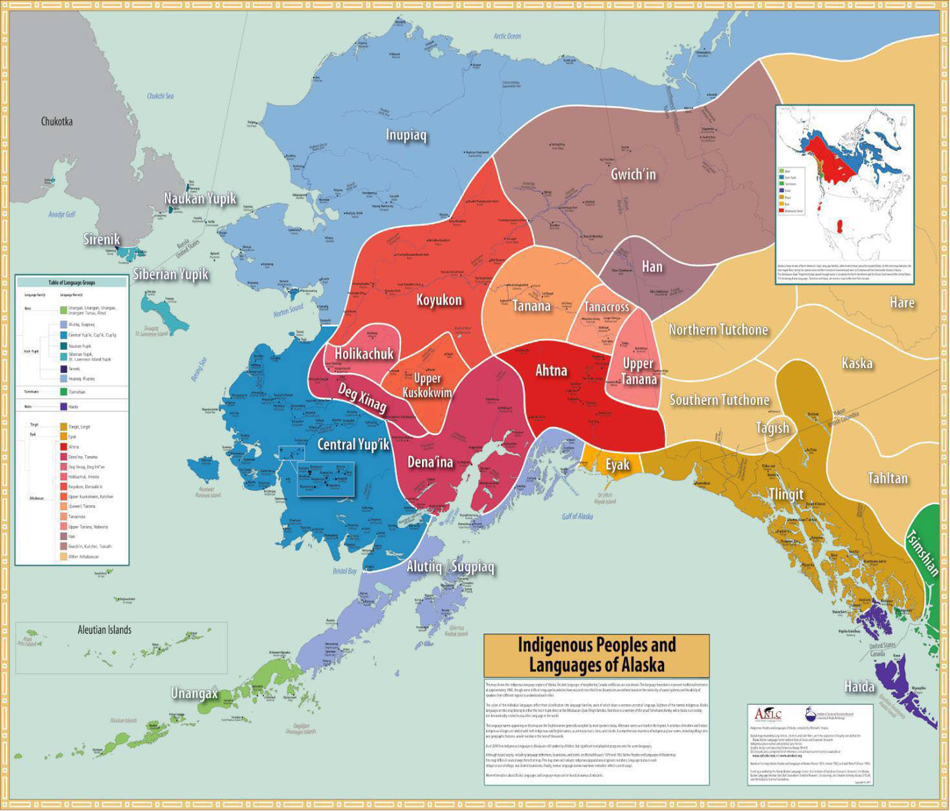

Appendix C: Alaska Borough/Census Areas Map
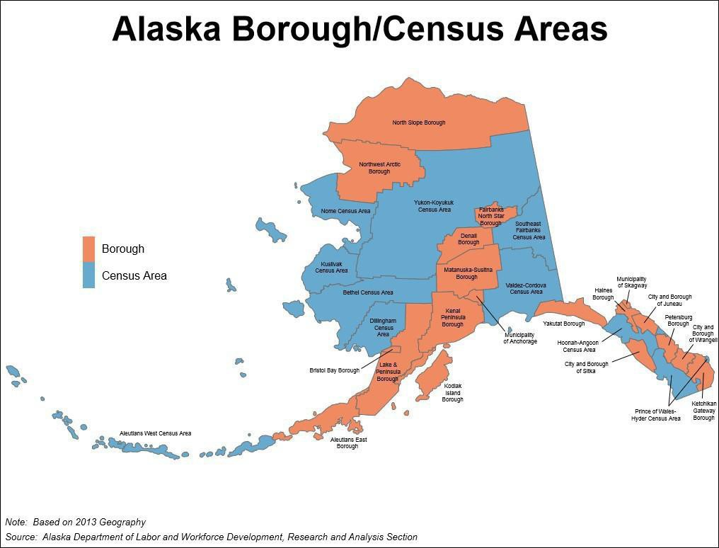

Appendix D: I Speak Card

